3GPP TSG SA WG5 Meeting #156 S5-244638

Maastricht, The Netherlands 19 - 23 August 2024

Source: China Mobile, ZTE

Title: Rel-19 pCR TR 28.858 Add use case for ML Incremental Pre-training

Document for: Approval

Agenda Item: 6.19.1

1 Decision/action requested
The group is asked to discuss and agree on the proposal.

2 References
[1] 3GPP TR 28.908-018 “Study on Artificial Intelligence/Machine Learning (AI/ ML) management”.
[2] 3GPP TR 28.9xx-00 “Study on Artificial Intelligence/Machine Learning (AI/ ML) Lifecycle Management (LCM) Phase 2”.

3 Rationale
The consumer would like to change a pre-trained ML model without reinitialize the model due to the consideration of energy consumption and retention of the valuable knowledge of the existing ML model. The incremental pre-training is applied for training a pre-trained model to change or consolidate the AIML capabilities of an ML model while an ML updating triggered

4 Detailed proposal
Start of modification

5 Use cases, potential requirements and possible solutions

5.1 Management Capabilities for ML training
5.1.X ML incremental pre-training

5.1.X.1 Description
ML incremental pre-training refers to training an already trained ML model (e.g. a pre-trained model) with domain related dataset. Re-training typically involves starting from scratch or reinitializing the model training process on a new dataset (i.e. reset the ML model parameters), which may lead to the model forgetting previously learned knowledge and is suitable for thoroughly renewing the model when there is a significant change in data distribution.
In contrast, incremental pre-training is a process of gradually updating the model by introducing new data on the basis of an existing ML model, especially for a pre-trained model. Since this method would not reinitialize the parameters of the model, it would focus more on training old knowledge while enhancing adaptability to new data, has a lower computational cost, which is suitable for scenarios where data accumulates gradually and the model needs to continuously adapt to new situations.
Type of inference is not changed when re-training a model, while incremental pre-training of an ML model, e.g., pre-trained model, means the multiple types of inference of an ML model would be altered.

ML Model training process defined in TS 28.105 covers incremental pre-training.

5.1.X.2 Use cases
5.1.X.2.1 ML incremental pre-training for a pre-trained ML model
An ML model can be trained by dataset that covers more than one type of inferences, i.e. pre-trained. In addition, a pre-trained Model may be pre-trained with large-scaled datasets not only related to the purpose of inference. For example, an ML model may be pre-trained with all the current and historical datasets, as much as possible, listed in clause 4a.1 in TS 28.105 to improve the comprehensive capability of the ML model.
However, the accuracy and precision of the pre-trained ML model is desirable to be further improved which means the AIML capability could be more focus on afterwards downstream tasks. For example, as illustrated in Figure 5.1.x.2.1 -1, the ML model has the capability to analysis anomalies from RAN, CN and OAM but the consumer would like to request an ML model focus on OAM aspects for further fine-tuning to types of inference for MDA. Therefore, the pre-trained model can be incrementally pretrained for alter or change the AI/ML capabilities to pay more concentration on downstream tasks.
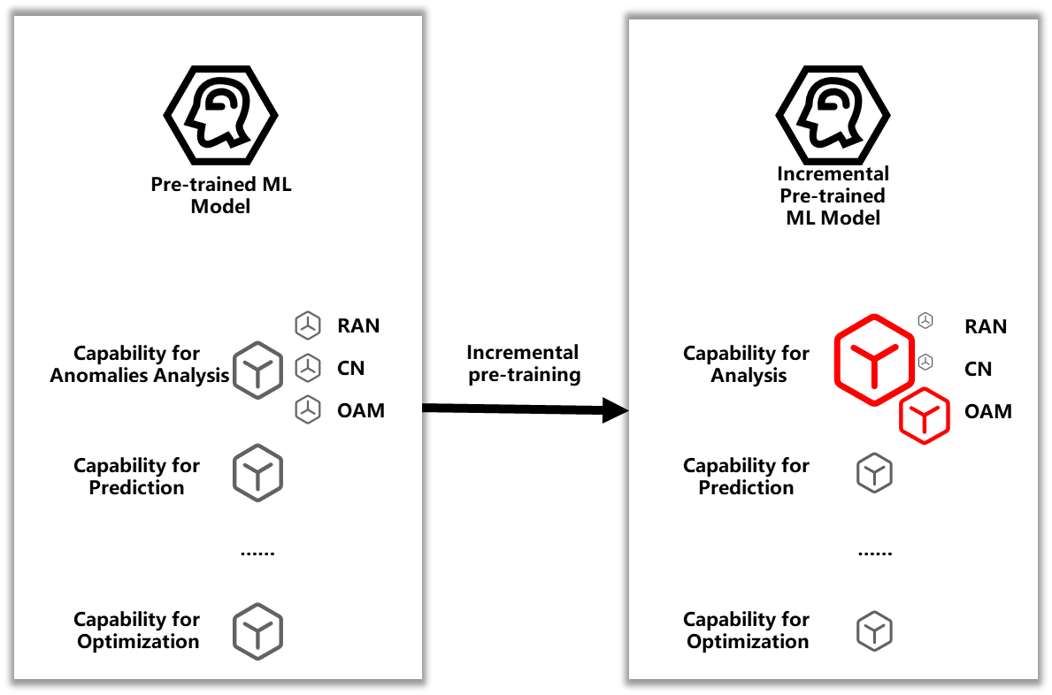
Figure 5.1.x.2.1 -1 Incremental pre-training to increase the AI/ML capability of anomaly analysis for OAM

5.1.X.3 Potential requirements
REQ-ML_ TRAIN-MLFT-1: The ML training MnS producer should have a capability to enable an authorized consumer to request the incremental pre-training of a pre-trained ML model to change or alter the potential AIML capabilities for a pre-trained model.

Editor note: It is for further discussion if the same requirements in existing TS 28.105 Table 6.2a.1.3-1 related to training function also applies for fine-tuning.
END of modification

