**3GPP TSG- Meeting # *S5-244608***

**Maastricht, The Netherlands, 19 - 23 August 2024 Revision of S5-244162**

**Source: Ericsson-LG Co., LTD, NEC**

**Title: Standardization of Federated Learning in 3GPP SA5**

**Document for: Endorsement**

**Agenda Item: 6.19.1**

1 Decision/action requested

***The group is asked to discuss and endorse the proposal.***

2 References

[1] 3GPP [TS 28.105](https://www.3gpp.org/DynaReport/28105.htm): " Management and orchestration; Artificial Intelligence/ Machine Learning (AI/ML) management"

[2] 3GPP [TR 28.858](https://www.3gpp.org/DynaReport/28858.htm): " Study on Artificial Intelligence / Machine Learning (AI/ML) management phase 2"

[3] 3GPP [TR 23.288](https://www.3gpp.org/DynaReport/23288.htm): "Architecture enhancements for 5G System (5GS) to support network data analytics services"

# 3 Discussion

## 3.1 Background

In clause 4 “Concepts and overview” in TS 28.105 [1], different concepts and technics are briefly mentioned. One of them in learning architecture is federated learning.

Contributions related to FL have been submitted in previous SA5 meetings and not agreed. One reason could be the lack of motivation and relevance of the content of clause 4 in TS 28.105 [1] in the context of SA5.

**Observation 1:** **SA5 scope**

There is no aligned view of to what extent FL should be standardized in SA5. An important aspect that needs to be discussed and agreed on is the interoperability aspect of Federated Learning. As stated in TS 28.105 [1], ML models and algorithms are proprietary (see clause 3 in TS 28.105 [1]), consequently exchange of models and features are not subject for standardization.

**Observation 2: Domain aspects**

**RAN Domain:** In a previous submission (not agreed), a scenario has been proposed where the FL server was in RAN Domain Function and FL client was in gNB. This scenario requires exposure of features and models trained by RAN to management system and vice versa.

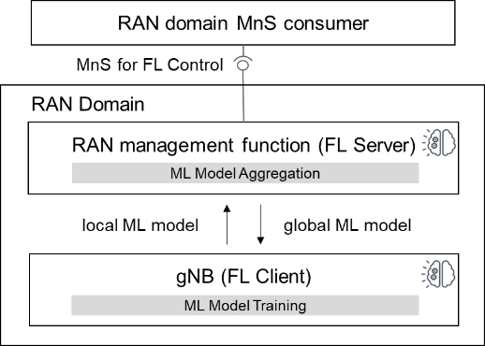

**Core Domain:**

Federated Learning has been defined in SA2 specification for NWDAF, see TS 23.288 [3], however SA2 has no requirement for management support of Federated Learning in SA5. Figure below illustrates the scenario where ML training function and AI/ML inference function are both located in the NWDAF.

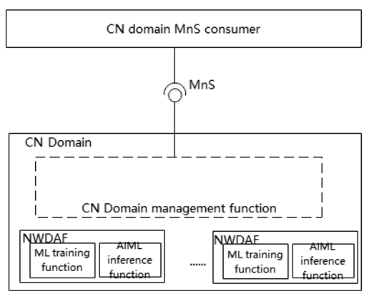

This scenario requires exposure of features and models trained by CN to management system and vice versa.

**3GPP Management Domain:**

The scenario for FL training located within a management system is proprietary and not to be standardized (Clause 3 and 7.1 in TS 28.105 [1]).

## 3.2 Proposed way forward for SA5

The above observations in clause 3.1 needs to be confirmed by SA5 group.

It is proposed to add relevant information and conclusion based on 3.1 in TR 28.858 [2]. It is also recommended to update TS 28.105, see clause 4, detailed proposal.

# 4 Detailed proposal

It is requested to endorse the following:

For release 19 study it is highly recommended that all submitted contributions shall include a clear motivation of the use case and why it is needed and what problem to be solved.