3GPP TSG SA WG5 Meeting #156 S5-244607d1

Maastricht, The Netherlands 19 - 23 August 2024

Source: ZTE Corporation

Title: pCR TR 28.858 Add Potential Requirements for ML Model Transfer

Document for: Approval
Agenda Item: 6.19.1

1 Decision/action requested
The group is asked to discuss and approval.

2 References
[1] 3GPP TR 28.858: " Study on Artificial Intelligence / Machine Learning (AI/ML) management Phase 2"

3 Rationale
SA1 has specified traffic characteristics and performance requirements for AI/ML model transfer in 5GS in Rel-18, and is studying the phase 2 in Rel-19. In TR 22.874 and 22.876, model complexity (e.g., model size, number of parameters) and required KPI (e.g., Max DL E2E latency, DL data rate) for different model type are sumaried as follows:
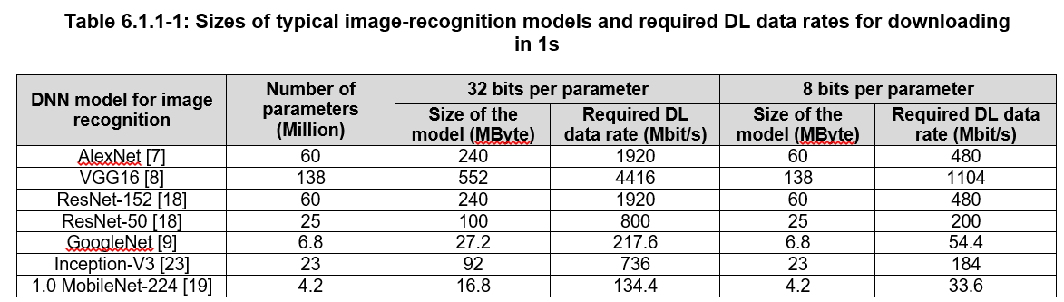
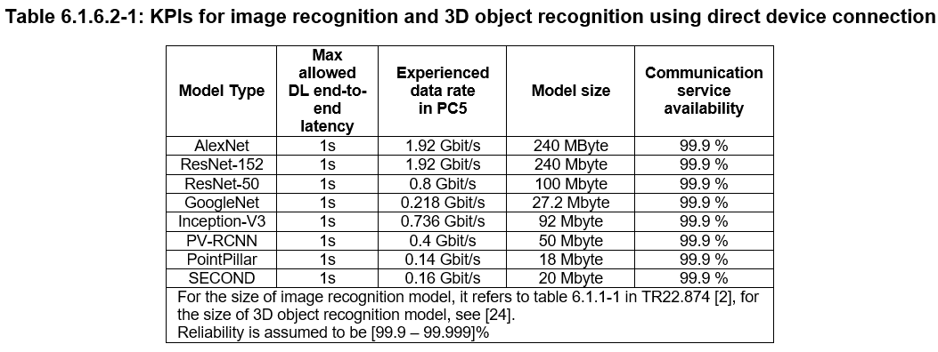
RAN groups have studied ML Model transfer in Rel-18 as well, where Solution 4b that OAM can transfer/deliver AI/ML model(s) to UE is considered. Besides, Model Complexity (e.g., number of parameters, size) and Computational Complexity (TOPs, FLOPs, MACs) are introduced as common KPIs for common evaluation. It’s identified that the model complexity of the model has impact on the ML Model transfer. When the ML Model size is larger than 45kBytes, ML Model transfer via control plane is not supported based on the current number of RRC segments.
Therefore, this contribution proposes a new use case on the topic of ML Model Transfer/Deliver. This contribution is related to WT-2.1 AI/ML Model transfer in 5GS.

4 Detailed proposal
1st Change

5.1.7 Managing ML Model Transfer in RAN

5.1.7.1 Description
ML Model Transfer Use Case in TR 38.843 refers to the delivery of an AI/ML model over the air interface. ML Model Delivery refers to delivery of an AI/ML model from one entity to another entity, where the coorespongding term in SA5 is ML Model Loading.

5.1.7.2 Use cases

5.1.7.2.1 Map ML Model Delivery in RAN to ML Model Loading in SA5
The solution 4b in TR 38.843 states that OAM can transfer/deliver AI/ML model(s) to UE. TS 28.105 specifies that the ML training function can be located in the RAN domain, which indicates that RAN can use ML training MnS services defined in [TS 28.105] to train ML Models which can then be loaded to gNB(s) using ML Model loading mechanism defined in TS 28.105.
The ML Model delivery specified in solution 4b with OAM involved should be investiaged in the study phase in SA5.

5.1.7.3 Potential Requirements
REQ-Loading_MGT-01: The 3GPP Management System should have a capability to support ML Model Loading.

End of changes

