3GPP SA4 #128 S4-241122
Jeju, Korea, 20 May – 24 May 2024
CR-Form-v12.0
PSEUDO CHANGE REQUEST
 | 26.822 | CR | pseudo | rev | - | Current version: | 0.0.1
For HELP on using this form: comprehensive instructions can be found at
http://www.3gpp.org/Change-Requests.

Proposed change affects: | UICC apps |  | ME |  | Radio Access Network |  | Core Network

Title: | [FS_5G_RTP_Ph2] Congestion control enhancement to support AL-FEC awareness handling
Source to WG: | Qualcomm Incorporated
Source to TSG:
Work item code: | FS_5G_RTP_Ph2 |  |  |  |  |  | Date: |  |  | 05/20/2024
Category: | B |  |  |  |  |  | Release: |  |  | Rel-19
 | Use one of the following categories:  F (correction)  A (mirror corresponding to a change in an earlier release)  B (addition of feature),  C (functional modification of feature)  D (editorial modification)  Detailed explanations of the above categories can  be found in 3GPP TR 21.900. |  |  |  |  |  |  |  | Use one of the following releases:  Rel-10 (Release 10)  Rel-11 (Release 11)  Rel-12 (Release 12)  Rel-13 (Release 13)  Rel-14 (Release 14)  Rel-15 (Release 15)  Rel-16 (Release 16)  Rel-17 (Release 17)  Rel-18 (Release 18)
Reason for change: |  | This addresses Key issue #4: Application-layer FEC awareness for PDU Set handling, and in particular  network dropping extra PDUs in a PDU Set encoded with application-layer FEC, if any, may send a false signal to the application on the packet loss rate and the congestion level in the network, and lead to undesired adaptation from the application such as increased redundancy ratio and reduced sending rate.  This paper proposes a solution to handling the packet losses resulting from AL-FEC awareness PDU Set handling
Summary of change: |  | Added a solution to handling the packet losses resulting from AL-FEC awareness PDU Set handling
Consequences if not approved: |  | 3GPP may not be vested to pursue solutions to enabling application-layer FEC awareness for PDU Set handling that could be beneficial.
Clauses affected:
 |  | Y | N
Other specs |  |  |  | Other core specifications |  |  |  | TS/TR ... CR ...
affected: |  |  |  | Test specifications |  |  |  | TS/TR ... CR ...
(show related CRs) |  |  |  | O&M Specifications |  |  |  | TS/TR ... CR ...
Other comments:
This CR's revision history:

.

Proposed changes

* * * * 1st change * * * *
Add the following to the References clause:
[WebRTC-code] WebRTC source code: https://source.chromium.org/chromium/chromium/src/+/main:third_party/webrtc, retrieved May 1, 2024.
[NADA] RFC 8698, Network-Assisted Dynamic Adaptation: A Unified Congestion Control Scheme for Real-Time Media, 2020.
[SCReAMv2] Self-Clocked Rate Adaptation for Multimedia, draft-johansson-ccwg-rfc8298bis-screamv2-00, 2024.

* * * * End of 1st change * * * *

changes

* * * * 2nd change * * * *

6.x Solution #x: Congestion control enhancement to support AL-FEC awareness handling

6.x.1 Key Issue mapping
This maps to Key Issue #4.

6.x.2 Description

6.x.2.1 Potential Benefits of Application-layer FEC awareness for PDU Set handling

When the RTP source adds redundant PDUs for an ADU, the redundancy is over budgeted to account for error in the estimation of the packet loss rate in the network. That is, there are more packets than needed for reconstructing the ADU. At the last hop of the PDU Set delivery, if the base station is aware of AL-FEC, it can drop PDUs that are no longer needed for rescontructing the ADU. This has two benefits:
- Reducing the usage of resources and hence improving the spectral efficiency (the amount of resources per PDU Set)
- Lowering the power consumption of the UE because the network can let the UE go to the sleep mode earlier.
This AL-FEC aware PDU Set handling is illustrated in the figure below. Packets 0 and 1 are served in the first time slot (which is a ‘D’ slot), and packets 2 and 3 in the second slot, and so on. In Case-1, without AL-FEC awareness, the redundant packets are still transmitted, which wastes network resources and keeps the UE awake longer before the network lets the UE go to the sleep mode. In contrast, in Case-2, with AL-FEC awareness, the use of network resources becomes more efficient, and the UE goes to the sleep mode earlier.
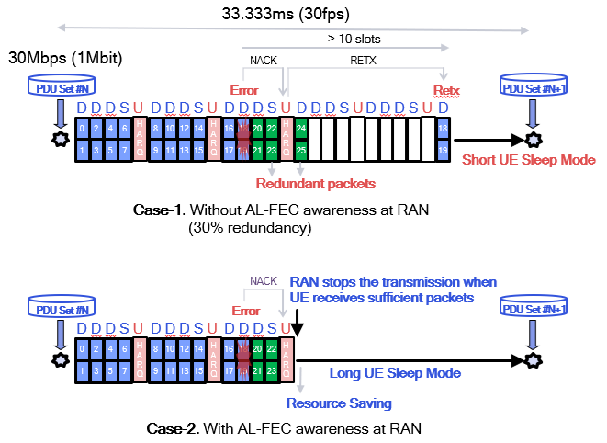
Figure 6.x-1 Potential Benefits of AL-FEC awareness at RAN

Simulation study is carried out for the following scenario to quantify the benefits:
TDD with slot pattern DDDSU, 30kHz SCS, HARQ Retransmission (up to 3 times), 100MHz bandwidth, IBLER = 10%, 30fps, MDS AL-FEC code, redundancy ratio 30% (FEC code rate = 22%). The power consumption values are presented by relative power as defined in TS 38.840.
Table 6.x-1 Potential Benefits of AL-FEC aware PDU Set handling at RAN
 | 99-Percentile Latency  (ms) | Power Consumption | Network loading
Case 1 – without AL-FEC awareness at RAN | 27 | 312 | 91.08%
Case 2 – with AL-FEC awareness at RAN | 27  (0%) | 270  (-13%) | 74.03%  (-19%)

We see from the table that AL-FEC aware handling reduces power consumption of the UE by 13%, which is significant for the UE. It also reduces the network loading by 19%, and this allows the network to accommodate more users.
Observation 1: AL-FEC aware PDU Set handling can potentially reduce the UE power consumption and network loading.

6.x.2.2 Implications of Application-layer FEC awareness for PDU Set handling on congestion control
Many congestion control algorithms, such as Google congestion control algorithms [WebRTC-code], NADA [NADA] and SCReAMv2 [SCReAMv2], use packet losses as a signal of network congestion. Therefore, it is important for the congestion control algorithms to correctly interprete packet losses in the case of AL-FEC awareness handling of the PDU Set.

6.x.2.3 The Proposed Solution

6.x.2.3.1 Case 1: In congestion
When there is congestion, as long as the AL-FEC awareness handling of the PDU Set does not alter the packet loss statistics, there is no impact on congestion control. Examples are given below.
Example 1: the network can discard repair packets rather than source packets in the case of FlexFEC without changing the overall packet loss rate, which will not lead to over reduction of the sending rate.
Example 2: the network can discard redundant packets across different PDU Sets while still meeting the required redundancy ratios for reconstructing the respective ADUs.

6.x.2.3.2 Case 2: Not in congestion
When there is no congestion, the network can discuss obsolete packets (by obsolete, it means that the packets are no longer needed for reconstructing the ADU at the receiver), which will increase the packet loss rate observed by the RTP sender, and to avoid the RTP sender mis-interprete the packet losses as signals of congestion, the network can indicate to the RTP sender that there is no network congestion and such packet losses should not be taken into account by the congestion control algorithm for determining the sending rate. The signaling can be achieved by the absence of ECN marking in the fraction of packets not being dropped when ECN is enabled.

* * * * End of 2nd change * * * *

