3GPP TSG-SA WG4 Meeting #128 S4-241019

South Korea, Jeju, 20 – 24 May 2024

CR-Form-v12.0
PSEUDO CHANGE REQUEST
 | 26.822 | CR |  | rev | - | Current version:
For HELP on using this form: comprehensive instructions can be found at
http://www.3gpp.org/Change-Requests.

Proposed change affects: | UICC apps |  | ME |  | Radio Access Network |  | Core Network

Title: | [FS_5G_RTP_Ph2] KI#x on Media delivery over multiple sessions
Source to WG: | Nokia Corporation
Source to TSG:
Work item code: | FS_5G_RTP_Ph2 |  |  |  |  |  | Date: |  |  | 14/05/2024
Category: |  |  |  |  |  |  | Release: |  |  | Rel-19
 | Use one of the following categories:  F (correction)  A (mirror corresponding to a change in an earlier release)  B (addition of feature),  C (functional modification of feature)  D (editorial modification)  Detailed explanations of the above categories can  be found in 3GPP TR 21.900. |  |  |  |  |  |  |  | Use one of the following releases:  Rel-10 (Release 10)  Rel-11 (Release 11)  Rel-12 (Release 12)  Rel-13 (Release 13)  Rel-14 (Release 14)  Rel-15 (Release 15)  Rel-16 (Release 16)  Rel-17 (Release 17)  Rel-18 (Release 18)
Reason for change: |  | A new key issue is proposed to study media and metadata delivery over multiple sessions.
Summary of change:
Consequences if not approved:
Clauses affected:
 |  | Y | N
Other specs |  |  |  | Other core specifications |  |  |  | TS/TR ... CR ...
affected: |  |  |  | Test specifications |  |  |  | TS/TR ... CR ...
(show related CRs) |  |  |  | O&M Specifications |  |  |  | TS/TR ... CR ...
Other comments:
This CR's revision history:

=========================== CHANGE 1 (all new) ==========================

5.X Key Issue #x: Media and metadata delivery over multiple sessions

5.13.1 Description
In XR communication, certain media types, e.g., avatar and associated animation data, can be transmitted over a data channel. At the same time, it may still be possible to have a UE-to-UE voice call, e.g., an MTSI call, as the latency constraints for voice are higher. While SDP procedures take care of grouping appropriate media flows for synchronization and other functionalities within the same RTP session, it needs to be studied how the same can be achieved when related media streams and metadata are delivered over different RTP sessions and data channels.
Other use cases where associated media may be sent over different RTP sessions are teleconferencing applications that allow establishing a voice channel to a UE. The voice in this case maybe over a direct UE-to-UE communication (MTSI call), while other media (e.g., presentations, video) are delivered via a network media function. A high-level illustration is shown in Figure 5.X.1 below. Here the voice is delivered UE-to-UE, and the associated RTP session is shown as Session 3. The video from UE A to UE B is delivered via a network media function over two RTP sessions, Session 1 and Session 2. Depending on the use case and application requirements, the network media function may apply operations such as upscaling, merging video streams, or animation in case of avatar data.

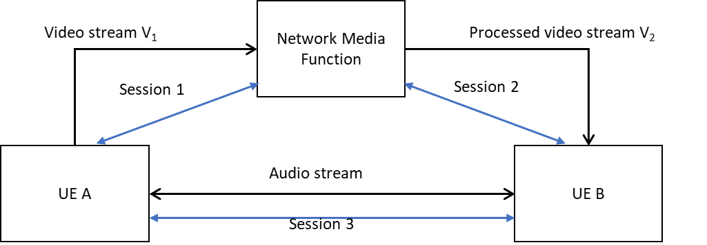
Figure 5.X.1 An example scenario with multiple media sessions.

In this key issue, it is proposed to study:
- Whether it is feasible to have components of an XR call that are sent over different paths, e.g., a UE-to-UE voice channel and a UE-MF-UE or AS/MF-to-UE channel for avatar data (sans audio).
- How to achieve cross-session referencing for XR media and metadata that are sent over different RTP sessions and data channels that don’t have common endpoints.

