3GPP TSG-S4 Meeting # 128 S4-240XXX
Jeju Island, KR, 20-24 May 2024
CR-Form-v12.2
PSEUDO CHANGE REQUEST
 | 26.510 | CR | pseudo | rev |  | Current version: | 1.2.3
For HELP on using this form: comprehensive instructions can be found at
http://www.3gpp.org/Change-Requests.

Proposed change affects: | UICC apps |  | ME | X | Radio Access Network |  | Core Network | X

Title: | Improving M6
Source to WG: | Tencent Cloud, Qualcomm, BBC
Source to TSG: | S4
Work item code: | 5GMS_Pro_Ph2 |  |  |  |  |  | Date: |  |  | 2024-04-20
Category: | B |  |  |  |  |  | Release: |  |  | Rel-18
 | Use one of the following categories:  F (correction)  A (mirror corresponding to a change in an earlier release)  B (addition of feature),  C (functional modification of feature)  D (editorial modification)  Detailed explanations of the above categories can  be found in 3GPP TR 21.900. |  |  |  |  |  |  |  | Use one of the following releases:  Rel-8 (Release 8)  Rel-9 (Release 9)  Rel-10 (Release 10)  Rel-11 (Release 11)  …  Rel-16 (Release 16)  Rel-17 (Release 17)  Rel-18 (Release 18)  Rel-19 (Release 19)
Reason for change: |  | - Aligning the M6 general APIs with the recent changes in R18:  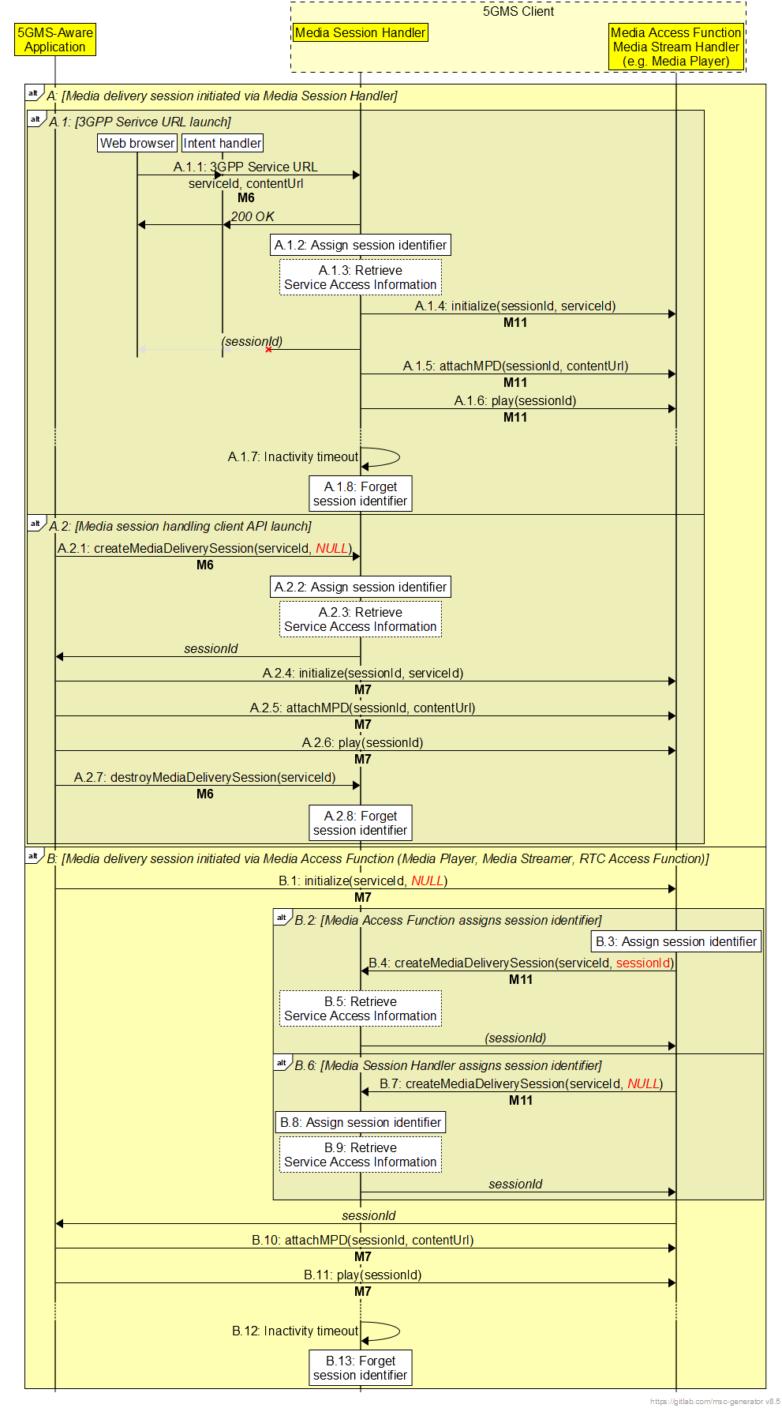  Exluding B.2-B.5  And  - The client API for the dynamic policy is not properly specified. The activation and usage of the BDT should be part of the dynamic policy activation over that API.
Summary of change: |  | - 5.4.2.1:updating the process of assigning the media delivery session identifier.  - 10.2.1: new entry in the table  - 10.2.2: updating the methods  - 10.2.3: updating the events  - 10.3: updating dynamic policy APIs
:
Consequences if not approved: |  | M6 is underdefined and not clear.
Clauses affected:
 |  | Y | N
Other specs |  |  | X | Other core specifications |  |  |  | TS/TR ... CR ...
affected: |  |  | X | Test specifications |  |  |  | TS/TR ... CR ...
(show related CRs) |  |  | X | O&M Specifications |  |  |  | TS/TR ... CR ...
Other comments:
This CR's revision history:

1st Change

5 Media delivery session life-cycle

5.4.2.1 Explicit media session handling initiation/termination
Prior to or during a media delivery session, the Media-aware Application or Media Access Function, may request the Service Access Information Function by invoking an appropriate API method on the Media Session Handler at reference points M6 or M11, respectively and providing the external service id.
Media session handling of a new media delivery session may be explicitly initiated by a Media-aware Application or Media Access Function by invoking an appropriate API method on the Media Session Handler at reference points M6 or M11, respectively. A media entry point document or URL, for instance obtained from the Service Access Information, shall be provided as input parameter to the API method.
In response, the Media Session Handler shall allocate a globally unique media delivery session identifier for use by the Media Client in its subsequent interactions with the Media AF and Media AS.
The Media Session Handler shall attempt to acquire full Service Access Information for the specified external service identifier from the Media AF using the operation defined in clause 5.3.2.3 and, if successful, shall return the media delivery session identifier to the invoker of the API method.
Subsequent interactions by the Media-aware Application with the Media Session Handler at reference point M6 shall cite the relevant media delivery session identifier.
a) If it initiates media delivery, the Media-aware Application shall also pass this media delivery session identifier to the Media Access Function at reference point M7 for subsequent use in interactions between the Media Access Function and the Media Session Handler at reference point M11.
b) Alternatively, if media delivery is initiated by the Media Access Function on behalf of the Media-aware Application, the media delivery session identifier shall instead be passed to the Media Access Function at reference point M11 for use in subsequent interactions between them at this reference point.
Subsequent interactions by the Media Access Client with the Media AS at reference point M4 shall cite the relevant media delivery session identifier to enable media access logged by the Media AS to be correlated with media session handling operations logged by the Media AF.
The Media-aware Application or Media Access Function may explicitly terminate media session handling of the media delivery session by invoking an appropriate API method on the Media Session Handler at reference point M6 or M11, respectively, citing the target media delivery session identifier as input parameter.

2ndChange

10 UE media session handling APIs

10.1 Introduction
This clause defines the abstract client APIs exposed by the Media Session Handler to the Media-aware Application at reference point M6 and to the Media Access Function at reference point M11. The APIs may be used to query a subset of information from Service Access Information and its updates as well as to receive the notifications of various events during the media delivery session.
NOTE: Client-driven management of edge processing resources via reference point M6 is not specified in this release.

10.2 Media Session Handler client API

10.2.1 Media Session Handler internal properties
The Media Session Handler maintains internal properties as defined table 10.2.1-1. Note that the parameters are conceptual. They serve only for the purpose of defining the media session handling APIs.
Table 10.2.1-1: Parameters of Media Session Handler
States and Parameters |  | Definition
_Configuration[externalServiceId] |  | The Media Session Handler maintains a separate configuration for each set of Service Access Information it has knowledge of, indexed by its external service identifier or 3GPP Service URL.
 | streamingAccessInformation | The Streaing Access Information resource
 | _mediaDeliverySessionIdentifier | The media delivery session identifier, if assigned.
 | _networkAssistance | Network Assistance configuration.
 | _policyTemplate | Policy Template configuration.
 | _consumptionReporting | Consumption reporting configuration.
 | _metricsReporting | Metrics reporting configuration.
 | _edgeConfiguration | Edge resource confinguration.
_status[mediaDeliverySessionId] |  | The Media Session Handler maintains a separate status record for each currently active media delivery session, indexed by media delivery session identifier.
 | _generalStatus | General status information. (See table 10.2.3-1.)
 | _dynamicPolicyStatus | Dynamic Policy status information. (See table 10.3.2-1)
 | _networkAssistanceStatus | Network Assistance status information. (See table 10.4.2-1)
 | _consumptionReportingStatus | Consumption Reporting status information. (See table 10.5.2-1.)
 | _metricsReportingStatus | Metrics Reporting status information. (See table 10.6.2-1.)

10.2.2 General Media Session Handler methods

10.2.2.1 Create a media delivery session
A 3GPP Service URL (see clause 6) may be used to implicitly trigger the creation of a new media delivery session with the Media Session Handler.
The Media Session Handler also offers the explicit createMediaDeliverySession() method, which is used to create a new media delivery session in the Media Session Handler.
The input parameters of the method are specified in table 10.2.2.1-1:
Table 10.2.2.1-1: Input parameters for createMediaDeliverySession() method
Name | Type | O | Description
serviceId | string | M | The external service identifier (see table 8.2.3.1-1) of the Provisioning Session that this media delivery session pertains to.
domainName | string | M | The Fully-Qualified Domain Name (FQDN) of the Media AS endpoint supporting the media delivery session at reference point M4.
accessToken | string | O | An access token that the Media Session Handler presents to the Media AF to authorise invocation of media session handling operations at reference point M5.

Upon success, the Media Session Handler shall
- Return the value of the mediaDeliverySessionIdentifier of Configuration[ExtServiceId] if exists and has an assigned value.
- Assign a new value, to uniquely identify the media delivery session in the Media Delivery System, to the mediaDeliverySessionIdentifier of Configuration[ExtServiceId] if this configuration exists, but does not have a media delivery session identifier value, and then return this value.
The return value of the method is specified in table 10.2.2.1-2.
Table 10.2.2.1-2: Return value for createMediaDeliverySession() method
Type | Description
string | The media delivery session identifier.

10.2.2.2 Destroy a media delivery session
The destroyMediaDeliverySession() method is used to end the media delivery session and release the allocated resources by the Media Session Handler. With this method, the Media Session Handler does not maintain the internal properties corresponding to the media delivery session identifier. The input and return parameters of the method are specified in tables 10.2.2.4-1 and 10.2.2.4-2.
Table 10.2.2.2-1: Input parameters for destroyMediaDeliverySession() method
Name | Type | Description
mediaDeliverySessionIdentifier | String | The media delivery session identifier.

Table 10.2.2.2-2: Return value for destroyMediaDeliverySession() method
Type | Description
string | Status as described in 10.2.3.

10.2.3 General Media Session Handler information
Table 10.2.3-1 specifies the status information that can be obtained from the Media Session Handler through reference points M6 and M11.
Table 10.2.3-1: General Media Session Handler Status Information
Status | Type | Parameter | Definition
SESSION_HANDLING_STATUS | Enumeration:  ACTIVATED  STOPPED  ERRORED | Media delivery session identifier | The status of media delivery session:  ACTIVATED: The Media Delivery Session is assigned.  STOPPED: The Media Delivery Session is released, and the identifier is not in use.  ERRORED: There is an error in media session handling.

Table 10.2.3-2 provides a list of general notification events exposed by the Media Session Handler through reference points M6 and M11.
Table 10.2.3-2: General Media Session Handler Notification Events
Event | Definition | Payload
SESSION_HANDLING_ACTIVATED | Triggered when media session handling was activated for a specific Media Entry Point. | Media delivery session identifier,  Media Entry Point URL.
SESSION_HANDLING_STOPPED | Triggered when media session handling stopped for a specific Media Entry Point. | Media delivery session identifier,  Media Entry Point URL.
STREAM_ACCESS_INFORMATION_UPDATE | Triggered when an update to the Stream Access Information is available. | Media delivery session identifier,  Stream Access Information.

Table 10.3.3-3 provides a list of general error events exposed by the Media Session Handler through reference points M6 and M11.
Table 10.2.3-3: General Media Session Handler Error Events
Status | Definition | Payload
ERROR_SESSION_HANDLING | Triggered when there is an error in the media session handling. | Media delivery session identifier.

2nd Change

10.3 Dynamic Policy client API

10.3.1 Dynamic Policy methods

10.3.1.1 Retrieve Background Data Transfer information
The getBDTInfo() method is used to retrieve information about the next Background Data Transfer opportunity window at one of the Service Operation Points that are available in the context of a particular media delivery session.
The input parameters of the method are specified in tables 10.3.1.1-1.
Table 10.3.1.1-1: Input parameters for getBDTInfo() method
Name | Type | Description
sessionId | string | The media delivery session identifier (as specified in clause 7.3.2) of an initialised media delivery session in the Media Session Handler.
serviceOperationPointReference | string | The external reference identifier of a Service Operation Point that uniquely identifies a Policy Template within the context of sessionId.

The return value of the method is specified in table 10.3.1.2-1.
Table 10.3.1.2-1: Return value for getBDTInfo() method
Type | Description
object | Information about a Background Data Transfer opportunity.  The object shall contain the time window start and end times and the maximum allowed data volume in bytes.

10.3.1.2 Activate Dynamic Policy
The activatePolicy() method is employed to request the application of a dynamic policy that is configured at the Media Session Handler to a media delivery session. The scope of the dynamic policy is all application flows that match the application identifier or Media AS domain name declared when the media delivery session was created (see table 10.2.2.1 1). The application may also provide the estimated transfer volume if the media delivery session is expected to be within the bounds of a Background DataTransfer time window. The Media Session Handler conveys the request to the Media AF and provides the corresponding response to the invoker of the method. The input parameters of the method are specified in table 10.3.1.2-1.
Table 10.3.1.2-1: Input parameters for activatePolicy() method
Name | Type | Optionality | Description
sessionId | string | M | The media delivery session identifier (as specified in clause 7.3.2) of an initialised media delivery session in the Media Session Handler.
serviceOperationPointReference | string | M | The external reference identifier of a Service Operation Point that uniquely identifies a Policy Template within the context of sessionId.
estimatedTransferVolume | integer | C | The estimated volume of data to be transferred, expressed in bytes.  Minimum value 1 byte.  Required to be populated when the Policy Template corresponding to the referenced Service Operation Point declares a Background Data Transfer policy.

The return value of the method is specified in table 10.3.1.2-2.
Table 10.3.1.2-2: Return value for activatePolicy() method
Type |  | Description
object
 | recommendedDownlinkBitRate | The recommended downlink bit rate for the requested Service Operation Point.
 | recommendedUplinkBitRate | The recommended uplink bit rate for the requested Service Operation Point.
 | backgroundDataTransferActivated | Indicates whether Background Data Transfer has been successfully activated for the media delivery session for the duration of the indicated time window.

Table 10.3.2-2 provides a list of general notification events exposed by the Media Session Handler.
Table 10.3.2-2: Notification Events relating to Dynamic Policies
Event | Definition | Payload
POLICY_ACTIVATED | Triggered when a new Dynamic Policy is successfully activated for the media delivery session. | Media delivery session identifier,  Recommended downlink bit rate,  Recommended uplink bit rate.
POLICY_DEACTIVATED | Triggered when the Dynamic Policy for this media delivery session is deactivated. | Media delivery session identifier.
BACKGROUND_DATA_TRANSFER_OPPORTUNITY | Triggered when a new Background Data Transfer opportunity window opens. | Media delivery session identifier,  Service Operation Point reference,  Opportunity windows start date–time,  Opportunity windows end date–time,  Data volume quota,  Maximum uplink bit rate,  Maximum downlink bit rate.

Table 10.3.3-3 provides a list of general error events exposed by the Media Session Handler.
Table 10.3.2-3: Error Events relating to Dynamic Policies
Status | Definition | Payload
ERROR_INVALID_‌SERVICE_‌OPERATION_‌POINT | Triggered when the provided Service Operation Point reference is not valid for the media delivery session. | Media delivery session identifier,  Service Operation Point reference.
ERROR_UNAUTHORISED | Triggered when the application is not authorised to instantiate a dynamic policy for the provided Service Operation Point reference. | Media delivery session identifier,  Service Operation Point reference.
ERROR_BACKGROUND_DATA_TRANSFER | Triggered when there is an error during a Background Data Transfer, for example if it is cancelled before the end of the advertised opportunity window. | Media delivery session identifier,  Error reason.

