3GPP TSG-SA4 Meeting #128 S4aI240894r01

Jeju, Korea, 20-24 May 2024 (revision of S4aI240052)
CR-Form-v12.3
CHANGE REQUEST
 | 26.804 | CR | 0006 | rev | 3 | Current version: | 18.1.0
For HELP on using this form: comprehensive instructions can be found at
http://www.3gpp.org/Change-Requests.

Proposed change affects: | UICC apps |  | ME | X | Radio Access Network |  | Core Network | X

Title: | [FS_AMD] Multi-CDN and Multi-Access Media Delivery
Source to WG: | Dolby France SAS
Source to TSG: | S4
Work item code: | FS_AMD |  |  |  |  |  | Date: |  |  | 2024-05-13
Category: | B |  |  |  |  |  | Release: |  |  | Rel-19
 | Use one of the following categories:  F (correction)  A (mirror corresponding to a change in an earlier release)  B (addition of feature),  C (functional modification of feature)  D (editorial modification)  Detailed explanations of the above categories can  be found in 3GPP TR 21.900. |  |  |  |  |  |  |  | Use one of the following releases:  Rel-8 (Release 8)  Rel-9 (Release 9)  Rel-10 (Release 10)  Rel-11 (Release 11)  …  Rel-17 (Release 17)  Rel-18 (Release 18)  Rel-19 (Release 19)  Rel-20 (Release 20)
Reason for change: |  | Document the FS_AMD key topic “c) Multi-Access and Multi-CDN Delivery” description and collaboration scenarios.
Summary of change: |  | Addition of new clause 5.x Multi-CDN and Multi-Access Media Delivery including sub-clause structure and headings. Addition of prose for Description and Collaboration Scenarios.
Consequences if not approved: |  | FS_AMD objectives not achieved.
Clauses affected: |  | 2, 5.x (NEW)
 |  | Y | N
Other specs |  |  | X | Other core specifications |  |  |  | TS/TR ... CR ...
affected: |  |  | X | Test specifications |  |  |  | TS/TR ... CR ...
(show related CRs) |  |  | X | O&M Specifications |  |  |  | TS/TR ... CR ...
Other comments:
This CR's revision history: |  | S4-240591: SA4#127-bis-e, description and collaboration scenarios  S4-240844: updates with comments received at SA4#127-e-bis  S4aI240052: updated to match proposed template and address pending comments.  S4al240894: S4al240052 endorsed at SA4 post 127-bis-e and comments/changes accepted for ease of reading. Updates with comments received at SA4 post 127-bis-e and introduction of candidate solutions. More background on candidate solution is contained in S4-240895. Multi-access media delivery overview and collaboration scenarios have been moved to S4-241082.

FIRST CHANGE

2 References
[DASH9] Draft Text of ISO/IEC FDIS 23009-9 Information technology - Dynamic adaptive streaming over HTTP (DASH) – Part 9: Redundant Encoding and Packaging for segmented live media (REaP), ISO/IEC JTC 1/SC 29/WG 3 NO 1165, Jan. 26, 2024. [Online]. Available: https://www.mpeg.org/standards/MPEG-DASH/9/
[UNPKG24] Emma Roth, "A popular open-source content delivery network went down for hours", The Verge, Apr. 12, 2024. [Online]. Available: https://www.theverge.com/2024/4/12/24128276/open-source-unpkg-cdn-down (accessed May 9, 2024).
[NET23] Sebastian Moss, "Cloudflare recovers from service outage after power failure at core North American data center", Data Center Dynamics, Nov. 3, 2023. [Online]. Available: https://www.datacenterdynamics.com/en/news/cloudflare-recovers-from-service-outage-after-power-failure-at-core-north-american-data-center/ (accessed May 9, 2024).
[FSLY21] Brian Barrett, "How an Obscure Company Took Down Big Chunks of the Internet", Wired, Jun. 8, 2021. [Online]. Available: https://www.wired.com/story/fastly-cdn-internet-outages-2021/ (accessed May 9, 2024).
[AKAM21] Josh Fomon, "CDN Provider Akamai Takes Down Popular Internet Services During Outage", Ookla, Jul. 22, 2021. [Online]. Available: https://www.ookla.com/articles/akamai-outage-july-22-2021 (accessed May 9, 2024).
[NET22] Charlotte Trueman, "Cloudflare outage brings hundreds of sites, services temporarily offline", Computer World, Jun. 21, 2022. [Online]. Available: https://www.computerworld.com/article/1627967/cloudflare-outage-brings-hundreds-of-sites-services-temporarily-offline.html (accessed May 9, 2024).
[VZ19] Jim Salter, "The Internet broke today: Facebook, Verizon, and more see major outages", Ars Technica, Jul. 3, 2019. [Online]. Available: https://arstechnica.com/information-technology/2019/07/facebook-cloudflare-microsoft-and-twitter-suffer-outages/ (accessed May 9, 2024).
[DEMX01] Marc Hoppner, "A content owner, a CDN and a player walk into a bar", (Jan. 6, 2023). Accessed: May 9, 2024. [Online Video]. Available: https://www.youtube.com/watch?v=S9EdoQFOQ9I&list
=PLkyaYNWEKcOf98lZxnCcL6y7ZIVU3oSYO&index=12
[DEMX02] Guillaume du Pantavice, "Improving streaming experience with Bayesian optimization, from AB to AZ test", (Dec. 25, 2021). Accessed: May 9, 2024. [Online Video]. Available: https://www.youtube.com/
watch?v=t4nRrLygVwo&list=PLkyaYNWEKcOfD1GYFxFbZXDP03XM-cZPg&index=19
[IEEE01] E. Ghabashneh and S. Rao, "Exploring the interplay between CDN caching and video streaming performance", IEEE INFOCOM 2020 – IEEE Conference on Computer Communications, Toronto, ON, Canada, 2020, pp. 516-525.
[ACM01] K. Vermeulen, L. Salamatian, S. H. Kim, M. Calder, and E. Katz-Bassett, "The central problem with distributed content: common CDN deployments centralize traffic in a risky way", In Proceedings of the 22nd ACM Workshop on Hot Topics in Networks (HotNets ’23). Association for Computing Machinery, New York, NY, USA, 70-78.
[MHV01] A. Bentaleb, R. Farahani, F. Tashtarian, C. Timmerer, H. Hellwagner, and R. Zimmermann, "Which CDN to Download From? A Client and Server Strategies", (Jan. 6, 2024). Accessed: May 9, 2024. [Online Video]. Available: https://www.youtube.com/watch?v=xCZmCnWgQRE
[VAS01] Will Law, "Content steering with MPEG DASH", (May 4, 2023). Accessed: May 9, 2024. [Online Video]. Available: https://www.youtube.com/watch?v=o9Pa5y-Usxw
[MWS23] W. Law and Y. Reznik, "DASH content steering at scale", Media Web Symposium (MWS’23), June 2023.
[DIFCS] ETSI TS 103 998: "DASH-IF: Content steering for DASH".
[CMMF] ETSI TS 103 973: "Coded multisource media format (CMMF) for content distribution and delivery".
[TS26510] 3GPP TS 26.510: "Interactions and APIs for provisioning and media session handling (Release 18)".
[TS26512] 3GPP TS 26.512: "5G Media streaming (5GMS) protocols (Release 18)".

SECOND CHANGE

5.x Multi-CDN media delivery

5.x.1 Description

5.x.1.1 Introduction
Media streaming applications traditionally obtain content from a single source over a single path within a network. This imposes several limitations:
1. Performance is constrained to that of the source and path chosen. Whatever the limits on network bandwidth and latency between the client and that source are directly translated to the client’s achievable Quality of Service (QoS) and Quality of Experience (QoE).
2 Disruptions or degraded performance caused by the source in use or on any of the network links between the client and source can lead to poor user experience, often in the form of lower playback quality, rebuffering, or complete playback failure.
This study considers integration of different technologies into the 5G Media Streaming System that addresses these, and similar, issues by allowing media streaming applications to efficiently access content across multiple Content Delivery Networks (CDNs) and/or multiple access networks. Different client implementations may then beneficially use the content on these multiple sources or networks concurrently, potentially guided by service or network provider. In addition, formats and techniques for generating content for multiple CDN or multiple access network delivery such as MPEG-DASH Part 9 (ReAP) [DASH9] may be considered. Further extensions include the ability for a client to use multiple access networks at the same time to support media delivery. Study of integration of different technologies into the 5G Media Streaming System is of relevance to address content provisioning, content hosting, impacts on user plane reference points M2 and M4, and on media session handling at reference point M5 as well as potential benefits in terms of quality and resource usage.

5.x.1.2 Challenges Multi-CDN deployments aim to address

CDNs are often used by content distributors to globally scale delivery of their content to end-users. These networks consist of a number of Points of Presence (PoPs) located at various locations around the networks’ edge. These PoPs help load-balance delivery of content as well as improve Quality of Service (QoS) by reducing the distance/latency between every client and the content they are accessing. In many cases, content distributors employ multiple CDNs to leverage the strengths of one CDN over another in every location those CDNs have a PoP. For example, a client experiencing degraded performance while using one CDN may switch to another that is offering better performance at that time and location. As another example, a content distributor may prefer one CDN over another at a given time to reduce delivery costs and/or meet monthly contractual commitments. These Multi-CDN deployments aim to solve content delivery issues that exist when only one CDN is used; but the benefits they provide may not be fully realized because of the various challenges experienced and underlying methods used to stream content to every client.
Challenges Multi-CDN deployments and architectures aim to address may include:
1. Sustained CDN-/network-wide service disruptions where network access, connectivity or QoS is severely degraded. Examples may include cases where an entire CDN’s network is degraded because of a network-wide misconfiguration or power failure. The duration of these events may last minutes to hours and affect a majority of the client population. Examples of recorded instances can be found in [UNPKG24], [NET23], [FSLY21], [AKAM21], [NET22], and [VZ19].
2. Intermittent or short-term disruptions affecting QoS for an individual or small group of clients. Examples include short periods of congestion within the network, isolated HTTP request/response failures or delays caused by application server congestion, etc. The following discusses these in greater detail: [DEMX01], [DEMX02], [IEEE01], [ACM01], [MHV01], [VAS01], and [MWS23]
3. Augmentation of one CDN's performance with that of another to achieve a level of performance that neither can provide on its own. An example is a peer-to-peer CDN where each peer has limited uplink capacity and is unable to satisfactorily service client demand on its own.

5.x.2 Collaboration scenarios

5.x.2.1 Multi-CDN media delivery
In this scenario, the 5GMSd Client requests adaptive media streaming content from two or more 5GMSd Application Servers. The Client may choose one 5GMSd AS or use multiple simultaneously. This allows the client to distribute network load across Application Servers and M4 downlink transports, optimize costs, as well as improve QoS.
The client’s Media Session Handler discovers the URLs of these Application Servers from the 5GMSd Application Function (AF), either through a Media Entry Point or from a separate piece of metadata. QoE metrics from the client may be used by the AF to determine the best Application Server(s) for each client to use when streaming media.
Figure 5.x.2.1-1 shows the client communicating with multiple Application Servers. Each AS has no direct communication with its peers; rather it communicates (minimally) with the Application Provider and with the 5GMSd AF (not depicted) via reference point M3d.
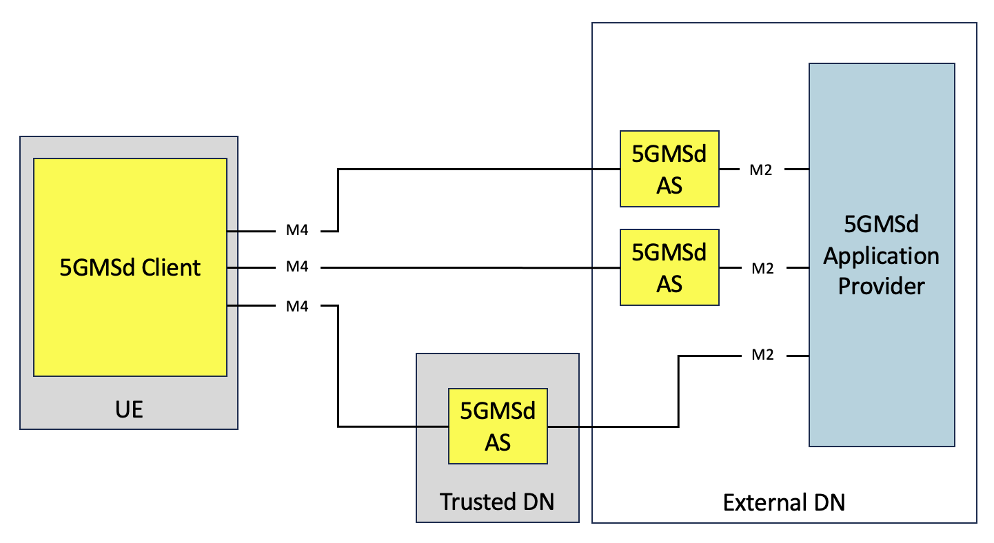
Figure 5.x.2.1-1: Multi-CDN media delivery within 5G system

5.x.2.2 Multi-access media delivery
These scenarios address integration of different technologies into the 5G Media Streaming System that allow media streaming applications to efficiently access content across multiple access networks. These scenarios are expanded upon in clause 5.x.
Editor’s Note: These collaboration scenarios are proposed as a separate CR to TR 26.804 labelled Multi-access media delivery. References to the appropriate clauses should be updated accordingly once clause numbers have been finalized.

5.x.2.3 Joint multi-CDN and multi-access media delivery
In this scenario, the 5GMSd Client is directly connected to multiple data, or access, networks (e.g., an unmanaged Wi-Fi network and the 5G network), as described in clause 5.x.2.2. The client requests adaptive media streaming content from two or more 5GMSd Application Servers. The Client may choose one or use multiple simultaneously. This allows the client to distribute network load across access networks and Application Servers, optimize costs, as well as improve QoS.
The client’s Media Session Handler discovers the URLs of these Application Servers from the 5GMSd Application Function (AF), either through a Media Entry Point or from a separate piece of metadata. QoE metrics from the client may be used by the AF to determine the best Application Server(s) for each client to use when streaming media.
Figure 5.x.2.3-1 shows the client communicating with multiple Application Servers through different data networks. Neither data network nor AS has direct communication with its peers. Rather each 5GMSd AS communicates (minimally) with the Application Provider at reference point M2 and with the 5GMSd AF (not depicted) via reference point M3d.
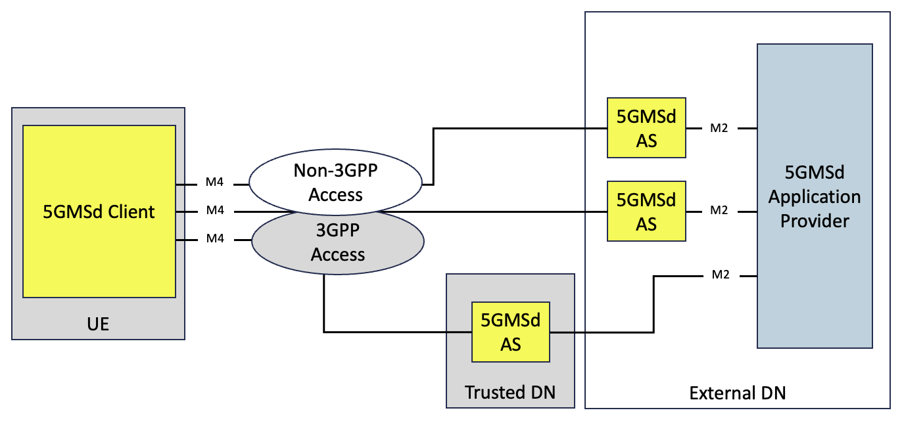
Figure 5.x.2.3-1: Multi-access media delivery within 5G system

5.x.3 Architecture mapping

5.x.4 High-level call flow

5.x.5 Gap analysis and requirements

5.x.6 Candidate solutions

5.x.6.1 Server-side CDN switching
These candidate solutions include approaches where a media streaming client or population of clients changes or switches between two or more CDNs based on recommendations from a remote server. An example includes the DASH Industry Forum’s content steering architecture [DIFCS].
Editor’s Note: Inclusion and expansion on these sets of solutions is dependent on interest from working group.

5.x.6.2 Client-side CDN switching
These candidate solutions include approaches where a media streaming client changes or switches between two or more CDNs based on decisions made locally.
Editor’s Note: Inclusion and expansion on these sets of solutions is dependent on interest from working group.

5.x.6.3 Concurrent CDN access
This candidate solution includes approaches where a 5GMSd Client accesses and downloads, via reference point M4, CMMF-encoded media objects [CMMF], and possibly original source media, from two or more 5GMSd Application Servers simultaneously. Additionally, the 5GMSd Client may access these 5GMSd Application Servers over different access networks (such as 3GPP and non-3GPP access networks).
In this solution, support for multi-CDN media delivery can be realized by the following procedures:

1. CMMF-encoded media objects are striped across multiple 5GMSd Application Servers. The 5GMSd Application Provider may make the CMMF-encoded media objects available at reference point M2or they may be created by the 5GMSd Application Server performing content preparation on regular media objects (e.g., CMAF media segments) that have been ingested from the 5GMSd Application Provider at reference point M2.
2. Upon initialization of a playback session, the 5GMSd Media Client’s Media Session Handler obtains relevant Service Access Information from the 5GMSd Application Function at reference point M5. At a minimum, this includes details concerning the location of each 5GMSd Application Server where the CMMF-encoded media may be obtained, as well as appropriate signalling to indicate that the media is CMMF-encoded.
3. The 5GMSd Media Client connects to and downloads CMMF-encoded media objects from each 5GMSd Application Server simultaneously, and possibly the original source media as well, via reference point M4, terminating the download from each 5GMSd AS early upon obtaining enough CMMF-encoded objects to recover the source MPEG-DASH or HLS media segment. Once decoded, the source media segment is delivered to the Media Player in the 5GMSd Media Client for presentation.

5.x.7 Summary and Conclusions

END OF CHANGES

