3GPP TSG SA WG 1 Meeting #106 S1-241389
Jeju , Korea, 27-31 May 2024 (revision of S1-241155,1283,1293)

Source: CATT
pCR Title: Pseudo-CR: Use Case on assisting vehicular communications via multi-orbits satellite access
Draft Spec: 3GPP TR 22.887 v0.0.0
Agenda item: 7.3
Document for: Approval
Contact: Qing Wan wanqing1@cictmobile.com

Abstract: This contribution proposes a use case of multi-orbits satellite access applied in Internet of Vehicles (IoV) services and associated potential service requirements for TR22.887.
1. Introduction
Satellite access can be applied as a complement of terrestrial access networks to deal with the challenge of the network availability and reliability in vehicular communications. The differentiated characteristics of LEO satellite and GEO satellite will lead to flexible and hybrid solutions to fulfil the communication need of different IoV services. This use case illustrate how GEO satellite and LEO satellite are used to assist vehicular communication.
2. Reason for Change
Introduce a use case about multi-orbits satellite access applied in vehicular communication to FS_5GSAT_Ph4 study.
3. Conclusions
<Conclusion part (optional)>
4. Proposal
It is proposed to agree on the following changes to 3GPP TR22.887 v0.0.0
* * * First Change * * * *

2 References
The following documents contain provisions which, through reference in this text, constitute provisions of the present document.
- References are either specific (identified by date of publication, edition number, version number, etc.) or non-specific.
- For a specific reference, subsequent revisions do not apply.
- For a non-specific reference, the latest version applies. In the case of a reference to a 3GPP document (including a GSM document), a non-specific reference implicitly refers to the latest version of that document in the same Release as the present document.
[x1] Dhinesh Kumar R, Rammohan A, Revolutionizing Intelligent Transportation Systems with Cellular Vehicle-to-Everything (C-V2X) technology: Current trends, use cases, emerging technologies, standardization bodies, industry analytics and future directions. Vehicular Communications, Vol.43, 2023, 100638
[x2] 5G Automotive Association (5GAA), C-v2x use cases and service level requirements -volume i，5GAA website, https://5gaa.org/c-v2x-use-cases-and-service-level-requirements-volume-i/, 2019
[x3] 5GAA discusses how C-V2X turns Connected and Safe Mobility into Reality at Mobile World Congress 2022 in Barcelona, https://5gaa.org/5gaa-discusses-how-c-v2x-turns-connected-and-safe-mobility-into-reality-at-mobile-world-congress-2022-in-barcelona/

* * * Second Change * * * *

5 Use cases

5.X Use case on assisting vehicular communications via multi-orbits satellite access

5.X.1 Description
Cellular Vehicle-to-Everything technology (C-V2X) is expected to play a critical role in the development of Intelligent Transportation Systems (ITS) and connected vehicles in the near future [x1]. Its evolution to 5G is fostering the synergies between the automotive industry and other verticals to support more scenarios and enhanced driving experience. The 5G Automotive Association(5GAA) is shaping the path to 5G and has identified 7 major groups of use cases as Table.1 depicts.
Table.1 Typical C-V2X Use Cases on 5GAA Technical Reports [x2]
Use Case Category | Use Case Examples
Safety | - Emergency braking  - Intersection Management | - Assisted collision warning  - Lane change
Vehicle Operations Management | - ECU software update  - Vehicle Health Monitoring | - Remote support
Convenience | - Infotainment  - Assisted and cooperative navigation | - Autonomous smart parking
Autonomous Driving  (L4 and L5) | - Control if autonomous/self-driving is allowed or not  - Tele-operation | - Handling of dynamic maps(update/download)  - Data/Sensor Sharing
Platooning | - Platooning management  - Determine position in platoon  - Dissolve a platoon | - Manage distance within platoon  - Leave a platoon  - Control of platoon in steady state
Traffic Efficiency and Environmental Friendliness | - Speed Harmonization  - Traffic jam information, e.g. traffic Light coordination | - Routing advisor, e.g. Bus Lane sharing
Society and Community | - Emergency vehicle approaching  - Traffic light priority | - Patient monitoring  - Accident Report
The communication needs of each specific use case can vary in e.g. latency, capacity, data rate, reliability, etc. For example, software update will request a large amount of vehicles scattered all over the world to download Gigabyte-level data simultaneously without stringent requirements in the latency. Assisted collision warning requests timely information exchange between ITS and the vehicles but the message size is only hundreds of bytes.
However, it is almost consensus that ubiquitous connectivity shall be a fundamental pre-requisite to enabling full-scale digital experience for cars and a fully connected car. Relying only on the coverage of terrestrial access network, it is still a challenge to ensure the network availability and reliability of fully connected cars. Satellite access networks can complement terrestrial network based solutions, especially in white spots (e.g. rural or remote areas) and in the event of outages and congestion. GEO satellite can provide the global coverage and bring capacity in very high-density vehicle places, while LEO satellite can support low latency communication on top of this capability. Today, over 200 million connected vehicles worldwide are equipped with applications sharing hazard and traffic warnings on the road. [x3] The differentiated characteristics of LEO and GEO satellites will lead to flexible and hybrid solutions based on multi-orbits satellite strategy and terrestrial access network.
This use case illustrates the usage of GEO satellite and LEO satellite in assisting the communication between ITS and the vehicles under the coordination of terrestrial network.

5.X.2 Pre-conditions
TerRAN deployed by the terrestrial network operator TerOP has full coverage in the urban areas (e.g AreaA) and rural area, but limited or even no coverage in deserts and depopulated area (e.g. AreaB).
TerOP has service agreements with satellite operator SatOP1 for sharing SatRAN#1(GEO satellite based NG-RAN) and SatOP2 for sharing SatRAN#2(LEO satellite based NG-RAN) to realize the global coverage of all the country.
The telematics devices (e.g. UE#1, UE#2, UE#3) installed on the autonomous trucks are the subscribers of TerOP and are allowed for multi-orbits satellite services under the agreement between TerOP and the vehicle management company, who is the owner of the autonomous trucks.
All UEs are capable of GEO and LEO satellite access.

5.X.3 Service Flows
1. All the trucks are launched out to deliver the goods. UE#1, UE#2 and UE#3 are registered to 5GC via nearby TerRAN and communicate with ITS via TerRAN as Fig 5.X.3 (a) shows, where
- UE#1 and UE#3 are downloading new firmware of Infotainment system with the traffic routed following blue colour line.
- UE#2 and UE#3 are requested to share road and sensor information for enhanced safety when they are driven into AreaA, and the data traffic is routed following red colour line.
2. As UE#1 moves into AreaB, UE#1 is switched to SatRAN#1 regarding the operator’s policy and criteria (e.g. QoS, satellite visibility), and continues the data transmission(with minimum interruption) and the signalling exchange as Fig 5.X.3(b) shows.
3. UE#2 and UE#3 are trapped in the crossroads together with hundreds of other vehicles due to the road collapse, which causes the congestion of TerRAN. Regarding the operator’s policy and criteria, UE#3 is switched to SatRAN#2 to transmit all traffic and the signalling at the time T1, and switched to SatRAN#1 to finish the data transmission of firmware downloading at the time T2 when LEO is passed away as Fig 5.X.3(b) shows.
4. When UE#1 detects the coverage of TerRAN, UE#1 will be switched back to TerRAN regarding the operator’s policy. Also, UE#2 will be switched back to TerRAN after the congestion is solved.
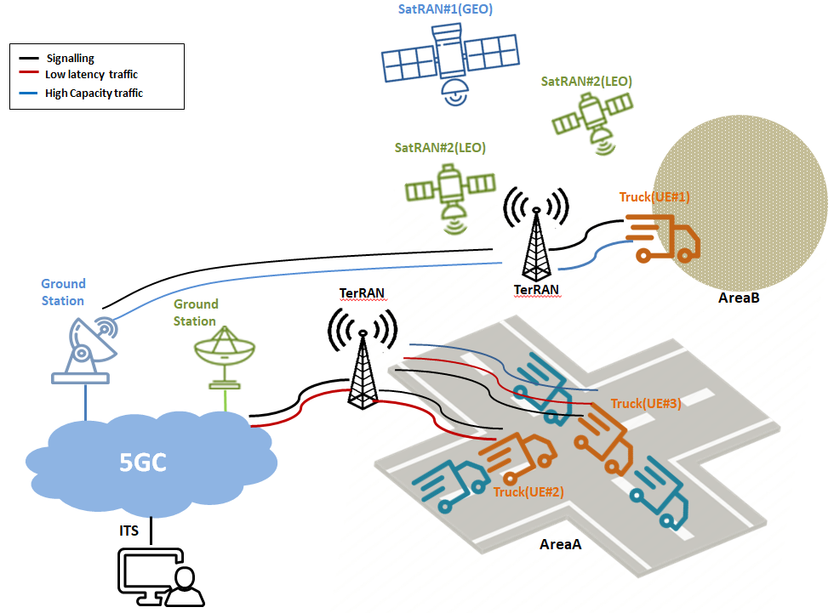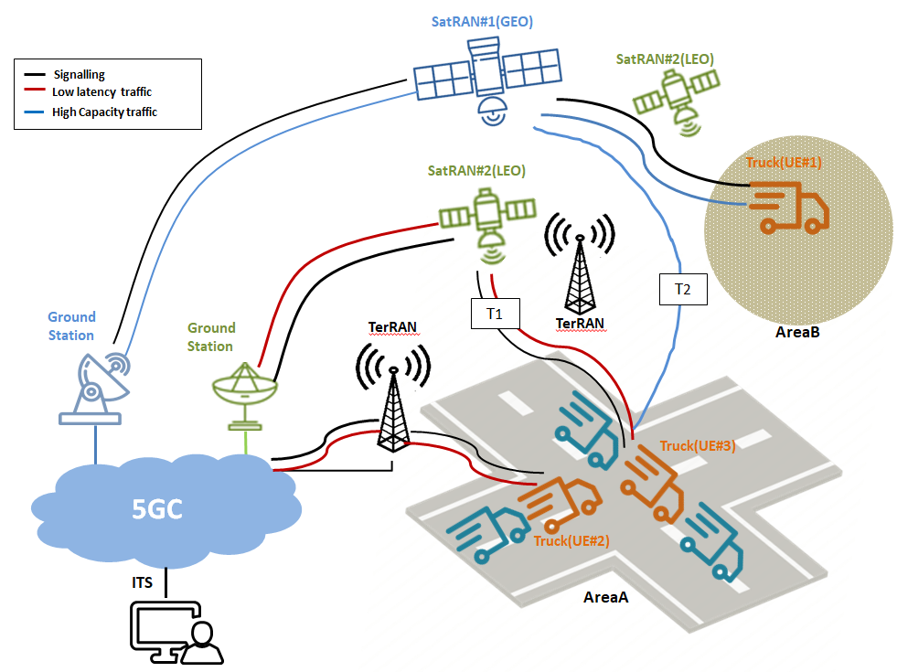
(a) communication via terrestrial RAN (b)communication via multiple satellite RANs
Fig 5.X.3-1 Assist Vehicular Communication via Multi-orbits Satellite Access

5.X.4 Post-conditions
Thanks to multi-orbits satellite services, UE#1 and UE#3 complete the firmware download and upgrade successfully; UE#3 exchanges the information of traffic jam and road collapse with TIS and is navigated to a new route.

5.X.5 Existing features partly or fully covering the use case functionality
SA1has identified a series of requirements related to satellite access and captured them in TS 22.261.
For RAN sharing, the following requirement can be applicable for this use case.
- A 5G satellite access network shall support NG-RAN sharing.
For the service continuity and user plane aspects, the following requirements can be partly applicable for this use case but not consider multi-orbit situation.
- A 5G system with satellite access shall support service continuity between 5G terrestrial access network and 5G satellite access networks owned by the same operator or owned by different operators having an agreement.
- A 5G system with satellite access shall be able to select the communication link providing the UE with the connectivity that most closely fulfils the agreed QoS.
- A 5G system with satellite access shall be capable of supporting simultaneous use of 5G satellite access network and 5G terrestrial access networks.
5.X.6 Potential New Requirements needed to support the use case
[PR 5.X.6-1] Subject to regulatory requirement and operator’s policy, a 5G system with multi-orbits satellite access shall support directing a UE to connect to one of satellite access networks in different orbits considering e.g.QoS, satellite visibility.
[PR 5.X.6-2] Subject to regulatory requirement and operator’s policy, a 5G system with multi-orbits satellite access shall minimize the service interruption when UE communication connection moves between different orbit types of satellite access networks belonging to the same PLMN.
[PR 5.X.6-3] A 5G network with multi-orbits satellite access shall be able to collect charging information for a UE served by different orbit types of satellite access networks.

* * * End of Changes * * * *

