3GPP TSG-SA WG1 Meeting #106 S1-241355

Jeju, South Korea, 27 - 31 May 2024 (revision of S1-241260,S1-241106)

Source: ZTE, CEPRI, China Unicom, China Telecom, CMCC, vivo, AsianInfo

Title: New SID on Study on Enhanced Group Communication Service

Document for: Agreement

Agenda Item: 4

3GPP™ Work Item Description
Information on Work Items can be found at http://www.3gpp.org/Work-Items
See also the 3GPP Working Procedures, article 39 and the TSG Working Methods in 3GPP TR 21.900

Title: Study on Enhanced Group Communication Service

Acronym: FS_EGCS

Unique identifier:

Potential target Release: Rel-20

1 Impacts
{For Normative work, identify the anticipated impacts. For a Study, identify the scope of the study}
Affects: | UICC apps | ME | AN | CN | Others (specify)
Yes |  | X |  | X
No |  |  | X
Don't know | X |  |  |  | X

2 Classification of the Work Item and linked work items

2.1 Primary classification
This work item is a
X | Study
 | Normative – Stage 1
 | Normative – Stage 2
 | Normative – Stage 3
 | Normative – Other*
* Other = e.g. testing

2.2 Parent Work Item

For a brand-new topic, use “N/A” in the table below. Otherwise indicate the parent Work Item.
Parent Work / Study Items
Acronym | Working Group | Unique ID | Title (as in 3GPP Work Plan)
N/A | N/A | N/A | N/A

2.3 Other related Work Items and dependencies
{List here other Work Items which relate to the proposed one, such as a Work Item in an earlier Release if further enhancing the feature from the previous Release)}
Other related Work /Study Items (if any)
Unique ID | Title | Nature of relationship

Dependency on non-3GPP (draft) specification:

3 Justification
With the diversity application growing, multiple sensors, cameras etc., can be grouped to support specific application e.g., inspection application. The application needs one kind of group communication which supports information exchange either among multiple UEs in the group or with network. It includes multiple communication connections with different QoS demands and these communication connections each other have relationship according to the application demand.
3GPP has specified group communication and management related requirements in different specifications(e.g. TS 22.468, TR 22.874, TR 22.876, TS 22.261 ), which mainly focus on forming a collection of devices by the application layer to operate, e.g., a collection of smart home equipment or wearable equipment. However, considering the variable network conditions and status inside/outside the group during the operation, following challenge need be considered:

A.In general, there may exist multiple PDU sessions among one or more UEs in a same group, which requires the multiple QoS monitoring for the multiple PDU sessions among one or multiple UEs for a same service.
- There may exist multiple data flows among multiple UEs in a same group, considering that these UEs are grouped for a same service, there may exist specific and different QoS policies for multiple data flows among multiple UEs.
Considering that the 3GPP network naturally has the information of the group communication and group member status, following aspects need to be studied to enhance the group communication for this kind of service:
(1) The service level QoS is split by application server. The split QoS requirements and the relationship among them are shared to the network to guide the network to provide communication service in a whole for the application without the application server awaring detail communication process.

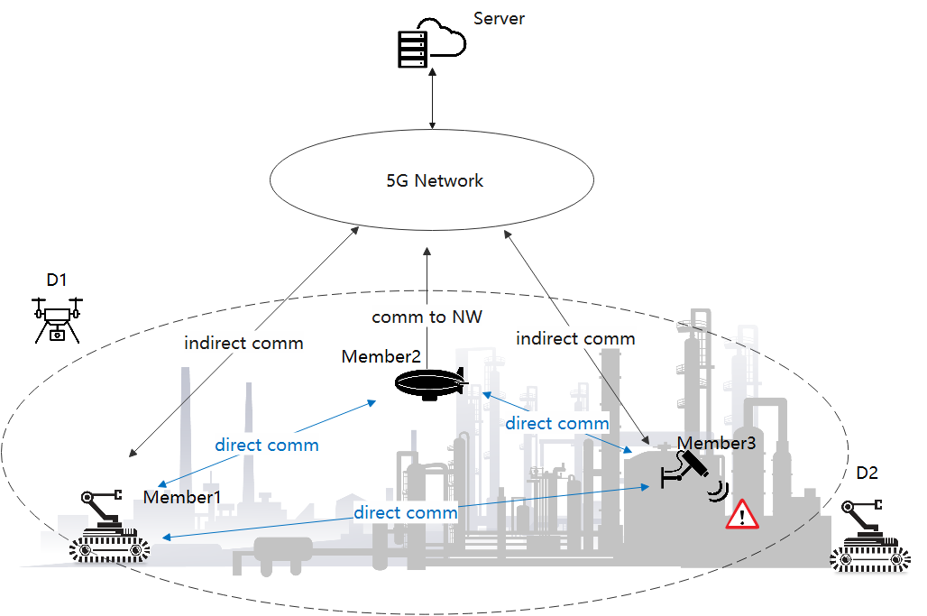

Figure 1. Example of inspection task in smart factory.
As example shown in Figure 1, the inspection task and its corresponding communication requirements are different according to its complexity, inspected product line and manufacturing environments (e.g., lighting, noise, and temperature) of workshops in a factory, thus the single device is not sufficient to guarantee efficient operations and provides real-time warning. Thus, the application server firstly splits the inspection task into three sub-tasks, where the sub-task1 is to inspect the corner area, the sub-task 2 is to inspect the high-altitude area, while the sub-task 3 is to inspect the area with large coverage. In this way, according to the different capabilities of devices (e.g., the robots can move to inspect large-scale area, the UAV can fly to inspect the high-altitude area, the camera is suitable for monitoring corner area), the application server provides following QoS information to the network:
--three communication QoS policies for the respect three sub-tasks and related UEs;
--three candidate UE lists for the respect three sub-tasks;
--information of data transmission order among the different data flows of a same service;
--the assistance information, e.g., the area information, the time information for the inspection task, etc.
Based on the provided information listed above, the network provides the service for the application as a whole without application awareness communication detail, e.g. to combination and synchronization of different service flows among different UEs of a same service, to monitor the service quality.

Based on the analysis above, it is proposed to study the enhanced group communication service, as per detailed objectives listed in the next section.

4 Potential Additional Requirement

6.7 Priority, QoS, and policy control

6.7.2 Requirements
The 5G system shall allow flexible mechanisms to establish and enforce priority policies among the different services (e.g. MPS, Emergency, medical, Public Safety) and users.
NOTE 1: Priority between different services is subject to regional or national regulatory and operator policies.
The 5G system shall be able to provide the required QoS (e.g. reliability, end-to-end latency, and bandwidth) for a service and support prioritization of resources when necessary for that service.
The 5G system shall enable the network operator to define and statically configure a maximum resource assignment for a specific service that can be adjusted based on the network state (e.g. during congestion, disaster, emergency and DDoS events) subject to regional or national regulatory and operator policies.
The 5G system shall allow decoupling of the priority of a particular communication from the associated QoS characteristics such as end-to-end latency and reliability.
The 5G system shall be able to support a harmonised QoS and policy framework applicable to multiple accesses.
The 5G system shall be able to support E2E (e.g. UE to UE) QoS for a service.
NOTE 2: E2E QoS needs to consider QoS in the access networks, backhaul, core network, and network to network interconnect.
The 5G system shall be able to support QoS for applications in a Service Hosting Environment.
A 5G system with multiple access technologies shall be able to select the combination of access technologies to serve an UE on the basis of the targeted priority, pre-emption, QoS parameters and access technology availability.
The 5G system shall support a mechanism to determine suitable QoS parameters for traffic over a satellite backhaul, based e.g. on the latency and bandwidth of the specific backhaul .
NOTE 3: The case where a backhaul connection has dynamically changed latency and/or bandwidth needs to be considered.
The 5G system shall be able to provide multiple QoS policies for multiple QoS flows in multiple sessions among one or multiple UEs for the same service for group communication.

6.23 QoS monitoring

6.23.2 Requirements
The 5G system shall provide a mechanism for supporting real-time E2E QoS monitoring within a system.
NOTE 1: The end points in E2E are the termination points of the communication service within the boundary of the 5G system.
The 5G system shall support combined QoS monitoring for a group of UEs.
NOTE 1A: Combined monitoring stands for the monitoring of several UEs for which the monitoring results are reported together. An example for combined QoS monitoring is that the 5G networks monitors the service bit rates of all connections associated with the group of UEs.
The 5G network shall provide an interface to an application for QoS monitoring (e.g. to initiate QoS monitoring, request QoS parameters, events, logging information).
The 5G system shall be able to provide real time QoS parameters and events information to an authorized application/network entity.
NOTE 2: The QoS parameters to be monitored and reported can include latency (e.g. UL/DL or round trip), jitter, and packet loss rate.
The 5G system shall be able to log the history of the communication events.
NOTE 3: The communication history may include timestamps of communication events and position-related information. Examples of such information are the positions of UEs and of radio base stations associated with communication events. Communication events include instances when the required QoS is not met.
The 5G system shall support different levels of granularity for QoS monitoring (e.g. per flow or set of flows) in one UE or among multiple sessions in multiple UEs..
The 5G system shall be able to provide event notification upon detecting an error that the negotiated QoS level cannot be met/guaranteed.
The 5G system shall be able to provide information that identifies the type and the location of a communication error (e.g. cell ID).
The 5G system shall be able to provide notification of communication events to authorized entities per pre-defined patterns.
NOTE 4: An example for a communication event is that the service bit rate drops below a pre-defined threshold for QoS parameters. When such an event occurs, the authorized entity is notified, and the event is logged.
The 5G system shall support event-based QoS monitoring.
NOTE 5: An example for a triggering event is a position change of the pertinent UE. A position change can, for instance, be inferred from a 5G position service that tracks the UE.
The 5G system shall be able to respond to a request from an authorized entity to provide real-time QoS monitoring information within a specified time after receiving the request (e.g., within 5 s).
NOTE 6: The response time can be specified by the user.
The 5G system shall support real time QoS monitoring with a specified update/refresh rate.
NOTE 6a: The update/refresh rate can be specified by the user.
NOTE 6b: The update/refresh rates for QoS monitoring measurements and reporting can be different.
The 5G system shall be able to provide statistical information of service parameters and error types while a communication service is in operation.
NOTE 7: The time span for collection and evaluation of statistical values can be specified by the user.
The 5G system shall provide information on the current availability of a specific communication service in a particular area (e.g. cell ID) upon request of an authorized entity.
The 5G system shall provide a means by which an MNO informs a third party of network events (failure of network infrastructure affecting UEs in a particular area, etc.).
Based on MNO policy, the 5G system shall provide a mechanism to automatically report service degradations, communications loss, and sustained connection loss in a specific geographic area (e.g., a cell sector, a cell or a group of cells) to a third party.
NOTE 8: These reports use a standard format. The specific values, thresholds, and conditions upon which alarms occur can include the measured values for end-to-end latency, service bit rate, communication service availability, end-to-end latency jitter, etc. for a UE, the UE’s location, and the time(s) during which the degradation occurred.
The 5G system shall provide a mechanism for an authorised third party to report to an MNO service degradations, communication loss, and sustained connection loss.
NOTE 9: These reports use a standard format. The specific values, thresholds, and conditions upon which alarms occur can include the measured values for end-to-end latency, service bit rate, communication service availability, end-to-end latency jitter, etc. for a UE, the UE’s location, and the time(s) during which the degradation occurred.
NOTE 10: What the MNO does with such reports is out of scope of 3GPP.
Based on operator request, for direct network connection scenarios in non-public networks, the 5G system shall be able to activate/deactivate efficient QoS monitoring with a finer granularity (e.g. per data packet) in a specific QoS flow (e.g. supporting URLLC services) to report on data packets not meeting the required QoS level.
NOTE 11: The QoS parameters to be monitored and reported can include latency (e.g. UL or DL).
NOTE 12: The above requirement does not assume UE impacts.

5 Expected Output and Time scale
{If this WID covers both stage 2 and stage 3, clearly indicate the different completion dates.}

New specifications {One line per specification. Create/delete lines as needed}
Type | TS/TR number | Title | For info  at TSG# | For approval at TSG# | Rapporteur
Internal TR | 22.XXX | Study on Enhanced Group Communication Service | TSG#105 (Sep, 2024) | TSG#106 (Dec, 2024) | Yansheng Liu, ZTE ,  liu.yansheng@zte.com.cn

Impacted existing TS/TR {One line per specification. Create/delete lines as needed}
TS/TR No. | Description of change | Target completion plenary# | Remarks

6 Work item Rapporteur(s)
Yansheng Liu, ZTE , liu.yansheng@zte.com.cn

7 Work item leadership
SA1

8 Aspects that involve other WGs
None identified yet

9 Supporting Individual Members
Supporting IM name
ZTE
CEPRI
China Unicom
China Telecom
CMCC
vivo
AsianInfo

