3GPP TSG-RAN WG4 Meeting #111 R4-241XXX
Fukuoka City, Fukuoka, Japan, 20th – 24th May, 2024

Agenda item: 7.19.4
Source: Moderator (Samsung)
Title: Ad-hoc minutes for [111][328] NR_MIMO_evo_DL_UL_demod
Document for: Aprroval

Discussion
For BS side
Issue 2-1-1: Minimum requirements for tests need to be defined for Rel-18 DMRS
- Proposals
  - Option 1: Use the new simulation results to define requirements for BS Demodulation of Rel-18 DMRS (Nokia, Ericsson, Samsung)
  - Option 2: Reuse legacy value to define requirements for BS Demodulation of Rel-18 DMRS. (Huawei, Samsung as compromise)
- Recommended WF
  - Is Option 2 agreeable?
Discussion:
Nokia: fine for us.

Tentative Agreement:
Option 2 (Reuse legacy value to define requirements for BS Demodulation of Rel-18 DMRS.)

For UE side
Issue 1-2-1: Test metric of TypeII-CJT-r18 codebook
- Proposals
  - Option 1: 1.8 for both 2Rx and 4Rx case (Nokia, Ericsson)
  - Option 2: 2.3 for both 2Rx and 4Rx case (Samsung)
  - Option 3: 1.6 for both 2Rx and 4Rx case (Huawei)
  - Option 4: 1.7 for 2Rx case, 1.6 for 4Rx case (MTK)
- Recommended WF
  - Based on companies simulation results, is Option 1 agreeable?
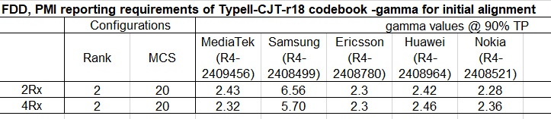
Discussion:
Huawei: double check companies’ views, is there strong view to use option 1?
Samsung: one question for Huawei, even considering some margin, even 1.8 is enough.
Nokia: 1.8 has include the lowest value with margin.
E///: this is PMI reporting, this is ratio for following PMI vs random PMI. Considering margin (80%), 1.8 is reasonable.
MTK: we are also fine with 1.8 proposal.
HW: comprise if all other companies agreed.

Tentative Agreement:
Set 1.8 as the test metric for both 2Rx and 4Rx cases for TypeII-CJT-r18 codebook.

Issue 1-1-2: Test metric of TypeII-Doppler-r18 codebook
- Proposals
For FR1 TDD:
  - Option 1: 4.0 for 2Rx case, and 3.5 for 4Rx case. (Ericsson)
  - Option 2: 3.6 for 2Rx case, and 5.6 for 4Rx case. (Samsung)
  - Option 3: 1.15 for both 2Rx and 4Rx (Huawei)
  - Option 4: 4.2 for 2Rx case, and 3.9 for 4Rx case. (MTK)
- Recommended WF
  - Based on the latest simulation results, is there any possible to define 2.7 for TDD case?
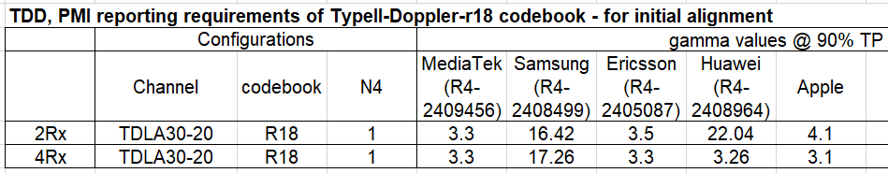
Discussion:
Huawei: we are wondering if 2.5 is ok?
Moderator: 2.7 is calculated using the formula (minimum simulation result -1)*80/100+1
Huawei: RAN4 never has a common formula to calculate
MTK: we are fine with 2.5 and 2.7, we are willing to align the method.
Huawei: no justification to define formula for all.
Nokia: just to find a way for the future. 2.7 is fine for us which align with the formula.
Huawei: thanks companies to try to find a way to align.
Samsung: for CSI reporting, it is hard to find a unified formula. This margin has too many uncertainty. A formula is a good starting point, but maybe need to consider more factors. 2.5 could be a comprise value to move forward.
Huawei: since different conditions, it is very hard to define a common formula.

Tentative Agreement:
Set 2.5 as the test metric for both 2Rx and 4Rx FR1 TDD cases for TypeII-Doppler-r18 codebook.

Issue 1-1-3: Test setup for FR1 FDD case of TypeII-Doppler-r18 codebook
- Proposals
  - Option 1: Propose to use only 2 first allocated PDSCH slots, like in TDD, to improve prediction accuracy (MTK)
- Recommended WF
  - More discussion needed
Discussion:
MTK: use current configuration the gain is limited, so propose to use better configuration.
Huawei: consider we have spent so many effort on this simulation configuration, I doubt the necessity to set new configuration.
Samsung: similar view as Huawei.
Apple: we like the proposal from MTK which could show obvious gain, but considering the very large span of gamma value, only if all companies are fine with this proposal, we are fine.
Huawei: the gains based on many factors for simulations. It is hard to judge how much gain is enough.
MTK: similar as TDD for the gain.
Huawei: because there are large span for the TDD simulation results, it is hard to reflect the gain through the final test metric.
Samsung: we already has agreements in last meeting, we need to follow, although we could understand the logical. It is hard to ask companies to rerun and realign the results. Try to define requirement based on current simulation results, if companies willing to provide more simulations we could try to maintain on later meetings.
QC: we share the comments from Samsung.

Tentative Agreement:
Define FR1 FDD requirement for TypeII-Doppler-r18 codebook based on current simulation results with current configuration agreed in RAN4#110bis meeting.

Issue 1-1-2: Test metric of TypeII-Doppler-r18 codebook
- Proposals
For FR1 FDD:
  - Option 1: 1.9 for 2Rx case, and 2.0 for 4Rx case (Apple)
  - Option 2: 2.0 for both 2Rx and 4Rx (Ericsson)
  - Option 3: 2.4 for 2Rx case, and 3.4 for 4Rx case. (Samsung)
  - Option 4: 1.15 for both 2Rx and 4Rx (Huawei)
  - Option 5: 1.4 for 2Rx, and 1.6 for 4Rx, if keep current configuration (MTK)
- Recommended WF
  - Based on the latest simulation results, is there any possible to define 1.8 for FDD case?
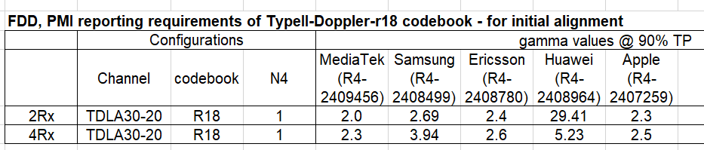
Tentative Agreement:
Set 1.8 as the test metric for both 2Rx and 4Rx FR1 FDD cases for TypeII-Doppler-r18 codebook.

Issue 1-1-7: explicitly define for clarification what “equal probability of each applicable i₁, i₂ combination”
- Background: we have below agreement on RAN4#110 meeting
Agreement:
- Explicitly define random precoding frequency domain granularities as random i₁ with wideband granularity and random i₂ with subband granularity with ‘typeII-Doppler-r18’ and ‘typeII-CJT-r18’ codebook.
- Proposals
  - Option 1: clarify granularity more clearly as below (MTK)
PDSCH & PDSCH DMRS Precoding configuration for random Precoding |  | Single Panel Type I, Random precoder selection updated per slot, with equal probability of each applicable i1, i2 combination  (i1 with wideband granularity and i2 with subband granularity)

- Recommended WF
  - Is Option 1 agreeable?
Discussion:
E///: fine for this proposal. Just to check is this only for CJT codebook?
Moderator: this is for all Type II codebook, MTK will submit maintenance CRs and HW will capture this agreement in Doppler codebook CR.

Tentative Agreement:
Option 1 is agreed, capture the info of (i1 with wideband granularity and i2 with subband granularity) into the CRs for Rel-18 evolution MIMO topic, the details of wording could be updated during the CR drafting.

Issue 1-1-4: Timing mismatch between the prediction reference and precoder usage in PDSCH transmission
- Proposals
  - Option 1: RAN4 to send LS to RAN1 to request update to specification with extended delta parameter options. (Nokia, MTK)
  - Option 2: No need to send LS to RAN1 and RAN2 as the timing mismatch problem between the prediction reference and precoder usage in PDSCH transmission could be solved. (Samsung)
- Observation: Configure the maximum δ value and maximum N4 value could benefit for solving the timing mismatch problem between the prediction reference and precoder usage in PDSCH transmission.
- Observation: RAN1 has already discussed the higher δ value options in RAN1#110bis-e, RAN1#111 and RAN1#112 meetings. The δ value options are narrowed down from {0, 1, 2, 3, 4, 5, 6, 8} to {0, 1, 2} through rounds of discussions.
- Recommended WF
  - More discussion needed
Discussion:
Nokia, MTK: the idea is we think this is benefit for the system. RAN4 see this mismatch problem, and need to let RAN1 know RAN4 found this problem.
HW, Apple: checked with RAN1 colleagues, it is not necessary to send the LS.
QC: not convinced by current clarification. Don’t have strong view.
HW: if companies have strong willing to do this, it is fine to submit documents on RAN1 directly.
Prefer to send the LS: MTK, Nokia
No need to send the LS: HW, Apple, Samsung

