3GPP TSG-RAN WG4 Meeting#111 R4-2409955
Fukuoka City, Fukuoka , Japan, 20th – 24th May, 2024
Agenda item: 10.2.4
Source: ZTE Corporation
Title: Way Forward for [111][311] NR_BS_RF
Document for: Approval

WF for U6GHz EIRP mask
Issue 2-1 The applicability of frequency range within band n104
Agreement:
- Option 1: 6425-7075MHz
Issue 2-2 The naming for this requirement
Agreement:
- OTA spatial emission
Issue 2-3 Which sub-clause to capture the requirement
Agreement:
- Use the new clause 9.9 to capture the requirement

Issue 2-4 The applicable BS types to fulfill the Expected EIRP requirements
Agreement:
- BS type 1-H and BS type 1-O

Issue 2-5 The coordinate system for Expected EIRP requirement
Agreement:

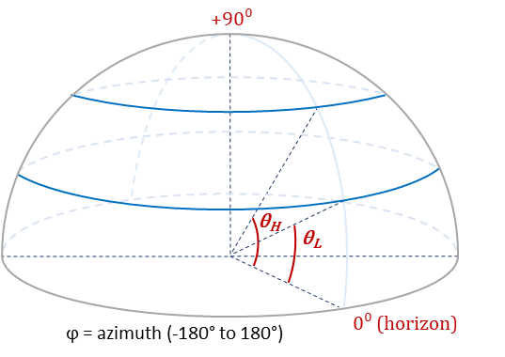

Issue 2-6 Mechanical tilts related
Agreement:
- NOTE 2: An IMT base station shall comply with the specified limits on expected e.i.r.p. spectral density for all declared mechanical tilts.

Agreement:

Table 2.2.2-1: [CAR] declarations
Parameter | Description
Θ_{min} | Minimum angle along θ axis
θ_{max} | Maximum angle along θ axis
ϕ_{min} | Minimum angle along ϕ axis
ϕ_{max} | Maximum angle along ϕ axis
- NOTE 1: further discuss the definition of Θ_{min} θ_{max} ϕ_{min} ϕ_{max}
- NOTE 2: reusing the existing declaration is not precluded, e.g. OTA peak directions set.

Issue 2-7 Expected EIRP calculation in discrete spatial sampling grid
Agreement:
- P$\left(θ_{L} , θ_{H}\right)=\frac{π}{2MN\left(sinθ_{H}-sinθ_{L}\right)}\sum_{n=n_{L}}^{n_{H}}{\sum_{m=1}^{M}{P1\left(θ_{n},φ_{m}\right) cos\left(θ_{n}\right)}} , where P1 is measured as EIRP$
- M is the number of sampling points in the azimuth range;
- [N is the number of sampling points over upper hemisphere in the elevation range ]
- $n_{L}$ is the lowest elevation sampling angles within the $\left(θ_{L} , θ_{H}\right)$ bounding range
- $n_{H}$ is the highest elevation sampling angles within the $\left(θ_{L} , θ_{H}\right)$ bounding range
- m is the azimuth point within the $\left(-π , π\right)$ bounding range
- m=1MEIRPP1θn,φm is to produce the global sum over the whole azimuth ranges for EIRP above the horizon in a given bin.
- Note: the equation is assuming the angles in radians and the elevation angle is from horizon rather than the coordinate system defined in 3GPP
Note: the 1st equation should be carefully reviewed by companies.

Issue 2-12 draft CRs

9.9 OTA spatial emission

9.9.1 General
OTA spatial emission requirements are defined to set requirement on emission in unintended directions.

9.9.2 Protection of FSS UL
The requirement is defined to protect FSS (Earth-to-space) UL receiver operating within frequency range 6425 to 7075MHz from interference.

9.9.2.1 Minimum requirement for BS type 1-H and BS type 1-O
For BS type 1-H and BS type 1-O, the requirement is defined as a maximum allowed Expected EIRP(EEIRP) level profile above horizon for elevation angular ranges listed in Table 9.9.2.1-1 and the elevation angles are described in figure 9.9.2.1-1.
EEIRP is defined as the average value of the EIRP, with the averaging being performed:
- Over azimuth angles from −180° to +180 ° and over the specified elevation angle range [θ_{L} ≤ θ < θ_{H}] in table 9.9.2-1
[- With the BS generating beams within the OTA peak directions set.]

Table 9.9.2.1-1: Maximum allowed EEIRP level as function of elevation angular range
Elevation angular ranges  [θ_{L} ≤ θ < θ_{H}](Degrees) | EEIRP  (dBm/MHz)
0<θ<5 | 27
5<θ<10 | 23
10<θ<15 | 19
15<θ<20 | 18
20<θ<30 | 16
30<θ<60 | 15
60<θ<90 | 15
Note 1: The requirement is applicable for the frequency range 6425 to 7075 MHz within band n104.
Note 2: An IMT base station shall comply with the specified limits on EEIRP spectral density
for all declared mechanical tilts.

Figure 9.9.2.1-1: Definitions of [θ_{L} and θ_{H}] angles.

Open issue for U6GHz EIRP mask and OTA testing
Issue 2-8 Expected EIRP sampling grid for average EIRP
- Recommended for further discussion:
  - Need further discussions
Issue 2-9 Other related with conformance testing declaration and RF channels
- Recommended for further discussion:
  - The following issues to be considered:
- the number of mechanical down-tilt and its corresponding angular coverage range;
- For each angular coverage range, the number of beams for conformance testing and its corresponding weighting factor;
- To balance the number for beams for conformance testing/complexity and test accuracy;
- The impacts of potential factors (measurement sampling grid for summation error etc) on EIRP accuracy.
- In conformance testing, consideration of converting coordinate system to 3GPP coordinate system, to align with other test cases
- Other issues are not precluded.
Issue 2-10 Other related with RF channels
- Recommended for further discussion:
  - Need further discussions

Issue 2-11 Other related with confidence intervals
- Recommended for further discussion:
  - Need further discussions

Issue 3-1: Co-location reference antenna
- Recommended for further discussion
  - Further discuss the wideband antennas and check its possibility of translation between reference co-location antenna and wideband antenna;
  - Further discuss co-location scenarios between two AAS BS especially for FR1 high bands;
  - Other issues are not precluded.

