3GPP TSG-RAN WG4 Meeting #111 revision of R4-2409548

Fukuoka City, Fukuoka, Japan, 20th – 24th May, 2024
CR-Form-v12.3
CHANGE REQUEST
 | 38.108 | CR | 0073 | rev |  | Current version: | 17.7.0
For HELP on using this form: comprehensive instructions can be found at
http://www.3gpp.org/Change-Requests.

Proposed change affects: | UICC apps |  | ME |  | Radio Access Network | X | Core Network

Title: | CR to TS 38.108: Corrections for non-regenerative payload and gateway
Source to WG: | Huawei, HiSilicon
Source to TSG: | R4
Work item code: | NR_NTN_solutions-Core |  |  |  |  |  | Date: |  |  | 2024-05-13
Category: | F |  |  |  |  |  | Release: |  |  | Rel-17
 | Use one of the following categories:  F (correction)  A (mirror corresponding to a change in an earlier release)  B (addition of feature),  C (functional modification of feature)  D (editorial modification)  Detailed explanations of the above categories can  be found in 3GPP TR 21.900. |  |  |  |  |  |  |  | Use one of the following releases:  Rel-8 (Release 8)  Rel-9 (Release 9)  Rel-10 (Release 10)  Rel-11 (Release 11)  …  Rel-17 (Release 17)  Rel-18 (Release 18)  Rel-19 (Release 19)  Rel-20 (Release 20)
Reason for change: |  | Based on related discussion on Rel-19 regenerative payload (NR_NTN_Ph3-Core WI), in this CR we introduce corrections for non-regenerative payload and gateway terminology in SAN RF specification.
Summary of change: |  | - Update definitions, to align terminology with (non-)regenerative payload (instead of bend pipe, or NTN payload RF).  - Update SAN definition to be generic enough to contain both non-regenerative and regenerative payload options.  - Align usage of the “satellite-gateway” term.  - Update SAN figures to align gateway terminology (gateway vs. satellite-gateway) and payload terminology (remove “NTN payload RF” and replace it with the “satellite payload”).
Consequences if not approved: |  | Non-regenerative payload terminology would remain mis-aligned and ambiguous.
Clauses affected: |  | 3.1, 4.3
 |  | Y | N
Other specs |  | X |  | Other core specifications |  |  |  | TS 38.101-1 CR0093
affected: |  | X |  | Test specifications |  |  |  | TS 38.181 CR0023
(show related CRs) |  |  | X | O&M Specifications
Other comments:
This CR's revision history:

------------------------------ Modified section ----------------------------------

3 Definitions, symbols and abbreviations

3.1 Definitions
For the purposes of the present document, the terms given in 3GPP TR 21.905 [1] and the following apply. A term defined in the present document takes precedence over the definition of the same term, if any, in 3GPP TR 21.905 [1].
basic limit: emissions limit relating to the power supplied by a single transmitter to a single antenna transmission line in ITU-R SM.329 [2] used for the formulation of unwanted emission requirements for FR1-NTN.
beam: beam (of the antenna) is the main lobe of the radiation pattern of an antenna array.
NOTE: For certain antenna array, there may be more than one beam.
beam centre direction: direction equal to the geometric centre of the half-power contour of the beam.
beam direction pair: data set consisting of the beam centre direction and the related beam peak direction.
beam peak direction: direction where the maximum EIRP is found.
beamwidth: beam which has a half-power contour that is essentially elliptical, the half-power beamwidths in the two pattern cuts that respectively contain the major and minor axis of the ellipse.
Channel edge: lowest or highest frequency of the NR carrier, separated by the SAN channel bandwidth.
directional requirement: requirement which is applied in a specific direction within the OTA coverage range for the Tx and when the AoA of the incident wave of a received signal is within the OTA REFSENS RoAoA or the minSENS RoAoA as appropriate for the receiver.
equivalent isotropic radiated power: equivalent power radiated from an isotropic directivity device producing the same field intensity at a point of observation as the field intensity radiated in the direction of the same point of observation by the discussed device.
NOTE: Isotropic directivity is equal in all directions (i.e. 0 dBi).
equivalent isotropic sensitivity: sensitivity for an isotropic directivity device equivalent to the sensitivity of the discussed device exposed to an incoming wave from a defined AoA.
NOTE 1: The sensitivity is the minimum received power level at which specific requirement is met.
NOTE 2: Isotropic directivity is equal in all directions (i.e. 0 dBi).
feeder link: Wireless link between satellite-gateway and satellite.
Geostationary Earth Orbit: Circular orbit at 35,786 km above the Earth's equator and following the direction of the Earth's rotation. An object in such an orbit has an orbital period equal to the Earth's rotational period and thus appears motionless, at a fixed position in the sky, to ground observers.
Low Earth Orbit: Orbit around the Earth with an altitude between 300 km, and 1500 km.
Highest Carrier: The carrier with the highest carrier frequency transmitted/received in a specified frequency band.
Lowest Carrier: The carrier with the lowest carrier frequency transmitted/received in a specified frequency band.
maximum carrier output power: mean power level measured per carrier at the indicated interface, during the transmitter ON period in a specified reference condition.
maximum carrier TRP output power: mean power level measured per RIB during the transmitter ON period for a specific carrier in a specified reference condition and corresponding to the declared rated carrier TRP output power (P_{rated,c,TRP}).
maximum total output power: mean power level measured within the operating band at the indicated interface, during the transmitter ON period in a specified reference condition.
maximum total TRP output power: mean power level measured per RIB during the transmitter ON period in a specified reference condition and corresponding to the declared rated total TRP output power (P_{rated,t,TRP}).
measurement bandwidth: RF bandwidth in which an emission level is specified.
minSENS: the lowest declared EIS value for the OSDD's declared for OTA sensitivity requirement.
minSENS RoAoA: The reference RoAoA associated with the OSDD with the lowest declared EIS.
minimum elevation angle: Minimum angle under which the satellite can be seen by a UE.
necessary bandwidth: The width of the frequency band which is just sufficient to ensure the transmission of information at the rate and with the quality required under specified conditions.
non-terrestrial networks: Networks, or segments of networks, using an airborne or space-borne vehicle to embark a transmission equipment relay node or SAN.
operating band: frequency range in which NR operates (paired or unpaired), that is defined with a specific set of technical requirements.
NOTE: The operating band(s) for a SAN is declared by the manufacturer according to the designations in tables 5.2-1 and 5.2-2.
OTA coverage range: a common range of directions within which TX OTA requirements that are neither specified in the OTA peak directions sets nor as TRP requirement are intended to be met.
OTA peak directions set: set(s) of beam peak directions within which certain TX OTA requirements are intended to be met, where all OTA peak directions set(s) are subsets of the OTA coverage range.
NOTE: The beam peak directions are related to a corresponding contiguous range or discrete list of beam centre directions by the beam direction pairs included in the set.
OTA REFSENS RoAoA: the RoAoA determined by the contour defined by the points at which the achieved EIS is 3dB higher than the achieved EIS in the reference direction assuming that for any AoA, the receiver gain is optimized for that AoA.
NOTE: This contour will be related to the average element/sub-array radiation pattern 3dB beamwidth.
OTA sensitivity directions declaration: set of manufacturer declarations comprising at least one set of declared minimum EIS values (with SAN channel bandwidth), and related directions over which the EIS applies.
NOTE: All the directions apply to all the EIS values in an OSDD.
polarization match: condition that exists when a plane wave, incident upon an antenna from a given direction, has a polarization that is the same as the receiving polarization of the antenna in that direction.
radiated interface boundary: operating band specific radiated requirements reference where the radiated requirements apply.
NOTE: For requirements based on EIRP/EIS, the radiated interface boundary is associated to the far-field region.
Radio Bandwidth: frequency difference between the upper edge of the highest used carrier and the lower edge of the lowest used carrier.
rated beam EIRP: For a declared beam and beam direction pair, the rated beam EIRP level is the maximum power that the SAN is declared to radiate at the associated beam peak direction during the transmitter ON period.
rated carrier output power: mean power level associated with a particular carrier the manufacturer has declared to be available at the indicated interface, during the transmitter ON period in a specified reference condition.
rated carrier TRP output power: mean power level declared by the manufacturer per carrier, for SAN operating in single carrier, multi-carrier, or carrier aggregation configurations that the manufacturer has declared to be available at the RIB during the transmitter ON period.
rated total output power: mean power level associated with a particular operating band the manufacturer has declared to be available at the indicated interface, during the transmitter ON period in a specified reference condition.
rated total TRP output power: mean power level declared by the manufacturer, that the manufacturer has declared to be available at the RIB during the transmitter ON period.
reference beam direction pair: declared beam direction pair, including reference beam centre direction and reference beam peak direction where the reference beam peak direction is the direction for the intended maximum EIRP within the OTA peak directions set.
receiver target: AoA in which reception is performed by SAN types 1-H or SAN type 1-O.
receiver target redirection range: union of all the sensitivity RoAoA achievable through redirecting the receiver target related to particular OSDD.
receiver target reference direction: direction inside the OTA sensitivity directions declaration declared by the manufacturer for conformance testing. For an OSDD without receiver target redirection range, this is a direction inside the sensitivity RoAoA.
reference RoAoA: the sensitivity RoAoA associated with the receiver target reference direction for each OSDD.
requirement set: one of the NR SAN requirement's set as defined for SAN type 1-H, SAN type 1-O.
SAN channel bandwidth: RF bandwidth supporting a single NR RF carrier with the transmission bandwidth configured in the uplink or downlink.
NOTE 1: The SAN channel bandwidth is measured in MHz and is used as a reference for transmitter and receiver RF requirements.
NOTE 2: It is possible for the SAN to transmit to and/or receive from one or more satellite UE bandwidth parts that are smaller than or equal to the SAN transmission bandwidth configuration, in any part of the SAN transmission bandwidth configuration.
SAN RF Bandwidth: RF bandwidth in which a SAN transmits and/or receives single or multiple carrier(s) within a supported operating band.
NOTE: In single carrier operation, the SAN RF Bandwidth is equal to the SAN channel bandwidth.
SAN RF Bandwidth edge: frequency of one of the edges of the SAN RF Bandwidth.
SAN transmission bandwidth configuration: set of resource blocks located within the SAN channel bandwidth which may be used for transmitting or receiving by the SAN.
SAN type 1-H: Satellite Access Node operating at FR1-NTN with a requirement set consisting of conducted requirements defined at individual TAB connectors and OTA requirements defined at RIB.
SAN type 1-O: Satellite Access Node operating at FR1-NTN with a requirement set consisting only of OTA requirements defined at the RIB.
SAN total assigned bandwidth: Bandwidth of the total assigned band (frequencies range) as defined in SM.1541-6 [9].
SAN transponder bandwidth: Total bandwidth of the carrier(s) in operation by one SAN transponder.
NOTE: When the SAN transponder operates one carrier only, the SAN transponder bandwidth is equal to the SAN channel bandwidth of this carrier.
SAN transponder: part of the SAN permitting to receive, channelize and transmit signals within an allocated bandwidth.
satellite: A space-borne vehicle embarking a transparent payload, or a regenerative payload telecommunication transmitter, placed into Low-Earth Orbit (LEO) or Geostationary Earth Orbit (GEO).
Satellite Access Node: node providing NR user plane and control plane protocol terminations towards NTN Satellite capable UE, and connected via the NG interface to the 5GC. It encompasses a satellite payload on board a NTN platform, a satellite-gateway and gNB functions.
satellite-gateway: An earth station or gateway is located at the surface of Earth, and providing sufficient RF power and RF sensitivity for accessing to the satellite.
------------------------------ Next modified section ----------------------------------

4.3 Requirement reference points

4.3.1 SAN type 1-H
For SAN type 1-H, the requirements are defined for two points of reference, signified by radiated requirements and conducted requirements.

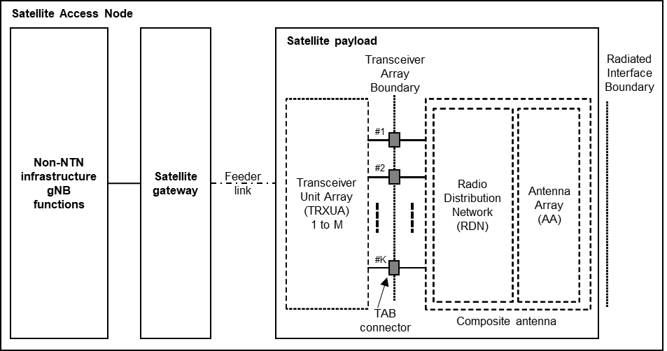
Figure 4.3.1-1: Radiated and conducted reference points for SAN type 1-H
Radiated characteristics are defined over the air (OTA), where the radiated interface is referred to as the Radiated Interface Boundary (RIB). Radiated requirements are also referred to as OTA requirements. The (spatial) characteristics in which the OTA requirements apply are detailed for each requirement.
Conducted characteristics are defined at individual or groups of TAB connectors at the transceiver array boundary, which is the conducted interface between the transceiver unit array and the composite antenna.
The transceiver unit array is part of the composite transceiver functionality receiving and transmitting modulated signal to ensure radio links with users.
The satellite payload is composed by a transceiver unit array and a composite antenna array. The transceiver unit array contains an implementation specific number of transmitter units and an implementation specific number of receiver units.
The composite antenna contains a radio distribution network (RDN) and an antenna array. The RDN is a linear passive network which distributes the RF power generated by the transceiver unit array to the antenna array, and/or distributes the radio signals collected by the antenna array to the transceiver unit array, in an implementation specific way.
How a conducted requirement is applied to the transceiver array boundary is detailed in the respective requirement clause.

4.3.2 SAN type 1-O
For SAN type 1-O, the radiated characteristics are defined over the air (OTA), where the operating band specific radiated interface is referred to as the Radiated Interface Boundary (RIB). Radiated requirements are also referred to as OTA requirements. The (spatial) characteristics in which the OTA requirements apply are detailed for each requirement.

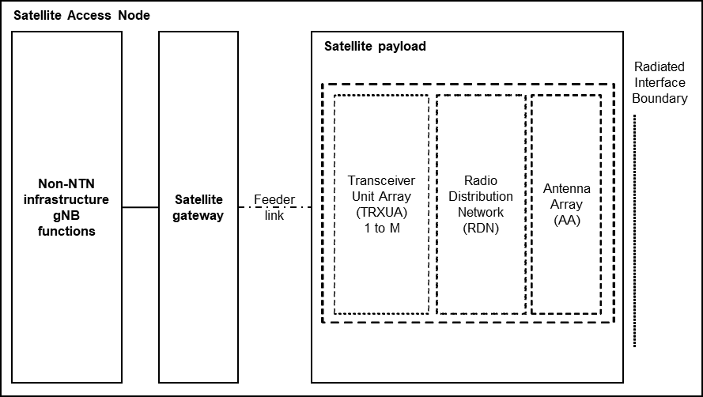
Figure 4.3.2-1: Radiated reference points for SAN type 1-O
------------------------------ End of modified section -------------------------

