3GPP TSG-RAN WG4 Meeting #111 R4-2408004
Fukuoka, Japan, May 20th – 24th, 2024
Agenda item: 7.5.5
Source: Moderator (MediaTek)
Title: Topic summary for [111][207] NR_MG_enh2_part1
Document for: Information

Introduction
This document is the topic summary for [111][207] NR_MG_enh2_part1 with the following topics covered:
- Topic 1: Draft CR handling (AI 7.5.1)
- Topic 2: Case 1 requirements (Pre-configured MG and concurrent MG) (AI 7.5.1)
- Topic 3: Case 2 requirements (NCSG and concurrent MG) (AI 7.5.1)
- Topic 4: Performance discussion for NR_MG_enh2 Part 1 (AI 7.5.3)
- Note: suggested issues for online discussion: 2-1-7, 3-2-1 and 4-3-1.

Topic #1: Core part CR handling (AI 7.5.1)

Companies’ contributions summary
T-doc number | Company | Proposals / Observations / Draft CR Title
R4-2407345 | Apple | Draft CR for collision between Pre-MG activation/deactivation and measurement gap
R4-2407787 | BeammWave, Nokia | (NR_MG_enh2-Core) 38.133 CR addressing the use of expected to in normative text
R4-2407830 | Xiaomi | Draft CR for R18 PreMG core requirements maintence
R4-2409249 | Huawei, HiSilicon | draftCR on RRM requirements for con-MG + pre-MG
R4-2409659 | Nokia | Draft CR 38.133 Corrections to Case 1 core requirements for NR_MG_enh2
R4-2409784 | MediaTek inc. | Draft CR on concurrent Pre-MG dynamic collision
R4-2409795 | MediaTek, Intel | Big CR to TS 38.133 on core requirement maintenance for R18 NR and MR-DC measurement gaps and measurements without gaps

Open issues summary

Sub-topic 1-1: Draft CRs handling
Issue 1-2-1: R4-2407345 [38.133 clause 9.1.12.4] (Apple)
- Recommended WF
    - The changes in 9.1.12.4 should be merged with issue 1-2-6.
    - Status: The CR can be merged.

Issue 1-2-2: R4-2407830 [38.133 clause 8.19.5.1, 8.19.5.2, 8.19.5.3, 9.1.12.2, 9.1.12.3] (Xiaomi)
- Recommended WF
  - The changes in 8.19.5.1, 8.19.5.2, 8.19.5.3, 9.1.12.2, 9.1.12.3 should be merged with issue 1-2-6.
  - Status: The CR can be merged.

Issue 1-2-3: R4-2407787 [38.133 clause 9.1.12.4, 9.1.13.2] (BeammWave, Nokia)
- Recommended WF
  - The changes in 9.1.12.4, 9.1.13.2 should be merged with issue 1-2-6.
  - Status: The CR can be merged.

Issue 1-2-4: R4-2409249 [38.133 clause 8.19.5, 9.1.12.4] (Huawei, HiSilicon)
- Recommended WF
  - The changes in 8.19.5 should be merged with issue 1-2-6.
  - The changes in 9.1.12.4 should be merged with issue 1-2-6.
  - Status: The CR can be merged.

Issue 1-2-5: R4-2409659 [38.133 clause 9.1.12.3, 9.1.12.4] (Nokia)
- Recommended WF
  - The changes in 9.1.12.3, 9.1.12.4 should be merged with issue 1-2-6.
  - Status: The CR can be merged.
Issue 1-2-6: R4-2409784 [38.133 clause 3.1, 8.19.5.1, 8.19.5.2, 8.19.5.3, 9.1.12.4] (MediaTek)
- Recommended WF
  - Address and merge all changes from issues 1-2-1 to 1-2-5.
  - Status: New revision number is needed.

Topic #2: Case 1 requirements (Pre-configured MG and concurrent MG) (AI 7.5.1)
Main technical topic overview. The structure can be done based on sub-agenda basis.

Companies’ contributions summary
Moderator’s note: Draft CR are mentioned in Topic #1. Besides, TDoc number of R4-2405804 and R4-2404966 will be handled in thread [210].
T-doc number | Company | Proposals / Observations
R4-2407344 | Apple | Proposal 1: for scenario 1:  - For UE supporting dynamic collision, activation requirements should state that the pre-configured gap activation shall be applied 5ms after the ending point of the overlapping measurement gap.  - For UE not supporting dynamic collision, activation delay of Pre-MG defined in clause 8.19 applies since the overlapped MG is dropped.  Proposal 2: for scenario 2, for both UE supporting and not supporting dynamic collision, deactivation delay of Pre-MG defined in clause 8.19 applies since the overlapped MG is dropped.  Proposal 3: for scenario 3, for both UE supporting and not supporting dynamic collision, UE continues the measurement within the overlapped concurrent gap occasion (MG#2), i.e. existing priority rule applies without any change.  Proposal 4: For scenario 4, RAN4 can directly apply the agreements decided for the fully simultaneous multiple Pre-MG activation/deactivation, i.e. the new status of two Pre-MG are applied after the extended T1.
R4-2407829 | Xiaomi | Observation 1: The overall (de)activation procedure in all dynamic collision scenarios can be consisted with the processing time for the trigger event and other extension for RF processing.  Observation 2: Since UE will postpone the status change of Pre-MG in Scenario 1, the Pre-MG status change taking effective time point needs to be updated.  Proposal 1: The time point when Pre-MG activation/deactivation take effects shall explicitly defined in TS38.133 as the accompanied draftCR [3] proposed.
R4-2408242 | ZTE Corporation, Sanechips | Proposal 1: For the UE not supporting dynamic collision, when collision between Pre-MG activation/deactivation procedure and another MG instance happens, depend on the priority: if the Pre-MG has higher priority, then UE drops another MG instance. Otherwise, the UE drops the Pre-MG activation/deactivation procedure and perform measurements associated with the MG instance.
R4-2408620 | vivo | Proposal 1: For issue 2-1-5, no consider optimizations of the collision handling for concurrent gaps in Rel-18.
R4-2409162 | Nokia | - RAN4 to clarify the UE behavior for Case 1 in case dynamic collisions are not supported, i.e. if the UE receives the Pre-MG activation/deactivation command or is triggered by BWP switch in the collision case, it will ignore the RRC command in case of network-based Pre-MG (de-)activation and will ignore the BWP switch trigger in case of UE autonomous Pre-MG (de-)activation.
R4-2409248 | Huawei, HiSilicon | Proposal 1: When UE does not support FG 32-2, it should consider pre-MG colliding with another MG no matter the pre-MG is activated or deactivated.  Proposal 2: For dynamic collision scenario 1, do not make any further clarification.  Proposal 3: For dynamic collision scenario 2, make the following further clarification.  When a collision occurs between a measurement gap occasion and a Pre-MG deactivation procedure, and the Pre-MG is configured with higher priority, the measurement gap occasion shall be dropped if the measurement gap occasion collides with an occasion of the Pre-MG.  Proposal 4: For dynamic collision scenario 3, remove the related requirements in clause 9.1.12.4.  Proposal 5: RAN4 not to define UE behaviour and requirements for dynamic collision scenario 4.  Proposal 6: RAN4 not to make further optimization on the MG collision definition.  Proposal 7: Void clause 8.19.5.3.
R4-2409744 | MediaTek inc. | Proposal 1: To enhance and clarify the current wording of the current spec, RAN4 shall discuss issues 2-1-1 and 2-1-2 directly in the CRs.  Proposal 2: For scenarios in issue 2-1-3, the existing agreement shall apply, i.e. ‘The UE continues the measurement within the overlapped concurrent gap occasion (MG#2), i.e. existing priority rule applies without any change’.  Proposal 3: To enhance and clarify the current wording of the current spec, RAN4 shall discuss issues 2-1-4 directly in the CRs.  Proposal 4: RAN4 not to consider optimizations of the collision handling for concurrent gaps in Rel-18.  Proposal 5: When the UE doesn’t support the dynamic collision capability and the UE is configured with Pre-MG with higher priority, the event of overlapping specified in Scenarios 1 and 2 are left for UE implementation, i.e. RAN4 not to define any further requirements.

Open issues summary

Sub-topic 2-1: Collision handling for dynamic collisions
Sub-topic description: This sub-topic covers issues related to the collision cases for concurrent gaps with Pre-MG. The summary of the issues on this topic are provided below:
Scenario 1: the pre-configured MG activation procedure is overlapped with one of concurrent gap occasion during the dynamic collision (i.e. Pre-MG has higher priority than the MG)
Scenario 2: pre-configured MG deactivation procedure is overlapped with one of concurrent gap occasion during the dynamic collision (i.e. Pre-MG has higher priority than the MG)
Scenario 3: pre-configured MG activation procedure is overlapped with one of concurrent gap occasion where the MG has higher priority than the Pre-MG.
Scenario 4: One pre-configured MG deactivation procedure is overlapped with another pre-configured MG activation procedure during the dynamic collision (This scenario is for Pre-MG + Pre-MG).

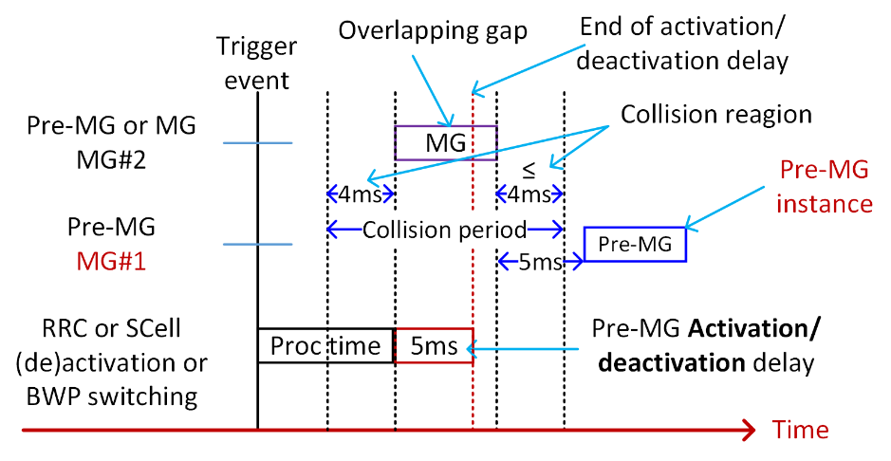
Figure: the collision scenarios for concurrent gaps with Pre-MG during dynamic collision.

Open issues and candidate options before meeting:

Issue 2-1-1: [Case 1] - [Scenario 1] Further clarification on the agreement from scenario 1?
- Background:
  - Agreements from dynamic collision:
    - A collision between a change in the status of a pre-configured MG (MG#1) and a gap instance happens when the change occurs ≤ 4 ms before the start or ≤ 4 ms after the end of a gap instance of an activated concurrent MG (MG#2) the Pre-MG status and dropping rule shall be applied 5ms after the overlapping MG and UE should continue the measurement within the MG#2
      - TBD whether same Pre-MG activation delay requirements as Rel-17 can still be re-used
      - The collision scenario in this issue is depicted in the figure below:
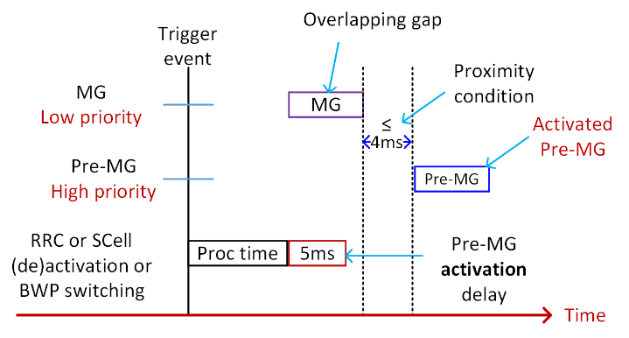
- Proposals
  - Option 1: MTK
    - To enhance and clarify the current wording of the current spec, RAN4 shall discuss issues 2-1-1 and 2-1-2 directly in the CRs.
  - Option 2: Apple,
    - For UE supporting dynamic collision, activation requirements should state that the pre-configured gap activation shall be applied 5ms after the ending point of the overlapping measurement gap.
    - For UE not supporting dynamic collision, activation delay of Pre-MG defined in clause 8.19 applies since the overlapped MG is dropped.
  - Option 3: Xiaomi
    - The time point when Pre-MG activation/deactivation take effects shall explicitly defined in TS38.133 as the accompanied draftCR [R4-2407830] proposed.
  - Option 4: HW
    - For dynamic collision scenario 1, do not make any further clarification.

- Recommended WF
  - Discuss the options yet taking into consideration that we already have an existing agreement.

Issue 2-1-2: [Case 1] - [Scenario 2] When the pre-configured MG deactivation procedure is overlapped with one of concurrent gap occasion during the dynamic collision (i.e. Pre-MG has higher priority than the MG)
- Background:
  - Agreement from the previous meeting:
    - [Case 1] - [Scenario 2] When the pre-configured MG deactivation procedure is overlapped with one of concurrent gap occasion during the dynamic collision (i.e. Pre-MG has higher priority than the MG)
      - When a pre-MG deactivation and a Type-2 MG collide, and the pre-MG has higher priority, UE should drop the colliding Type-2 MG occasion
  - The collision scenario in this issue is depicted in the figure below:
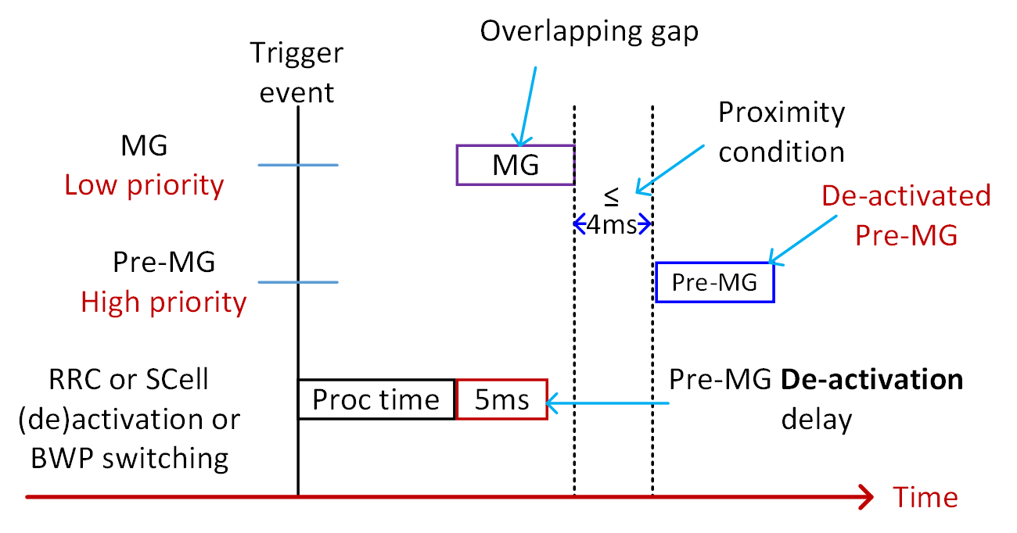
- Proposals
  - Option 1: Apple
    - For scenario 2, for both UE supporting and not supporting dynamic collision, deactivation delay of Pre-MG defined in clause 8.19 applies since the overlapped MG is dropped.
  - Option 2: MTK
    - To enhance and clarify the current wording of the current spec, RAN4 shall discuss issues 2-1-1 and 2-1-2 directly in the CRs.
  - Option 3: HW
    - Clarify requirements for Case 1, scenario 2 in 38.133 section 9.1.12.4:
- When a collision occurs between a measurement gap occasion and a Pre-MG deactivation procedure, and the Pre-MG is configured with higher priority, the measurement gap occasion shall be dropped if the measurement gap occasion collides with an occasion of the Pre-MG. The measurement gap occasion shall remain to be dropped until the ending point of the Pre-MG deactivation procedure.

- Recommended WF
  - Discuss the options.

Issue 2-1-3: [Case 1] - [Scenario 3] When the pre-configured MG activation procedure is overlapped with one of concurrent gap occasion where the MG has higher priority than the Pre-MG
- Background:
  - Agreement from online session [R4-2317305]
    - The UE continues the measurement within the overlapped concurrent gap occasion (MG#2), i.e. existing priority rule applies without any change.
  - The collision scenario in this issue is depicted in the figure below:
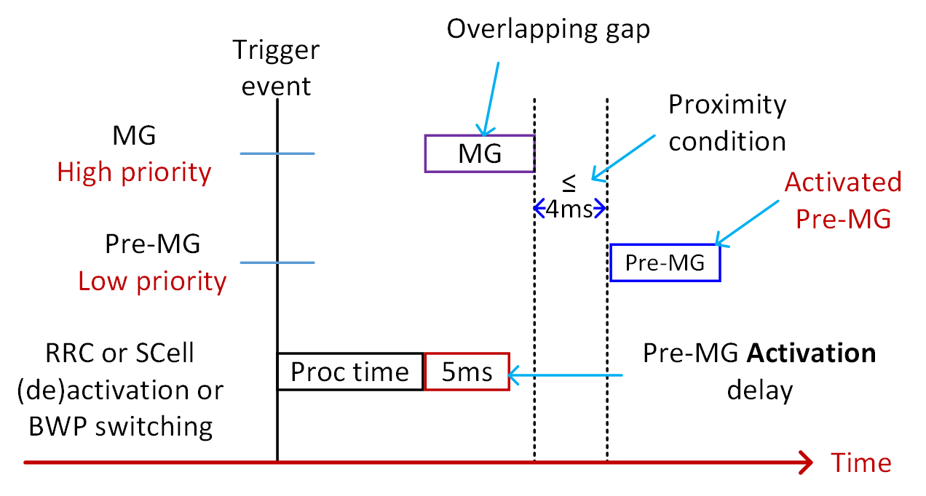
- Proposal:
  - Option 1: Apple, MTK
    - For scenario 3, for both UE supporting and not supporting dynamic collision, UE continues the measurement within the overlapped concurrent gap occasion (MG#2), i.e. existing priority rule applies without any change.
  - Option 2: HW
    - For dynamic collision scenario 3, remove the related requirements in clause 9.1.12.4.
- Recommended WF
  - Discuss the options yet taking into consideration that we already have an existing agreement.

Issue 2-1-4: [Case 1] - [Scenario 4] When one pre-configured MG deactivation procedure is overlapped with another pre-configured MG activation procedure during the dynamic collision
Moderator’s note: this issue is a mix between an existing issue of fully overlapping activation/deactivation Pre-MG with collision a Pre-MG gap in the concurrent gap with Pre-MG.
- Background:
  - Agreements from fully overlap with activation/deactivation [R4-2310175]:
      - For Case 1 (Pre-configured MG and multiple concurrent MGs), under the assumption that the baseline requirement considers collisions on Pre-MG is only considered when Pre-MG is activated, extend the delay by T1 ms for fully overlapped simultaneous activation/deactivation for Pre-MG + Pre-MG
      - T1 = 2ms.
      - FFS if this activation delay collide with existing gaps
      - An illustration example is captured below [R4-2306330]:
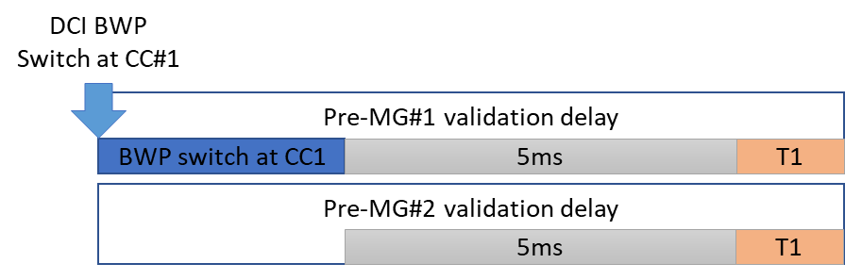
  - Agreements from dynamic collision:
    - A collision between a change in the status of a pre-configured MG (MG#1) and a gap instance happens when the change occurs ≤ 4 ms before the start or ≤ 4 ms after the end of a gap instance of an activated concurrent MG (MG#2) the Pre-MG status and dropping rule shall be applied 5ms after the overlapping MG [and UE should continue the measurement within the MG#2]
      - TBD whether same Pre-MG activation delay requirements as Rel-17 can still be re-used
      - The collision scenario in this issue is depicted in the figure below:
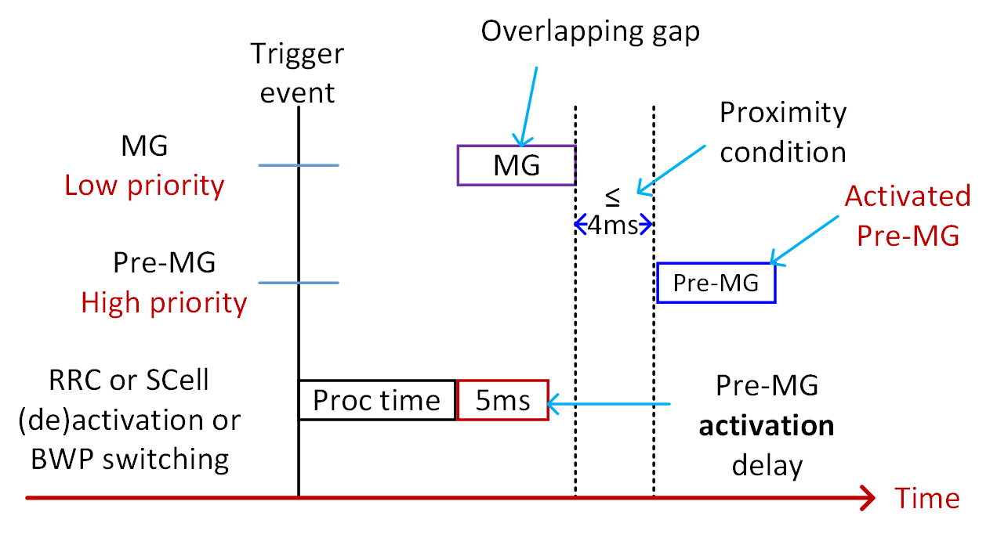
- Proposals
  - if fully overlapped simultaneous activation/deactivation for Pre-MG + Pre-MG collides with activated Pre-MG:
    - Option 1: Apple
      - For Scenario 4, RAN4 can directly apply the agreements decided for the fully simultaneous multiple Pre-MG activation/deactivation, i.e. the new status of two Pre-MG are applied after the extended T1.
    - Option 2: HW, MTK
      - RAN4 not to define UE behaviour and requirements for Scenario 4.
    - Option 3: MTK
      - No new requirements are needed to address Case 1, scenario 4.
- Recommended WF
  - Collect views.

Issue 2-1-5: [Case 1] - [New issue - dropping rule optimization] Whether to optimise the concurrent measurement gaps are collided when collided?
- Proposal:
  - Option 1: vivo, HW, MTK
    - No consider optimizations of the collision handling for concurrent gaps in Rel-18.

- Recommended WF
  - Option 1 is agreeable: ‘RAN4 not to consider optimizations of the collision handling for concurrent gaps in Rel-18’.

Issue 2-1-6: [Case 1] - [New issue - spec cleaning] This issue related to further cleaning in current spec writing [multiple options can be selected based on discussion]:
- Proposal:
  - Option 1: HW
    - Void clause 8.19.5.3.
  - Option 2: MediaTek
    - To enhance and clarify the current wording of the current spec, RAN4 shall discuss issues 2-1-1 and 2-1-2 directly in the CRs.
- Recommended WF
  - Discuss in the draft CR of issue 1-2-6.

Issue 2-1-7: [Case 1] - [New issue – Dynamic collision] What is the UE behaviour when the UE doesn’t support dynamic collision FG?
- Proposal:
  - Option 1: ZTE
    - For the UE not supporting dynamic collision, when collision between Pre-MG activation/deactivation procedure and another MG instance happens, depend on the priority: if the Pre-MG has higher priority, then UE drops another MG instance. Otherwise, the UE drops the Pre-MG activation/deactivation procedure and perform measurements associated with the MG instance.
  - Option 2: Nokia
    - RAN4 to clarify the UE behavior for Case 1 in case dynamic collisions are not supported, i.e. if the UE receives the Pre-MG activation/deactivation command or is triggered by BWP switch in the collision case, it will ignore the RRC command in case of network-based Pre-MG (de-)activation and will ignore the BWP switch trigger in case of UE autonomous Pre-MG (de-)activation.
  - Option 3: Huawei
    - When UE does not support FG 32-2, it should consider pre-MG colliding with another MG no matter the pre-MG is activated or deactivated.
  - Option 4: MTK
    - When the UE doesn’t support the dynamic collision capability and the UE is configured with Pre-MG with higher priority, the event of overlapping specified in Scenarios 1 and 2 are left for UE implementation, i.e. RAN4 not to define any further requirements.
- Recommended WF
  - Discuss the option.

Topic #3: Case 2 requirements (NCSG and concurrent MG) (AI 7.5.1)
Main technical topic overview. The structure can be done based on sub-agenda basis.

Companies’ contributions summary
T-doc number | Company | Proposals / Observations
R4-2407344 | Apple | Proposal 5: RAN4 should discuss the following scenarios:  - Scenario 1: UE is configured with two NCSGs. Association between SCell MO and one NCSG is provided.  - The measurement should be done with the associated NCSG.  - Scenario 2: UE is configured with two NCSGs. Association between SCell MO and NCSG is not provided.  - NW is encouraged to provide association between SCell MO and one of the NCSG. Otherwise, RAN4 needs to discuss which NCSG shall be used for measurement?  - Scenario 3: UE is configured with one NCSG and one type-2 legacy gap. Association between SCell MO and NCSG or MG is not provided.  - The measurement should be done with the associated NCSG.  - Scenario 4: UE is configured with one NCSG and one type-2 legacy gap. MO is associated to NCSG.  - The measurement should be done with the associated NCSG.  - Scenario 5: UE is configured with one NCSG and one type-2 legacy gap. MO is associated to MG.  - In theory this is possible, e.g. it is an intra-frequency measurement with gap when the SCell is in active mode and UE doesn’t support intra-frequency measurement with NCSG on this band (UE reports ‘gap’). RAN4 shall discuss whether to define requirement for this scenario. If so, whether the MO shall be moved from MG to NCSG when the SCell becomes deactivated.
R4-2408165 | CMCC | Proposal 1: when the SMTC of deactivated SCell is fully or partially overlapped with NCSG, the deactivated SCell is measured via NCSG regardless of gap association.
R4-2408242 | ZTE Corporation, Sanechips | Proposal 1: For the UE not supporting dynamic collision, when collision between Pre-MG activation/deactivation procedure and another MG instance happens, depend on the priority: if the Pre-MG has higher priority, then UE drops another MG instance. Otherwise, the UE drops the Pre-MG activation/deactivation procedure and perform measurements associated with the MG instance.  Observation 1: Regarding the R17 UE behavior alignment, based on current R17 spec, it can be clarified that: All deactivated SCell should be measured via NCSG regardless the UE capability report of intraFreq-needForNCSG given that all or part of the SMTC occasions of the deactivated SCell are overlapped with the NCSG.  Observation 2: If skipping the gap association, all deactivated SCells are measured within NCSG, it is hard to decide which NCSG to apply for one deactivated SCell MO under the gap combination of NCSG + NCSG.  Proposal 2: Prefer to reuse the gap association rule to determine in which MG the deactivated SCell MO would be performed, this is the most straightforward and uniform for any gap combination.  Proposal 3: Based on the principle of reusing the gap association rule to determine in which MG the deactivated SCell MO would be performed, when the deactivated SCell switches to be activated, still reuse the R17 conditions to decide whether this SCell can be measured with the NCSG. That is, keep alignment with the understanding of R17 UE behaviors.
R4-2408311 | China Telecom | Proposal 1: When the SCell is deactivated, the deactivated SCell’s MO will be measured within NCSG if the SMTC is partially or fully overlapped with NCSG regardless of gap association.
R4-2408321 | Ericsson | Observation 1: In Rel-17, when UE supports NCSG, deactivated SCell measurement will be performed within NCSG provided that NCSG is configured by the NW.  Proposal 1: When the SCell is deactivated,  - the deactivated SCell’s MO will be measured within the only NCSG if the SMTC is partially or fully overlapped regardless of gap association.  - the deactivated SCell’s MO will be measured within the associated NCSG if NCSG+NCSG is configured.
R4-2408620 | vivo | Proposal 2: For the issue When the UE is configured with concurrent gaps with NCSG, what is the potential changes to UE behaviour for NCSG upon SCell activation (in Rel-18), option 1 and option 2 are OK.
R4-2409162 | Nokia | - The collision case between measured deactivated SCell MO’s outside NCSG, if allowed in Rel-17 for scenarios with non-overlapping of deactivated SCell MO’s with NCSG, and concurrent MG occasions needs to be considered for Case 2 requirements in Rel-18.  - In case of non-overlapping of deactivated SCell measurement with NSCG and collision between deactivated SCell measurement with concurrent MG occasion, the deactivated SCell measurement shall be dropped, regardless of the concurrent MG priority.  - No capability for the support of deactivated SCell measurements with NCSG is introduced in Rel-18.
R4-2409248 | Huawei, HiSilicon | Proposal 8: When SCell is deactivated, the corresponding MO is implicitly associated to NCSG with which the SMTC is partially or fully overlapped, regardless of configured MG association.  Proposal 8a: In case of NCSG + NCSG, the deactivated SCell’s MO is measured within the associated NCSG, and no requirement applies if the association is not provided.
R4-2409744 | MediaTek inc. | Proposal 6: RAN4 shall either wait for the outcome of the issue on whether all deactivated Scell will be measured via NCSG regardless the UE capability report of intraFreq-needForNCSG from Rel-17 maintenance on Rel-17 MGE; or define a new UE capability and continue the discussion in Rel-18 regardless the outcome from Rel-17 discussion.

Open issues summary
Before Meeting, moderators shall summarize list of open issues, candidate options and possible WF (if applicable) based on companies’ contributions.

Sub-topic 3-2: Rel-18 UE behavior for deactivated SCell measurements with NCSG
Sub-topic description: This sub-topic covers NCSG upon SCell activation issue in concurrent gap with NCSG.
Open issues and candidate options before meeting:
- Agreement from previous meetings:
< Agreement >:
- New in Rel-18
  - When Type-2 MG and NCSG are both configured, some serving cell MOs may associated to the NCSG and some are not.
    - Question 1: What is the expected UE behaviour (assume SMTC partially overlapped with NCSG)
      - Option 1: skip gap association, all deactivated Scells are measured within NCSG. (This implies some new rule to override the existing gap association rule)
      - Option 2: Still follow the gap association, i.e., (This implies we follow Rel-17 gap association rule)
        - Deactivated Scell MO associated with NCSG is measured within NCSG
        - Deactivated Scell MO not associated with NCSG is measured outside NCSG
    - Question 2: Whether additional UE capability indication is needed

Issue 3-2-1: [Case 2] When the UE is configured with Concurrent gaps with NCSG, what is the potential changes to UE behaviour for NCSG upon SCell activation (in Rel-18)
- Proposals
  - Option 1: MTK, ZTE, vivo,
    - Still follow the gap association, i.e., (This implies we follow Rel-17 gap association rule)
      - Deactivated Scell MO associated with NCSG is measured within NCSG
      - Deactivated Scell MO not associated with NCSG is measured outside NCSG
  - Option 1a: ZTE
    - Based on the principle of reusing the gap association rule to determine in which MG the deactivated SCell MO would be performed, when the deactivated SCell switches to be activated, still reuse the R17 conditions to decide whether this SCell can be measured with the NCSG. That is, keep alignment with the understanding of R17 UE behaviours
  - Option 2: Huawei, E///, CMCC, vivo, China Telecom
    - When the SCell is deactivated,
      - the deactivated SCell’s MO will be measured within NCSG if the SMTC is partially or fully overlapped with NCSG regardless of gap association.
    - Option 2a: E///, HW
      - When the SCell is deactivated, the deactivated SCell’s MO will be measured within the associated NCSG if NCSG+NCSG is configured.
  - Option 3: Apple,
    - RAN4 should discuss the following scenarios:
      - Scenario 1: UE is configured with two NCSGs. Association between SCell MO and one NCSG is provided.
        - The measurement should be done with the associated NCSG.
      - Scenario 2: UE is configured with two NCSGs. Association between SCell MO and NCSG is not provided.
        - Discuss whether to define requirement for this scenario. If so, which NCSG shall be used for measurement?
      - Scenario 3: UE is configured with one NCSG and one type-2 legacy gap. Association between SCell MO and NCSG or MG is not provided.
        - The measurement should be done with the associated NCSG.
      - Scenario 4: UE is configured with one NCSG and one type-2 legacy gap. MO is associated to NCSG.
        - The measurement should be done with the associated NCSG.
      - Scenario 5: UE is configured with one NCSG and one type-2 legacy gap. MO is associated to MG.
        - Discuss whether to define requirement for this scenario. If so, whether the MO shall be moved from MG to NCSG when the Scell becomes deactivated.
  - Option 4: Nokia,
    - The collision case between measured deactivated SCell MO’s outside NCSG, if allowed in Rel-17 for scenarios with non-overlapping of deactivated SCell MO’s with NCSG, and concurrent MG occasions needs to be considered for Case 2 requirements in Rel-18.
  - Option 5: Nokia,
    - In case of non-overlapping of deactivated SCell measurement with NSCG and collision between deactivated SCell measurement with concurrent MG occasion, the deactivated SCell measurement shall be dropped, regardless of the concurrent MG priority.
  - Option 6: Nokia,
    - No capability for the support of deactivated SCell measurements with NCSG is introduced in Rel-18.

- Recommended WF
  - Discuss the options.

Topic #4: Performance Part 1 (Pre-MG/NCSG and concurrent MG) (AI 7.5.3)
Main technical topic overview. The structure can be done based on sub-agenda basis.

Companies’ contributions summary
T-doc number | Company | Proposals / Observations
R4-2408170 | CMCC | Proposal 1: it is proposed to have con-NCSG TC4 (test on deactivated SCell in FR1 with concurrent gap and NCSG)
R4-2408312 | China Telecom | Proposal 1: It’s proposed to define Con-NCSG TC4 Event triggered reporting test on deactivated SCell in FR1 with concurrent gap and NCSG.
R4-2408323 | Ericsson | Proposal 1: RAN4 to define TC4 to verify deactivated SCell behaviour in NCSG+ConMGs.
R4-2409252 | Huawei, HiSilicon | Proposal 1 (for Case 1): For TC1 and TC2, define separate test requirements for UE capable and incapable of FG 32-2. For TC3 and TC4, do not verify dynamic collision handling behaviour.  Proposal 2 (for Case 2): Introduce Con-NCSG TC4. Do not introduce inter-frequency neighbour cell (cell 3) in the TC.

Open issues summary
Before Meeting, moderators shall summarize list of open issues, candidate options and possible WF (if applicable) based on companies’ contributions.

Sub-topic 4-2: Test cases for Case 1
Sub-topic description: This sub-topic covers test cases for Case 1.
Open issues and candidate options before meeting:

Issue 4-2-3: [Case 1] Test cases list for Case 1: whether to do further setting changes to the agreed TCs
- Background: <agreement from the last meeting>
- Modify TC1 and TC2 for dynamic collision to additionally verify gap collision behavior and pre-MG activation delay.
  - FFS whether to apply to TC3 and TC4
- TC5 and TC6 are not needed.
No | Test case category | Test purpose | Volunteering company
Con-Pre-MG TC1 | Event triggered reporting test on intra-frequency and inter-frequency in FR1 with concurrent gap and autonomous activation/deactivation of Pre-MG + Type-2 | - When pre-MG being deactivated at the beginning of testing, UE can report the results of Cell2 within the required period  - Pre-MG activation/deactivation delay  - After pre-MG being activated by UE autonomously, UE can report the results of Cell2 and Cell3 within the required period  - Verify the gap collision rule | MediaTek
Con-Pre-MG TC2 | Event triggered reporting test on intra-frequency and inter-frequency in FR2 with concurrent gap and network-controlled activation/deactivation of Pre-MG + Type-2 | - When pre-MG being deactivated at the beginning of testing, UE can report the results of Cell2 within the required period  - Pre-MG activation/deactivation delay  - After pre-MG being activated by network-control, UE can report the results of Cell2 and Cell3 within the required period  - Verify the gap collision rule | Huawei
Con-Pre-MG TC3 | Event triggered reporting test on intra-frequency in FR2 with concurrent gap with Pre-MG and autonomous activation/deactivation of two Pre-MG for FR2 | - Verify that the UE correctly activates and deactivates the pre-MG and makes correct measurement and reporting of an event with activated and deactivated pre-MG  - Multiple Pre-MG activation/deactivation delay  - Verify that the UE makes correct reporting of an event:  - After pre-MG being activated by UE autonomously, UE can report the results of Cell2 and Cell3 within the required period. | Xiaomi
Con-Pre-MG TC4 | Event triggered reporting test on intra-frequency in FR1 with concurrent gap with Pre-MG and network-controlled activation/deactivation of two Pre-MG for FR1 | - Verify that the UE correctly activates and deactivates the pre-MG and makes correct measurement and reporting of an event with activated and deactivated pre-MG  - Multiple Pre-MG activation/deactivation delay  - Verify that the UE makes correct reporting of an event:  - After pre-MG being activated by UE network-controlled, UE can report the results of Cell2 and Cell3 within the required period. | CMCC
No | Test case category | Test purpose | Volunteering company
Con-Pre-MG TC5 | Inter-frequency measurement with autonomous activation/deactivation of Pre-MG in FR1 with dynamic collision | - Verify the gap association;  - Verify the dynamic gap collision when Pre-MG activation  - the UE shall NOT report corresponding valid ACK/NACK for those PDSCHs scheduled in the slots overlapped with the Type2 MG occasions.  - the UE shall be able to receive PDSCH and report corresponding valid ACK/NACK for those PDSCHs scheduled in the slots overlapped with the Pre-MG occasion overlapped in dynamic collision
Con-Pre-MG TC6 | Inter-frequency measurement with network-controlled activation/deactivation of Pre-MG in FR2 with dynamic collision | - Verify the gap association;  - Verify the dynamic gap collision when Pre-MG activation  - the UE shall NOT report corresponding valid ACK/NACK for those PDSCHs scheduled in the slots overlapped with the Type2 MG occasions.  - the UE shall be able to receive PDSCH and report corresponding valid ACK/NACK for those PDSCHs scheduled in the slots overlapped with the Pre-MG occasion overlapped in dynamic collision

- Proposals
  - Option 1: Huawei
    - For TC1 and TC2, define separate test requirements for UE capable and incapable of FG 32-2.
  - Option 2: Huawei
    - For TC3 and TC4, do not verify dynamic collision handling behaviour.

- Recommended WF
  - Discuss the options.

Sub-topic 4-3: Test cases for Case 2
Sub-topic description: This sub-topic covers test cases for Case 2.

Issue 4-3-1: [Case 2] Test cases list for Case 2: Whether to support ‘Con-NCSG TC4’?
- Background:
  - Agreement:
    - FFS Con-NCSG TC4, pending on the core part maintenance conclusions.

- Proposals
No | Test case category | Test purpose | Volunteering companies
Con-NCSG TC4 | Event triggered reporting test on deactivated SCell in FR1 with concurrent gap and NCSG | • Intra-frequency cell search/measurement delay for deactivated SCC is met for Cell2 in NCSG, and Inter-frequency cell search/measurement delay for Cell3 in MG  • UE receives data in Cell1 meeting scheduling restriction requirements, and UE will not cause any interruption on Cell1 outside VIL windows.

  - Option 1: Whether to support ‘Con-NCSG TC4’
    - Yes: CMCC, E///, HW, China Telecom
    - No:
  - Option 2: Whether to introduce inter-freq neighbouring cell (Cell 3) for ‘Con-NCSG TC4’?
    - Yes:
    - No: HW

- Recommended WF
  - Provide comments for the above options.

------- End of Document -------

