3GPP TSG-RAN WG4 Meeting # 111 R4-240xxxx

Fukuoka city, Fukuoka, Japan, 20 May – 24 May 2024

|  |  |  |  |  |  |  |  |  |
| --- | --- | --- | --- | --- | --- | --- | --- | --- |
| *CR-Form-v12.3* | | | | | | | | |
| **CHANGE REQUEST** | | | | | | | | |
|  | | | | | | | | |
|  | **38.133** | **CR** | **Draft** | **rev** |  | **Current version:** | **18.5.0** |  |
|  | | | | | | | | |
| *For* [***HE******LP***](http://www.3gpp.org/3G_Specs/CRs.htm#_blank)*on using this form: comprehensive instructions can be found at* [*http://www.3gpp.org/Change-Requests*](http://www.3gpp.org/Change-Requests)*.* | | | | | | | | |
|  | | | | | | | | |

|  |  |  |  |  |  |  |  |  |
| --- | --- | --- | --- | --- | --- | --- | --- | --- |
| ***Proposed change affects:*** | UICC apps |  | ME | **X** | Radio Access Network |  | Core Network |  |

|  |  |  |  |  |  |  |  |  |  |  |
| --- | --- | --- | --- | --- | --- | --- | --- | --- | --- | --- |
|  | | | | | | | | | | |
| ***Title:*** | Draft CR on TC for scheduling and measurement restriction relaxation for L1-RSRP on FR2-1 | | | | | | | | | |
|  |  | | | | | | | | | |
| ***Source to WG:*** | MediaTek inc. | | | | | | | | | |
| ***Source to TSG:*** | R4 | | | | | | | | | |
|  |  | | | | | | | | | |
| ***Work item code:*** | NR_FR2_multiRX_DL-Perf | | | | |  | ***Date:*** | | | 2024-05-13 |
|  |  | | | |  | |  | | |  |
| ***Category:*** | **B** |  | | | | | ***Release:*** | | | Rel-18 |
|  | *Use one of the following categories:* ***F*** *(correction)* ***A*** *(mirror corresponding to a change in an earlier release)* ***B*** *(addition of feature),* ***C*** *(functional modification of feature)* ***D*** *(editorial modification)*  Detailed explanations of the above categories can be found in 3GPP [TR 21.900](http://www.3gpp.org/ftp/Specs/html-info/21900.htm). | | | | | | | | *Use one of the following releases: Rel-8 (Release 8) Rel-9 (Release 9) Rel-10 (Release 10) Rel-11 (Release 11) … Rel-16 (Release 16) Rel-17 (Release 17) Rel-18 (Release 18) Rel-19 (Release 19)* | |
|  |  | | | | | | | | | |
| ***Reason for change:*** | | To introduce test case for scheduling and measurement restriciton relaxation for multi-RX. | | | | | | | | |
|  | |  | | | | | | | | |
| ***Summary of change:*** | | Add test case for scheduling and measurement restriciton relaxation of multi-RX. | | | | | | | | |
|  | |  | | | | | | | | |
| ***Consequences if not approved:*** | | The test case of multi-RX does not implement. | | | | | | | | |
|  | |  | | | | | | | | |
| ***Clauses affected:*** | | (new)A.7.5.x, A3.14.2 | | | | | | | | |
|  | |  | | | | | | | | |
|  | | **Y** | **N** |  | | | |  | | |
| ***Other specs*** | |  | **X** | Other core specifications | | | | TS/TR ... CR ... | | |
| ***affected:*** | | **X** |  | Test specifications | | | | TS/TR ... CR ... | | |
| ***(show related CRs)*** | |  | **X** | O&M Specifications | | | | TS/TR ... CR ... | | |
|  | |  | | | | | | | | |
| ***Other comments:*** | |  | | | | | | | | |
|  | |  | | | | | | | | |
| ***This CR's revision history:*** | |  | | | | | | | | |

<Start of the 1st change>

Table A.3.14.2-3: CSI-RS Reference Measurement Channels for SCS=120kHz

|  |  |  |  |  |  |  |
| --- | --- | --- | --- | --- | --- | --- |
|  | CSI-RS.3.1 TDD | CSI-RS.3.2 TDD | CSI-RS.3.3 TDD | CSI-RS.3.4 TDD | CSI-RS.3.5 TDD | CSI-RS.3.6 TDD |
| Resource Type | periodic | periodic | aperiodic | aperiodic | periodic | periodic |
| Resource Set Config |  |  |  |  |  |  |
| nzp-CSI-ResourceSetId | 0 | 0 | 0 | 0 | 0 | 0 |
| repetition | n.a. | off | off | on | n.a. | off |
| aperiodicTriggeringOffset | n.a. | n.a. | 4 | 4 | n.a. | n.a. |
| trs-Info | n.a. | n.a. | n.a. | n.a. | n.a. | n.a. |
| **Resource Config** |  |  |  |  |  |  |
|  |  | 0 for resource #0 | 0 for resource #0 | 0 for resource #0 |  | 2 for resource #0 |
|  |  |  |  | 1 for resource #1 |  |
|  |  |  |  | 2 for resource #2 |  |
|  |  |  |  | 3 for resource #3 |  |
| nzp-CSI-RS-ResourceId | 0 for resource #0 | 1 for resource #1 | 1 for resource #1 | 4 for resource #4 | 0 for resource #0 | 3 for resource #1 |
|  |  |  |  | 5 for resource #5 |  |
|  |  |  |  | 6 for resource #6 |  |
|  |  |  |  | 7 for resource #7 |  |
| powerControlOffset | 0 | 0 | 0 | 0 | 0 | 0 |
| powerControlOffsetSS | db0 | db0 | db0 | db0 | db0 | db0 |
| scramblingID | 0 | 0 | 0 | 0 | 0 | 0 |
| Period (slots) | slot40 | slot80 | n.a. | n.a. | slot320 | slot80 |
| Offset | 8 | 16 | n.a. | n.a. | 8 | 16 |
| qcl-InfoPeriodicCSI-RS | TCI.State.0 | TCI.State.0 | n.a. | n.a. | TCI.State.0 | TCI.State.0 |
|  |  | TCI.State.1 |  |  |  | TCI.State.1 |
| frequencyDomainAllocation | 000001 | 0001 | 0001 | 0001 | 000001 | 0100 |
| nrofPorts | 2 | 1 | 1 | 1 | 1 | 1 |
|  |  | 6 for resource #0 | 6 for resource #0 | 0 for resource #0 |  | 6 for resource #0 |
|  |  |  |  | 1 for resource #1 |  |
|  |  |  |  | 2 for resource #2 |  |
|  |  |  |  | 3 for resource #3 |  |
| firstOFDMSymbolInTimeDomain | 5 for resource #0 | 10 for resource #1 | 10 for resource #1 | 4 for resource #4 | 5 for resource #0 | 10 for resource #1 |
|  |  |  |  | 5 for resource #5 |  |
|  |  |  |  | 6 for resource #6 |  |
|  |  |  |  | 7 for resource #7 |  |
| cdm-Type | FD-CDM2 | noCDM | noCDM | noCDM | FD-CDM2 | noCDM |
| density | 1 | 3 | 3 | 3 | 1 | 3 |
| startingRB | 0 | 0 | 0 | 0 | 0 | 0 |
| nrofRBs | 276 (Note 1) | 276 (Note 1) | 276 (Note 1) | 276 (Note 1) | 276 (Note 1) | 276 (Note 1) |
| Note 1: If the configured value of PRBs is larger than the width of the corresponding BWP relevant for the test case, the Test Equipment shall implement CSI-RS only in the width of that BWP. | | | | | | |

Table A.3.14.2-3A: CSI-RS Reference Measurement Channels for SCS=120kHz

|  |  |  |  |  |  |
| --- | --- | --- | --- | --- | --- |
|  | CSI-RS.3.1A TDD | CSI-RS.3.2A TDD | CSI-RS.3.3A TDD | CSI-RS.3.4A TDD | CSI-RS.3.5A TDD |
| Resource Type | periodic | aperiodic | periodic | periodic | periodic |
| Resource Set Config |  |  |  |  |  |
| nzp-CSI-ResourceSetId | 1 | 1 | 1 | 0 | 1 |
| repetition | off | off | off | off | off |
| aperiodicTriggeringOffset | n.a. | 6 | n.a. | n.a. | n.a. |
| trs-Info | n.a. | n.a. | n.a. | n.a. | n.a. |
| **Resource Config** |  |  |  |  |  |
| nzp-CSI-RS-ResourceId | 12 for resource #0 | 22 for resource #0 | 14 for resource #0 | 0 for resource#0 | 1 for resource #1 |
|  |  |
|  |  |
|  |  |
| 13 for resource #1 | 23 for resource #1 | 15 for resource #1 |
|  |  |  |
|  |  |  |
|  |  |  |
| powerControlOffset | 0 | 0 | 0 | 0 | 0 |
| powerControlOffsetSS | db0 | db0 | db0 | [db6] | [db6] |
| scramblingID | 0 | 0 | 0 | 0 | 0 |
| Period (slots) | slot160 | n.a. | slot80 | Slot80 | Slot80 |
| Offset | 8 | n.a. | 16 | 8 | 8 |
| qcl-InfoPeriodicCSI-RS | n.a. | n.a. | n.a. | TCI.State.0 | TCI.State.1 |
|  |  |  |
| frequencyDomainAllocation | 0001 | 0001 | 0001 | 0001 | 0010 |
| nrofPorts | 1 | 1 | 1 | 1 | 1 |
| firstOFDMSymbolInTimeDomain | 6 for resource #0 | 7 for resource #0 | 6 for resource #0 | 5 | 5 |
|  |  |
|  |  |
|  |  |
| 10 for resource #1 | 11 for resource #1 | 10 for resource #1 |
|  |  |  |
|  |  |  |
|  |  |  |
| cdm-Type | noCDM | noCDM | noCDM | noCDM | noCDM |
| density | 3 | 3 | 3 | 3 | 3 |
| startingRB | 0 | 0 | 0 | 0 | 0 |
| nrofRBs | 276 (Note 1) | 276 (Note 1) | 276 (Note 1) | 276 (Note 1) | 276 (Note 1) |
| Note 1: If the configured value of PRBs is larger than the width of the corresponding BWP relevant for the test case, the Test Equipment shall implement CSI-RS only in the width of that BWP. | | | |  |  |

<End of the 1st change>

<Start of the 2nd change>

### A.7.5.x UE L1-RSRP Scheduling and Measurement Restrictions on FR2-1

#### A.7.5.x.1 Test Purpose and Environment

The purpose is to verify that the NR UE correctly follows the L1-RSRP scheduling restrictions requirements defined in clause 9.5.6.3 and measurement restrictions defined in clause 9.5.5.2.

There is no measurement gap and no DRX configured in the test. The test has higher layer parameter *timeRestrictionForChannelMeasurements* configured. The test is for sDCI based sceneriao and consists of two time periods, T1 and T2.

Before the test starts,

- UE is connected to Cell 1 (PCell) on radio channel 1 (PCC).

- UE is configured with *groupBasedBeamReporting-r17* for SSB index 0 and SSB index 1.

- UE is configured with 2 different TCI states for PCell, PDCCH TCI state 0 (QCL-ed to SSB0) and TCI state 1 (QCL-ed to SSB1).

- *tci-PresentInDCI* is not configured in the PDSCH configuration, i.e. TCI state for the PDSCH is identical to the PDCCH TCI state.During T1, the time multiplexed (allocation in Frequency is symbolic) downlink transmissions from each Angle of Arrival is shown in Figure A.7.5.x.1-1. UE transmits periodic L1-RSRP group-based beam reports for SSB index 0 and SSB index 1. After UE transmits first valid L1-RSRP group-based beam report, TCI state 0 and TCI state 1 are activated for CORESET index p and CORSET index q which indicates for 2 PDSCH reception.

During T2, the time multiplexed (allocation in Frequency is symbolic) downlink transmissions from each Angle of Arrival is shown in Figure A.7.5.x.1-2. At the beginning of T2, the CSI-RS resource index 0 and CSI-RS resource index 1 are configured and transmitted with repoting configuration in the same RRC message. CSI-RS resource 0 is QCL-ed to SSB index 0, and CSI-RS resource 1 is QCL-ed to SSB index 1.

For scheduling restriction relaxation, the UE is required to receive both PDSCHs on the symbols overlapped with CSI-RS configured for L1-RSRP and sends ACK correctly.

For measurement restriction relaxation, the UE is required to measure both CSI-RS resource index 0 and CSI-RS resource index 1 at the same time from the beginning of T2.

The test parameters are given in table A.7.5.x.1-1, table A.7.5.x.1-2, table A.7.5.x.1-3 and table A.7.5.x.1-4 below.

Table A.7.5.x.1-1: Supported test configurations

|  |  |
| --- | --- |
| Configuration | Description |
| 1 | 120 kHz SSB SCS, 100 MHz bandwidth, TDD duplex mode |

Table A.7.5.x.1-2: General test parameters for NR L1-RSRP scheduling and measurement restriction test case in FR2

|  |  |  |  |  |
| --- | --- | --- | --- | --- |
| **Parameter** | **Unit** | **Value** | | **Comment** |
| RF Channel Number |  | 1 | |  |
| SSB configuration |  | SSB.1 FR2 | |  |
| SMTC configuration |  | SMTC pattern 1 | |  |
| CSI-RS configuration for CSI reporting |  | CSI-RS.3.4A TDD | CSI-RS.3.5A TDD | 2 CSI-RS resources configured |
| CSI-RS resource index |  | 0 | 1 |  |
| reportConfigType |  | periodic | periodic |  |
| reportQuantity |  | cri-RSRP | cri-RSRP |  |
| CSI reporting periodicity | slot | 320 | 320 |  |
| DRX cycle length | s | OFF | |  |
| T1 | s | [0.8] | |  |
| T2 | s | [0.5] | |  |

Table A.7.5.x.1-3: Cell specific test parameters for NR L1-RSRP scheduling and measurement restriction test case in FR2

|  |  |  |
| --- | --- | --- |
| Parameter | Unit |  |
| Cell 1Duplex mode |  | TDD |
| TDD configuration |  | TDDConf.3.1 |
| BWchannel | MHz | 100: NRB,c = 66 |
| Data RBs allocated |  | 24 |
| PDSCH/PDCCH subcarrier spacing | KHz | 120 |
| PDSCH Reference measurement channel QCL-ed to SSB index 0 |  | SR.3.2 TDD |
| PDSCH Reference measurement channel QCL-ed to SSB index 1 |  | SR.3.2 TDD |
| RMSI CORESET RMC configuration |  | CR.3.1 TDD |
| Dedicated CORESET (CORESET index p) RMC configuration QCL-ed to SSB index 0 |  | CCR.3.1 TDD |
| Dedicated CORESET (CORESET index q) RMC configuration QCL-ed to SSB index 1 |  | CCR.3.1 TDD |
| PDSCH TCI state QCL-ed to SSB index 0 |  | TCI.State.0 |
| PDSCH TCI state QCL-ed to SSB index 1 |  | TCI.State.1 |
| OCNG Pattern |  | OP.4 defined in A.3.2.1 |
| Initial BWP configuration |  | DLBWP.0.1  ULBWP.0.1 |
| Dedicated UL BWP configuration |  | DLBWP.1.3  ULBWP.1.3 |
| TRS Configuration QCL-ed to SSB index 0 |  | TRS.2.1 TDD |
| TRS Configuration QCL-ed to SSB index 1 |  | TBD |
| EPRE ratio of PSS to SSS | dB | 0 |
| EPRE ratio of PBCH DMRS to SSS |
| EPRE ratio of PBCH to PBCH DMRS |
| EPRE ratio of PDCCH DMRS to SSS |
| EPRE ratio of PDCCH to PDCCH DMRS |
| EPRE ratio of PDSCH DMRS to SSS |
| EPRE ratio of PDSCH to PDSCH DMRS |
| EPRE ratio of OCNG DMRS to SSSNote 1 |
| EPRE ratio of OCNG to OCNG DMRS Note 1 |
| Propagation condition |  | AWGN |
| Note 1: OCNG shall be used such that both cells are fully allocated, and a constant total transmitted power spectral density is achieved for all OFDM symbols | | |

Table A.7.5.x.1-4: NR OTA test parameters for NR L1-RSRP scheduling and measurement restriction test case in FR2

|  |  |  |  |  |  |
| --- | --- | --- | --- | --- | --- |
| **Parameter** | **Unit** | **SSB index 0** | | **SSB index 1** | |
|  |  | **T1** | **T2** | **T1** | **T2** |
| Angle of arrival configuration |  | Setup X1 according to A.3.15.3 | | | |
| AoA1 | | AoA2 | |
| Beam AssumptionNote 2 |  | Rough | | Rough | |
| SSB  Note1, 3 | dB | -2.1 | | -2.1 | |
| SSB_RP Note1 | dBm/ SCS | -91 | | -91 | |
| CSI_RS_RP | dBm/ SCS | N/A | [-85] | N/A | [-85] |
| Io Note 4 | dBm/95.04MHz | -66.41 | | -66.41 | |
| Time multiplexing of the downlink transmissions from each AoA |  | Defined in Figure A.7.5.x.1-1 for T1 and Figure A.7.5.x.1-2 for T2 | | | |
| Note 1: SSB Es/Iot, SSB_RP and Io levels have been derived from other parameters for information purposes. They are not settable parameters themselves.  Note 2: Information about types of UE beam is given in B.2.1.3, and does not limit UE implementation or test system implementation  Note 3: Calculation of Es/IotBB includes the effect of UE internal noise up to the value assumed for the associated Refsens requirement in clause 7.3.2 of TS 38.101-2 [19], and an allowance of 1dB for UE multi-band relaxation factor ΔMBP from TS 38.101-2 [19] Table 6.2.1.3-4.  Note 4: Calculation of Io does not consider the different power level between CSI-RS and SSB | | | | | |

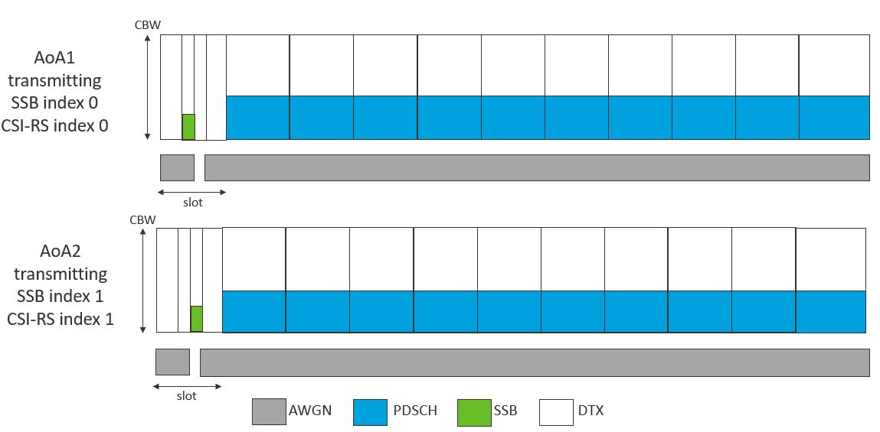

Figure A.7.5.x.1-1: Time multiplexed downlink transmissions during T1

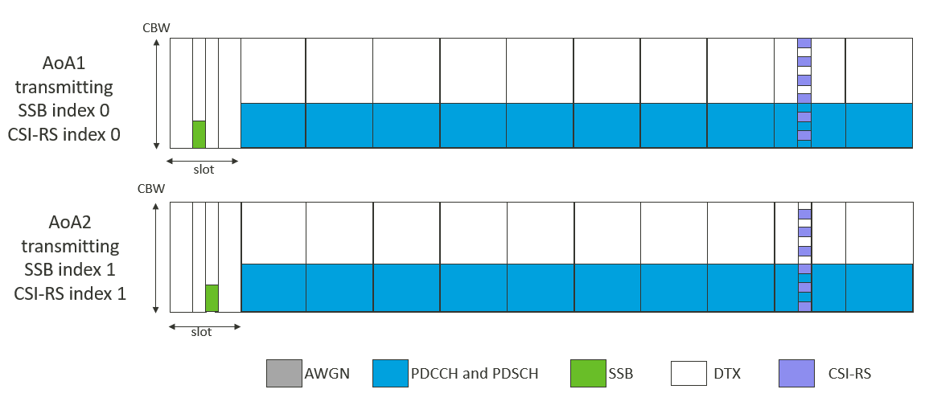

Figure A.7.5.x.1-2: Time multiplexed downlink transmissions during T2

#### A.7.5.x.2 Test Requirements

The UE behaviour follows the requirements defined in clause 9.5.6.3 and 9.5.5.2.

During T2,

* UE is required to receive both PDSCHs and send ACK correctly.
* No later than Y + 40 ms + 320 slot from the beginning of time period T2, UE shall send L1-RSRP report including the valid results for both CSI-RS resource 0 and CSI-RS resource 1 while meeting the accuracy requirements defined in clause 10.1.X.

- Y is the RRC processing delay, which is 10ms

<End of the 2nd change>