3GPP TSG-RAN WG4 Meeting # 111 R4-24xxxxx
Fukuoka, Japan, 20 May – 24 May 2024

Agenda item: 7.3.4
Source: Moderator (Ericsson)
Title: Topic summary for [111][203] FR2_multiRx_part1
Document for: Information

Introduction
This draft provides summary for following subtopics.
Suggested issues for online discussion
1-3-2, 1-1-1, 1-1-2, 1-2-2, 1-3-3

Topic #1: RRM requirements Core
Main technical topic overview. The structure can be done based on sub-agenda basis.

Companies’ contributions summary
T-doc number | Company | Proposals / Observations
R4-2407295 | Apple | Observation 1: With the current definition of multi-RX operation, it is true that UE may have to activate two panels while not being triggered to conduct measurements if the configured reporting is semi-persistent or aperiodic.  Observation 2: If adopting the revised definition “UE is in multi-RX operation if UE has reported a valid group-based beam reporting (GBBR) report,” the possible scenarios where fast beam sweeping is enabled is further restricted.  Proposal 1: Given UE indication of its preference of multi-RX/single-RX operation has been allowed, it is OK to take the current definition of multi-RX operation, i.e., “UE is configured with group-based beam reporting (GBBR) report.” If there is a power consumption concern, the UE can always indicate single-Rx operation via UAI and fall back to single RX operation.  Proposal 2: It is beneficial to define UE behavior after UE sends UAI message. To allow both types of UE behavior, it is reasonable to inform the network. The possible means could be some indication of UE behavior types associated with the current UAI message.
R4-2407456 | Qualcomm Incorporated | Proposal 1: Remove CBD from the applicable resources for scheduling restriction relaxation.  Proposal 2: Update the condition of scheduling restriction relaxation for RLM/ (cell level) BFD as follows:  - (From) [The CSI-RS and only one of the PDSCHs with different QCLed typeD are on the same OFDM symbol(s)]  - (To) The CSI-RS and both of the PDSCHs, or the CSI-RS and one of the PDSCHs with different QCL typeD when partially overlapping PDSCHs are scheduled, are on the same OFDM symbol(s)  Proposal 3: The following can be removed from the condition of measurement restriction relaxation for RLM and BFD.  - The two CSI-RS resources and both PDSCHs are overlapped on the same OFDM symbol
R4-2407695 | MediaTek inc. | Observation 1: It will lead to unnecessary UE power consumption if UE is mandated to operate in multi-RX mode as long as UE is configured with group-based beam reporting (GBBR) report  Proposal 1: For fast beam sweeping, additionally consider the following condition for the UE is in multi-Rx operation:  - UE sent a recent valid Rel-17 group-based beam reporting (GBBR).  Proposal 2: If UE recently reported ‘Not valid’ for one of the RSRP for a beam pair, this means UE is allow to fallback to single panel for the later reception QCL-ed to that beam pair  Proposal 3: Remove the following condition of measurement restriction relaxation for CSI-RS based L1 measurements.  - [The two CSI-RS resources and both PDSCHs are overlapped on the same OFDM symbol].  Proposal 4: For DCI based dual TCI state switching in mDCI, the 2 TCI state switching procedures can be treated independently. In other words, UE should be able to receive PDSCH with a target TCI state of which the switching is finished earlier.
R4-2407851 | Xiaomi | Proposal 1: RAN4 to discuss the ending point of fast beam sweeping.
R4-2408247 | ZTE Corporation, Sanechips | Proposal 1: For the condition of measurement restriction, similar as the condition of scheduling restriction, no need to mention “UE is multi-Rx operation” in the spec.  Proposal 2: For mDCI, scheduling restriction relaxation is allowed for the case of the CSI-RS and both of the PDSCHs are on the same OFDM symbol(s), or the CSI-RS and one of the PDSCHs with different QCL typeD are on the same OFDM symbol(s) when partially overlapping PDSCHs are scheduled.  Observation 1: Under mDCI, it is possible that non-overlapping PDSCHs scheduled respectively by different TRPs and dual TCI states referring to the beam pair reported in GBBR are indicated to receive the non-overlapping PDSCHs.  Proposal 3: For mDCI, even though non-overlapping PDSCHs scheduled by different TRPs, scheduling restriction relaxation is allowed provided the CSI-RS overlapping with both PDSCHs.  Proposal 4: For sDCI, the measurement restriction relaxation is allowed for the case of CSI-RSs and both of the PDSCHs are on the same OFDM symbol(s), or one of the CSI-RSs and one of the PDSCHs with different QCL typeD are on the same OFDM symbol(s) when partially overlapping PDSCHs are scheduled.  Proposal 5: For mDCI, measurement restriction relaxation is allowed provided one of the PDSCH is overlapping with the two CSI-RS.  Observation 2: The enhancements relevant to RLM/BFD/CBD imply four aspects:  - Faster beam sweeping  - Measurement restriction relaxation  - PTRP reduction for TRP specific  - Scheduling restriction relaxation  Based on the summary of all achieved progress in previous meetings, whether faster beam sweeping is allowed for SSB based cell specific CBD, SSB basd TRP specific BFD, SSB based TRP specific CBD and CSI-RS based TRP specific CBD, are still suspending.  Proposal 6: Faster beam sweeping is allowed for SSB based cell specific CBD.  Proposal 7: Faster beam sweeping is not allowed for SSB basd TRP specific BFD, SSB based TRP specific CBD and CSI-RS based TRP specific CBD.  Proposal 8: Regarding the mDCI based dual TCI state switching, some principles should be considered:  - P1: Since the beam switching only happens within CP, so during the whole timeDurationForQCL, UE can receive other DCI or other PDSCH with different TCI state assumption. This is the general principle.  - P2: For the overlapping PDSCHs, which can only be received via beam pair reported through GBBR, no matter the dual TCI state switching happens in sequence or in parallel.  - P3: For the non-overlapping PDSCHs, which can be received via independent beams reported through non-GBBR or beam pair reported through GBBR.  - P4: When receiving DCI 0(reported through GBBR) which scheduling PDSCH 0, since unsure whether and when any overlapping PDSCH 1 would be scheduled, the behavior of TCI state switching at UE side is same as the single TCI state swithching case.  Proposal 9: If TCI 1 and TCI 2 are in a beam pair, UE to receive on TCI 1 and TCI 2 between C and D. After D, to receive on TCI 2 and TCI 4. Between C and D, UE capable of multi-Rx can receive overlapping PDSCH 0 and PDSCH 1 simultaneously. Otherwise, UE to receive on TCI 2 alone till D. After D, UE can receive on TCI 2 and TCI 4.’
R4-2408278 | vivo | Proposal 1: When multiple PDSCHs are not scheduled within 300s since group-based beam reporting is configured, the UE is allowed to exit fast beam sweeping.  Proposal 2: Update UE feature for multi-Rx 30-1 as in Table 1.  Proposal 3: Conditions for measurement restriction are  - Both CSI-RSs are not in any CSI-RS resource set with repetition ON, and  - Th two CSI-RSs are QCL-ed with typeD to reference signals in a resource group in the latest Rel-17 group based beam report, and  - One CSI-RS has same QCL source as the active TCI state of one PDSCH, and the other CSI-RS has same QCL source as the active TCI state of the other PDSCH, when at least one of the PDSCHs is scheduled on the same OFDM symbol as both the CSI-RSs.  Proposal 4: Conditions for P_{TRP}=1 for CSI-RS based TRP specific BFD requirements for multi-Rx operation is  - Both CSI-RSs are not in any CSI-RS resource set with repetition ON  - The two CSI-RSs are QCL-ed with typeD to reference signals in a resource group in the latest Rel-17 group based beam report, and  - The CSI-RS in set ${\overline{q}}_{0,0}$ has same QCL source as the active TCI state of one PDSCH, and the CSI-RS in set ${\overline{q}}_{0,1}$ has same QCL source as the active TCI state of the other PDSCH, when at least one of the PDSCHs is scheduled on the same OFDM symbol as both the CSI-RSs.  Proposal 5: No additional requirements are needed for DCI based dual TCI state switch delay for m-DCI.
R4-2408558 | Huawei, HiSilicon | Observation 1: For sTRP, regarding tci-PresentInDCI is present or not, the Rx beam for PDSCH are determined as follows:  - When tci-PresentInDCI is disabled:  - Offset less than timeDurationForQCL (T1 in the Figure)  - QCLed with the CORESET with lowest controlResourceSetId  - Offset equal or larger than timeDurationForQCL (T2 in the Figure)  - QCLed with the CORESET used for the PDCCH transmission  - When tci-PresentInDCI is enabled:  - Offset less than timeDurationForQCL (T1 in the Figure)  - QCLed with the CORESET with lowest controlResourceSetId  - Offset equal or larger than timeDurationForQCL (T2 in the Figure)  - QCLed with the RS in indicated TCI states  Observation 2: For mTRP sDCI , regarding enableTwoDefaultTCI-States is configured or not, the Rx beam for PDSCH are determined as follows:  - When enableTwoDefaultTCI-States is configured:  - Offset less than timeDurationForQCL (T1 in the Figure)  - QCLed with the TCI states with lowest codepoints with two different TCI states  - Offset equal or larger than timeDurationForQCL (T2 in the Figure)  - QCLed with the RS in indicated TCI states  - When enableTwoDefaultTCI-States is not configured:  - Offset less than timeDurationForQCL (T1 in the Figure)  - QCLed with the CORESET with lowest controlResourceSetId  - Offset equal or larger than timeDurationForQCL (T2 in the Figure)  - QCLed with the RS in indicated TCI states  Observation 3: For mTRP, regarding tci-PresentInDCI is present or not, the Rx beam for PDSCH are determined as follows:  - When tci-PresentInDCI is disabled:  - Offset less than timeDurationForQCL (T1 in the Figure)  - QCLed with the CORESET with lowest controlResourceSetId with the same value of coresetPoolIndex  - Offset equal or larger than timeDurationForQCL (T2 in the Figure)  - QCLed with the CORESET used for the PDCCH transmission  - When tci-PresentInDCI is enabled:  - Offset less than timeDurationForQCL (T1 in the Figure)  - QCLed with the CORESET with lowest controlResourceSetId with the same value of coresetPoolIndex  - Offset equal or larger than timeDurationForQCL (T2 in the Figure)  - QCLed with the RS in indicated TCI states  Observation 4: When the offset between DCI and PDSCH is equal or larger than timeDurationForQCL, following conditions can be kept.  - [The two CSI-RS resources and both PDSCHs are overlapped on the same OFDM symbol].  Observation 5: For mDCI, when the offset between DCI and PDSCH is less than the threshold of timeDurationForQCL, if the default beam for PDSCH from two TRP as defined in RAN1 spec are QCL with reported GBBR, UE shall also be able to receive PDSCH simultaneously.  Observation 6: For sDCI, when the offset between DCI and PDSCH is less than the threshold of timeDurationForQCL, if the default beams are QCLed with two different TCI states as defined in RAN1 spec, which is QCL-ed with reported GBBR, UE shall also be able to receive PDSCH simultaneously.  Observation 7: Regarding the PDSCH overlapping conditions, the PDSCH could be the actual scheduled PDSCH when the offset is equal or larger than timeDurationForQCL, or the PDSCH to be buffered using default beam when the offset is smaller than timeDurationForQCL regardless whether there is scheduled PDSCH or not.  Proposal 1: With the understanding of observation 7, the measurement restriction relaxation can be modified as follows:  Both the CSI-RS for L1-RSRP and the other CSI-RS are not in any CSI-RS resource set configured with repetition ON, and  - Resources of the active TCI states or default QCL assumption as defined in TS38.214 for two PDSCHs have been reported as a resource group in Rel-17 group-based RSRP report, and  - [The two CSI-RSs and both PDSCHs are overlapped on the same OFDM symbol, and]  - The CSI-RS for L1-RSRP has same QCL source as the active TCI state/or default QCL assumption of one [PDSCH], and the other CSI-RS has same QCL source as the active TCI state / or default QCL assumption of the other [PDSCH]  Observation 8: Even if the CSI-RS from different TRPs QCLed with group via GBBR, UE may not be able to use the best beam/panel to measure CSI-RS if UE is forced to perform simultaneous measurement.
R4-2408687 | Nokia | Proposal 1: For fast beam sweeping, the UE is in multi-Rx operation if following condition is met:  a. Rel-17 group-based beam reporting (GBBR) is activated/triggered by the network.  Observation 1: When scheduling restrictions don’t apply, the expected beam sweeping factor is N=1 for L1 FR2 measurements.  Observation 2: When the CSI-RS for L1-RSRP has same QCL source as the active TCI state of one PDSCH, and the other CSI-RS has same QCL source as the active TCI state of the other PDSCH, the UE is expected to use Rx beam pair optimized through GBBR-r17 for simultaneous reception without further beam sweeping.  Observation 3: When measurement restrictions apply, RAN4 requirements state that longer delay is expected and no requirements apply.  Observation 4: A condition of PDSCH scheduling for measurement restrictions would imply that requirements change for each measurement occasion depending on the scheduling.  Proposal 2: Measurement restrictions due to multi Rx operation are enhanced when the following condition is met: The CSI-RS for L1-RSRP has same QCL source as the active TCI state of one PDSCH, and the other CSI-RS has same QCL source as the active TCI state of the other PDSCH.  Proposal 3: For Issue 2-1-1, the UE can receive simultaneously TCI 1 and TCI 2 between points C and D if they have been reported as a beam pair using GBBR-17.  Proposal 4: There is no TCI switching delay for a dual to single TCI state switch in s-DCI when the target TCI state is one of the source TCI states. This requirement will be same for a UE independent of whether the UE is configured with non-GBBR together with GBBR r not.
R4-2409701 | Ericsson | - Remove the following condition from the measurement restrictions for a UE supporting multi-rx chain.  - The two CSI-RS resources and both PDSCH are overlapped on the same OFDM symbol.  - For mDCI based dual DCI state switch, TCI state switch on each coreset is independent without any restriction on the DCI reception.  - Between point C and D, UE to receive on TCI state 0 alone, if new TCI state 0 and old TCI state 1 are not in a beam pair.

Open issues summary

Sub-topic 1-1: Conditions for multi-RX operation and fast beam sweeping.
Background:
In last meeting, RAN4 agreed on following
- For fast beam sweeping, the UE is in multi-Rx operation if following condition is met:
  - UE is configured with group-based beam reporting (GBBR) report.

Issue 1-1-1: When is UE considered to be in multi-rx operation
- Proposals
  - Proposal 1: Keep the agreed definition
    - Given UE indication of its preference of multi-RX/single-RX operation has been allowed, it is OK to take the current definition of multi-RX operation
  - Proposal 2: Add following additional condition
    - P2a:
      - UE sent a recent valid Rel-17 group-based beam reporting (GBBR).
      - If UE recently reported ‘Not valid’ for one of the RSRP for a beam pair, this means UE is allow to fallback to single panel for the later reception QCL-ed to that beam pair.
    - P2b: Rel-17 group-based beam reporting (GBBR) is activated/triggered by the network.

- Recommended WF:
    - Further discuss.

Issue 1-1-2: End point for fast beam sweeping application.
- Proposals
  - Proposal 1: When multiple PDSCHs are not scheduled within 300s since group-based beam reporting is configured, the UE is allowed to exit fast beam sweeping.

- Recommended WF:
    - Discuss whether need to define end point.

Issue 1-1-3: Conditions for applicability of faster beam sweeping for CBD
- Proposals
  - Proposal 1: Faster beam sweeping is allowed for SSB based cell specific CBD.
  - Proposal 2: Faster beam sweeping is not allowed SSB based TRP specific CBD and CSI-RS based TRP specific CBD.
- Recommended WF:
  - The WI was closed. Unless there is a big issue, RAN4 should not revert previous agreements.

Issue 1-1-4: Conditions for applicability of faster beam sweeping for BFD
- Proposals
  - Proposal 1: Faster beam sweeping is not allowed for SSB based TRP specific BFD
- Recommended WF:
  - The WI was closed. Unless there is a big issue, RAN4 should not revert previous agreements.

Issue 1-1-5: Update the condition of scheduling restriction relaxation for RLM/ (cell level) BFD:
- Proposals
  - (From) [The CSI-RS and only one of the PDSCHs with different QCLed typeD are on the same OFDM symbol(s)]
  - (To) The CSI-RS and both of the PDSCHs, or the CSI-RS and one of the PDSCHs with different QCL typeD when partially overlapping PDSCHs are scheduled, are on the same OFDM symbol(s)
- Recommended WF
  - Check if they are agreeable

Sub-topic 1-2: UE feature list

Issue 1-2-1: Update UE feature for multi-Rx 30-1 as in Table 1
Proposals:
  - Add the missed mandatory/optional parameter
- Recommended WF
  - Agreeable.

Issue 1-2-2: UE behaviour for UAI multiRx-PreferenceFR2-r18=single
- Proposals:
  - Proposal 1: It is beneficial to define UE behavior after UE sends UAI message. To allow both types of UE behavior, it is reasonable to inform the network. The possible means could be some indication of UE behavior types associated with the current UAI message.
- Recommended WF
  - In RAN2 spec, there is no UE behaviour defined in response to any of the UAI.
  - RAN4 can discuss specific solutions if there is a strong need for this

Sub-topic 1-3: Measurement and scheduling restrictions

Issue 1-3-1: Scheduling restriction for sDCI and mDCI
- Proposals
  - For mDCI, scheduling restriction relaxation is allowed for the case of the CSI-RS and both of the PDSCHs are on the same OFDM symbol(s), or the CSI-RS and one of the PDSCHs with different QCL typeD are on the same OFDM symbol(s) when partially overlapping PDSCHs are scheduled
  - For mDCI, even though non-overlapping PDSCHs scheduled by different TRPs, scheduling restriction relaxation is allowed provided the CSI-RS overlapping with both PDSCHs
- Recommended WF
  - Last meeting this issue was concluded. Unless good motivation is identified, better not to rediscuss

Issue 1-3-2: measurement restriction for sDCI and mDCI
Background: As per RAN1 spec highlighted in Huawei contribution R4-2408558
- timeDurationForQCL
  - SCS of 60 kHz: s7, s14, s28
  - SCS of 120 kHz: s14, s28.
- sTRP
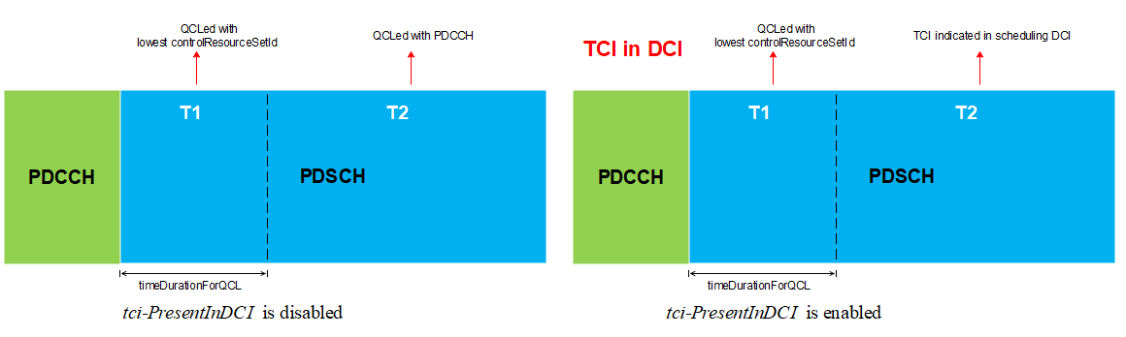
- Moderator Observation for sTRP:
  - Same slot scheduling:
    - PDSCH always have QCL assumption of lowest CORESET. QCL source corresponding to indicated TCI state in DCI is only used for cross slot scheduling. In other words, for same slot scheduling, PDCCH and PDSCH has same QCL assumptions
  - Cross slot scheduling:
    - If the scheduling offset is more than timeDurationForQCL, it is possible to use the beam indicated in TCI state as QCL source, else it is always the same beam as PDCCH or the lowest CORESETID is used for PDSCH reception.

mTRP sDCI: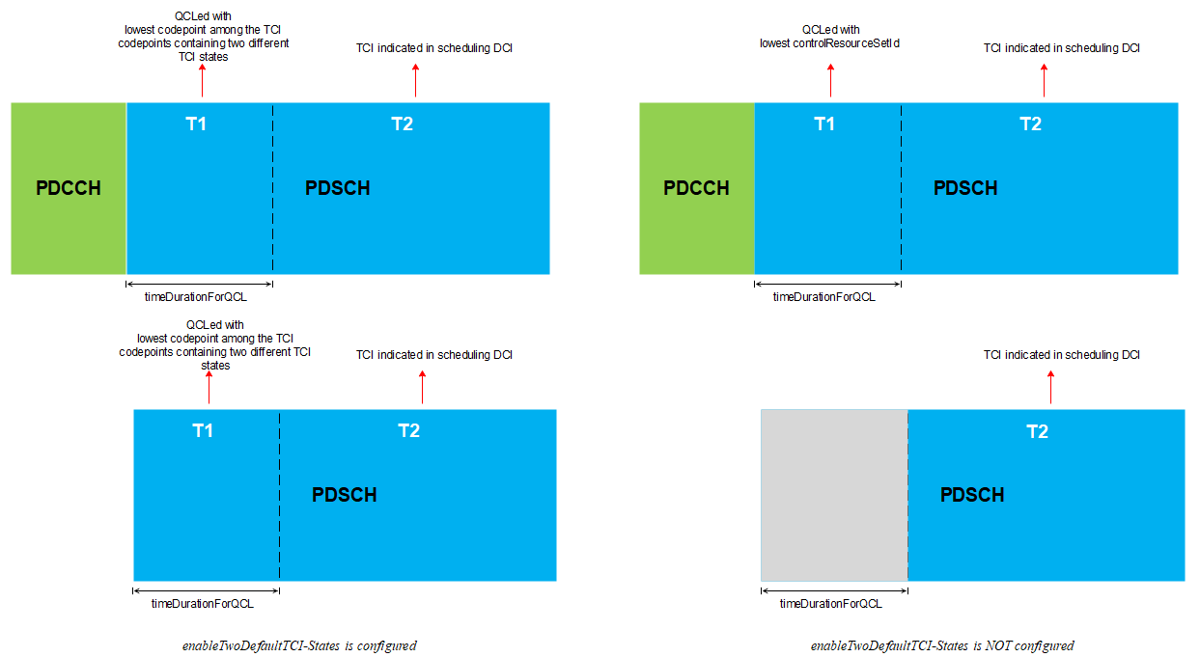
- Moderator Observation for mTRP sDCI:
  - Same slot scheduling or Scheduling offset is lower than timeDurationForQCL:
    - PDSCH always use QCL assumption of lowest codepoint among the TCI code points containing two different TCI states. That means the TCI state indicated in DCI is not used for same slot scheduling.
  - Cross slot scheduling:
    - If the scheduling offset is more than timeDurationForQCL, beam indicated in TCI state are used.
- Moderator Observation for mTRP mDCI:
  - For each TRP, sTRP observation applies.

After PDCCH processing time, UE knows if there is an overlapped PDSCH with CSI-RS or not. For simplicity, let’s assume PDCCH processing time as timeDurationForQCL. That means if the scheduling offset is before timeDurationForQCL, UE need to buffer the data worth of timeDurationForQCL and process it later. If the scheduling offset is larger than timeDurationForQCL, UE can know what’s the QCL assumptions for the PDSCH and it can determine whether to receive on single beam or beam pair.

- Moderator recommendation
  - Same slot scheduling or scheduling offset less than timeDurationForQCL
    - Option 1: Remove the measurement restrictions (i.e., remove the following conditions)
      - The two CSI-RS resources and both PDSCHs are overlapped on the same OFDM symbol
      - The CSI-RS for L1-RSRP has same QCL source as the active TCI state of one PDSCH, and the other CSI-RS has same QCL source as the active TCI state of the other PDSCH
    - Option 2: Modify the measurement restrictions
      - the measurement restriction relaxation can be modified as follows:
        - Both the CSI-RS for L1-RSRP and the other CSI-RS are not in any CSI-RS resource set configured with repetition ON, and
        - Resources of the active TCI states or default QCL assumption as defined in TS38.214 for two PDSCHs have been reported as a resource group in Rel-17 group-based RSRP report, and
        - [The two CSI-RSs and both PDSCHs are overlapped on the same OFDM symbol, and]
        - The CSI-RS for L1-RSRP has same QCL source as the active TCI state/or default QCL assumption of one [PDSCH], and the other CSI-RS has same QCL source as the active TCI state / or default QCL assumption of the other [PDSCH]
  - Cross slot scheduling when scheduling offset is larger than timeDurationForQCL
    - Option 1: Remove the measurement restrictions (i.e., remove the following conditions)
      - The two CSI-RS resources and both PDSCHs are overlapped on the same OFDM symbol
      - The CSI-RS for L1-RSRP has same QCL source as the active TCI state of one PDSCH, and the other CSI-RS has same QCL source as the active TCI state of the other PDSCH
    - Option 2: Modify the measurement restrictions
      - the measurement restriction relaxation can be modified as follows:
        - Both the CSI-RS for L1-RSRP and the other CSI-RS are not in any CSI-RS resource set configured with repetition ON, and
        - Resources of the active TCI states or default QCL assumption as defined in TS38.214 for two PDSCHs have been reported as a resource group in Rel-17 group-based RSRP report, and
        - [The two CSI-RSs and both PDSCHs are overlapped on the same OFDM symbol, and]
        - The CSI-RS for L1-RSRP has same QCL source as the active TCI state/or default QCL assumption of one [PDSCH], and the other CSI-RS has same QCL source as the active TCI state / or default QCL assumption of the other [PDSCH]

Issue 1-3-3: The scheduling restriction and measurement restriction relaxation for CBD
- Proposals
  - Proposal 1: Remove CBD from the applicable resources for scheduling restriction relaxation.

- Recommended WF
  - The WI was closed. Unless there is a big issue, RAN4 should not revert previous agreements.

Issue 1-3-4: Capturing multi-RX activated condition for MR
- Proposals
  - Proposal 1: For the condition of measurement restriction, similar as the condition of scheduling restriction, no need to mention “UE is multi-Rx operation” in the spec.
- Recommended WF
  - Check if they are agreeable

Sub-topic 1-4: TCI state switch
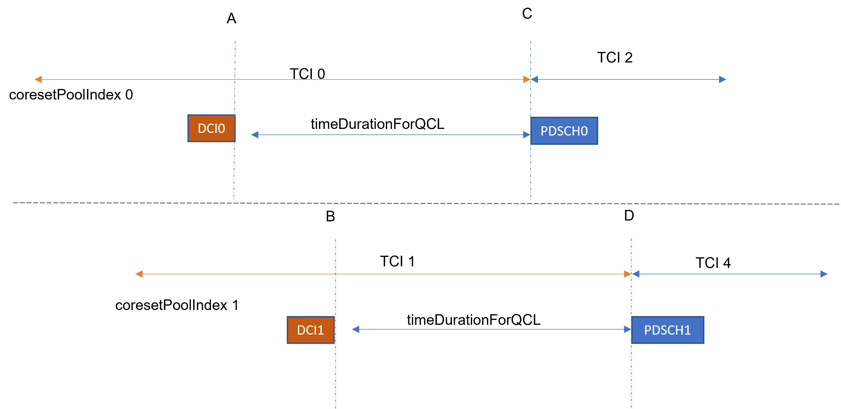
Issue 1-4-1: DCI based dual TCI state switch delay for mDCI:
- Proposals:
  - Proposal 1: For DCI based dual TCI state switching in mDCI, the 2 TCI state switching procedures can be treated independently. In other words, UE should be able to receive PDSCH with a target TCI state of which the switching is finished earlier.
  - Proposal 2: If TCI 1 and TCI 2 are in a beam pair, UE to receive on TCI 1 and TCI 2 between C and D. After D, to receive on TCI 2 and TCI 4. Between C and D, UE capable of multi-Rx can receive overlapping PDSCH 0 and PDSCH 1 simultaneously. Otherwise, UE to receive on TCI 2 alone till D. After D, UE can receive on TCI 2 and TCI 4.
  - Proposal 3: No additional requirements are needed for DCI based dual TCI state switch delay for m-DCI.
  - Proposal 4:
    - For mDCI based dual DCI state switch, TCI state switch on each coreset is independent without any restriction on the DCI reception.
    - Between point C and D, UE to receive on TCI state 0 alone, if new TCI state 0 and old TCI state 1 are not in a beam pair.
  - Proposal 5:
    - Update the DCI based dual TCI state switch for m-DCI with “UE shall be able to receive PDSCHs with target TCI states simultaneously after slot max(n1, n2) + timeDurationForQCL
    - the UE can receive simultaneously TCI 1 and TCI 2 between points C and D if they have been reported as a beam pair using GBBR-17
- Recommended WF:
  - For DCI based TCI state switch, switching happens within CP and UE can receive entire timeDurationForQCL. Based on this assumption, please discuss following.
- Please further discuss whether following is agreeable
  - If TCI 1 and TCI 2 are a beam pair.
      - UE to receive on TCI 1 and TCI 2 between C and D. After D, to receive on TCI 2 and TCI 4
  - If TCI 1 and TCI 2 are not a beam pair.
      - No requirements till point D. i.e., UE is not expected to receive on TCI 2 till point D.

Issue 1-4-2: DCI based dual TCI state switch delay for sDCI:
- Proposals:
  - Proposal 1: There is no TCI switching delay for a dual to single TCI state switch in s-DCI when the target TCI state is one of the source TCI states. This requirement will be same for a UE independent of whether the UE is configured with non-GBBR together with GBBR or not.
- Recommended WF:
  - In previous meetings company’s concern was if UE configured with non-GBBR, beam may be different (GBBR may have different beam assumption) and they need additional time for TCI state switch.
  - With the above background, please check if we can keep the requirement unchanged. Else, further discussion needed.

CR Handling
As suggested by chairman, CR cap for lowest AI is one for company. To follow the cap, I suggest we consider one CR for revision and CRs to be merged with other company CR. To avoid last minute rush in the meeting, following work split is suggested for revisions.

T-doc number | Company | Clauses covered in original CR | Recommendation for revision in CR | Email Title for revision
R4-2407036 | BeammWave | 8.10E.3.2 | Please check if the change is agreeable?
R4-2407786 | BeammWave, Nokia | 8.10E.3.2 | Please check if the change is agreeable?
R4-2407869 | OPPO | 8.5.2, 8.5.3, 8.5.5, 8.5.6, 8.5.7 | 8.5 (please capture all the changes from clause 8.5 from other company CR) | [111][203] FR2_multiRx_part1  - revision of Clause 8.5
R4-2408256 | ZTE Corporation, Sanechips | 8.10E.3.1, 8.10E.3.2, 8.10E.6 | 8.10E (please capture all the changes from clause 8.10E from other company CR) | [111][203] FR2_multiRx_part1  - revision of Clause 8.10E
R4-2408257 | ZTE Corporation, Sanechips | 8.5.2.2, 8.5.3.3, 8.5.5.2, 8.5.6.2 | Merged
R4-2408258 | ZTE Corporation, Sanechips | 7.6.8 | Merged
R4-2408259 | ZTE Corporation, Sanechips | 8.5.3.3, 8.5.5.2, 8.5.6.2 | Merged
R4-2408260 | ZTE Corporation, Sanechips | 8.18 | Merged
R4-2408281 | vivo | 8.18.2, 8.18.3, 8.18.6, 8.18.8 | 8.18 (please capture all the changes from clause 8.18 from other company CR) | [111][203] FR2_multiRx_part1  - revision of Clause 8.18
R4-2408559 | Huawei, HiSilicon | 7.6.8 | 7.6.8 (please capture all the changes from clause 7.6.8 from other company CR) | [111][203] FR2_multiRx_part1  - revision of Clause 7.6
R4-2409137 | Nokia | 3.6.x (new), 8.1.2, 8.1.3, 8.1.7, 8.5, 8.10E.4, 8.18 | 3.6.x | [111][203] FR2_multiRx_part1  - revision of Clause 3.6.X
R4-2409702 | Ericsson | 8.1.3.3, 8.5.3.3, 8.18.3.3, 8.18.6.3, 9.5.5.2 | 9.5.5.2 (please capture all the changes from clause 9.5 from other company CR) | [111][203] FR2_multiRx_part1  - revision of Clause 9.5
R4-2407304 | Apple | 8.1.3, 8.5.3 | 8.1 (please capture all the changes from clause 8.1 from other company CR) | [111][203] FR2_multiRx_part1  - revision of Clause 8.1
R4-2409706 | Ericsson, Vivo | Big CR | To be updated after the meeting

