3GPP TSG-RAN WG4 Meeting #111 R4-24XXXXX
Fukuoka, Japan, 20 – 24 May, 2024

Agenda item: 4.8
Source: Huawei, HiSilicon
Title: Ad-hoc minutes #1 for [111][201] Maintenance_up_to_R17
Document for: Approval

Introduction
The document provides minutes for ad-hoc session #1 for [111][201] Maintenance_up_to_R17.

Topic #1: Open issues

Sub-topic 4-1: Measurement of deactivated SCell in NCSG
- Proposals
  - Option 1 (OPPO, Ericsson, vivo, Nokia):
    - The Rel-17 UE behaviour is that when the SMTC of deactivated SCell is fully or partially overlapped with NCSG, the deactivated SCell is measured via NCSG regardless the UE capability report of intraFreq-needForNCSG. Otherwise, the UE performs the deactivated SCell measurements outside of NCSG.
    - RAN4 not to consider a new UE capability for NCSG based deactivated SCell measurements in Rel-17
  - Option 1a (OPPO):
    - Clarify in spec that intraFreq-needForNCSG is limited to the activated SCell and UE is capable to measure the deactivated SCell within NCSG by default
- Recommended WF
  - Agree on option 1
  - Discuss whether any spec change such as option 1a is needed.

Sub-topic 2-1: Interruption requirements for R16 NFG
- Proposals
  - Option 1 (Nokia, Deutsche Telekom, Orange, NTT DOCOMO, INC., TELECOM ITALIA S.p.A., Telia Company, T-Mobile USA, Verizon, Vodafone):
    - For Scenario 1 (LTE – NR inter-RAT measurement): a UE supporting interRAT-NeedForGaps-r16=FALSE may cause interruptions with a ratio of 5 % for FR1 and 8% for FR2.
    - For Scenario 2: If needForInterruptionConfigNR-r18 is not enabled, a UE indicating “no-gap” as part of NeedForGapsInfoNR-r16 may cause interruptions with a ratio of 3 % in FR1 and 7 % in FR2.
- Recommended WF
  - Discuss the options

Sub-topic 2-2: Measurement requirements for R16 NFG
- Proposals
  - Option 1 (Nokia, Deutsche Telekom, Orange, NTT DOCOMO, INC., TELECOM ITALIA S.p.A., Telia Company, T-Mobile USA, Verizon, Vodafone):
    - For Scenario 1: If the SMTC of the NR interRAT carrier is partially overlapping with measurement gaps, the UE shall perform NR interRAT measurements using the gaps.
    - For Scenario 2: If the SMTC is partially overlapping with measurement gaps, the UE shall perform the measurements using the gaps.
- Recommended WF
  - Discuss the options

Sub-topic 4-2: NCSG patterns
- Proposals
  - Option 1 (OPPO):
    - VIL should be specific to NCSG patterns, i.e. VIL=1ms for NCSG pattern #0-11 and VIL=0.75ms for NCSG pattern #12-23.
    - Consider the following two methods to capture proposal 2 is agreed:
      - Option a: explicitly capture VIL in the NCSG patterns in Table 9.1.9.3-1, e.g. by adding one more column for VIL.
      - Option b: implicitly associated VIL with NCSG patterns in the VIL requirements, e.g. Table 9.1.9-1 for NCSG pattern #0-11 and Table 9.1.9-2 for NCSG pattern #12-23.
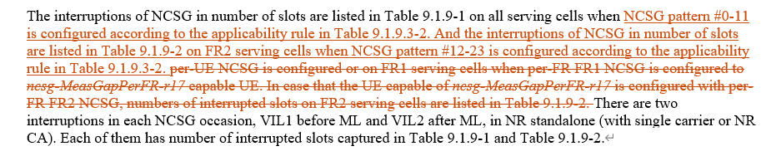
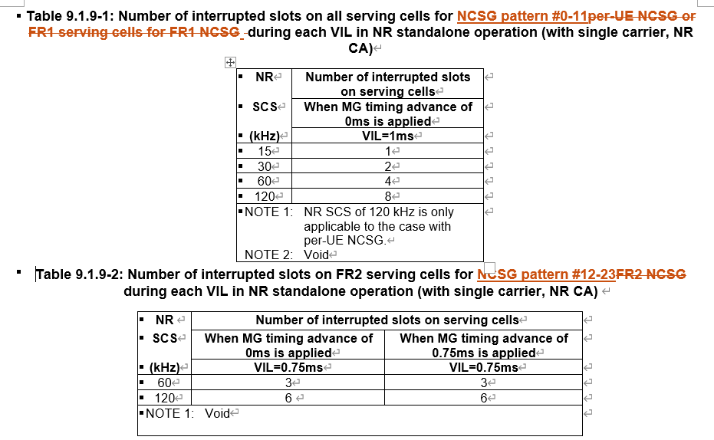
- Recommended WF
  - Discuss the options

Sub-topic 5-1: Alignment of terminology for satellite orbit types
- Proposals
  - Option 1 (Nokia):
    - In the core part of TS 38.133, align the terminology by replacing GEO for GSO (Geosynchronous Orbits).
    - In TS 38.133, replace the terminology LEO by NGSO.
  - Option 2 (Ericsson):
    - It’s not RAN4’s intention to update “LEO” naming to “NGSO” in RAN4 RF and RRM specifications for the time being.
    - This might be done later based on the conclusion of the corresponding studies if any.
    - Whether to change IE names as in RAN2 LS is up to RAN2
- Recommended WF
  - Discuss the options

Sub-topic 3-1: Applicability of tci-ActivatedConfig for SCell
- Proposals
  - Option 1 (Nokia):
    - Update the RAN4 UE requirements capturing that tci-ActivatedConfig can be configured for a deactivated SCell and a direct activated SCell.
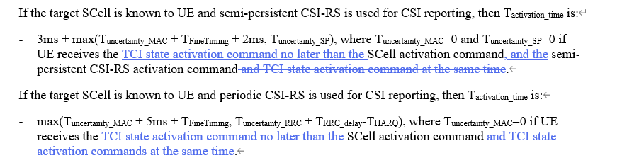
    - If proposal 1 is not agreeable, send LS to RAN2 clarifying the RAN2 understanding of the applicability of tci-ActivatedConfig.
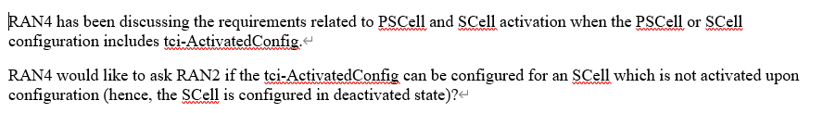
- Recommended WF
  - Discuss the options

Sub-topic 6-1: PUCCH SCell activation with multiple SCell
- Proposals
  - Option 1 (Huawei):
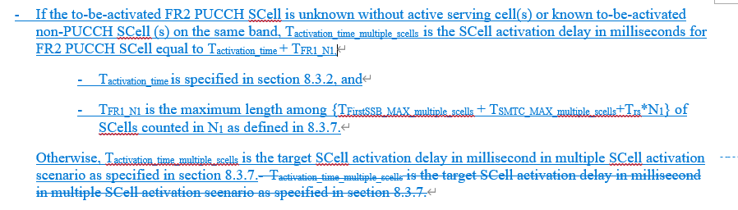
- Recommended WF
  - Discuss the options

Sub-topic 6-2: Interruption requrirements for SRS antenna switching
- Proposals
  - Option 1 (Huawei, vivo):
    - Void Table 8.2.2.2.16.2 (Interruption length in slots of victim CC when 1 SRS symbol is configured, and aggressor and victim cells are asynchronized)
    - The SRS AS interruption requirements for NR SA shall be modified as for the following two cases:
      - Interruption length in symbols of victim CC when 1 SRS symbol is configured
      - Interruption length in slots of victim CC for rest of the SRS configurations
- Recommended WF
  - Discuss the options

Sub-topic 7-1: Power levels and thresholds in SDT TCs
- Proposals
  - Option 1 (Nokia):
    - The cg-SDT-RSRP-ChangeThreshold of A.7.2.1 should be changed to 14dB. Same applies for equivalent test in RedCap. The cd-SDT-RSRP-ChangeThreshold of A.6.2.1 is suggested changed to 8dB. Same applies for equivalent test in RedCap.
    - The values for the power in A.7.2.1 for T1, T3 and T6 to be changed from -100 to -104dBm/SCS, power for T2 from -87 to -80dBm/SCS and the values for T4 and T5 to be changed from -75.5dBm to -78dBm. Same applies for equivalent test in RedCap, resulting in an Io range from -72 to -49 dBm/BW.
    - The values for the power in A.6.2.1 for T2 to be changed from -92dBm to -88dBm and the values for T4 andT5 to be changed from -82dBm to -86dBm. Same applies for equivalent test in RedCap. The range for Io is within the range of -50 to -70dBm/BW.
    - RAN4 to review the P0 value of the RedCap SDT test for FR2. For SDT RedCap test case, a value of -104dBm/BW is suggested.
- Recommended WF
  - Discuss the options

Sub-topic 1-1: MAC CE based active TCI state list update delay
- Proposals
  - Option 1 (Apple):
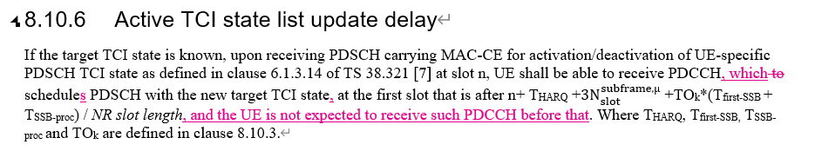
  - Option 2 (vivo):
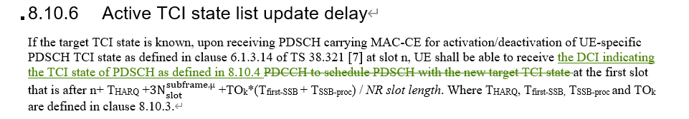
  - Option 3 (Nokia):
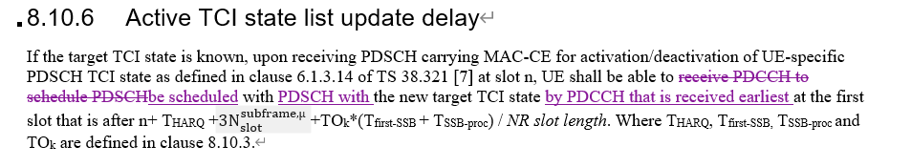
- Recommended WF
  - Discuss the options

Sub-topic 1-2: DCI based active TCI state switch delay
- Proposals
  - Option 1 (vivo):
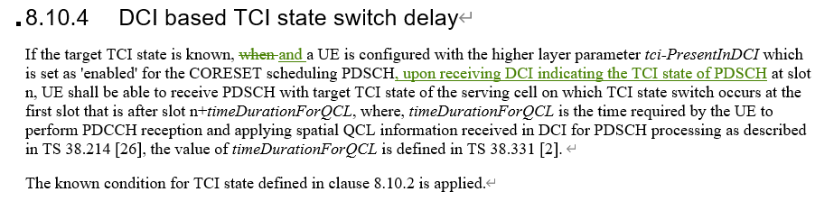
- Recommended WF
  - Discuss the options

Sub-topic 1-3: Test case for MAC CE based active TCI state switching delay
- Proposals
  - Option 1 (Nokia): for A.7.5.8.1.1 (NR PCell FR2 active TCI state switch for a known TCI state)
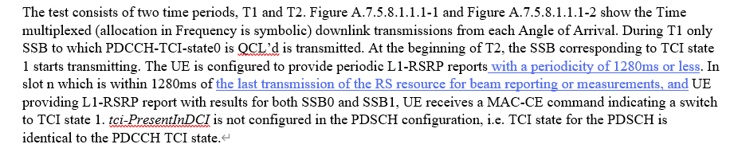
- Recommended WF
  - Discuss the options

