3GPP TSG-RAN WG4 Meeting #110bis R4-2408945
Changsha, China, 15th – 19th April, 2024

Agenda item: 10.13.4
Source: Moderator (CMCC)
Title: Topic summary for [111][134] FS_Ambient_IoT_solutions_part1
Document for: Information

Introduction
This way forward captures the agreements for co-existence evaluation for Rel-19 ambient IOT study item.
The summary in RAN4#111 is R4-2408945. The way forward agreed in RAN4#110bis is in R4-2406714.

Deployment scenarios and spectrum usage

Topic 2-1: Deployment scenario
Issue 2-1-1: deployment scenarios for D1T1
Agreement in RAN4#110bis:
Issue 2-1-1: deployment scenarios for D1T1
Option 1-1: Legacy NR gNB are outdoor macro gNB while AIoT reader/CW/devices are all indoors. Legacy NR UE is only allowed outdoors.
Option 1-2: Legacy NR gNB are outdoor macro gNB while AIoT reader/CW/devices are all indoors. Legacy NR UE is indoor accessing to outdoor NR marco gNB
Option 2-1: Legacy NR gNB are co-located with AIoT reader and CW. All of NR and AIoT BS/UE/Reader/Device/CW are indoors. AIoT reader /CW and Legacy gNB share same hardware
Option 2-2: Legacy NR gNB are co-located with AIoT reader and CW. All of NR and AIoT BS/UE/Reader/Device/CW are indoors. AIoT reader /CW and Legacy NR gNB do not share same hardware. (less limitation on the power boosting)
Agreement:
- RAN4 to first evaluate co-existence for deployment scenario of option 1-1 and 1-2, and further study option 2-1 and 2-2.
Issue 2-3-2: Priorities of spectrum deployment mode for co-existence evaluation
Agreement:
- Prioritize the following spectrum deployment mode for RAN4 co-existence evaluation
  - A-IoT is located within a NR transmission bandwidth configuration
  - A-IoT which is operating indoor shares in-band spectrum with outdoor macro BS

Agreement in RAN4#111:
- Consider only adjacent channel co-existence evaluation for in-band deployment scenario for NR and AIOT
- Encourage companies to provide the simulation results for option 1-1 and 1-2
  - FFS on co-site scenario (option 2-1 and 2-2)

Issue 2-1-2: deployment scenarios for D2T2
Agreement in RAN4#110bis:
Option 1-1: Legacy NR gNB are outdoor macro gNB, AIoT intermediate UE/CW/devices are all indoors. Legacy NR UE is only allowed outdoor.
Option 1-2: Legacy NR gNB are outdoor macro gNB, AIoT intermediate UE/CW/devices are all indoors. Legacy NR UE is indoor.
Agreement:
- For D2T2 co-existence evaluation, Legacy NR gNB are outdoor macro gNB, AIoT intermediate UE/CW/devices are all indoors.
  - Consider option 1-1 and option 1-2 as the starting point

Topic 2-2: Spectrum usage
Issue 2-2-1: Spectrum usage for R2D in D1T1
Agreement in RAN4#110bis:
- FFS on whether to prioritize FDD DL spectrum for R2D for D1T1 for co-existence evaluation.

Agreement in RAN4#111:
- Use FDD DL as starting point for co-existence evaluation for R2D in D1T1
  - FFS on FDD UL spectrum.

Issue 2-2-2: Spectrum usage for CW transmission in D1T1 for the case that D2R backscattering is transmitted in the same carrier as CW for D2R backscattering
Agreement in RAN4#110bis:
For the case that D2R backscattering is transmitted in the same carrier as CW for D2R backscattering, and for topology 1, the following cases for CW transmission are studied.
· Case 1-1: CW is transmitted from inside the topology, transmitted in DL spectrum
· Case 1-2: CW is transmitted from inside the topology, transmitted in UL spectrum
· Case 1-4: CW is transmitted from outside the topology, transmitted in UL spectrum

Agreement:
- For the case that D2R backscattering is transmitted in the same carrier as CW for D2R backscattering, consider the following for co-existence evaluation
  - CW transmits in either UL or DL spectrum
  - FFS on inside topology and outside topology.

Agreement in RAN4#111:
- Use inside topology as starting point for co-existence evaluation (case 1-1, case 1-2) for calibration.
- Further discuss the difference of outside topology (case 1-4) from co-existence study perspective.

Issue 2-2-4: Spectrum usage for R2D in D2T2
Agreement in RAN4#110bis:
- Use FDD UL spectrum for R2D in D2T2.

Issue 2-2-5: Spectrum usage for CW transmission in D2T2 for the case that D2R backscattering is transmitted in the same carrier as CW for D2R backscattering
Agreement in RAN4#110bis:
For the case that D2R backscattering is transmitted in the same carrier as CW for D2R backscattering, and for topology 2, the following cases for CW transmission are studied.
· Case 2-2: CW is transmitted from inside the topology (i.e., intermediate UE), transmitted in UL spectrum
· Case 2-3: CW is transmitted from outside the topology, transmitted in DL spectrum
· Case 2-4: CW is transmitted from outside the topology, transmitted in UL spectrum
Agreement:
- For the case that D2R backscattering is transmitted in the same carrier as CW for D2R backscattering
  - Use UL spectrum as the starting point for co-existence evaluation.
    - It won’t preclude the use of DL for backscattering transmission.
    - FFS on the minimum distance between the intermediate UE and A-IoT device

Tentative Agreement:
- Use case 2-2 as starting point for co-existence evaluation for calibration.
  - FFS on case 2-3
- Further discuss the difference of outside topology (case2-4) from co-existence study perspective.

Issue 3-2-3: Evaluation cases for -A1 and -A2
In last RAN1 meeting, the following CW cancellation was discussed but no agreements are reached.
- For [monostatic backscatter], FFS
  - [140dB for BS]
  - [120dB for UE]
- For [bistatic backscatter]
  - Assuming CW has no impact to the receiver sensitivity loss.

Proposal in RAN4#111:
Proposal 1 (CMCC): following CW interference cancellation evaluation methodology is suggested. Besides, RAN4 needs to further discuss whether it is still necessary to evaluate -A2 evaluation case if CW interference cancellation capability is already much high, i.e. remaining CW interference is much lower than noise floor.
- Methodology: residual self-interference= Tx power - self-interference cancellation capability
- self-interference cancellation capability = spatial isolation + RF cancellation + digital cancellation if applicable
Proposal 2 (Apple): Consider D2T2-A1 only to avoid the requirement of full-duplex capable intermediate UEs if CW is transmitted on UL spectrum
Proposal 3 (vivo): For the D2R, only the interference of IM3, which produced by D2R and CW, is considered as the impact of CW in the co-existence evaluation, and the impact of CW itself can be ignored.
Recommended WF:
Do not consider CW interference for calibration purpose for D1T1-A2 and D2T2-A2
FFS on how to consider CW cancellation capability in formal simulation

Issue 2-2-6: Minimum distance between intermediate UE and device
Agreement in RAN4#111:
- Use 1m as starting point for minimum distance between intermediate UE and device.

Evaluation methodology and cases

Topic 3-1: Evaluation methodology
Issue 2-4-1: Evaluation methodology
Agreement in RAN4#110bis:
- Use the Monte-Carlo method as baseline for co-existence evaluation, i.e. Section 5.3 in TR38.803
- Depending on the discussion on deployment scenarios, for some cases, calculation for the worst interference link may be enough.
- FFS on whether RAN4 needs to perform link level simulation

Proposal in RAN4#111:
Proposal 1 (Huawei):
- Deterministic calculations can be used to evaluate the worst-case scenario for the following: interference between indoor NR UE and A-IoT devices, as well as interference between A-IoT devices and outdoor NR macro-BS.
- Path ② is between an indoor NR UE and an A-IoT device, while path ③ is between an A-IoT device and an outdoor NR macro-BS. These paths can be evaluated by deterministic calculations.
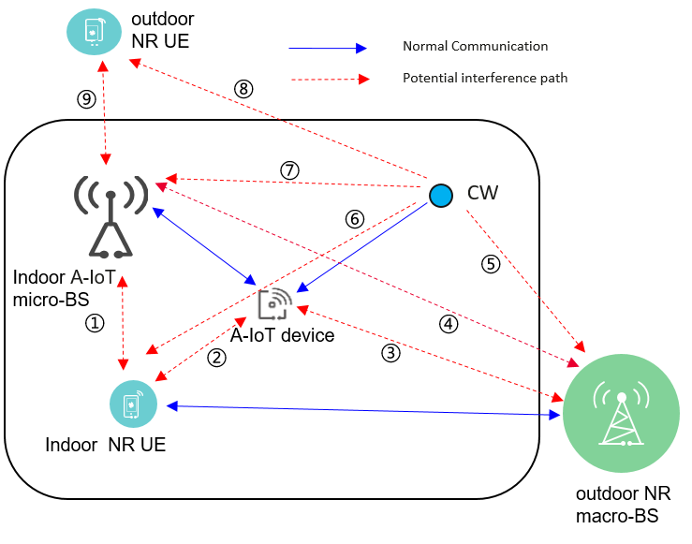
Proposal 2 (CMCC):
- it’s suggested to use monte-carlo simulation method rather than calculation for all co-existence evaluation.
- Considering final relationship between SINR and BLER will impact final co-existence results. it’s suggested to align LLS simulation parameters in RAN4 and show the high priority sets of parameters to reduce the workload of LLS and try best to converge final relationship between SNR and BLER.
- there is no need to use monte-carlo simulation method to evaluate the interference when device as victim. Instead we can use LLS to simulate under which power difference between reader and interference signal, the device could successfully receive R2D signal.
Proposal 3 (CATT):
- Link level simulation is needed to determine guard RB size to cancel ICI between A-IoT carriers and NR carriers in same cell for A-IoT in-band or guard band operation in NR spectrum and ensure A-IoT performance.
Proposal 4 (vivo)
- Based on the worst case calculation, the following cases are identified as no co-existence issue no matter for option 1-1 and option 1-2, and corresponding simulation can be considered to be skipped:
Deployment scenario and topology | spectrum | aggressor | victim
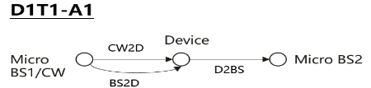 | R2D: DL  CW2D and D2R: UL | CW and/or device | NR UL
 |  | NR DL | Device
 | R2D: DL  CW2D and D2R: DL | CW and/or device | NR DL
 |  | NR DL | Device
 |  | NR DL | Reader
 | R2D: UL  CW2D and D2R: UL | Device | NR UL
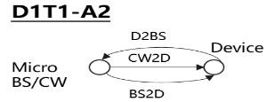 | R2D: DL  CW2D and D2R: UL | CW and/or device | NR UL
 |  | NR DL | device
 | R2D: DL  CW2D and D2R: DL | CW and/or device | NR DL
 |  | NR DL | Device
 |  | NR DL | Reader
 | R2D: UL  CW2D and D2R: UL | Device | NR UL

Recommended WF:
Discuss whether the following interference cases can be evaluated by deterministic calculation:
- interference between indoor NR UE and A-IoT devices
- interference between A-IoT devices and outdoor NR macro-BS
Regarding link level simulation, FFS on the following aspects:
- LLS to simulate under which power difference between reader and interference signal, the device could successfully receive R2D signal.
- Link level simulation is needed to determine guard RB size to cancel ICI between A-IoT carriers and NR carriers in same cell for A-IoT in-band or guard band operation in NR spectrum and ensure A-IoT performance.

Issue 2-4-2: Performance metric for AIOT
Agreement in RAN4#110bis:
- For NR system, use 5% throughput loss as performance metric as legacy.
- For AIOT system, including reader, device, intermediate UE, further discuss the performance metric:
  - Option 1: [10%] BLER, [Rx power]
  - Option 2: SINR degradation
  - Other options are precluded

Proposal in RAN4#111:
- Proposal 1 (Huawei): SINR degradation can serve as metric. It is recommended [1dB] SINR degradation for A-IoT BS and [3dB] SINR degradation for A-IoT intermediate UE.
- Proposal 2 (Apple): SINR degradation is preferred with less dependency on RAN1 design. FFS how much degradation is considered acceptable.
- Proposal 3 (CATT): Use 1dB SINR degradation for 5% and 50% CDF SINR point as performance metric for A-IoT co-existence evaluation for DL and UL.
- Proposal 4 (Qualcomm):
  - RAN4 to use the same performance metric (CINR/CNR degradation) as RAN1 for R2D link in coexistence study. CINR/CNR, where CINR/CNR is defined as the ratio of signal power spectral density in the signal transmission bandwidth to the noise and interference (if any) power spectral density in the device envelop detector channel bandwidth.
  - RAN4 to use SINR degradation as the performance for D2R link in coexistence study.
- Proposal 5 (Sony): RAN4 needs further discuss if the same performance metric and if the same threshold value for successful decoding should be used for the R2D link and D2R link.
- Proposal 6 (Spreadtrum): 10% BLER for AIOT system
- Proposal 7 (CMCC):
  - it’s suggested to use 10% BLER as performance metric for all kinds of devices, reader of topology 1 and 2. Outage probability: 5% worst victim is suggested as the candidate value.
  - align the definition of SNR from co-existence simulation output and the definition of SNR from SNR-BLER relationship, i.e. align the definition of the bandwidth of wanted bandwidth and the bandwidth of noise+interference bandwidth when calculate SINR.
  - sensitivity of device should be taken into consideration and only the devices that meet sensitivity threshold should be included into final BLER statistics.
- Proposal 8 (OPPO, R4-2408817): Use 1% misdetection rate as performance metric for evaluation
- Proposal 9 (vivo, R4-2408093): It is suggested that success rate is used as performance metric for Rx requirement definition, e.g., 10% BLER, 90% success rate, etc.
Recommended WF:
Companies have different views on the performance metric for AIOT. 4 companies support to use SINR degradation, 4 companies support to consider BLER/misdetection rate/success rate.
It is recommended that:
- Use SINR for calibration purpose
- FFS on performance metric for co-existence evaluaion and requirements definition.
Agreement:
- Use [SINR/SIR] for calibration purpose
  - FFS on the details of SINR definition
- FFS on performance metric for co-existence evaluation and requirements definition.

Issue 2-4-2: SINR definition for D2R
Proposal 1(Huawei): Considering that the CW node is a component of the A-IoT system, and as such, the SINR before any degradation (which includes CW interference) is used as the baseline reference. The SINR includes CW interference is used as the baseline reference before any degradation.
Proposal 2 (Ericsson):
• SNR for baseline operation: In legacy coexisting study, the baseline scenario is without the aggressor network and the SNR to operate A-IoT should be known. In legacy coexisting study, the throughput is used and a table of SINR to throughput is used so the SNR operation is given. For UL receiving at A-IoT BS, such SINR operation point relating to both the RF isolation capability (CW transmission leakage to receiving band) and may be baseband capability to further attenuate the CW signal. Maybe the RF part could be discussed in RAN4, but baseband part may rely on RAN1
RAN1 provide the SNR for baseline operation.
Recommended WF:
Do not consider CW interference for calibration purpose for D1T1-A2 and D2T2-A2
FFS on how to consider CW cancellation capability in formal simulation

Issue 2-4-2: SINR definition for R2D
RAN1 agreement (R4-2403815):
Proposal#5 (V05r1)
For the R2D LLS for ED, report followings (as start point).
- CINR/CNR, where CINR/CNR is defined as the ratio of signal power spectral density in the transmission bandwidth to the noise and interference (if any) power spectral density in the device ED channel bandwidth.
- signal transmission bandwidth
- ED channel bandwidth
FFS: exact definition of ED channel bandwidth for RF-ED, IF receiver
FFS: which and how to report for R2D ZIF receiver and D2R

Proposal (Ericsson):
• SNR for baseline operation: In legacy coexisting study, the baseline scenario is without the aggressor network and the SNR to operate A-IoT should be known. In legacy coexisting study, the throughput is used and a table of SINR to throughput is used so the SNR operation is given. For UL receiving at A-IoT BS, such SINR operation point relating to both the RF isolation capability (CW transmission leakage to receiving band) and may be baseband capability to further attenuate the CW signal. Maybe the RF part could be discussed in RAN4, but baseband part may rely on RAN1
RAN1 provide the SNR for baseline operation.

Recommended WF:
Use RAN1 definition of CINR/CNR for R2D link evaluation.

Topic 3-2: Evaluation cases
Issue 3-2-1: device type
Agreement in RAN4#110bis:
- Prioritize device 1 and 2a without a frequency shifter for coexistence evaluation.

Proposal in RAN4#111:
Proposal 1 (OPPO): If the device 2a co-existence study is concluded as feasible, the same conclusion can be applied to device 2b for scenario C.
Proposal 2 (Spreadtrum): For co-existence evaluation, device 1 and 2a with small or large frequency shift capability are deprioritized.
Proposal 3 (Sony): The amplification of the R2D and D2R link in device 2a needs to be taken into account in order to perform the co-existence simulation. The gain of the amplification can be further discussed.
Recommended WF:
Keep the previous agreement. FFS on device 2b.
Amplification will be discussed under issue 4-3-4.

Issue 3-2-2: Evaluation cases when CW is aggressor
Proposal 1 (CMCC): During co-existence simulation, there is no need to consider CW unwanted interference due to its almost perfect unwanted emission performance outside the transmission bandwidth, i.e. don’t need to consider the interference when CW as aggressor.
Proposal 2 (Qualcomm): since CW signal is only occupied single tone or several tones, the impact would be marginal if NR UE and A-IoT are in adjacent channel considering the NR UE RF filter could remove the CW interference.
Proposal 3 (Ericsson): Use the IBE mask of UE specification as starting point for CW IBE mask.
Recommended WF:
2 companies propose that the impact of CW signal in adjacent channel can be ignored from co-existence evaluation perspective consider that CW is single tone or multiple tones. In this case, it seems no need to simulate the cases when CW is aggressor.
1 company propose to use IBE mask of UE spec as starting point for CW.
More discussion is needed.

Issue 3-2-4: Evaluation cases for D1T1 for device 1 and 2a between NR and AIOT
Recommended WF:
Use the following cases highlighted in cyan is used for calibration purposes.
Deployment scenario and topology | spectrum | aggressor | victim
· Case 1-1: CW is transmitted from inside the topology, transmitted in DL spectrum  · Case 1-2: CW is transmitted from inside the topology, transmitted in UL spectrum | R2D: DL  CW2D and D2R: UL | CW and/or device | NR UL
 |  | NR UL | device and/or reader
 |  | reader | NR DL
 |  | NR DL | device
 | R2D: DL  CW2D and D2R: DL | CW and/or device | NR DL
 |  | NR DL | device and/or reader
 | R2D: UL  CW2D and D2R: UL | Reader | NR UL
 |  | NR UL | reader
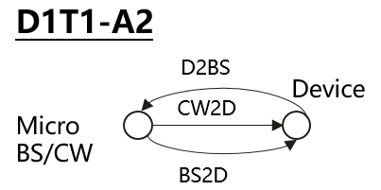  Self interference cancelation is needed for reader  · Case 1-1: CW is transmitted from inside the topology, transmitted in DL spectrum  · Case 1-2: CW is transmitted from inside the topology, transmitted in UL spectrum | R2D: DL  CW2D and D2R: UL | CW and/or device | NR UL
 |  | NR UL | device and/or reader
 |  | reader | NR DL
 |  | NR DL | device
 | R2D: DL  CW2D and D2R: DL | CW and/or device | NR DL
 |  | NR DL | device and/or reader
 | R2D: UL  CW2D and D2R: UL | reader | NR UL
 |  | NR UL | reader
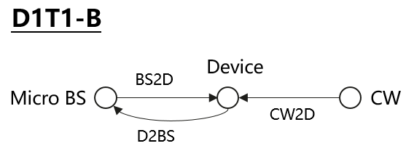  Self interference cancellation is needed for reader  · Case 1-4: CW is transmitted from outside the topology, transmitted in UL spectrum | R2D: DL  CW2D and D2R: UL | CW and/or device | NR UL
 |  | NR UL | device and/or reader
 |  | reader | NR DL
 |  | NR DL | device
 | R2D: UL  CW2D and D2R: UL | reader | NR UL
 |  | NR UL | reader

Issue 3-2-5: Evaluation cases for D2T2 for device 1 and 2a between NR and AIOT
Recommended WF:
Use the following cases highlighted in cyan is used for calibration purposes.
Deployment scenario and topology | spectrum | aggressor | victim
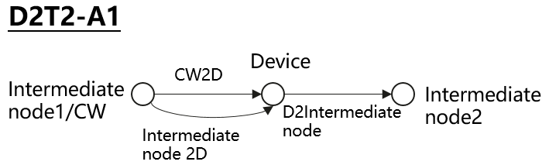  Case 2-2: CW is transmitted from inside the topology (i.e., intermediate UE), transmitted in UL spectrum | R2D: UL  CW2D and D2R: UL | CW and/or device | NR UL
 |  | NR UL | Device and/or reader
 |  | reader | NR UL
 |  | NR UL | device
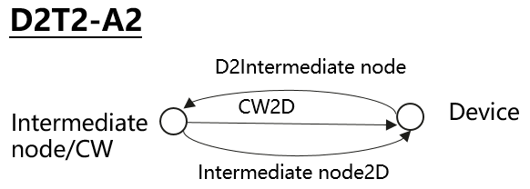  \  Case 2-2: CW is transmitted from inside the topology (i.e., intermediate UE), transmitted in UL spectrum  Self interference cancelation is needed for reader | R2D: UL  CW2D and D2R: UL | CW and/or device | NR UL
 |  | NR UL | Device and/or reader
 |  | reader | NR UL
 |  | NR UL | device
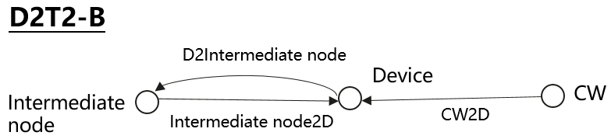  Case 2-3: CW is transmitted from outside the topology, transmitted in DL spectrum  Case 2-4: CW is transmitted from outside the topology, transmitted in UL spectrum  Self interference cancelation is needed for reader | R2D: UL  CW2D and D2R: UL | CW and/or device | NR UL
 |  | NR UL | Device and/or reader
 |  | reader | NR UL
 |  | NR UL | device
 | R2D: UL  CW2D and D2R: DL | CW and/or device | NR DL
 |  | NR DL | device and/or reader

Issue 3-2-6: Evaluation cases for device 2b between AIOT and NR
Proposal 1 (Sony): Device type 2b needs to be taken into account in the co-existence study, with the scenarios shown below:
D1T1-C  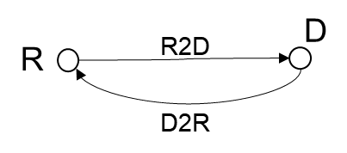 | R2D: DL  D2R: UL | CW and/or device | NR UL
 |  | NR UL | device and/or reader
 |  | reader | NR DL
 |  | NR DL | device
 | R2D: DL  D2R: DL | CW and/or device | NR DL
 |  | NR DL | device and/or reader
 | R2D: UL  D2R: UL | reader | NR UL
 |  | NR UL | reader

D2T2-C  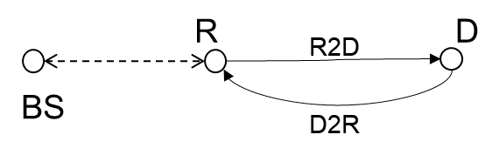 | R2D: UL  D2R: UL | CW and/or device | NR UL
 |  | NR UL | Device and/or reader
 |  | reader | NR UL
 |  | NR UL | device

Proposal 2 (Huawei):
Coexistence case No. | Deployment & Topology | Device Type | R2D spectrum | D2R spectrum
D2b_Case1 | 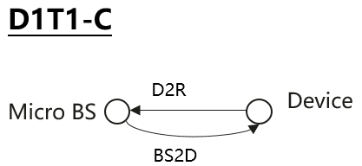 | Device 2b | DL | UL
D2b_Case2 | 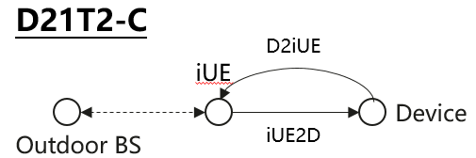 | Device 2b | UL | UL

Recommended WF:
FFS on the evaluation cases for device 2b.

Issue 3-2-7: Multi-operator scenario
Proposal (Spreadtrum): Multiple A-IoT operators co-existence scenario should be investigated in Rel-19 A-IoT.
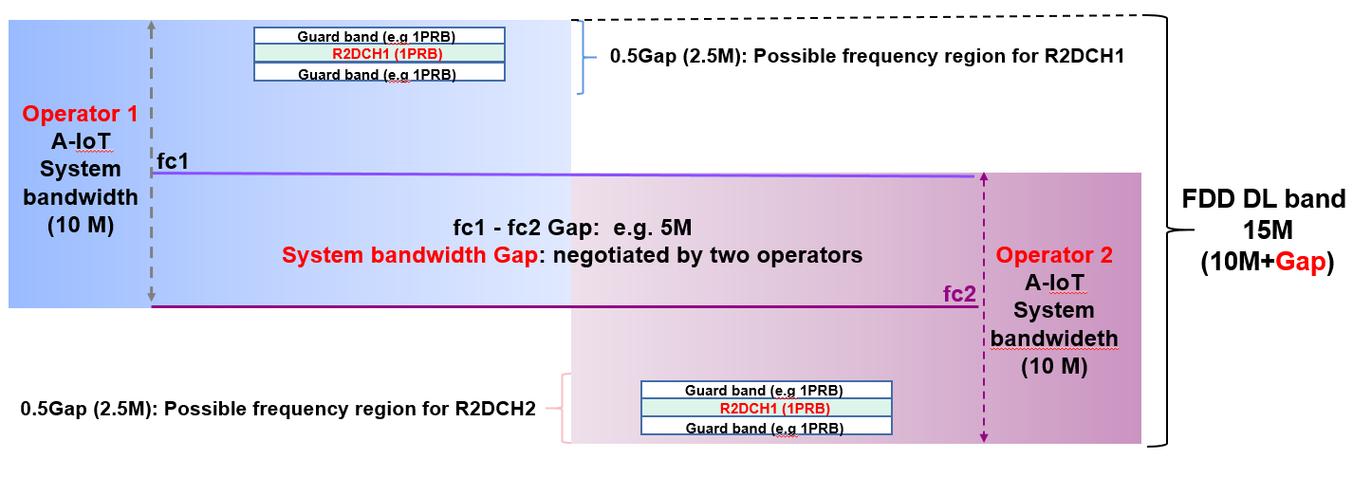
Figure 2.5-1: one possible FDM candidate for multiple A-IoT operators scenario

Proposal (Ericsson)
RAN4 discuss the A-IoT adjacent channel definition with below two options:
Option 1: A-IoT coexisting channels defined within the same macro BS channel.
Option 2: A-IoT coexisting channels defined within two adjacent macro BS channels.
Figure 3: A-IoT adjacent channel definition

Recommended WF:
More clarification is needed on the multiple A-IOT operator scenario.

Evaluation parameters

Topic 4-1: Adjacent RB Tx and Rx charateristics
Agreement in RAN4#110bis
- Prioritize the following spectrum deployment mode for RAN4 co-existence evaluation
  - A-IoT is located within a NR transmission bandwidth configuration
  - A-IoT which is operating indoor shares in-band spectrum with outdoor macro BS

Moderator note: According to last meeting agreement, “in-band” spectrum deployment mode is prioritized. Hence it is recommended to discuss the Tx and Rx characteristics for co-existence evaluation for “in-band” spectrum deployment mode.

Issue 4-1-1: A-IOT reader
Recommended WF:
With 0RB guard band between AIOT and NR for inband spectrum deployment mode for calibration
 |  | In-band
 |  | Tx | Rx
NR UE/A-IOT Intermediate UE | For formal simulation | Legacy UE IBE requirement | ICS=ACS value  According to SBFD analysis, ICS could be equals to ACS
 | For calibration purpose | Legacy UE IBE | ACS
NR BS | For formal simulation | Based on companies’ input since there is no such requirements in 38.104 | Based on companies’ input in dB scale
 | For calibration purpose | ACLR of legacy gNB | ACS of legacy gNB
A-IOT BS | For formal simualtion | Option 1: ACLR1:40dB，ACLR2:50dB  Option 2: ACLR:45 | ACS of legacy gNB
 | For calibration purpose | ACLR of legacy gNB 45 | ACS of legacy gNB
CW | For formal simulation
 | For calibration purpose | ??? | ???

Issue 4-1-2: Tx for device 1 and 2a
Proposal (CMCC):
For device 1 and 2a, ICS is assumed as 0dB since there is no in-band selectivity. For Tx leakage requirement, it is related to following several factors.
- D2R Data rate
- Coding, i.e. FEC + line coding
- Modulation scheme
  - Since there is no agreement in RAN1 about small frequency shit, at starting point it’s suggested to only considering chip modulation, e.g. OOK/BPSK
For device 1 and 2a, it’s suggested to use following value for IBE as starting point with assuming 5kbps D2R date rate, Manchester code, BPSK modulation scheme. Following assumes that Tx signal is at frequency center
- 25dBc at the edge of center 1PRB, i.e. 90kHz offset from frequency center
- 35dBc with 1 guard RB away from center PRB, i.e. 270kHz offset from frequency center
- 41dBc with 2 guard RB away from center PRB, i.e. 450kHz offset from frequency center

Recommended WF:
For device 1 and 2a, 25dBc is used for calibration purposes
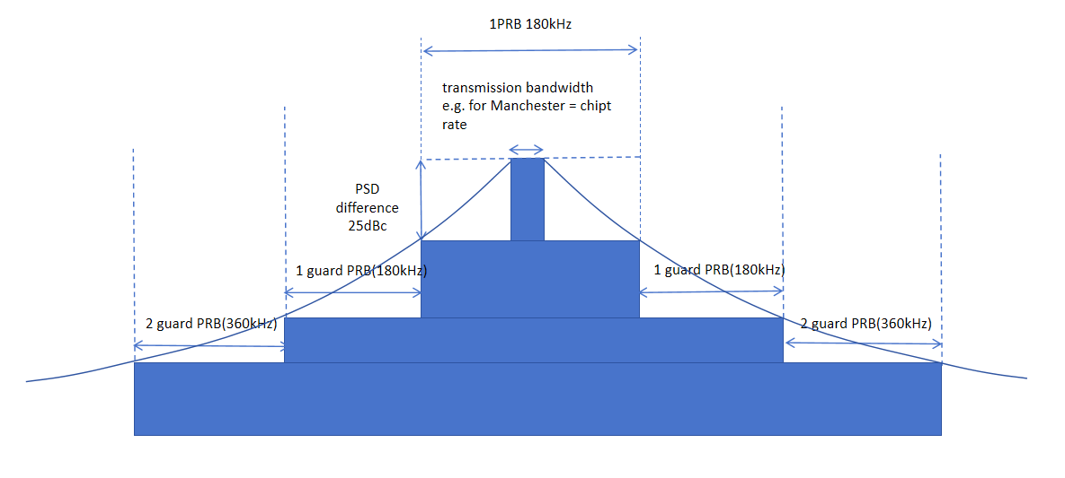
Issue 4-1-3: Rx for device 1 and 2a
Proposal (CMCC, Ericsson): For device 1 and 2a, RF-ED based device can’t have any in-band selectivity.
Recommended WF:
Assume no frequency selectivity for co-existence evaluation for calibration purposes for device 1 and 2a.

Topic 4-2: General paramters and layout
Issue 4-2-1: General parameters
Recommended WF:
Use following parameters as starting point. The “Note” column captures agreements from RAN1 for information.
General Parameter | D1T1&D2T2 | Note (RAN1 agreements refer to R1-2403782, R1-2403815)
Carrier frequency | 900MHz as baseline | 900MHz (M), 2GHz (O)
Channel BW for NR | 10MHz with 15KHz SCS
Channel BW for AIOT | DL: 180kHz with 15KHz SCS  UL: 15KHz or 180KHz | DL: 180k(M), 360k(O), 1.08MHz(O)  UL: FFS  15 kHz as baseline
Waveform (CW) | CW: Unmodulated single tone | Companies to report waveform, e.g., unmodulated single tone, multi-tone(multiple unmodulated single tone)
Waveform (R2D) | OOK waveform generated by OFDM modulator | OOK waveform generated by OFDM modulator
A-IoT DL power control | No
A-IoT UL power control | No
Traffic model | Full buffer
Frequency reuse | 1

Moderator note: Definition of channel bandwidth, transmission bandwidth and occupied bandwidth will be discussed in summary#135.

Issue 4-2-2: Layout for D1T1
Agreement in RAN1#116bis (R1-2403782) are highlighted in green. Discuss the remaining parts in RAN4#111 meeting.
Parameter | Assumptions for D1T1
Scenario | InF-DH
Hall size | 120x60 m
Room height | 10 m
Sectorization | None
Pathloss model | InF-DH NLOS model defined in TR38.901 is used for D2R and R2D links as pathloss model  Option 1: NLOS and LOS  Option 2 (Huawei):  - D2R/R2D: InF-DH NLOS model defined in TR38.901；  - CW to device: InF-DH LOS
BS deployment / Intermediate UE dropping | For D1T1-A2: 18 BSs on a square lattice with spacing D, located D/2 from the walls.  - L=120m x W=60m; D=20m  - BS height = 8 m  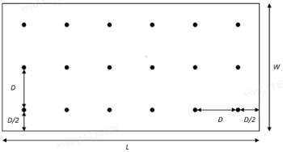  For D1T1-A1:  - FFS on layout: one node as transmission and CW, the neighbour node as reception
Device distribution | Device Height= 1.5 m  AIoT devices drop uniformly distributed over the horizontal area  Number of A-IoTs = Total area × activated density (1.5 A-IOT devices/m²)  1 active AIOT device under one reader at one drop  Minimum distance between device and reader along the ground equal to [2m] for calibration
Device mobility (horizontal plane only) | 3 kph
NR BS deployment | Hexagonal grid, 19 macro sites, 3 sectors per site with wrap around, 1 AIOT indoor scenario per sector  Option 1(Qualcomm): The distance between the center of factory and the center macro BS needed to be randomly setting for each snapshot and the distance is distributed uniformly within [factory length/2, macro BS ISD/2], i.e. minimum distance is 60m.  Option 2 (Spreadtrum): the minimum 2D distance between macro BS and indoor factory centre is set as 100m.  Option 3 (CMCC): The minimum distance between macro NR BS and indoor reader is 50m, i.e. distance between macro BS and indoor factory center is 110m  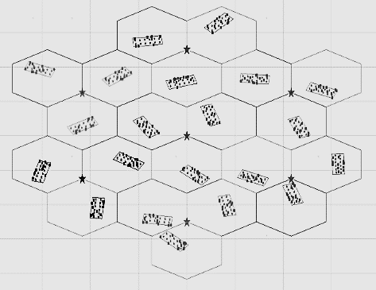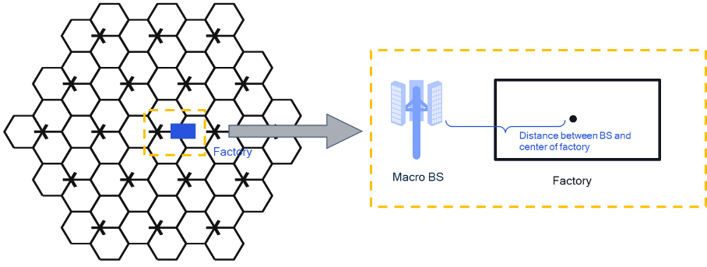
NR BS Inter-site distance | Option 1 (CMCC): 500  Option 2 (CATT): 750  Option 3 (spreadtrum): 200m (baseline), 300m (optional)
Minimum NR BS – NR UE distance (2D) | 35 m
NR UE (D1T1) dropping | For scenario option 1-1, uniformly distributed outdoor.  For scenario option 1-2, uniformly distributed, 80% indoor, 20% outdoor  UE number:  - Option 1: DL 1 UE per cell , UL 3UE per cell  - Option 2 (vivo): the UE number is same as the number of BS beam.
O2I penetration loss | Option 1 (CMCC): High penetration loss as in TR 38.901 for calibration  Option 2 (CATT): 50% low loss, 50% high loss

Recommended WF:
Discuss following parameters and strive to agree on some candidate values for evaluation in this meeting.

Issue 4-2-3: Layout for D2T2
Recommended WF:
Use InH-office as baseline for D2T2 co-existence evaluation.
Agreement in RAN1#116bis (R1-2403782) are highlighted in green. Discuss the remaining parts in RAN4#111 meeting.
Parameter | Assumptions for D2T2
Scenario | InH-office | InF-DL
Hall size | 120 x50 m | 300x150 m
Room height | 3m | 10 m
Sectorization | None
Pathloss model | - InF-DL and InH-Office model defined in TR38.901is used as pathloss model,  - NLOS for D2R and R2D links if InF-DL is used  - LOS for D2R and R2D links if InH-Office is used  LOS and NLOS
BS deployment / Intermediate UE dropping | - L=120m x W=50m;  - Intermediate UE height = 1.5 m  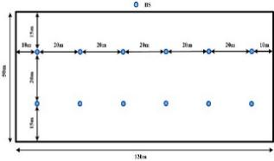  For D2T2-A2:  The intermediate UEs uniformly distributed over the horizon area  Number of intermediate UE: 2 UE at one drop for calibration  For D2T2-A1: FFS on layout  Proposal 1(vivo):  - The intermediate UEs uniformly distributed over the horizon area  - FFS on the total number of intermediate UE  Proposal 3 (xiaomi): RAN4 can first fix the intermediate UE at some points in the co-existence simulation, i.e., the center of the hall or the center of each side, as shown in Figure 2-1. | - L=300m x W=150m;  - Intermediate UE height = 1.5 m  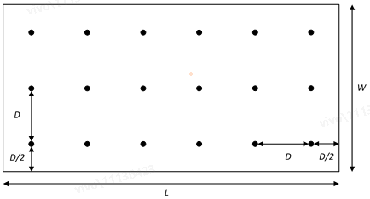  Proposal 2(vivo):  - The intermediate UEs uniformly distributed over the horizon area  - FFS on the total number of intermediate UE  Proposal 2 (CATT): fixed 18 intermediate UEs on a square lattice with spacing D, located D/2 from the walls  Proposal 3 (xiaomi): RAN4 can first fix the intermediate UE at some points in the co-existence simulation, i.e., the center of the hall or the center of each side, as shown in Figure 2-1.
Device distribution | Device Height= 1.5 m  AIoT devices drop uniformly distributed over the horizontal area  Number of A-IoTs = Total area × activated density (1.5 A-IOT devices/m²)  1 active AIOT device under one reader at one drop  Minimum distance between reader and device is 1m
Device mobility (horizontal plane only) | 3 kph | 3 kph
NR BS deployment | Hexagonal grid, 7 or 19 macro sites, 3 sectors per site with wrap around, 1 AIOT indoor scenario per sector  Option 1(Qualcomm): The distance between the center of factory and the center macro BS needed to be randomly setting for each snapshot and the distance is distributed uniformly within [factory length/2, macro BS ISD/2], i.e. minimum distance is 60m.  Option 2 (Spreadtrum): the minimum 2D distance between macro BS and indoor factory centre is set as 100m.  Option 3 (CMCC): The minimum distance between macro NR BS and indoor reader is 50m, i.e. distance between macro BS and indoor factory center is 110m
NR UE dropping | For scenario option 1-1, uniformly distributed outdoor.  For scenario option 1-2, uniformly distributed, 80% indoor, 20% outdoor  UE number:  - Option 1: DL 1 UE per cell, UL 3 UE per cell  - Option 2 (vivo): the UE number is same as the number of BS beam.
O2I penetration loss | Option 1 (CMCC): High penetration loss as in TR 38.901  Option 2 (CATT): 50% low loss, 50% high loss

Topic 4-3: Paramters for AIOT BS/intermedaite UE and device
Issue 4-3-1: AIOT micro-BS parameters for D1T1
Recommended WF:
Use following parameters as starting point. The “Note” column captures agreements from RAN1 for information.
A-IoT micro BS parameters | Recommended value | Note (RAN1 agreements refer to R1-2403782, R1-2403815)
A-IoT micro-BS total Tx power | 33dBm as baseline | - For BS in DL spectrum for indoor  - 33dBm(M), FFS: 38dBm(O), one smaller value [FFS: 23 or 26] dBm(M)  - FFS: additional constraints on PSD  - FFS: For UE in DL spectrum for indoor  - For UL spectrum for indoor,  - 23dBm (M)  - FFS: 26dBm(O)
A-IoT micro-BS receiver Noise Figure（dB） | 5 | For BS as reader  - 5dB  For UE as reader  - 7dB
A-IoT micro-BS antenna gain including feeder loss (dBi) | 6 dBi(M) as baseline | - For BS for indoor, 6 dBi(M), 2dBi(M)  - For intermediate UE, 0 dBi
Antenna configuration | 2 antenna elements as baseline, with (M,N,P,Mg,Ng) = (1,1,2,1,1) | For BS:  - 2(M) or 4(O) antenna elements for 0.9 GHz  For Intermediate UE:  - 1(M) or 2(O)

Issue 4-3-2: Intermediate UE parameters for D2T2
Recommended WF:
Discuss following parameters and strive to agree on some candidate values for evaluation in this meeting.
intermediate UE parameters | Recommended value | Note (RAN1 agreements refer to R1-2403782, R1-2403815)
intermediate UE total Tx power（dBm） | 23dBm as baseline | - For UL spectrum for indoor,  - 23dBm (M)  - FFS: 26dBm(O)
gain of antenna intermediate UE including feeder loss (dBi) | 0 | - For intermediate UE, 0 dBi
intermediate UE receiver Noise Figure（dB） | 7 | For UE as reader  7dB
Antenna configuration | 1 as baseline  Omni direction antenna | For Intermediate UE:  - 1(M) or 2(O)

Issue 4-3-3: CW parameters
Recommended WF:
Discuss following parameters and strive to agree on some candidate values for evaluation in this meeting.
intermediate UE parameters | D1T1 | D2T2 | Note (RAN1 agreements refer to R1-2403782, R1-2403815)
Tx power（dBm） | If UL spectrum is used, UE Tx power is assumed, i.e. 23dBm as baseline  If DL spectrum is used, AIOT micro-BS Tx power is assumed, i.e. 33dBm as baseline | Inter-mediate UE Tx power is assumed, i.e. 23dBm as baseline. | - 23dBm for UL spectrum, FFS 26dBm  - 33dBm(M), 38dBm (O) for DL spectrum  Note: only applicable for device 1/2a
Antenna gain | the value equals to UE Tx ant gain,  or BS Tx ant gain | Same as inter-mediate UE | - Company to report, the value equals to  - UE Tx ant gain, or  - BS Tx ant gain  Note: only applicable for device 1/2a
Other parameters | Same as AIOT micro-BS | Same as inter-mediate UE
CW cancellation (dB) | FFS | FFS | For [monostatic backscatter], FFS  - [140dB for BS]  - [120dB for UE]  For [bistatic backscatter]  Assuming CW has no impact to the receiver sensitivity loss.

Issue 4-3-4: AIOT device parameters
Recommended WF:
Discuss following parameters and strive to agree on some candidate values for evaluation in this meeting.
A-IoT device parameters | Device 1 | Device 2a | Device 2b | Note (RAN1 agreements refer to R1-2403782, R1-2403815)
A-IoT device Tx power (dBm) | <-10 | <-10 | [-10/-20]
A-IoT device effective antenna gain per Tx or Rx branch (dBi) | [0 as baseline] | [0 as baseline] | [0 as baseline] | For A-IoT device, 0dBi (M), -3dBi (O)
A-IoT device reflection （backscatter）loss (dB)  Note: due to, e.g., impedance mismatch | [OOK: -6 dB]  [PSK: 0 dB] | FFS | N/A | - OOK: Y dB  - PSK: X dB  Note: Only for device 1  FFS: for device 2a
A-IoT device power gain of reflection amplifier (dB) | N/A | 10 as baseline | N/A | - 10 dB (M)  - 15 dB (O)  Note: Only for device 2a
A-IoT Device receiver sensitivity (dBm) | [-36] | [-46] | [FFS] | For Budget-Alt1,  - For device 1 (RF-ED),  - FFS:{-30dBm ~ -36dBm}  - For device 2 if RF-ED is used  - FFS  - For device 2 if RF-ED is not used  - N/A
A-IoT device noise figure (dB) | [24] | [15] | [9] | FFS: 20dB or 24dB or 30dB for Budget-Alt2  FFS: different values for device architecture
Guard band | 1PRB, 2PRB, | 1PRB, 2PRB | 1PRB, 2PRB

Topic 4-4: Paramters for legacy NR
Issue 4-4-1: NR macro BS parameters
Recommended WF:
Discuss following parameters and strive to agree on some candidate values for evaluation in this meeting.
NR macro-BS Parameter | Recommended value
Macro-BS Tx power (dBm) | 46
BS antenna gain (dBi) | 15 (CATT)  8 (spreadtrum)
Height of macro NR BS (m) | 25
NR Macro-BS Noise Figure(dB) | 5
Network location | outdoor
Antenna configuration | (M,N,P,Mg,Ng) = (4,1,2,1,1) detailed other parameter refer to 38.803

Issue 4-4-2: NR UE parameters
Recommended WF:
Discuss following parameters and strive to agree on some candidate values for evaluation in this meeting.
NR UE Parameter | Recommended value | note
UE TX power in dBm | -40 to 23
NR UE Antenna gain (dBi) | 0
Height of UE antenna (m) | 1.5
NR UE noise floor (dBm) | -112.4 @ 180kHz | noise floor=-174+10*log (180*1000)+9
NR UE ACLR（dB） | 30 | For power class 3 NR UE
NR UE Maximum input level（dBm） | -25 | TS38101-1 7.4 Maximum input level
NR UE Noise Figure（dB） | 7 or 9
Antenna configuration | Omni direction antenna

