3GPP TSG-RAN WG4 Meeting #110bis R4-2408945
Changsha, China, 15th – 19th April, 2024

Agenda item: 10.13.4
Source: Moderator (CMCC)
Title: Topic summary for [111][134] FS_Ambient_IoT_solutions_part1
Document for: Information

Introduction
This summary focuses on the R19 ambient IOT study item under agenda 10.13, 10.13.1 and 10.13.2. The summary in RAN4#110bis is in R4-2405289. The way forward agreed in RAN4#110bis is in R4-2406714.
TDoc | Title | Source
R4-2409095 | A-IoT general overview | Ericsson
R4-2407299 | On coexistence between ambient IoT and NR/LTE | Apple
R4-2407410 | AIoT deployment scenario and impact on co-existence analysis | Sony
R4-2407525 | Discussion on deployment scenarios and spectrum usage for A-IoT | CATT
R4-2407715 | Discussion on deployment scenarios and spectrum usage for ambient IoT | Spreadtrum Communications
R4-2407918 | Discussion on A-IoT deployment scenarios and spectrum usage | Huawei, HiSilicon
R4-2408091 | Discussion on the deployment scenarios and spectrum usage for AIoT | vivo
R4-2408219 | Discussion on A-IoT deployment scenario and spectrum usage | CMCC
R4-2408820 | on deployment scenarios and spectrum usage for A-IoT | OPPO
R4-2409094 | A-IoT deployment scenario and spectrum usage | Ericsson
R4-2409426 | Discussion on deployment and spectrum usage | Qualcomm Incorporated
R4-2409573 | Discussion on spectrum usage for Ambient-IoT | LG Electronics UK
R4-2409596 | Discussion on deployment scenarios and spectrum usage | ZTE Corporation, Sanechips
R4-2407478 | Discussion on co-existence evaluation for ambient-IoT | CATT
R4-2407716 | Discussion on co-existence evaluation for ambient IoT and NR-LTE | Spreadtrum Communications
R4-2407821 | Discussion on the coexistence study of Ambient IoT and NR | Xiaomi
R4-2407919 | A-IoT co-existence evaluations | Huawei, HiSilicon
R4-2408092 | Preliminary co-existence evaluation for AIoT | vivo
R4-2408218 | Discussion on A-IoT co-existence evaluation | CMCC
R4-2408236 | Consideration on co-existence evaluations | China Telecom
R4-2408819 | on co-existence evaluations for A-IoT | OPPO
R4-2409098 | Coexisting study simulation assumptions | Ericsson
R4-2409427 | Discussion on Ambient IoT co-existence evaluation | Qualcomm Incorporated
R4-2409595 | Discussion on Co-existence evaluations | ZTE Corporation, Sanechips

TR skeleton
TDoc | Title | Source
R4-2407917 | TP to TR38.769 skeleton for RF part | Huawei, HiSilicon

Issue 1-1: TR skeleton
Recommended WF: discuss the TR skeleton in R4-2407917

Deployment scenarios and spectrum usage

Topic 2-1: Deployment scenario
Issue 2-1-1: deployment scenarios for D1T1
Agreement in RAN4#110bis:
Issue 2-1-1: deployment scenarios for D1T1
Option 1-1: Legacy NR gNB are outdoor macro gNB while AIoT reader/CW/devices are all indoors. Legacy NR UE is only allowed outdoors.
Option 1-2: Legacy NR gNB are outdoor macro gNB while AIoT reader/CW/devices are all indoors. Legacy NR UE is indoor accessing to outdoor NR marco gNB
Option 2-1: Legacy NR gNB are co-located with AIoT reader and CW. All of NR and AIoT BS/UE/Reader/Device/CW are indoors. AIoT reader /CW and Legacy gNB share same hardware
Option 2-2: Legacy NR gNB are co-located with AIoT reader and CW. All of NR and AIoT BS/UE/Reader/Device/CW are indoors. AIoT reader /CW and Legacy NR gNB do not share same hardware. (less limitation on the power boosting)
Agreement:
- RAN4 to first evaluate co-existence for deployment scenario of option 1-1 and 1-2, and further study option 2-1 and 2-2.
Issue 2-3-2: Priorities of spectrum deployment mode for co-existence evaluation
Agreement:
- Prioritize the following spectrum deployment mode for RAN4 co-existence evaluation
  - A-IoT is located within a NR transmission bandwidth configuration
  - A-IoT which is operating indoor shares in-band spectrum with outdoor macro BS

Proposal in RAN4#111:
Regarding option 1-1 and 1-2:
Proposal 1 (ZTE):
- for D1T1 deployment scenario, Option 1-2 should be taken into account as baseline even under the assumptions of without 900MHz indoor BS deployed.
Proposal 2 (Qualcomm): For option 1-1 in D1T1, prioritize the case that the outdoor legacy UE and indoor A-IoT devices are co-channel. For option 1-2 in D1T1, RAN4 consider two cases:
- • Case 1: The indoor legacy UE and indoor A-IoT devices are in adjacent channel.
- • Case 2: The indoor legacy UE and indoor A-IoT devices are in co-channel. FFS the co-channel coexistence conditions, such as guard band, minimum distance, etc.
Regarding option 2-1 and 2-2, several companies propose to continue study
Proposal 1 (Sony): Include the scenario in which legacy gNB, AIoT reader, and CW emitter are indoors in the co-existence study. The legacy gNB and AIoT reader are co-located, and the CW emitter may or may not be co-located with the legacy gNB and AIoT reader.
Proposal 2 (Ericsson):
- Keep the original deployment mode scope in SID and study further the coexisting of A-IoT and legacy NR/LTE.
- Co-located legacy BS and A-IoT BS should be studied for device 2b if device 2b architecture would exclude the RF ED architecture.
Proposal 3 (CATT): If “co-site” scenario needs further study including co-existence and guard RB should be decided.
Proposal 4 (Speadtrum): Option 2-1 needs to be prioritized for evaluation if the spectrum with indoor deployment.
Proposal 5 (ZTE):
- for D1T1 deployment scenario, Option 2-1 and 2-2 should be also considered according to the WID description.
- for D1T1 deployment scenario, Option 2-2 could be treated as worse case compared with option 2-1.
Recommended WF:
In last meeting, it was agreed to first evaluate deployment scenario of option 1-1 and 1-2, and further study option 2-1 and 2-2. According to last meeting agreement, there are two main reasons: firstly there are no existing NR gNB deployed indoor for spectrum below 1GHz according to operators’ input, secondly the feasibility of co-located NR gNB and AIOT reader (including power boosting and guard RBs) needs further study before conducting co-existence evaluation.
Hence, from moderator perspective, the agreement in last meeting is aligned with study item scope, it is recommended to keep the last meeting agreements for co-existence evaluation.
Regarding scenario option 1-1 and 1-2, discuss the following for co-existence evaluation:
- Whether to use option 1-2 as baseline
- Whether to consider co-channel co-existence evaluation for NR and AIOT

Issue 2-1-2: deployment scenarios for D2T2
Agreement in RAN4#110bis:
Option 1-1: Legacy NR gNB are outdoor macro gNB, AIoT intermediate UE/CW/devices are all indoors. Legacy NR UE is only allowed outdoor.
Option 1-2: Legacy NR gNB are outdoor macro gNB, AIoT intermediate UE/CW/devices are all indoors. Legacy NR UE is indoor.
Agreement:
- For D2T2 co-existence evaluation, Legacy NR gNB are outdoor macro gNB, AIoT intermediate UE/CW/devices are all indoors.
  - Consider option 1-1 and option 1-2 as the starting point

Proposal in RAN4#111:
Proposal (ZTE): for D2T2 deployment scenario, Option 1-2 should be taken into account as baseline even under the assumptions of without 900MHz indoor BS deployed.
Recommended WF:
Discuss whether to use scenario option 1-2 as baseline for co-existence evaluation.

Topic 2-2: Spectrum usage
Issue 2-2-1: Spectrum usage for R2D in D1T1
Agreement in RAN4#110bis:
- FFS on whether to prioritize FDD DL spectrum for R2D for D1T1 for co-existence evaluation.

Proposal in RAN4#111:
Option 1 (CATT): FDD UL
Option 2 (CMCC, Spreadtrum, Huawei, vivo, Ericsson, Qualcomm): FDD DL
Option 3 (LGE): For R2D for D1T1, study DL spectrum for R2D by system level simulation in 1st phase and study UL spectrum in 2nd phase.
Option 4 (Sony): The FDD UL spectrum for the R2D link should not be precluded in the D1T1 for co-existence evaluation.
Recommended WF:
It is recommended that:
- Use FDD DL as starting point for co-existence evaluation.

Issue 2-2-2: Spectrum usage for CW transmission in D1T1 for the case that D2R backscattering is transmitted in the same carrier as CW for D2R backscattering
Agreement in RAN4#110bis:
For the case that D2R backscattering is transmitted in the same carrier as CW for D2R backscattering, and for topology 1, the following cases for CW transmission are studied.
· Case 1-1: CW is transmitted from inside the topology, transmitted in DL spectrum
· Case 1-2: CW is transmitted from inside the topology, transmitted in UL spectrum
· Case 1-4: CW is transmitted from outside the topology, transmitted in UL spectrum

Agreement:
- For the case that D2R backscattering is transmitted in the same carrier as CW for D2R backscattering, consider the following for co-existence evaluation
  - CW transmits in either UL or DL spectrum
  - FFS on inside topology and outside topology.

Proposal in RAN4#111:
- Option 1 (Spreadtrum. Huawei): case 1-1 and case 1-4
- Option 2 (Ericsson): UL spectrum (case 1-2 or 1-4)
- Option 3 (CMCC): case1-1 and 1-2.
Recommended WF:
Regarding the spectrum usage for CW transmission, it was agreed in last meeting that CW transmits in either UL or DL spectrum. The left issue is on the side topology and outside topology.
It is recommended to keep the last meeting agreement and further discuss inside and outside topology in Issue 2-2-3.

Issue 2-2-3: Inside and outside topology for D1T1
Proposal 1 (Huawei):
- Assuming that the A-IoT Reader and CW node are co-located, D1T1-B is equivalent to D1T1-A2 in terms of layout.
- Assume AIoT BS and CW node if any are co-located in D1T1.
- If AIoT BS and CW node are co-located, then D1T1-B is equivalent to D1T1-A2 in terms of layout.
Proposal 2 (CMCC):
- Regarding for the self-interference, usually inside topology will have higher residual self-interference level due to less spatial isolation. So compared with outside topology, inside topology is the worst case and RAN4 can only focus on inside topology.
- it’s suggested to only focus on inside topology case since this is the worst case compared with outside topology case.
Proposal 3 (Ericsson): Model the CWT node layer with a grid shift to the network layer.
Proposal 4 (vivo):
- From co-existence perspective, whether CW inside or outside topology is not a critical issue, and the key issue which will impact the results of co-existence evaluation is the distribution of CW node.
- Take the CW distribution same as CW inside the topology for co-existence evaluation.
Proposal 5 (LGE): For CW transmission, consider both CW topologies, inside and outside for co-existence study.
Recommended WF:
There are different views on the CW distribution for the case of outside topology. In last meeting RAN1 agreements, it is also FFS for CW distribution.
Consider this situation, it is recommended that:
- Use inside topology as starting point for co-existence evaluation (case 1-1 and case 1-2).
- Further discuss the difference of outside topology from co-existence study perspective.

Issue 2-2-4: Spectrum usage for R2D in D2T2
Agreement in RAN4#110bis:
- Use FDD UL spectrum for R2D in D2T2.

Recommended WF:
Keep the last meeting agreement

Issue 2-2-5: Spectrum usage for CW transmission in D2T2 for the case that D2R backscattering is transmitted in the same carrier as CW for D2R backscattering
Agreement in RAN4#110bis:
For the case that D2R backscattering is transmitted in the same carrier as CW for D2R backscattering, and for topology 2, the following cases for CW transmission are studied.
· Case 2-2: CW is transmitted from inside the topology (i.e., intermediate UE), transmitted in UL spectrum
· Case 2-3: CW is transmitted from outside the topology, transmitted in DL spectrum
· Case 2-4: CW is transmitted from outside the topology, transmitted in UL spectrum
Agreement:
- For the case that D2R backscattering is transmitted in the same carrier as CW for D2R backscattering
  - Use UL spectrum as the starting point for co-existence evaluation.
    - It won’t preclude the use of DL for backscattering transmission.
    - FFS on the minimum distance between the intermediate UE and A-IoT device

Proposal in RAN4#111:
- Option 1 (Spreadtrum): case 2-2 and case 2-3
- Option 2 (Huawei, Ericsson): case 2-2 and 2-4
- Option 3 (Apple): Consider D2T2-A1 only to avoid the requirement of full-duplex capable intermediate UEs if CW is transmitted on UL spectrum. i.e. case 2-2
- Option 4 (OPPO): case 2-2 and case 2-3
Recommended WF:
In last meeting, it was agreed to use UL spectrum as the starting point for co-existence evaluation, i.e. case 2-2 and case 2-4. Consider the CW distribution for outside topology needs more discussion (Issue 2-2-3), it is recommended that:
- Use case 2-2 as starting point for co-existence evaluation.
- Further discuss the difference of outside topology (case2-4) from co-existence study perspective.

Issue 2-2-6: Minimum distance between intermediate UE and device
Option 1 (CMCC): Consider 2m minimum distance between the intermediate UE and device in simulation and further check the feasibility during RF requirement discussion.
- Refer to pico cell (2m) minimum distance
Option 2 (vivo, Ericsson): Take 1m as the starting point for minimum distance between intermediate UE and AIoT in the co-existence evaluation
- Refer to the traditional assumption for InF, the minimum distance between UTs is 1m.
Recommended WF:
Use 1m as starting point for minimum distance between intermediate UE and device.

Evaluation methodology and cases

Topic 3-1: Evaluation methodology
Issue 2-4-1: Evaluation methodology
Agreement in RAN4#110bis:
- Use the Monte-Carlo method as baseline for co-existence evaluation, i.e. Section 5.3 in TR38.803
- Depending on the discussion on deployment scenarios, for some cases, calculation for the worst interference link may be enough.
- FFS on whether RAN4 needs to perform link level simulation

Proposal in RAN4#111:
Proposal 1 (Huawei):
- Deterministic calculations can be used to evaluate the worst-case scenario for the following: interference between indoor NR UE and A-IoT devices, as well as interference between A-IoT devices and outdoor NR macro-BS.
- Path ② is between an indoor NR UE and an A-IoT device, while path ③ is between an A-IoT device and an outdoor NR macro-BS. These paths can be evaluated by deterministic calculations.
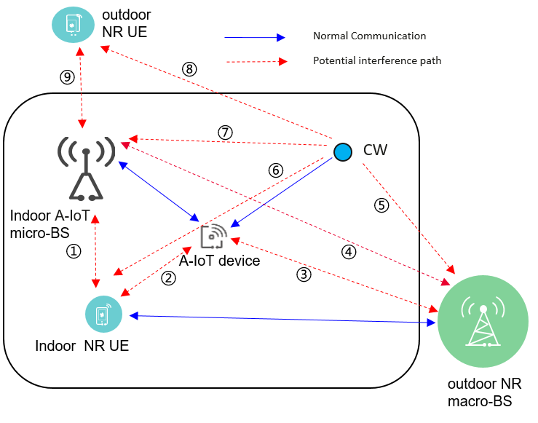
Proposal 2 (CMCC):
- it’s suggested to use monte-carlo simulation method rather than calculation for all co-existence evaluation.
- Considering final relationship between SINR and BLER will impact final co-existence results. it’s suggested to align LLS simulation parameters in RAN4 and show the high priority sets of parameters to reduce the workload of LLS and try best to converge final relationship between SNR and BLER.
- there is no need to use monte-carlo simulation method to evaluate the interference when device as victim. Instead we can use LLS to simulate under which power difference between reader and interference signal, the device could successfully receive R2D signal.
Proposal 3 (CATT):
- Link level simulation is needed to determine guard RB size to cancel ICI between A-IoT carriers and NR carriers in same cell for A-IoT in-band or guard band operation in NR spectrum and ensure A-IoT performance.

Recommended WF:
Discuss whether the following interference cases can be evaluated by deterministic calculation:
- interference between indoor NR UE and A-IoT devices
- interference between A-IoT devices and outdoor NR macro-BS
Regarding link level simulation, FFS on the following aspects:
- LLS to simulate under which power difference between reader and interference signal, the device could successfully receive R2D signal.
- Link level simulation is needed to determine guard RB size to cancel ICI between A-IoT carriers and NR carriers in same cell for A-IoT in-band or guard band operation in NR spectrum and ensure A-IoT performance.

Issue 2-4-2: Performance metric for AIOT
Agreement in RAN4#110bis:
- For NR system, use 5% throughput loss as performance metric as legacy.
- For AIOT system, including reader, device, intermediate UE, further discuss the performance metric:
  - Option 1: [10%] BLER, [Rx power]
  - Option 2: SINR degradation
  - Other options are precluded

Proposal in RAN4#111:
- Proposal 1 (Huawei): SINR degradation can serve as metric. It is recommended [1dB] SINR degradation for A-IoT BS and [3dB] SINR degradation for A-IoT intermediate UE.
- Proposal 2 (Apple): SINR degradation is preferred with less dependency on RAN1 design. FFS how much degradation is considered acceptable.
- Proposal 3 (CATT): Use 1dB SINR degradation for 5% and 50% CDF SINR point as performance metric for A-IoT co-existence evaluation for DL and UL.
- Proposal 4 (Qualcomm):
  - RAN4 to use the same performance metric (CINR/CNR degradation) as RAN1 for R2D link in coexistence study. CINR/CNR, where CINR/CNR is defined as the ratio of signal power spectral density in the signal transmission bandwidth to the noise and interference (if any) power spectral density in the device envelop detector channel bandwidth.
  - RAN4 to use SINR degradation as the performance for D2R link in coexistence study.
- Proposal 5 (Sony): RAN4 needs further discuss if the same performance metric and if the same threshold value for successful decoding should be used for the R2D link and D2R link.
- Proposal 6 (Spreadtrum): 10% BLER for AIOT system
- Proposal 7 (CMCC):
  - it’s suggested to use 10% BLER as performance metric for all kinds of devices, reader of topology 1 and 2. Outage probability: 5% worst victim is suggested as the candidate value.
  - align the definition of SNR from co-existence simulation output and the definition of SNR from SNR-BLER relationship, i.e. align the definition of the bandwidth of wanted bandwidth and the bandwidth of noise+interference bandwidth when calculate SINR.
  - sensitivity of device should be taken into consideration and only the devices that meet sensitivity threshold should be included into final BLER statistics.
- Proposal 8 (OPPO, R4-2408817): Use 1% misdetection rate as performance metric for evaluation
- Proposal 9 (vivo, R4-2408093): It is suggested that success rate is used as performance metric for Rx requirement definition, e.g., 10% BLER, 90% success rate, etc.
Recommended WF:
Companies have different views on the performance metric for AIOT. 4 companies support to use SINR degradation, 4 companies support to consider BLER/misdetection rate/success rate.
It is recommended that:
- Use SINR for calibration purpose
- FFS on performance metric for co-existence evaluaion and requirements definition.

Issue 2-4-2: SINR definition for D2R
Proposal (Huawei): Considering that the CW node is a component of the A-IoT system, and as such, the SINR before any degradation (which includes CW interference) is used as the baseline reference. The SINR includes CW interference is used as the baseline reference before any degradation.
Recommended WF:
Discuss the above proposal.

Issue 2-4-2: SINR definition for R2D
RAN1 agreement (R4-2403815):
Proposal#5 (V05r1)
For the R2D LLS for ED, report followings (as start point).
- CINR/CNR, where CINR/CNR is defined as the ratio of signal power spectral density in the transmission bandwidth to the noise and interference (if any) power spectral density in the device ED channel bandwidth.
- signal transmission bandwidth
- ED channel bandwidth
FFS: exact definition of ED channel bandwidth for RF-ED, IF receiver
FFS: which and how to report for R2D ZIF receiver and D2R

Recommended WF:
Use RAN1 definition of CINR/CNR for R2D link evaluation.

Topic 3-2: Evaluation cases
Issue 3-2-1: device type
Agreement in RAN4#110bis:
- Prioritize device 1 and 2a without a frequency shifter for coexistence evaluation.

Proposal in RAN4#111:
Proposal 1 (OPPO): If the device 2a co-existence study is concluded as feasible, the same conclusion can be applied to device 2b for scenario C.
Proposal 2 (Spreadtrum): For co-existence evaluation, device 1 and 2a with small or large frequency shift capability are deprioritized.
Proposal 3 (Sony): The amplification of the R2D and D2R link in device 2a needs to be taken into account in order to perform the co-existence simulation. The gain of the amplification can be further discussed.
Recommended WF:
Keep the previous agreement. FFS on device 2b. FFS on the amplification on device 2a.

Issue 3-2-2: Evaluation cases when CW is aggressor
Proposal 1 (CMCC): During co-existence simulation, there is no need to consider CW unwanted interference due to its almost perfect unwanted emission performance outside the transmission bandwidth, i.e. don’t need to consider the interference when CW as aggressor.
Proposal 2 (Qualcomm): since CW signal is only occupied single tone or several tones, the impact would be marginal if NR UE and A-IoT are in adjacent channel considering the NR UE RF filter could remove the CW interference.
Proposal 3 (Ericsson): Use the IBE mask of UE specification as starting point for CW IBE mask.
Recommended WF:
2 companies propose that the impact of CW signal in adjacent channel can be ignored from co-existence evaluation perspective consider that CW is single tone or multiple tones. In this case, it seems no need to simulate the cases when CW is aggressor.
1 company propose to use IBE mask of UE spec as starting point for CW.
More discussion is needed.

Issue 3-2-3: Evaluation cases for -A1 and -A2
In last RAN1 meeting, the following CW cancellation was discussed but no agreements are reached.
- For [monostatic backscatter], FFS
  - [140dB for BS]
  - [120dB for UE]
- For [bistatic backscatter]
  - Assuming CW has no impact to the receiver sensitivity loss.

Proposal in RAN4#111:
Proposal 1 (CMCC): following CW interference cancellation evaluation methodology is suggested. Besides, RAN4 needs to further discuss whether it is still necessary to evaluate -A2 evaluation case if CW interference cancellation capability is already much high, i.e. remaining CW interference is much lower than noise floor.
- Methodology: residual self-interference= Tx power - self-interference cancellation capability
- self-interference cancellation capability = spatial isolation + RF cancellation + digital cancellation if applicable
Proposal 2 (Apple): Consider D2T2-A1 only to avoid the requirement of full-duplex capable intermediate UEs if CW is transmitted on UL spectrum
Proposal 3 (vivo): For the D2R, only the interference of IM3, which produced by D2R and CW, is considered as the impact of CW in the co-existence evaluation, and the impact of CW itself can be ignored.
Recommended WF:
The main difference between -A1 and -A2 is that -A2 needs to consider the capability of CW cancellation.
Since companies have different views on the capability of CW cancellation, and RAN1 also had no agreement on that part. It is recommended that:
- Use D1T1-A1 and D2T2-A1 as starting point for co-existence evaluation.
- Further discuss the CW cancellation capability for D1T1-A2 and D2T2-A2 consider following methodology
- Methodology: residual self-interference= Tx power - self-interference cancellation capability
- self-interference cancellation capability = spatial isolation + RF cancellation + digital cancellation if applicable

Issue 3-2-4: Evaluation cases for D1T1 for device 1 and 2a between NR and AIOT
Recommended WF:
Depending on the discussion on above open issues, strive to pick some cases as starting point for co-existence evaluation.
Deployment scenario and topology | spectrum | aggressor | victim
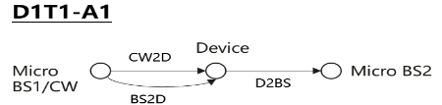  · Case 1-1: CW is transmitted from inside the topology, transmitted in DL spectrum  · Case 1-2: CW is transmitted from inside the topology, transmitted in UL spectrum | R2D: DL  CW2D and D2R: UL | CW and/or device | NR UL
 |  | NR UL | device and/or reader
 |  | reader | NR DL
 |  | NR DL | device
 | R2D: DL  CW2D and D2R: DL | CW and/or device | NR DL
 |  | NR DL | device and/or reader
 | R2D: UL  CW2D and D2R: UL | Reader | NR UL
 |  | NR UL | reader
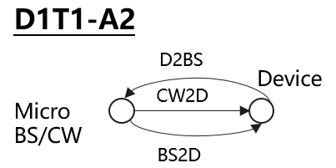  Self interference cancelation is needed for reader  · Case 1-1: CW is transmitted from inside the topology, transmitted in DL spectrum  · Case 1-2: CW is transmitted from inside the topology, transmitted in UL spectrum | R2D: DL  CW2D and D2R: UL | CW and/or device | NR UL
 |  | NR UL | device and/or reader
 |  | reader | NR DL
 |  | NR DL | device
 | R2D: DL  CW2D and D2R: DL | CW and/or device | NR DL
 |  | NR DL | device and/or reader
 | R2D: UL  CW2D and D2R: UL | reader | NR UL
 |  | NR UL | reader
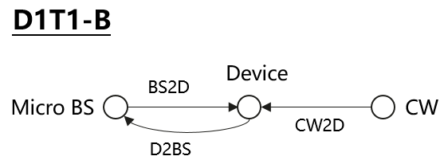  Self interference cancellation is needed for reader  · Case 1-4: CW is transmitted from outside the topology, transmitted in UL spectrum | R2D: DL  CW2D and D2R: UL | CW and/or device | NR UL
 |  | NR UL | device and/or reader
 |  | reader | NR DL
 |  | NR DL | device
 | R2D: UL  CW2D and D2R: UL | reader | NR UL
 |  | NR UL | reader

Issue 3-2-5: Evaluation cases for D2T2 for device 1 and 2a between NR and AIOT
Recommended WF:
Depending on the discussion on above open issues, strive to pick some cases as starting point for co-existence evaluation.
Deployment scenario and topology | spectrum | aggressor | victim
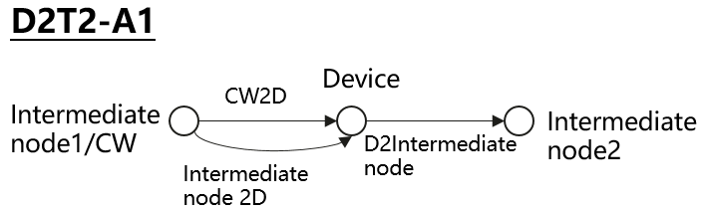  Case 2-2: CW is transmitted from inside the topology (i.e., intermediate UE), transmitted in UL spectrum | R2D: UL  CW2D and D2R: UL | CW and/or device | NR UL
 |  | NR UL | Device and/or reader
 |  | reader | NR UL
 |  | NR UL | device
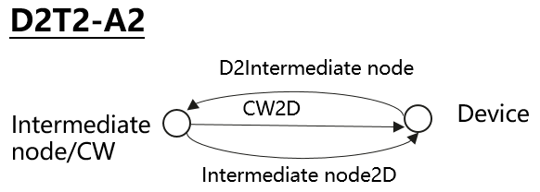  \  Case 2-2: CW is transmitted from inside the topology (i.e., intermediate UE), transmitted in UL spectrum  Self interference cancelation is needed for reader | R2D: UL  CW2D and D2R: UL | CW and/or device | NR UL
 |  | NR UL | Device and/or reader
 |  | reader | NR UL
 |  | NR UL | device
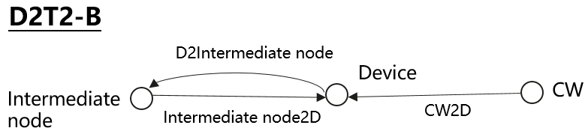  Case 2-3: CW is transmitted from outside the topology, transmitted in DL spectrum  Case 2-4: CW is transmitted from outside the topology, transmitted in UL spectrum  Self interference cancelation is needed for reader | R2D: UL  CW2D and D2R: UL | CW and/or device | NR UL
 |  | NR UL | Device and/or reader
 |  | reader | NR UL
 |  | NR UL | device
 | R2D: UL  CW2D and D2R: DL | CW and/or device | NR DL
 |  | NR DL | device and/or reader

Issue 3-2-6: Evaluation cases for device 2b between AIOT and NR
Proposal 1 (Sony): Device type 2b needs to be taken into account in the co-existence study, with the scenarios shown below:
D1T1-C  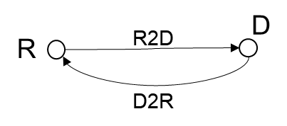 | R2D: DL  D2R: UL | CW and/or device | NR UL
 |  | NR UL | device and/or reader
 |  | reader | NR DL
 |  | NR DL | device
 | R2D: DL  D2R: DL | CW and/or device | NR DL
 |  | NR DL | device and/or reader
 | R2D: UL  D2R: UL | reader | NR UL
 |  | NR UL | reader

D2T2-C  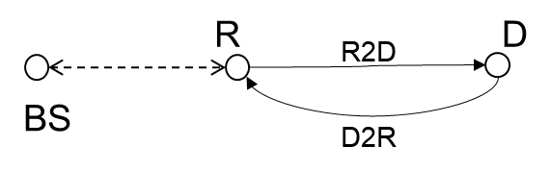 | R2D: UL  D2R: UL | CW and/or device | NR UL
 |  | NR UL | Device and/or reader
 |  | reader | NR UL
 |  | NR UL | device

Proposal 2 (Huawei):
Coexistence case No. | Deployment & Topology | Device Type | R2D spectrum | D2R spectrum
D2b_Case1 | 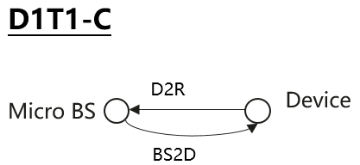 | Device 2b | DL | UL
D2b_Case2 | 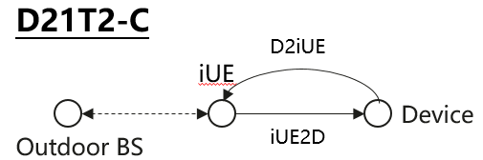 | Device 2b | UL | UL

Recommended WF:
FFS on the evaluation cases for device 2b.

Issue 3-2-7: Multi-operator scenario
Proposal (Spreadtrum): Multiple A-IoT operators co-existence scenario should be investigated in Rel-19 A-IoT.
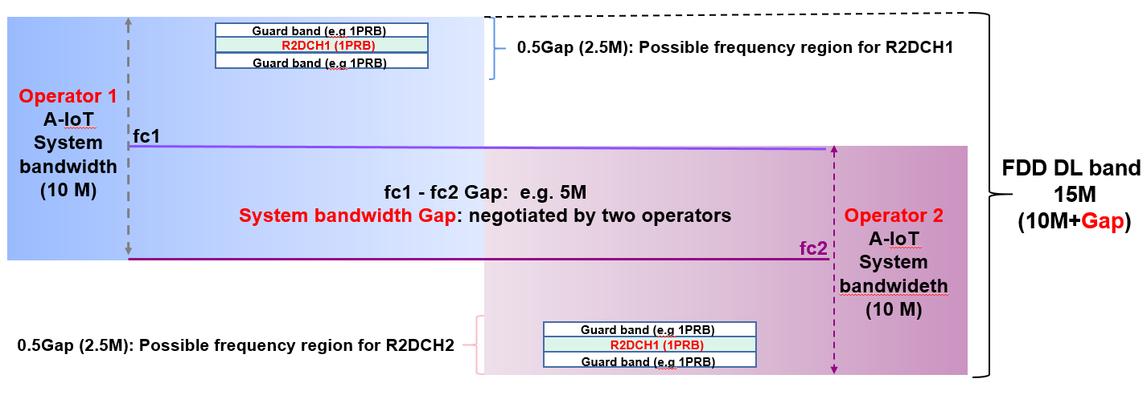
Figure 2.5-1: one possible FDM candidate for multiple A-IoT operators scenario

Recommended WF:
More clarification is needed on the multiple A-IOT operator scenario.

Evaluation parameters

Topic 4-1: Adjacent RB Tx and Rx charateristics
Agreement in RAN4#110bis
- Prioritize the following spectrum deployment mode for RAN4 co-existence evaluation
  - A-IoT is located within a NR transmission bandwidth configuration
  - A-IoT which is operating indoor shares in-band spectrum with outdoor macro BS

Moderator note: According to last meeting agreement, “in-band” spectrum deployment mode is prioritized. Hence it is recommended to discuss the Tx and Rx characteristics for co-existence evaluation for “in-band” spectrum deployment mode.

Issue 4-1-1: A-IOT reader
Recommended WF:
It is recommended to consider the following table for calibration purpose.
 |  | In-band
 |  | Tx | Rx
NR UE/A-IOT Intermediate UE | For formal simulation | Legacy UE IBE requirement | ICS=ACS value  According to SBFD analysis, ICS could be equals to ACS
 | For calibration purpose | Legacy UE IBE | ACS
NR BS | For formal simulation | Based on companies’ input since there is no such requirements in 38.104 | Based on companies’ input in dB scale
 | For calibration purpose | ACLR of legacy gNB | ACS of legacy gNB
A-IOT BS | For formal simualtion | Option 1: ACLR1:40dB，ACLR2:50dB  Option 2: ACLR:45 | ACS of legacy gNB
 | For calibration purpose | ACLR of legacy gNB | ACS of legacy gNB

Issue 4-1-2: Tx for device 1 and 2a
Proposal (CMCC):
For device 1 and 2a, ICS is assumed as 0dB since there is no in-band selectivity. For Tx leakage requirement, it is related to following several factors.
- D2R Data rate
- Coding, i.e. FEC + line coding
- Modulation scheme
  - Since there is no agreement in RAN1 about small frequency shit, at starting point it’s suggested to only considering chip modulation, e.g. OOK/BPSK
For device 1 and 2a, it’s suggested to use following value for IBE as starting point with assuming 5kbps D2R date rate, Manchester code, BPSK modulation scheme. Following assumes that Tx signal is at frequency center
- 25dBc at the edge of center 1PRB, i.e. 90kHz offset from frequency center
- 35dBc with 1 guard RB away from center PRB, i.e. 270kHz offset from frequency center
- 41dBc with 2 guard RB away from center PRB, i.e. 450kHz offset from frequency center

Recommended WF:
Discuss whether the following values can be used for calibration purpose.
For device 1 and 2a, assuming 5kbps D2R date rate, Manchester code, BPSK modulation scheme.
- 25dBc at the edge of center 1PRB, i.e. 90kHz offset from frequency center
- 35dBc with 1 guard RB away from center PRB, i.e. 270kHz offset from frequency center
- 41dBc with 2 guard RB away from center PRB, i.e. 450kHz offset from frequency center

Issue 4-1-3: Rx for device 1 and 2a
Proposal (CMCC, Ericsson): For device 1 and 2a, RF-ED based device can’t have any in-band selectivity.
Recommended WF:
Due to the architecture of device 1 and 2a, discuss whether to assume ICS/ACS=0dB for co-existence evaluation.

Topic 4-2: General paramters and layout
Issue 4-2-1: General parameters
Recommended WF:
Use following parameters as starting point. The “Note” column captures agreements from RAN1 for information.
General Parameter | D1T1&D2T2 | Note (RAN1 agreements refer to R1-2403782, R1-2403815)
Carrier frequency | 900MHz as baseline | 900MHz (M), 2GHz (O)
Channel BW for NR | 10MHz with 15KHz SCS
Channel BW for AIOT | DL: 180kHz with 15KHz SCS  UL: 15KHz or 180KHz | DL: 180k(M), 360k(O), 1.08MHz(O)  UL: FFS  15 kHz as baseline
Waveform (CW) | CW: Unmodulated single tone | Companies to report waveform, e.g., unmodulated single tone, multi-tone(multiple unmodulated single tone)
Waveform (R2D) | OOK waveform generated by OFDM modulator | OOK waveform generated by OFDM modulator
A-IoT DL power control | No
A-IoT UL power control | No
Traffic model | Full buffer
Frequency reuse | 1

Issue 4-2-2: Layout for D1T1
Agreement in RAN1#116bis (R1-2403782) are highlighted in green. Discuss the remaining parts in RAN4#111 meeting.
Parameter | Assumptions for D1T1
Scenario | InF-DH
Hall size | 120x60 m
Room height | 10 m
Sectorization | None
Pathloss model | InF-DH NLOS model defined in TR38.901 is used for D2R and R2D links as pathloss model  Option 1: NLOS and LOS  Option 2 (Huawei):  - D2R/R2D: InF-DH NLOS model defined in TR38.901；  - CW to device: InF-DH LOS
BS deployment / Intermediate UE dropping | 18 BSs on a square lattice with spacing D, located D/2 from the walls.  - L=120m x W=60m; D=20m  - BS height = 8 m  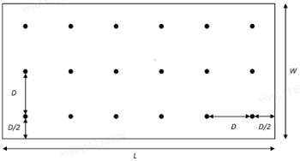  Proposal (vivo): For D1T1-A1 co-existence evaluation, for each Tag, the closest Reader serves as the CW node and the second closest serves as the Rx Reader for D2R.
Device distribution | Device Height= 1.5 m  AIoT devices drop uniformly distributed over the horizontal area with minimum 2D distance of 1m  1 active AIOT device under one reader at one drop  Minimum distance between reader and device is [2]m
Device mobility (horizontal plane only) | 3 kph
NR BS deployment | Hexagonal grid, 19 macro sites, 3 sectors per site with wrap around, 1 AIOT indoor scenario per sector  Option 1(Qualcomm): The distance between the center of factory and the center macro BS needed to be randomly setting for each snapshot and the distance is distributed uniformly within [factory length/2, macro BS ISD/2], i.e. minimum distance is 60m.  Option 2 (Spreadtrum): the minimum 2D distance between macro BS and indoor factory centre is set as 100m.  Option 3 (CMCC): The minimum distance between macro NR BS and indoor reader is 50m, i.e. distance between macro BS and indoor factory center is 110m  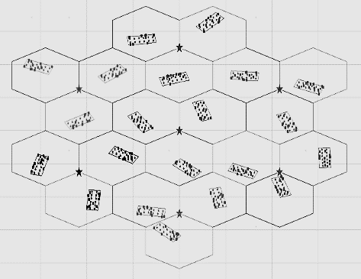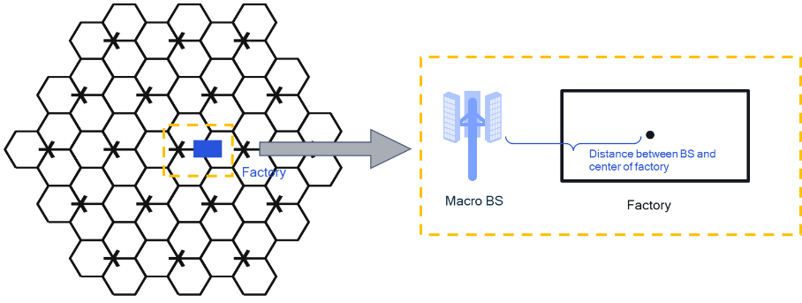
NR BS Inter-site distance | Option 1 (CMCC): 500  Option 2 (CATT): 750  Option 3 (spreadtrum): 200m (baseline), 300m (optional)
Minimum NR BS – NR UE distance (2D) | 35 m
NR UE (D1T1) dropping | For scenario option 1-1, uniformly distributed outdoor.  For scenario option 1-2, uniformly distributed, 80% indoor, 20% outdoor  UE number:  - Option 1: 1 UE per cell  - Option 2 (vivo): the UE number is same as the number of BS beam.
O2I penetration loss | Option 1 (CMCC): High penetration loss as in TR 38.901  Option 2 (CATT): 50% low loss, 50% high loss

Recommended WF:
Discuss following parameters and strive to agree on some candidate values for evaluation in this meeting.

Issue 4-2-3: Layout for D2T2
Recommended WF:
Discuss whether to use InH-office as baseline for D2T2 co-existence evaluation.
Agreement in RAN1#116bis (R1-2403782) are highlighted in green. Discuss the remaining parts in RAN4#111 meeting.
Parameter | Assumptions for D2T2
Scenario | InH-office | InF-DL
Hall size | 120 x50 m | 300x150 m
Room height | 3m | 10 m
Sectorization | None
Pathloss model | - InF-DL and InH-Office model defined in TR38.901is used as pathloss model,  - NLOS for D2R and R2D links if InF-DL is used  - LOS for D2R and R2D links if InH-Office is used
BS deployment / Intermediate UE dropping | - L=120m x W=50m;  - Intermediate UE height = 1.5 m  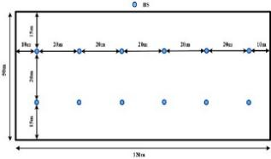  Proposal 1(vivo):  - In InH-office, the total number is 12;  - For each #snapshot, only a subset of intermediate UEs are activated simultaneously  - The number of activated UE is randomly between 0 and total UE number  - For each activated UE, only the nearest Tag is counted into co-existence evaluation.  Proposal 2 (CATT): fixed 18 intermediate UEs on a square lattice with spacing D, located D/2 from the walls  Proposal 3 (xiaomi): RAN4 can first fix the intermediate UE at some points in the co-existence simulation, i.e., the center of the hall or the center of each side, as shown in Figure 2-1. | - L=300m x W=150m;  - Intermediate UE height = 1.5 m  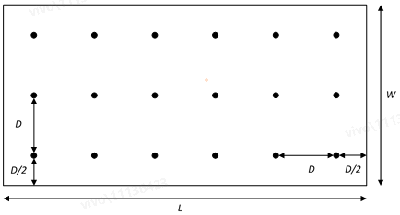  Proposal 2(vivo):  - In InF-DL, the total number is 18.  - For each #snapshot, only a subset of intermediate UEs are activated simultaneously  - The number of activated UE is randomly between 0 and total UE number  - For each activated UE, only the nearest Tag is counted into co-existence evaluation.  Proposal 2 (CATT): fixed 18 intermediate UEs on a square lattice with spacing D, located D/2 from the walls  Proposal 3 (xiaomi): RAN4 can first fix the intermediate UE at some points in the co-existence simulation, i.e., the center of the hall or the center of each side, as shown in Figure 2-1.
Device distribution | Device Height= 1.5 m  AIoT devices drop uniformly distributed over the horizontal area with minimum 2D distance of 1m  1 active AIOT device under one reader at one drop  Minimum distance between reader and device is [1]m (depending on issue 2-2-6)
Device mobility (horizontal plane only) | 3 kph | 3 kph
NR BS deployment | Hexagonal grid, 7 or 19 macro sites, 3 sectors per site with wrap around, 1 AIOT indoor scenario per sector  Option 1(Qualcomm): The distance between the center of factory and the center macro BS needed to be randomly setting for each snapshot and the distance is distributed uniformly within [factory length/2, macro BS ISD/2], i.e. minimum distance is 60m.  Option 2 (Spreadtrum): the minimum 2D distance between macro BS and indoor factory centre is set as 100m.  Option 3 (CMCC): The minimum distance between macro NR BS and indoor reader is 50m, i.e. distance between macro BS and indoor factory center is 110m
NR UE dropping | For scenario option 1-1, uniformly distributed outdoor.  For scenario option 1-2, uniformly distributed, 80% indoor, 20% outdoor  UE number:  - Option 1: 1 UE per cell  - Option 2 (vivo): the UE number is same as the number of BS beam.
O2I penetration loss | Option 1 (CMCC): High penetration loss as in TR 38.901  Option 2 (CATT): 50% low loss, 50% high loss

Topic 4-3: Paramters for AIOT BS/intermedaite UE and device
Issue 4-3-1: AIOT micro-BS parameters for D1T1
Recommended WF:
Use following parameters as starting point. The “Note” column captures agreements from RAN1 for information.
A-IoT micro BS parameters | Recommended value | Note (RAN1 agreements refer to R1-2403782, R1-2403815)
A-IoT micro-BS total Tx power | 33dBm as baseline | - For BS in DL spectrum for indoor  - 33dBm(M), FFS: 38dBm(O), one smaller value [FFS: 23 or 26] dBm(M)  - FFS: additional constraints on PSD  - FFS: For UE in DL spectrum for indoor  - For UL spectrum for indoor,  - 23dBm (M)  - FFS: 26dBm(O)
A-IoT micro-BS receiver Noise Figure（dB） | 5 | For BS as reader  - 5dB  For UE as reader  - 7dB
A-IoT micro-BS antenna gain including feeder loss (dBi) | 6 dBi(M) as baseline | - For BS for indoor, 6 dBi(M), 2dBi(M)  - For intermediate UE, 0 dBi
Antenna configuration | 2 antenna elements as baseline, with (M,N,P,Mg,Ng) = (1,1,2,1,1) | For BS:  - 2(M) or 4(O) antenna elements for 0.9 GHz  For Intermediate UE:  - 1(M) or 2(O)

Issue 4-3-2: Intermediate UE parameters for D2T2
Recommended WF:
Discuss following parameters and strive to agree on some candidate values for evaluation in this meeting.
intermediate UE parameters | Recommended value | Note (RAN1 agreements refer to R1-2403782, R1-2403815)
intermediate UE total Tx power（dBm） | 23dBm as baseline | - For UL spectrum for indoor,  - 23dBm (M)  - FFS: 26dBm(O)
gain of antenna intermediate UE including feeder loss (dBi) | 0 | - For intermediate UE, 0 dBi
intermediate UE receiver Noise Figure（dB） | 7 | For UE as reader  7dB
Antenna configuration | 1 as baseline  Omni direction antenna | For Intermediate UE:  - 1(M) or 2(O)

Issue 4-3-3: CW parameters
Recommended WF:
Discuss following parameters and strive to agree on some candidate values for evaluation in this meeting.
intermediate UE parameters | D1T1 | D2T2 | Note (RAN1 agreements refer to R1-2403782, R1-2403815)
Tx power（dBm） | If UL spectrum is used, UE Tx power is assumed, i.e. 23dBm as baseline  If DL spectrum is used, AIOT micro-BS Tx power is assumed, i.e. 33dBm as baseline | Inter-mediate UE Tx power is assumed, i.e. 23dBm as baseline. | - 23dBm for UL spectrum, FFS 26dBm  - 33dBm(M), 38dBm (O) for DL spectrum  Note: only applicable for device 1/2a
Antenna gain | the value equals to UE Tx ant gain,  or BS Tx ant gain | Same as inter-mediate UE | - Company to report, the value equals to  - UE Tx ant gain, or  - BS Tx ant gain  Note: only applicable for device 1/2a
Other parameters | Same as AIOT micro-BS | Same as inter-mediate UE
CW cancellation (dB) | FFS | FFS | For [monostatic backscatter], FFS  - [140dB for BS]  - [120dB for UE]  For [bistatic backscatter]  Assuming CW has no impact to the receiver sensitivity loss.

Issue 4-3-4: AIOT device parameters
Recommended WF:
Discuss following parameters and strive to agree on some candidate values for evaluation in this meeting.
A-IoT device parameters | Device 1 | Device 2a | Device 2b | Note (RAN1 agreements refer to R1-2403782, R1-2403815)
A-IoT device Tx power (dBm) | <-10 | <-10 | [-10/-20]
A-IoT device effective antenna gain per Tx or Rx branch (dBi) | [0 as baseline] | [0 as baseline] | [0 as baseline] | For A-IoT device, 0dBi (M), -3dBi (O)
A-IoT device reflection （backscatter）loss (dB)  Note: due to, e.g., impedance mismatch | [OOK: -6 dB]  [PSK: 0 dB] | FFS | N/A | - OOK: Y dB  - PSK: X dB  Note: Only for device 1  FFS: for device 2a
A-IoT device power gain of reflection amplifier (dB) | N/A | 10 as baseline | N/A | - 10 dB (M)  - 15 dB (O)  Note: Only for device 2a
A-IoT Device receiver sensitivity (dBm) | [-36] | [-46] | [FFS] | For Budget-Alt1,  - For device 1 (RF-ED),  - FFS:{-30dBm ~ -36dBm}  - For device 2 if RF-ED is used  - FFS  - For device 2 if RF-ED is not used  - N/A
A-IoT device noise figure (dB) | [24] | [15] | [9] | FFS: 20dB or 24dB or 30dB for Budget-Alt2  FFS: different values for device architecture
Guard band | 1PRB, 2PRB, | 1PRB, 2PRB | 1PRB, 2PRB

Topic 4-4: Paramters for legacy NR
Issue 4-4-1: NR macro BS parameters
Recommended WF:
Discuss following parameters and strive to agree on some candidate values for evaluation in this meeting.
NR macro-BS Parameter | Recommended value
Macro-BS Tx power (dBm) | 46
BS antenna gain (dBi) | 15 (CATT)  8 (spreadtrum)
Height of macro NR BS (m) | 25
NR Macro-BS Noise Figure(dB) | 5
Network location | outdoor
Antenna configuration | (M,N,P,Mg,Ng) = (4,1,2,1,1) detailed other parameter refer to 38.803

Issue 4-4-2: NR UE parameters
Recommended WF:
Discuss following parameters and strive to agree on some candidate values for evaluation in this meeting.
NR UE Parameter | Recommended value | note
UE TX power in dBm | -40 to 23
NR UE Antenna gain (dBi) | 0
Height of UE antenna (m) | 1.5
NR UE noise floor (dBm) | -112.4 @ 180kHz | noise floor=-174+10*log (180*1000)+9
NR UE ACLR（dB） | 30 | For power class 3 NR UE
NR UE Maximum input level（dBm） | -25 | TS38101-1 7.4 Maximum input level
NR UE Noise Figure（dB） | 7 or 9
Antenna configuration | Omni direction antenna

