3GPP TSG-RAN WG3 Meeting #XXX R3-24xxxx
City, Country, from – to Month YEAR

Agenda Item: x.y.z
Source: Company name
Title: [TP for BL CR xxxxx] Title
Document for: Discussions & Approval

1 Introduction
This TP follows discussions in R3-YYxxxx.
The styles used in this documents are inherited from the latest CR template which can be found here.

The following styles have been added:
Discussion
- Discussion B1
- Discussion B2
<<<<<<<<<<<<<<<<<<<< First Change >>>>>>>>>>>>>>>>>>>>

3GPP Drafting rules should be known “by heart” and can be found in TR 21.801.
NOTE: It is very useful to add in Word to the Quick Acces tool bar the “Style” and the “Outline Level” commands. With that you can comfortably assign a 3GPP pre-defined Style to a paragraph. E.g. “NO” for a NOTE, like for this paragraph. It is highly appreciated by rapporteurs to only use those predefined styles and not modify them (w.r.t font size, Line Spacing Options, Indentations etc.).
With the “Style” command you can check the current style applied to a paragraph/table item: it will show the style applied to the paragraph selected by the pointer.
See below how to “install” items in the Quick Access tool bar
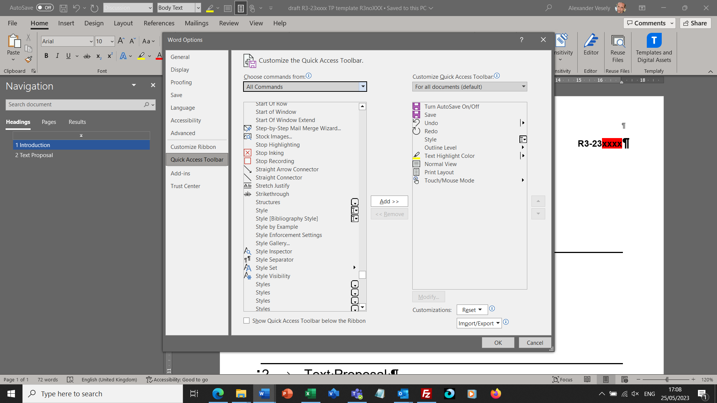
Figure 1-1: How to “install” Quick Access Toolbar command items for “Style” and “Outline Level”.

2 Text Proposal
<<<<<<<<<<<<<<<<<<<< First Change >>>>>>>>>>>>>>>>>>>>
<<<<<<<<<<<<<<<<<<<< Next Change >>>>>>>>>>>>>>>>>>>>
<<<<<<<<<<<<<<<<<<<< Last Change >>>>>>>>>>>>>>>>>>>>
<<<<<<<<<<<<<<<<<<<< Unmodified Text Omitted >>>>>>>>>>>>>>>>>>>>
<<<<<<<<<<<<<<<<<<<< End of Changes >>>>>>>>>>>>>>>>>>>>

