3GPP TSG RAN3 meeting #124 R3-243849
20th – 24th May, 2024 Fukuoka, Japan
Agenda Item: 10.3.2
Source: China Unicom
Title: Summary of Offline Discussion on SONMDT enhancements for network slicing
Document for: Discussion

Introduction
Offline discussion on SONMDT enhancements for network slicing

For chairman’s Notes
Proposal 1: RAN3 to support immediate MDT measurements collection on specific area per slice(s). FFS on whether to support logged MDT.
Proposal 2: RAN3 to work on logged MDT enhancement for slice-based cell reselection.
For successful handover, FFS if solutions are needed to optimize handovers to target cell not supporting slice.

Discussion

MDT enhancement
Enhancement on slice-specific immediate MDT measurements
As discussed in [2][5][9][10] and CR in [6], the main intension is to support per slice MDT collection for operators focusing on interested slice. It was proposed in the definition of MDT area scope in the MDT configuration can be extended by considering the slice-specific area limitation. While it was proposed in [3] that TS 28.552 already supports counters (for DL/UL delay/throughput) per supported S-NSSAI, whether if there any immediate MDT enhancements to consider beyond the counters.

Proposal 1a: RAN3 to support immediate MDT measurements collection on specific area per slice(s).
FFS on whether to support logged MDT
Proposal 1b: RAN3 to extend the definition of MDT area scope in the MDT configuration.
Skip it

Q1a: Do you agree with proposal 1a?
Q1b: If yes, do you agree with proposal 1b?

Logged MDT enhancements
There are a few proposals to illustrate that UE can takes the NSAG priority into account for cell reselection in [1][2] [3]. Differentiating from general reselection, A UE provided with slice-based cell reselection information may reselect different cells compared to the normal one, it can be helpful for NW to adjust the NW configuration if the UE logs and reports the NSAG information after performing cell reselection.
Proposal 2: RAN3 to work on logged MDT enhancement for slice-based cell reselection.
Q2: Are there any comments on proposal 2?

Introduce new MDT measurement
As discussed in [2][3][5][8][9], several new MDT measurements are proposed to introduce for slice, moderator tried to list all of them below:
- 1) the slice ID associated with the ongoing PDU session
- 2) slice specific L2 measurements at NG-RAN (e.g., Received RA Preambles per slice)
- 3) denied UEs slice service reason, e.g. slice not being supported in the cell from which UE is making the request, slice not being available in the cell from which UE is making the request, Insufficient radio resource for the slice in the cell from which UE is making the request.
- 4)unsupported and/or unavailable S-NSSAI
Proposal 3:FFS on RAN3 to introduce new MDT measurement for slicing?
Q3: Are there any comments on proposal 3? And which one do you support?

Skip it

SON Enhancement
As could be seen in [1][3][4][8][11], it is addressed that UE may handover to a cell which doesn’t have full slice support for the UE services. To detect such scenarios and take correction action in the future, it might be useful to collect slice-related information during handovers.
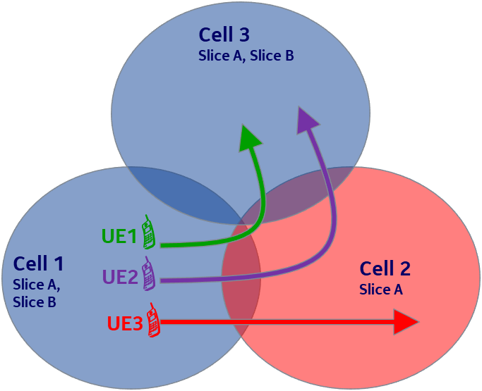
Several slice information UE can indicate to the network is listed below:
1) non-support of the slice at target cell
2) UE’s ongoing slice(s) in the source and target cell
3) slice-level user plane interruption times
4) the mapping of old S-NSSAI to alternative S-NSSAI

Proposal 4a: For successful handover, FFS if solutions are needed to optimize handovers to target cell not supporting slice.

Proposal 4b: RAN3 to consider collecting slice related information during connection failure scenarios for observability purposes.

Skip it

Q4: Are there any comments on proposal 4a and 4b?

UHI enhancement
As discussed in [1][8][9], UHI can be enhanced to contain slice information with each of the visited cells, with this information the selected target cell could analyse the history information to see if the UE had some service discontinuity for some of its slices and report back to the original source cells.
Proposal 5: RAN3 considers to record slice related information in UHI/MHI for following track decision and optimization.
Q5: Are there any comments on proposal 5?
Skip it

Partially Allowed NSSAI
As demonstrated in [10], source gNB could make a wrong mobility decision related to Partially Allowed NSSAI which can be considered as a slice aware MRO scenarios.
Proposal 6: To take Partially Allowed NSSAI as one of Slice aware MRO scenarios.
Q6: Are there any comments on proposal 6?
Skip it

Reference
- R3-243146, Further discussion on SON enhancements for network slicing (Nokia)
- R3-243166, SON for Network Slicing (Huawei)
- R3-243196, SON MDT for network slicing (Qualcomm Incorporated)
- R3-243262, Discussion on Slice-aware MRO use cases (Ericsson)
- R3-243263, MDT enhancements for Network Slicing (Ericsson, InterDigital, Deutsche Telekom)
- R3-243264, (TP for SON BL CR for TS 38.413) MDT enhancements for Network Slicing (Ericsson, InterDigital, Deutsche Telekom)
- R3-243265, Draft LS on MDT enhancements for Network Slicing (Ericsson, InterDigital, Deutsche Telekom)
- R3-243639, Discussion on network slicing for SONMDT (CATT)
- R3-243664, Discussion on SONMDT enhancements for network slicing (China Unicom)
- R3-243709, Further consideration on SON/MDT for Slicing (ZTE)
- R3-243725, Discussion on SONMDT for network slicing (CMCC)

