3GPP TSG-RAN WG2 Meeting #126 R2-240xxx
Fukuoka, Japan, May 20th – 26th, 2024

Agenda item: 7.2.5
Source: Huawei, HiSilicon
Title: Summary for [AT126][407][POS] Rel-18 SRSp enhancement fields in INMs (Huawei)
Document for: Discussion and Decision

Introduction
During RAN2#126, the following proposals from the tdoc have been discussed on whether internode message needs to include the fields related to SRS enhancements in Release 18
R2-2404764 Discussion on the remaining issues for R18 RRC [H905][H920-921] Huawei, HiSilicon discussion Rel-18 NR_pos_enh2

Proposal5: Add the RRC fields for R18 enhancements for positioning SRS transmission in RRC_INACITVE in R18 in the internode message HandoverPreparationInformation

In this email discussion, we discuss on the issues have been presented

Discussion

RAN2/3 to discuss the issue?
During the discussion in RAN2#126, the issue in the above section has been discussed in RAN2 and companies think there is a parallel discussion in RAN3 and parallel discussion should be avoided, and we should wait for RAN3 conclusions.
However, during offline discussion in RAN3 [CB # 13_Positioning], the following agreement has been reached regarding which group to discuss:
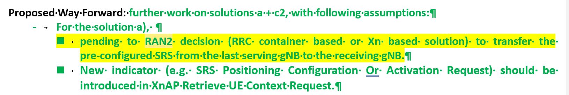
Based on the above progress, it seems that RAN3’s understanding is that RAN2 should discuss on this issue first. Hence, we would like to ask the following question:
Question1: Do companies agree that RAN2 should discuss the issue of whether to include R18 SRS enhancements for RRC_INACTIVE in RAN2?
Companies | Yes/No | Comments

Discussions on the INM
The background of the field in the legacy releases are as follows. In the legacy CG-SDT, the following has been captured in the current RRC spec in the internode message.
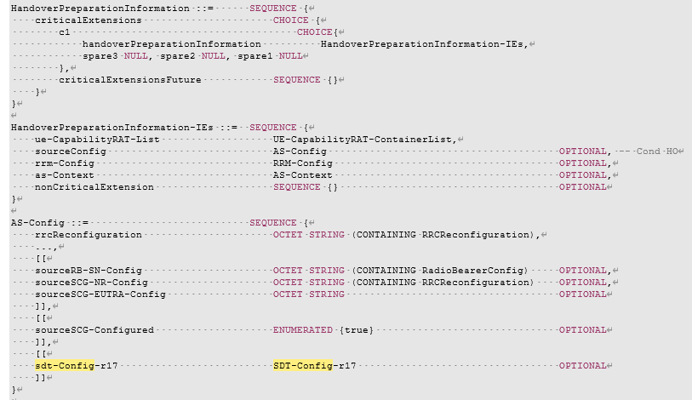
With the same reason as CG-SDT, we think the SRS configurations should also be included in the internode message to support the case when the UE sends RRC resume request in a cell different from the last serving gNB. This is already clear in the following procedure agreed in RAN3 for 38.305
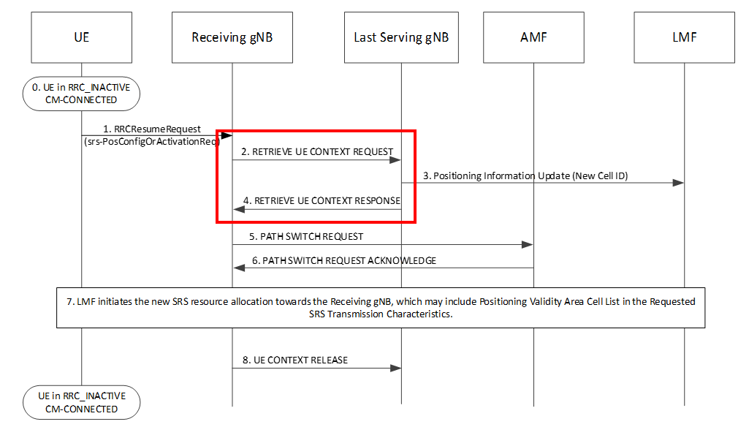
Within the XN-AP message RETRIEVE UE CONTEXT RESPONSE, the internode message HandoverPreparationInformation is used
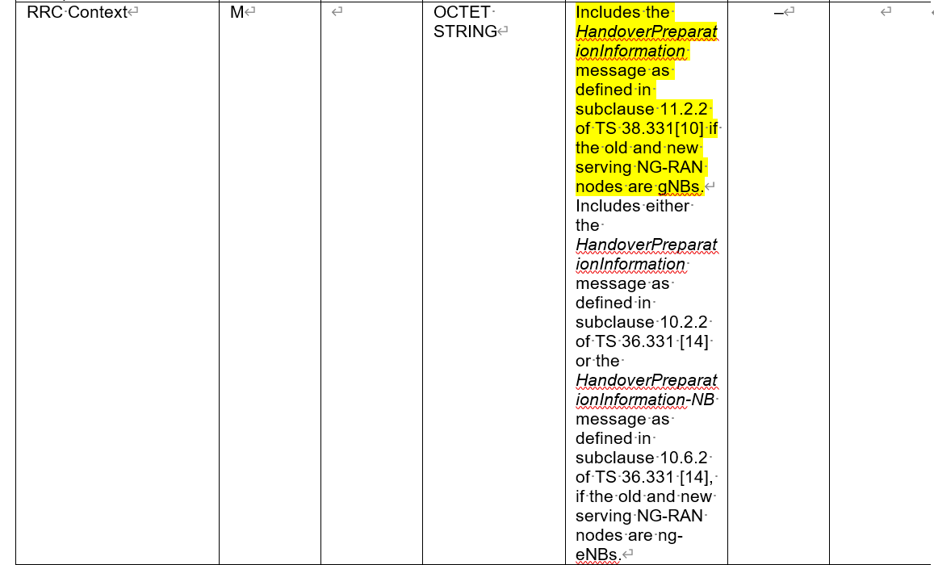
Hence, we ask the following question:
Question2: Do companies agree that SRS configurations for LPHAP introduced in RRCRelease message in R18 should be added to the internode message HandoverPreparationInformation?
Companies | Yes/No | Comments

Conclusion
TBD

