3GPP TSG-RAN Meeting #104 RP-24xxxx
June 17th ‒ 20th, 2024
Shanghai, CN

Agenda item: 9.1.5
Source: Moderator (RAN4 vice chair, Qualcomm Incorporated)
Title: Moderator's summary for Ku band
Document for: Information

Introduction
This document provides a summary of discussion for initiating a work item to define specifications for a new NR frequency band in the Ku frequency range.

Issues
A proposed work item description was provided in [1]. The objectives are copied below
The objectives are:
Phase 1
- Update coexistence study if needed [RAN4]
- Use the regulation requirements in ITU Regions 1, 2 and 3 to identify relevant adjacent band co-existence scenarios for NTN Ku Band covering the following frequency ranges, considering targeted deployment scenarios [RAN4]:
  - Downlink 10.70 – 12.70/12.75 GHz
  - Uplink 12.75-13.25 GHz (excluding US in region 2) & 13.75-14.5 GHz
- Specify RF requirements for satellite access node and relevant NTN VSAT types considering existing regulations on antenna sizes for certain parts of the Ku band. [RAN4].
- Specify RRM requirements to cover the Ku band. [RAN4]
- In addition to legacy channel bandwidths, support new channel bandwidths to align with typical existing Ku band operational constraints [RAN4]
- Study and specify enablers for half duplex FDD mode [RAN1]
  - Rational: Interference mitigation for uplink 12.70 GHz – 13.25 GHz being adjacent to 10.70 GHz– 12.70 GHz downlink

Phase 2
- Extend the phase 1 normative work to include uplink band 12.70 GHz – 13.25 GHz for the US in Region 2

Coexistence
Is a coexistence study needed in additional to the coexistence study already conducted for Ka band? If additional study is needed, what aspects different from the Ka band study should be considered?
Company | Comment
Charter Comm Inc | From our perspective, we would like to suggest waiting until the FCC rules before approving the WID. There is a current an FCC NOI considering 12.75-13.25 GHz as Mobile Wireless Spectrum. Until this NOI is completed, we should hold off in this work. Furthermore, in RAN3101, Intelsat provided a tdoc, RP231886 which proposed to hold this work until RAN#105 (Sept 2024). In this meeting, there was also a tdoc which was approved, RP232668, RAN4 New Proposals for Rel-19 in which RP231886 was withdrawn.
Ericsson | Yes, co-existence study should be considered as the frequency is substantially different to Ka band.
Huawei/HiSilicon | Update coexistence study if needed [RAN4]  In the above objective, it is not clear which co-ex is supposed to be updated – this should be clarified in the WID.

Proposed way forward:

Regional applicability
Recognizing the ongoing consultation in the US regarding the frequency range 12.70 – 13.25 GHz in the US, the proponents of [1] have suggested to structure the work item in two phases. The first phase of the work item would define requirements only for Region 1 and Region 3 countries as well as Region 2 countries not including the US. The second phase commencing after conclusion from the FCC would potentially extend the 12.70 – 13.25 GHz to the US as well. Yet, other companies preferred to discuss the 12.70 – 13.25 GHz altogether for all regions, only after conclusion from the FCC to allow the possibility of enabling a common band and/or common requirements worldwide.
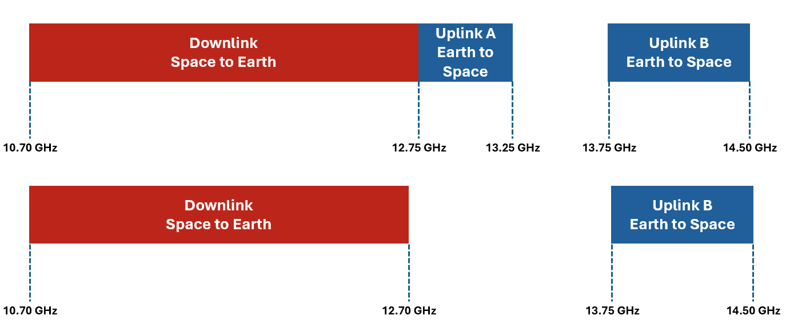
Figure 3. Phase 1: Normative work for ITU regions excluding US

Figure 4. Phase 2: Additional normative work for US

Company | Comment
Ericsson | UL A for Region 2 should only be started when the FCC consultation has progressed. It may be preferable for all regions to work on DL and UL B first in order to end up with a harmonized band plan if possible.
Huawei/HiSilicon | One practical approach to decide which way to go, may be to compare how many new bands would be need to be introduced for each of the two options on table (2 phases, vs postponing till FCC conclusion for 12.70 – 13.25 GHz).

Proposed way forward:

Channel bandwidths
The WID [1] suggests that new channel bandwidths aligned with typical existing Ku band operational constraints is needed. The addition of new channel bandwidths may require work outside of RAN4 as well as potential additional work inside RAN4. Moreover, the channel bandwidths have not been identified by the proponents.
Company | Comment
Ericsson | They could potentially be added in a second stage
Huawei/HiSilicon | Both “legacy” and new channel bandwidths shall be explicitly listed in the WID, so RAN4 is aware of the underlying work. It is not obvious what does the “legacy” mean in the current WID wording. Same for “typical existing Ku band operational constraints”.

Proposed way forward:

Half duplex
The WID [1] proposes an objective to introduce a half duplex FDD mode for NR NTN. It is acknowledged that this would require participation from RAN1 and therefore extends the scope of this work item beyond spectrum.
Company | Comment
Ericsson | This is connected to the 12.75-13.25 range so could be delayed/removed, returned to later as needed. There may be some other RAN1/2 objectives as below.
Huawei/HiSilicon | It is not clear whether half duplex FDD applies for UE only or it applies to network as well. According to the description of rational, it seems half duplex FDD is needed for network. But it is not clear how Ku spectrum are assigned among satellite operators, whether DL spectrum and UL spectrum assigned to an operator are adjacent to each other or not, hence it is not clear whether some duplex enhancement for network is needed or not.  Before the scenario can be clarified, we would prefer RAN4 to study and conclude on the spectrum scenario before RAN1 proceed with any study/work.

Proposed way forward:

Other issues
Any other issues?
Company | Comment
Ericsson | There is a need to check and decide whether the new band should inherit characteristics of FR1 FR2 or a newly defined range. This should consider not just RAN1, but also RAN1 aspects such as SCS, SSB, PRACH etc. If the range is not FR1 or FR2, some RAN1/2 spec and signaling changes are needed.  Suggest to add two objectives:  Check and confirm which FR the band is part of [RAN4, RAN1]  IF necessary, specify new NTN specific FR [RAN1, RAN2, RAN4]  Note: NTN FR does not impact decisions for TN FR for the 7-24GHz frequency range.  We that that we have an RRM objective in the WID. Its not clear what to do in RRM. Maybe better to come back later with RRM.
Huawei/HiSilicon | Reuse of the TR 38.863 may not be allowed by RAN Secretary. Please check. New TR may be needed instead (even if we would also prefer to reuse some of the existing TRs to capture Ku aspects).
Huawei/HiSilicon | Remove the following wording from the Justification:  Note: Further to the Release 18 NTN scope for operation above 10 GHz, Mobile VSATs (ESIMs) connected to NGSO Satellites may be considered at a later date.  Mobile VSAT for both Ka and Ku can be considered as non-spectrum item for Dec checkpoint. Besides, related Note is already captured in TS 38.101-5.
Huawei/HiSilicon | Specify RF requirements for satellite access node and relevant NTN VSAT types considering existing regulations on antenna sizes for certain parts of the Ku band. [RAN4].  - We suggest to clarify what are “relevant NTN VSAT types” to avoid unnecessary ambiguities.  - Replace “existing regulations” with “applicable regulations” as the US regulation is not yet existing, while it is expected to be also applicable.  - As “certain parts” is not very precise, suggest to simply remove it and keep “for Ku band”.  Is there any specific reason why we need to mention “antenna sizes” here? All applicable NTN VSAT regulations shall be reflected, i.e. not just those related to antenna sizes.

Moderator recommendation

Reference
- RP-240938, “New WID on Introduction of Ku Band for NR NTN,” Intelsat, Eutelsat Group, Thales

