Room Plan (15/3/99) Meeting rooms may change – depending on how many attend – please see registration desk / admin room for latest version
 | Monday 15 March | Tuesday 16 March | Wednesday 17 March | Thursday 18 March | Friday 19 March
09.00  10.30 | SMG4 OPENING PLENARY  Lecture Hall (180) | SMG4 IW  WeatherheadRm(30)  SMG4 GPRS  CommitteeRm(30)  T2SWG1/MEXE  AbbeyRM(40)  T2SWG2/MSTE  ShelleyRm(20)  T2SWG4  QuiteRm(15) | 3GPPCN3  MediaRm(80)  T2SWG1/MEXE  AssemblyRm(80)  T2SWG2/MSTE  ShellyRm(20)  T2SWG3/DGMH  ChaucerRm(20) | 3GPPCN3  MediaRm(80)  T2SWG1/MEXE  CommitteeRm(30)  T2SWG3/DGMH  WeatherHead(30)  T2SWG6  QuiteRm(15) | SMG4 CLOSING PLENARY  MediaRm(80)  T2SWG5  QuiteRm(15)
11.00  12.30 | SMG4 OPENING PLENARY  Lecture Hall (180) | SMG4 IW  WeatherheadRm(30)  SMG4 GPRS  CommitteeRm(30)  T2SWG1/MEXE  AbbeyRM(30)  T2SWG2/MSTE  ShelleyRm(20)  T2SWG4  QuiteRm(15) | 3GPPCN3  MediaRm(80)  T2SWG1/MEXE  AssemblyRm(80)  T2SWG2/MSTE  ShellyRm(20)  T2SWG3/DGMH  ChaucerRm(20) | 3GPPCN3  MediaRm(80)  T2SWG1/MEXE  CommitteeRm(30)  T2SWG3/DGMH  WeatherHead(30)  T2SWG6  QuiteRm(15) | SMG4 CLOSING PLENARY  MediaRm(80)  T2SWG5  QuiteRm(15)
14.00  15.30 | 3GPPT2 OPENING PLENARY  Lecture Hall (180)  SMG4 IW and GPRS  MediaRm(30) | SMG4 IW and GPRS  WeatherheadRm(30)  SMG4 GPRS  CommitteeRm(30)  T2SWG1/MEXE  AbbeyRM(40)  T2SWG2/MSTE  ShelleyRm(20)  T2SWG4  QuiteRm(15) | 3GPPCN3  MediaRm(80)  T2SWG1/MEXE  AssemblyRm(80)  T2SWG3/DGMH  ShellyRm(20)  T2SWG6  ChaucerRm(20) | 3GPPCN3  MediaRm(80)  T2SWG1/MEXE  CommitteeRm(30)  T2SWG4  WeatherHead(30)  T2SWG6  QuiteRm(15) | 3GPP T2 CLOSING PLENARY  MediaRm(80)
16.00  18.00 | 3GPPT2 OPENING PLENARY  Lecture Hall (180)  SMG4 IW and GPRS  MediaRm(30) | SMG4 IW and GPRS  WeatherheadRm(30)  SMG4 GPRS  CommitteeRm(30)  T2SWG1/MEXE  AbbeyRM(40)  T2SWG2/MSTE  ShelleyRm(20)  T2SWG4  QuiteRm(15) | 3GPPCN3  MediaRm(80)  T2SWG1/MEXE  AssemblyRm(80)  T2SWG3/DGMH  ShellyRm(20)  T2SWG6  ChaucerRm(20) | SMG4 CLOSING PLENARY  MediaRm(80)  3GPPCN3  CommitteeRm(30)  T2SWG5  WeatherHead(30)  T2SWG6  QuiteRm(15) | 3GPP T2 CLOSING PLENARY  MediaRm(80)

Coffee/Tea 10.30 and 15.30 each day
Lunch 12.30

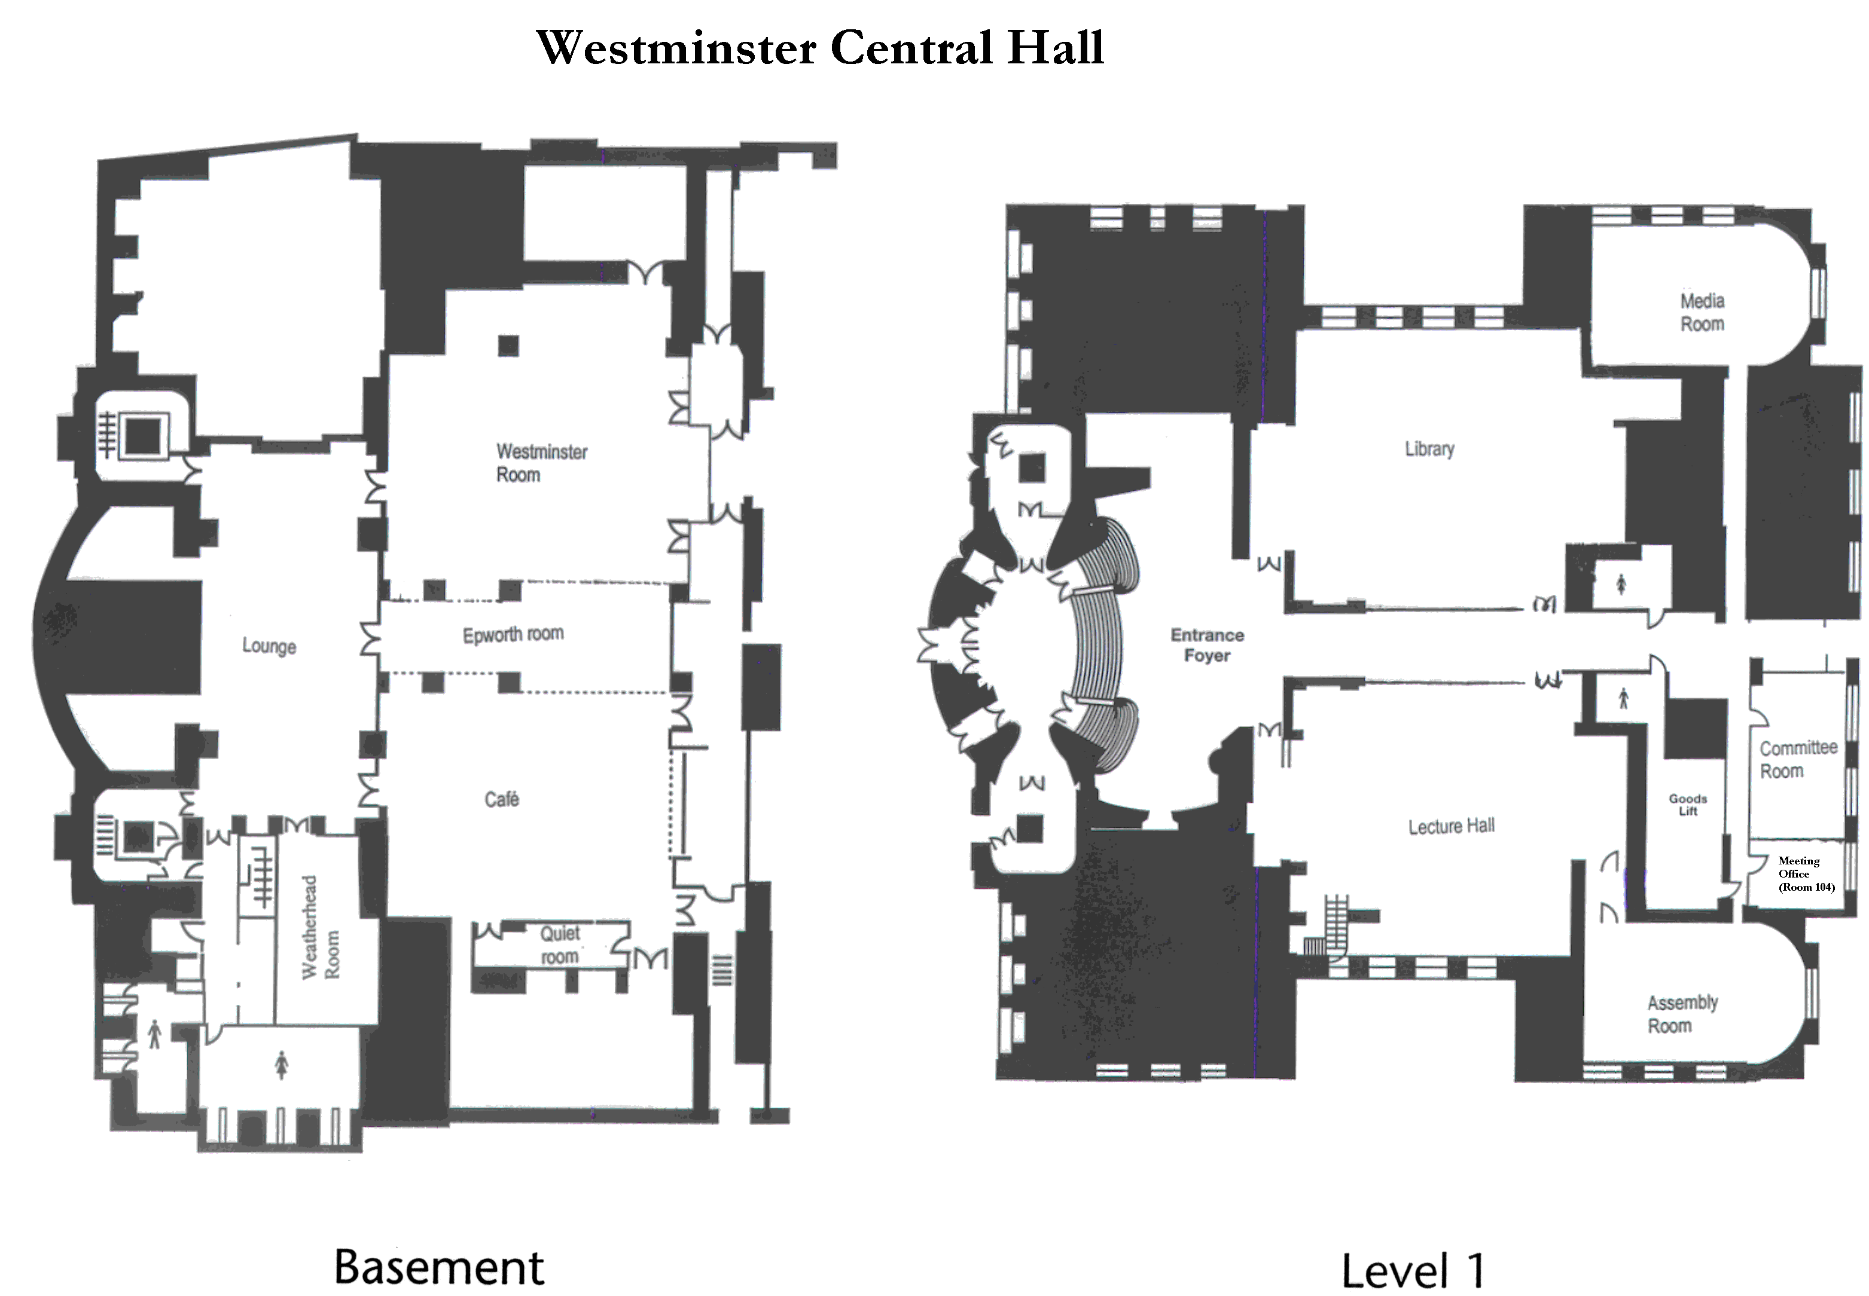

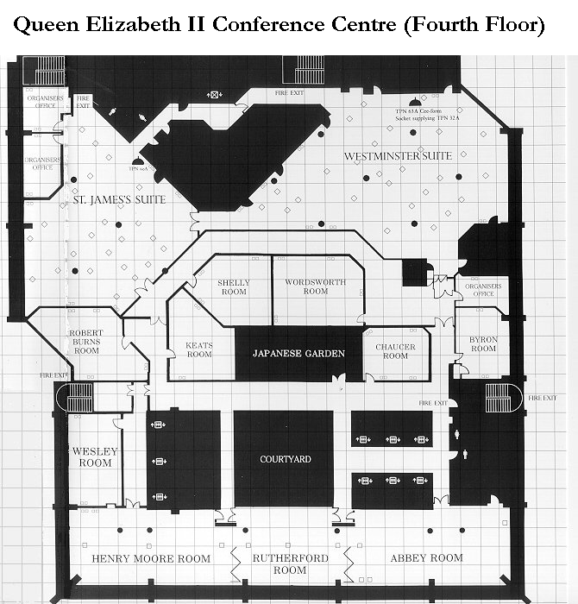
Network Instructions

- Disable WINS (Network control panel TCIP settings).
- Set IP address to server assigned (Network control panel TCIP settings)
- Ensure Microsoft Networking Client has log on to Windows NT domain enabled – Domain should be set to 3gpp & Primary Logon is Client for Microsoft Networks.
- Install and enable the NetBEUI protocol.
- Under the Identification Panel in Network control Panel set Workgroup to 3gpp.
- Reboot.
- Log onto network as
Domain = 3gpp
User = user1
Password = user1
- Add printer – enter //server/LaserJet.
- Do NOT print Test Page.

- The printer will appear as LaserJet in the top level directory of the Sever.

- Drivers for the printer are also available on the server.

