Sophia Antipolis, 7 February 2023

E3MAG has the pleasure of inviting you to
3GPP SA1, SA2, SA3, SA4, SA5, SA6 in Berlin

TITLE | TYPE | DATES | LOCATION | CTRY
3GPPSA1#102 | OR | 22– 26 May 2023 | Berlin | DE
3GPPSA2#157 | OR | 22– 26 May 2023 | Berlin | DE
3GPPSA3#111 | OR | 22– 26 May 2023 | Berlin | DE
3GPPSA4#124 | OR | 22– 26 May 2023 | Berlin | DE
3GPPSA5#149 | OR | 22– 26 May 2023 | Berlin | DE
3GPPSA6#55 | OR | 22– 26 May 2023 | Berlin | DE

Dear Delegate,

E3MAG has the pleasure of inviting you to the above-mentioned meetings.

Meeting Venue
Estrel Berlin

SONNENALLEE 225 | 12057 BERLIN
Tel +49 30 6831 0 hotel@estrel.com

Single room at EUR 158€, services charges and VAT included
Breakfast will be charged at 25€/person/day
Hotel booking link: https://reservations.travelclick.com/17417?groupID=3807314

The conditions are explained on the next page.
Meeting Registration
Please register for the meetings online at:
3GPPSA1#102
3GPPSA2#157
3GPPSA3#111
3GPPSA4#124
3GPPSA5#149
3GPPSA6#55

You might find the hotel cancellation policy unreasonable. If you need to cancel your room, on a reasonable basis, please contact e3mag@etsi.org.

We look forward to seeing you all in Berlin.

Yours sincerely,

E3mag

Accommodation
E3MAG is not responsible for reservation confirmations, cancelled or changed reservations or no-shows. Please contact the hotel directly to make any changes. Please make your own booking filling in the hotel registration form. You might find the hotel cancellation policy unreasonable. If you need to cancel your room, on a reasonable basis, please contact e3mag@etsi.org.

WLAN: There will be a wireless LAN.

Estrel Berlin Hotel Policy:

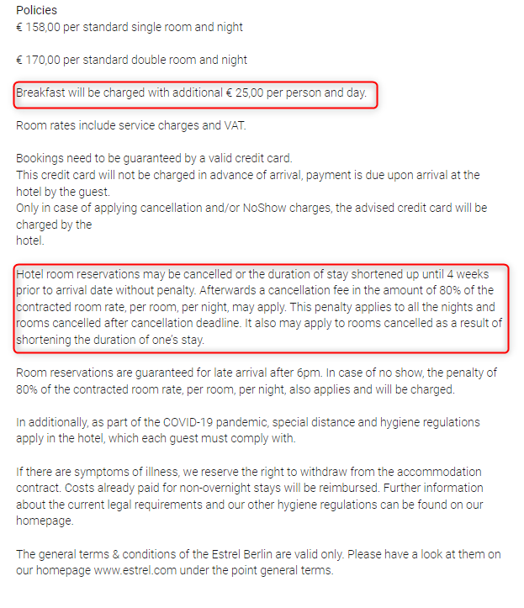

How to reach Estrel Berlin: Berlin-Brandenburg Airport (BER) is 13 kilometers away. The S-Bahn station Sonnenallee can be reached on foot in three minutes, a bus stop and a taxi stand are located directly at the Estrel.
- Contact, Location and Directions – Estrel Berlin
- estrel_lage_anfahrt_2022_ENG.pdf

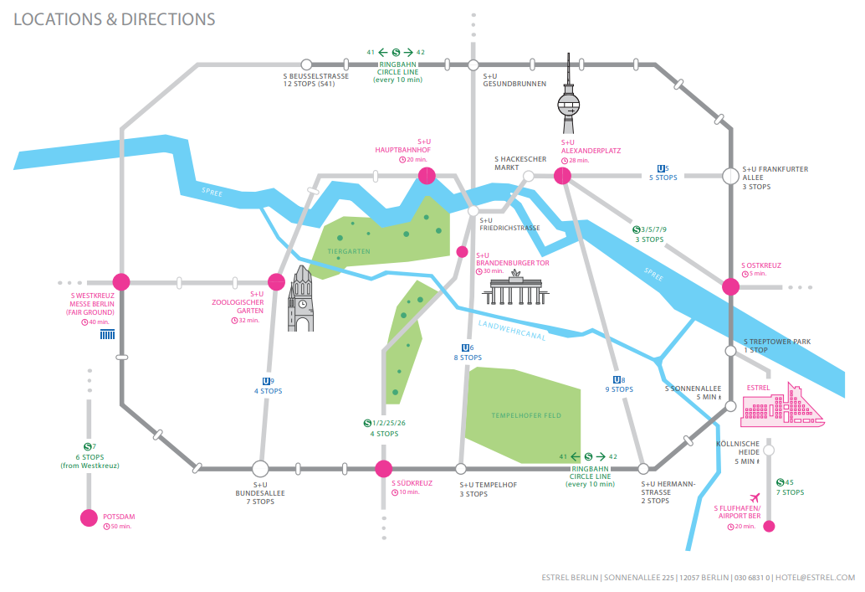

Host Contacts
For any questions about anything relating to the meeting please contact: e3mag@etsi.org

Visa letter

****VISA LETTER****
 Delegates needing a visa in order to attend a meeting hosted by E3MAG should make their hotel booking where the meeting will take place. As soon as they book their room please ask the hotel to provide you with a personal letter.
We would like to invite you to fill-in your own invitation letter which contains all your personal information. Please follow these steps:
- Please download the visa application letter template at
http://www.3gpp.org/delegates-corner#outil_sommaire
(Under meeting Delegates FAQs, meeting document template, “visa application letter template”)
- Please update the letter accordingly
- Please send your letter to e3mag@etsi.org for signature

