**3GPP TSG-SA WG6 Meeting #50-eS6-222213**

**E-Meeting, 22th – 31st August 2022**

**Source: Ericsson**

**Title: Discussion paper on redundant path establishment with dual UE – dual UP**

**Agenda item: 9.10**

**Document for: DISCUSSION & AGREEMENT**

**Contact: Áron Szabó (**[**aron.szabo@ericsson.com**](mailto:aron.szabo@ericsson.com)**)**

# 1. Introduction

This discussion paper proposes a solution with configuration and procedure description for redundant path establishment with dual UE – dual UP paths and corresponds to ”4.1 Key issue #1: Support for E2E redundant transport” in TR 23.700-34 [1].

# 2. Discussion

The proposed redundant path configuration with dual UE – dual UP paths significantly improves the service availability of a connection between a device and a DN by introducing dual UEs. Although redundant path transmission establishment between a single UE and a DN is already involved in TR 23.700-34 [1], service failure due to UE, gNB malfunction (e.g. failure of RAN CP to master gNB) still need to be covered.

The proposed solution handles cases of UE, gNB and UPF malfunction for device-to-DN connections by the establishment of Reliability Groups of corresponding UEs and gNBs and by disjoint path configuration between the device and the DN.

## 2.2 Discussion on the concept of the solution

The proposed configuration handles cases of UE, gNB and UPF malfunction for device-to-DN connections based on redundant RAN coverage supported by multiple gNBs and core network UP deployment that is aligned with RAN deployment supporting E2E redundant user plane paths.

Selection of different gNBs for the UEs in the same device is realized with Reliability Groups (RGs) for the UEs and also for the cells of gNBs, see Annex F of TS 23.501 [2]. The reliability group of the RAN (cells of gNBs) entities are pre-configured by the O&M system in RAN. Reliability Groups (RGs) are identified by S-NSSAI and RAT Frequency Selection Priority index.

Using RGs, selection of different gNBs and different cells for each UE in the device is realized. Once the RGs of the RAN are set up, UE selects cells from the same RG to ensure that different UEs in the same device are assigned to different gNBs. UE is handed over only to cells within the same RG. In case the UE connects to a cell in the wrong RG, gNB initiates HO to a cell in the appropriate RG whenever a suitable cell is available.

Beyond UEs and gNBs, the disjoint UP path establishment includes separate UPFs. To achieve this, the separate RGs are identified with the requested S-NSSAI. S-NSSAI might be recieved from 5GC (i.e. AMF) in URSP during the UE registration procedure. S-NSSAI is used for AMF and SMF selection. UPF is selected with S-NSSAI/DNN.

The RG of each UE is sent from AMF to RAN when the UE context is established, and maintained as part of the RAN context, so each gNB has knowledge about the reliability group of the connected UEs. UE RG parameter is encoded into RFSP (RAT/Frequency Selection Priority). The requested S-NSSAI is used as input to select the RFSP index value for the UE. RAN uses the RFSP for RRM purposes and is based on local configuration determines the UE Reliability Group. Examples of how RFSP may be used by the RAN:

* Derive UE specific cell reselection priorities to control idle mode camping
* Decide on redirecting active mode UEs to different frequency layers

## 2.3 Discussion on the functional architecture

*Our proposal is a CP/UP split architecture where the NRM Server handles the CP and the SEALDD handles the UP.* This approach is utilized in many places, for example in SMF due to scalability advantages, in TSN or in DetNet. It also allows for re-use of NRM capabilities.

Figure 1 indicates the application layer architecture variant for E2E redundant transmission path establishment with dual UE – dual UP.

Differences compared to the Data delivery enabler service architecture shown in Figure 6.1.1-4 of TR 23.700-34 are the following:

* the presence of SEAL NRM Server and SEAL NRM CL for network resource management during disjoint path establishment,
* the presence of dual SEALDD-UU over the disjoint paths,
* two UEs are indicated within the same device.

Following the configuration of SEALDD Server and SEALDD Client through the SEAL NRM Server and SEAL NRM CL, SEALDD Server and SEALDD Client are responsible for dual-UP uplink and downlink traffic on SEALDD-UUs, shown in Figure 1.

For uplink data delivery, VAL client sends application traffic to SEALDD Client on SEAL-C, the SEALDD Client assigns a sequence number and application flow ID to the application data packet and replicates the SEALDD packet for transport with UDP on the redundant SEALDD-UU. Sequence number and application flow ID are part of the SEALDD packet header. The SEALDD server eliminates the replication to recover the application data packet; remove the SEALDD header and sends the application data packet to VAL server on SEAL-S.

For downlink data delivery, VAL server sends application data packets to SEALDD server that assigns a sequence number and application flow ID to each application data packet and replicates the SEALDD packet for transport with UDP on the redundant IP flows to the SEALDD Client. Each IP flow is identified with UE IP address (one per UE), SEALDD Server IP address (one per server port), transport.

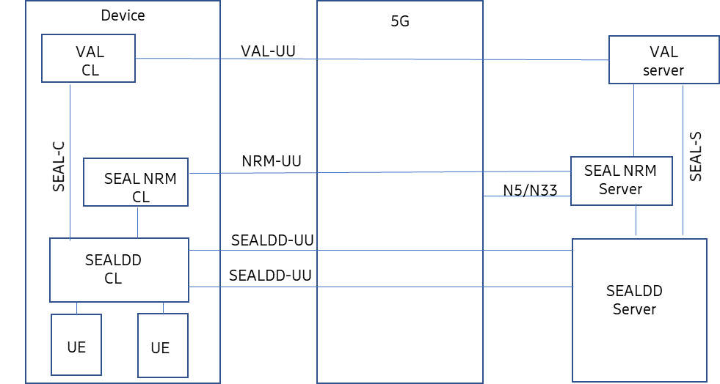

Figure 1: Functional model for E2E redundant transmission path establishment with dual UE – dual UP

References

1. 3GPP TR 23.700-34: “Technical Specification Group Services and System Aspects; Study on SEAL data delivery enabler for vertical applications”
2. 3GPP TS 23.501: "Technical Specification Group Services and System Aspects; System architecture for the 5G System (5GS)"