**3GPP TSG-SA WG6 Meeting #49-bis-e S6-221927**

**e-meeting, 22nd June – 1st July 2022 (revision of S6-221755)**

**Title: LS on Clarification of Edge Node Sharing**

**Response to:**

**Release: Release-18**

**Work Item: FS_eEDGEAPP**

**Source: 3GPP SA6**

**To: GSMA OPG**

**Cc: 3GPP SA2**

**Contact person: Yanmei Yang**

**yangyanmei@huawei.com**

**Send any reply LS to: 3GPP Liaisons Coordinator,** [**mailto:3GPPLiaison@etsi.org**](mailto:3GPPLiaison@etsi.org)

**Attachments:**

# 1 Overall description

Currently, SA6 captured Key Issue #22 (clause 4.22) in 3GPP TR 23.700-98 v1.0.1. The Key Issue was originated from GSMA OPG requirement for Edge Node Sharing.

It is to be noted that in SA6, in Edge Node Sharing context, we have two separate entities – PLMN operator and Edge Computing Service Provider (ECSP). It is possible that PLMN Operator and ECSP are same provider.

Also, during the discussion, SA6 mainly referred to clause 3.3.5, 3.5.4.3.3, Annex A.2.1 and Annex A.2.2 of GSMA OPG Operator Platform Telco Edge Requirements (v2.0).

SA6 would like to ask GSMA OPG for further clarification as the following:

GSMA OPG.02, clause 3.3.5 Edge Node Sharing mentions:

*“Two operators may decide to share edge nodes to maximise their edge presence. Using the figure below as an example, the mobile network of both operators covers the whole country. However, Partner A deploys edge sites in the country's North Region and operator B in the South Region. In this case, Operator B might deploy an application on Partner A's edge node while providing connectivity to the end-user over their own radio network”.*

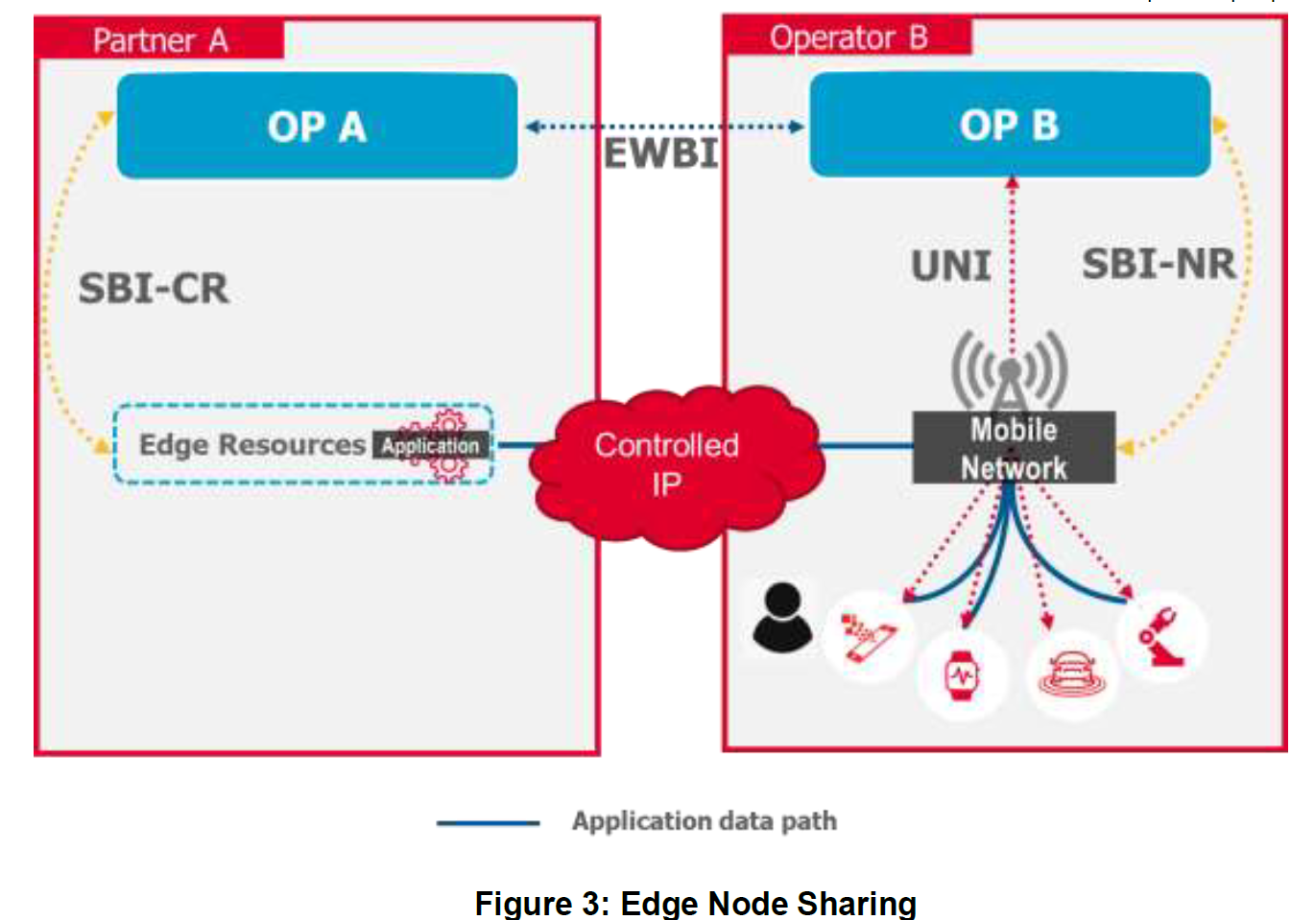

Q1: Figure 3 shows that Operator B provides PLMN connectivity to the UE. Considering, the mobile network of both operators covers the whole country, SA6 assumes that the UE can be located in the North Region and be served by operator B’s PLMN to consume an application on Partner A's edge node deployed in the North region. When UE moves into the South Region, is it possible that the application is deployed also on Partner B’s edge node in the South Region, so that the User Client doesn’t need to connect to the shared and relatively far-end application, instead, it can connect to the local application in the South Region?

Q2: When UE is served by Operator B’s mobile network and its User Client is trying to discover edge application resources, does OP B shares any information about partner OP A to user client (other than service discovery response)?

Q3: Figure 3 shows that the UNI request is towards OP B, can UNI request be sent towards OP A of Partner A in edge node sharing case, directly?

In addition, reading the following text from clause 3.5.4.3.3 in GSMA OPG requirement:

*Edge node sharing is a scenario wherein an OP, when serving the UNI requests originating from (its own) UCs, decides to provide the application from the Edge nodes of a partner OP (where the application is available). Like the scenario discussed in section 3.3.5, this decision may be due to the Operator's policy controls, specific Application Provider restrictions, due to constraints originating from the federation agreement between the Operators and others. An E/WBI service is required to support the publishing of application and Availability Zone information to enable specific applications to be served from a Leading OP’s Edge Cloud in the following scenarios:*

*• In a roaming scenario where local breakout (i.e. data plane access to Edge Cloud resources in visited network) is not available, the applications need to be served from the Home OP for consumption by roaming UCs;*

*• In a non-roaming scenario where an OP needs to allow its own UCs, the consumption of applications published by a Partner OP served from that partner’s Edge Cloud.*

Q4: It is possible that OP B will set certain limitation to allow only its own User Clients to consume the application deployed in its partner OP A, or the application in the partner OP can be consumed by any other User client (e.g. OP-A’s User Clients)?

Q4a) Further, UCs of OP B can consume only application deployed by OP B in OP A or they can consume other applications also deployed in OP A?

Q5: In SA6 context, Edge Computing Service Provider (which can be mapped to Operator Platform provider) can be a PLMN operator or a 3rd party. Is it possible that the OP is a 3rd party in figure 3 for the Edge Node Sharing case?

Q6: In clause 3.5.4.3.3, supported information for E/WBI is specified. Annex A.2.2 specifies EDGE-9 interface as mapping to E/WBI. Does all information applicable over EDGE-9? If not, which information is not applicable over EDGE-9?

**In addition, SA6 has another two different interpretation of Edge Node sharing deploymentin figure 3 in** GSMA OPG.02, clause 3.3.5

**Interpretation 1-1:** In North Region, the *shared edge nodes should contains both the* resource for EAS deployment and EES as it shown in figure 1-1. In this case, Operator B will share both the resource and Edge platform services provided by EES A with Operator A. Accordingly there is a proposal in SA6 to let UCs of Operator B connect to EES A directly to make discovery of EAS#1 (as it represented by Red line).

**Interpretation 1-2：**In North Region, *share edge nodes* only contains the resource for EAS deployment as it shown in figure 1-2. In this case, operator B deploys its edge application (EAS#1) on the shared node, but deploys its own EES (EES B) on operator B‘s own Edge Node in this region. Accordingly there is a proposal in SA6 to let UCs of Operator B connect to EES B, then to EES D (only for Operator A) to make discovery of EAS#1 (as it represented by Red line).

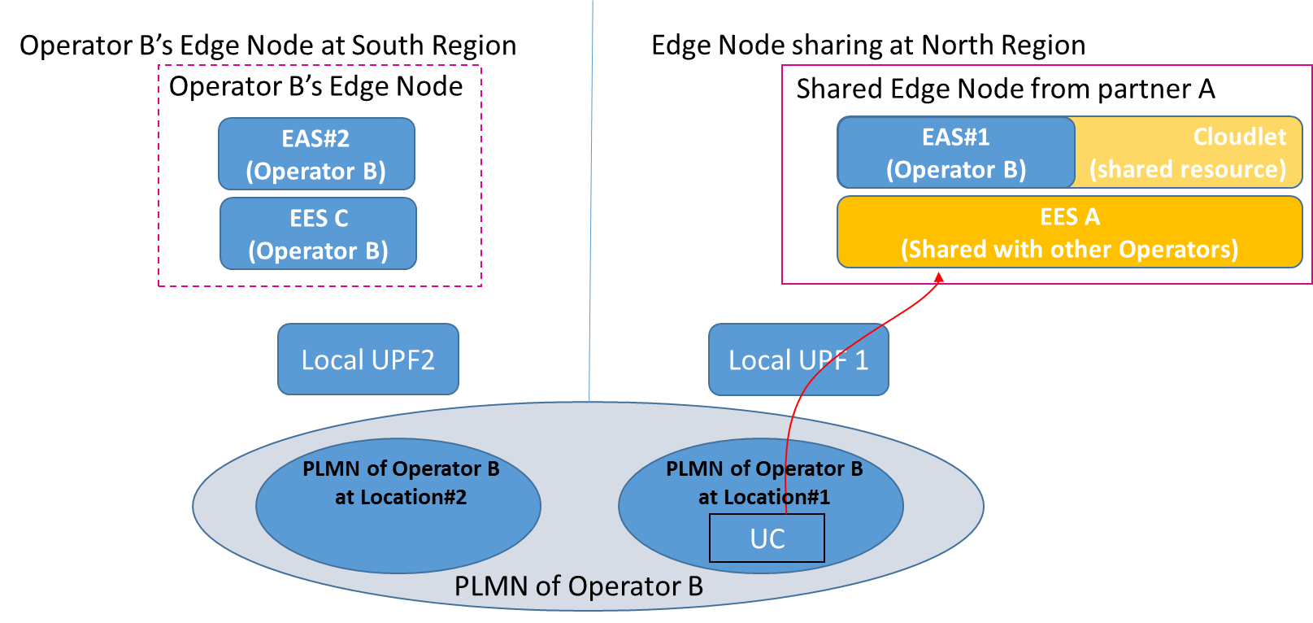

**Figure1-1: Deployment without Home OP’s local DN at Edge Node sharing location**

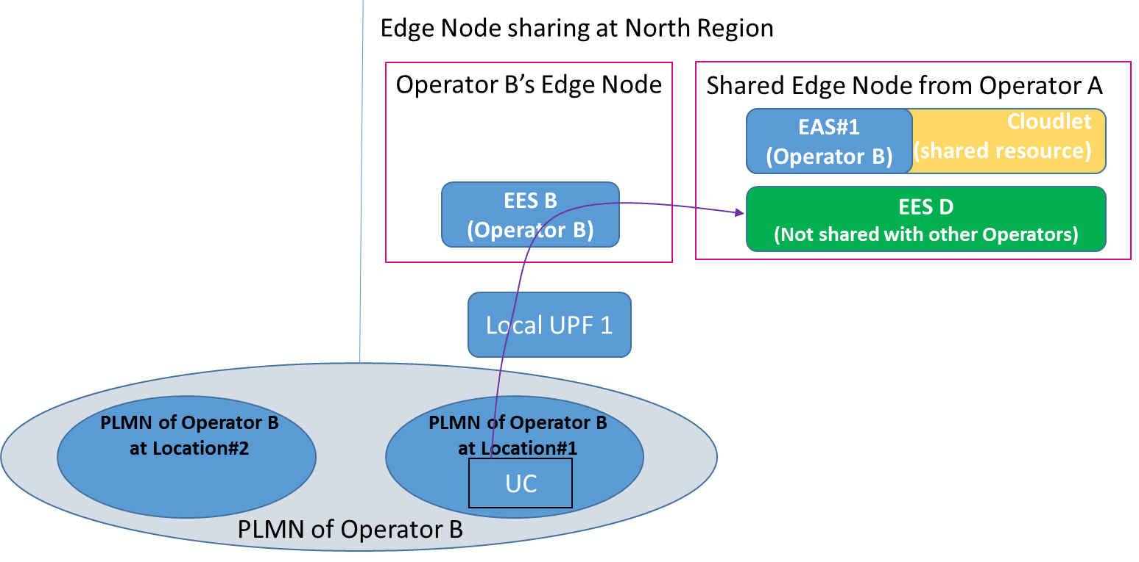

**Figure1-2: Deployment with Home OP’s local DN at Edge Node sharing location**

Q7: Which interpretation of the Edge Node Sharing deployment is the correct understanding? Interpretation 1-1, or Interpretation 1-2 or both?

Q8：If Operator B deploys its own EES (EES-C in figure 1-1) in a non-Edge Node sharing region (South region)? Should Do Operator B’s UCs haves to connect to EES C firstin figure 1-1, then to EES A (e.g., after getting redirected to EES A by EES C) to discover EAS#1?

SA6 would like to request answers to the above questions from GSMA OPG

# 2 Actions

**To GSMA OPG**

**ACTION:** SA6 requests GSMA to provide response to the questions in order to proceed the work in SA6 for edge node sharing.

# 3 Dates of next TSG SA WG 6 meetings

SA6#50-e 22nd August – 31st August 2022 online meeting

SA6#51-e 10th October – 19th October 2022 online meeting