3GPP TSG-SA WG6 Meeting #48-e S6-220580
e-meeting, 5th – 14th April 2022 (revision of S6-22xxxx)

Source: China Mobile, Huawei
Title: Deployment models
Spec: 3GPP TR 23.700-99
Agenda item: 9.4
Document for: Approval
Contact: Shaowen Zheng, zhengshaowen@chinamobile.com

1. Introduction
This paper proposes the deployment models for NSCE.
2. Reason for Change
The NSCE service have different deployment models in the scenarios regarding to the EDGE and NPN. This proposal describes examples of deployment models with respect to different deployment scenarios.
Also, the NSCE server should support the centralized and distributed deployment, the NSCE server(s) will have different deployment models and different relation with VAL server and 3GPP system. This proposal also describes examples of deployment models of NSCE server(s) in relation to VAL server and 3GPP system.
3. Conclusions
<Conclusion part (optional)>
4. Proposal
It is proposed to agree the following changes to 3GPP TR 23.700-99 v 0.5.0.

* * * First Change * * * *

X Deployment models

X.1 Deployment scenarios
The NSCE service provides application layer enablement to support the network slice management and control in addition to control and management plane capabilities from SA2 and SA5 pertaining to network slicing.
Usually a network slice may be available in the whole PLMN or in one or more Tracking Areas of the PLMN. The NSCE application service area is the area where the Network Slice Capability Enablement server owner provides its services, it could equal to or larger than the union of service area(s) of slice(s) the NSCE server could managed, as long as it is accessible.
A network slice will have only one owner and one NSCE service provider. But the NSCE service provider and slice owner may be different, for example the slice owner is VAL, but the NSCE service provider is MNO

This clause describes examples of deployment models with respect to different deployment scenarios as follows:
Scenario 1 shows a fundamental deployment of NSCE server. With PLMN slice(s) covering the whole PLMN, the NSCE server is deployed in the Centralized Data Network to provide the network slice capabilities exposure application service.
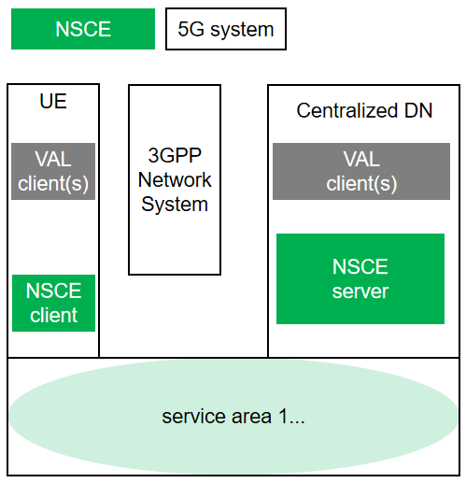
Figure X.1-1: Illustration of centralized NSCE deployment
Scenario 2 shows the edge deployment of NSCE server. With slice(s) covering a certain area, the NSCE server is deployed in the Edge Data Network 1, to provide the network slice capabilities exposure application service. Multiple edge NSCE servers could be distributed deployed as requested.
In this scenario, the slice service area could equivalent to the edge NSCE application service area.
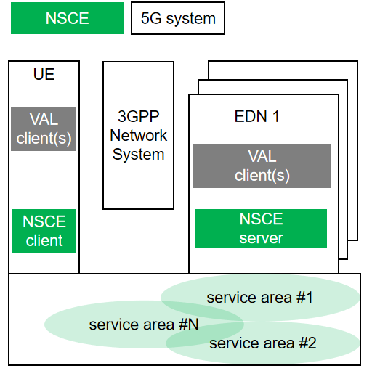
Figure X.1-2: Illustration of edge NSCE deployment
Scenario 3 shows the hierarchical deployment of NSCE server. In this scenario, both centralized NSCE server and distributed NSCE server exist. The centralized NSCE server could perform unified authentication, batch processing to avoid the frequent interaction between the OAM system and multiple NSCE server, to provide a global view of slices. While the edge NSCE server could enable slice management more flexibly and quickly, while ensuring the isolation of the network.
NSCE server #1 deployed in the PLMN A has the service area covering the whole PLMN and managing the PLMN slice covering the whole PLMN, in which case, such kind of NSCE service is most likely provided by MNO. NSCE server #2 deployed in the NPN only covers the service area #2, it could be provided by MNO or vertical. NSCE server #3 deployed in the EDN covers the service area #3. NSCE server #3 could be provided by different providers like MNO or vertical.
One slice would have only one owner and network slice management enablement service provider. But the service provider and the slice owner could be different.
Most likely, the slice#2 and slice#3 is owned by MNO and managed by VAL/MNO, but the case that the slice owned by VAL and managed by VAL also valid.
In some hierarchical deployments, access to the 3GPP network may be restricted to a single NSCE server, then interaction between NSCE servers may be required to support the acquisition of slice information to meet the needs of slice monitoring.

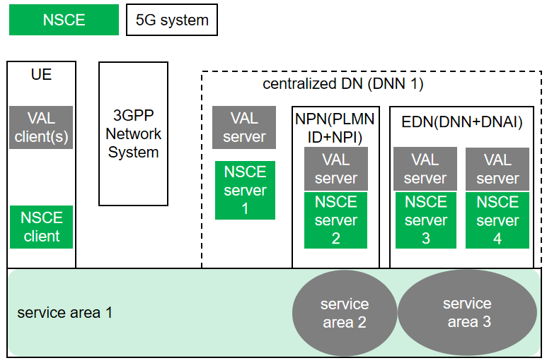
Figure X.1-3: Illustration of hierarchical NSCE deployment

X.2 Deployment of NSCE server(s) in relation to VAL server and 3GPP system
To support the centralized/distributed, and hierarchical deployment, the NSCE server(s) will have different deployment models and different relation with VAL server and 3GPP system. This clause describes examples of deployment models of NSCE server(s) in relation to VAL server and 3GPP system.
Figure X.2-1 illustrates the centralized NSCE deployment. The NSCE server could be deployed in PLMN domain by MNO, or deployed in VAL service provider domain by vertical.
Figure X.2-1: Illustration of centralized NSCE deployment
Figure X.2-2 illustrates the distributed NSCE deployment. The NSCE servers could be deployed in PLMN domain by MNO, deployed in VAL service provider domain by vertical, or deployed in different domain by different provider. The VAL server could communication with multiple NSCE servers via NSCE-S as long as other NSCE servers are discovered and accessible. Or, the VAL server may communicate with other NSCE servers via NSCE-E if needed.
Figure X.2-2: Illustration of distributed NSCE deployment
Figure X.2-3 illustrates the hierarchical deployment of NSCE. The centralized NSCE server is most likely provided by MNO. The distributed NSCE servers could be deployed by MNO, deployed by vertical, or deployed by different provider respectively. The VAL server could communication with multiple NSCE servers via NSCE-S as long as other NSCE servers are discovered and accessible. Or, the VAL server may communicate with other NSCE servers via NSCE-E if needed.

Figure X.2-3: illustration of hierarchical deployment

* * * Next Change * * * *
<Proposed change in revision marks>

* * * Next Change * * * *
<Proposed change in revision marks>

