**3GPP TSG-SA WG6 Meeting #48-e S6-220576**

**05th – 14th April 2022, Online (revision of S6-220xxx)**

**Source: vivo**

**Title: New KI on service switch in PIN**

**Document for: Approval**

**Agenda Item: 9.13**

**1. Introduction**

A new KI for PINAPP is proposed. The KI is for a service switch scenario.

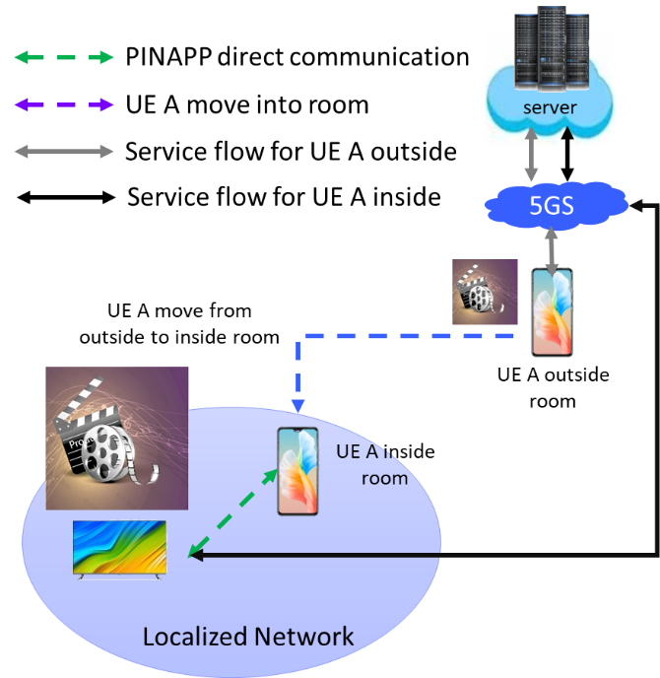

Figure 1-1: Service switch scenarios in PINAPP

When UE A located outside of room, the UE display the video on UE screen. UE 1 has the 5GS connection to application server.

When UE A move inside the room, there is a PIN deployed inside the room. And some of the PINAPP in PIN has the capability, for example, to display the video or music, and the PINAPP has better experience than the UE. It is possible to the PINAPP to represent UE to display content and to have a service switch.

So, when UE moves into the coverage of PIN, it may have the following actions:

- UE discovers the PINAPP which has the specific capability, for example, to display the video

- UE switches the video from UE to the PINAPP

- The PINAPP in PIN interacts with server and display the video

**2. Proposal**

It is proposed to agree the following text in 3GPP TR 23.700-78 v 0.1.0.

* * * * First change * * * *

# 4 Key issues

## 4.1 Key issue #a: Service switch in PIN

As indicated in clause 6.38 of TS 22.261[x], the following requirements will be studied in this TR phase and reflect in this key issues:

- The 5G system shall support mechanisms to aggregate, switch or split the service between non-3GPP RAT and PIN direct connections using licensed spectrum.

- The 5G system shall support applications on an Application Server connected to a CPN or PIN.

When UE is located outside of PIN, the UE has the direct connection to application server via 5GS. When UE moves into the coverage of PIN, some of the PINAPP in PIN has the capability, for example, to terminate the application traffic from application server. These PINAPPs have better experience than the UE, in screen or sound. It is possible for UE to switch the application traffic to the PINAPP to enrich a better experience at home or office.

It is required to study the following:

- How to realize the service switch from UE towards PINAPP by application mechanism in PIN?

NOTE: The coordination with SA2 about the support for switching application traffic between RATs is needed.

## 4.2 Key issue #x: <Title>

This clause describes the key issue with a suitable title. Please provide a high-level description of the key issue along with a list of open issues.

* * * * Next change * * * *

# 9 Overall evaluation

This clause provides a summary of architecture enhancements and solution evaluations.

## 9.1 Architecture enhancements

## 9.2 Key issue evaluations

### 9.2.1 General

All the key issues, solutions and architecture enhancements specified in this technical report are listed in Table 9.2.1-1.

Table 9.2.1-1 provides a mapping of the key issues to the related solutions. It also indicates whether the solution requires enhancement to the Release-17 architecture and lists the dependencies on other working groups.

Table 9.2.1-1 Key issue and solutions

| Key issues (evaluation clause reference) | Solution | Architectural enhancement  (clause reference) | Enhancements required | Dependency on other working groups |
| --- | --- | --- | --- | --- |
| KI #a PIN Management |  |  |  |  |
| *KI#1: <title>* | *Solution #x: <title>* | *6.x* | *Architecture / None* | *<WG>* |
| *Solution #y: <title>* | *6.y* | *Architecture / None* | *<WG>* |

### 9.2.2 Evaluation of key issue #a: Service switch in PIN

### 9.2.x Evaluation of key issue #x

This clause provides an overall evaluation of all the solutions defined for Key Issue #x.

* * * * End of changes * * * *