3GPP TSG-SA WG6 Meeting #47-e S6-220254
e-meeting, 14th – 22nd February 2022 (revision of S6-xxxx)

Source: Huawei, Hisilicon
Title: Solution on ACR scenario overlapping
Spec: 3GPP TR 23.700-98 v0.4.0
Agenda item: 9.9
Document for: Approval
Contact: Yajie Hu <Huyajie1@huawei.com>

1. Introduction
This pCR provides a Solution on ACR scenario overlapping.
2. Reason for Change
In current specification, multiple entities can detect ACR event and perform ACR procedure, so it may happen AC(s)/EEC has different capabilities with EAS(s)/EES, and select different approaches.
Firstly, the EES has all the information from UE side (AC profile) and EAS side regarding the ACR scenarios supported by the respective entities.
Secondly, not all ACR scenarios supported by ACs may be deployed by the EES.
So, EES is the best entity to determine which ACR approach can be enabled for the AC and EAS considering the detailed information (e.g EAS features, KPIs) of both the AC and the EAS and thus also avoiding the overlap of ACR initiations by multiple entities which introduce unnecessary signalling to resolve co-existence issues.
3. Conclusions
<Conclusion part (optional)>
4. Proposal
It is proposed to agree the following changes to 3GPP TR 23.700-98.

* * * First Change * * * *

7.X Solution #x: EES determines the selected ACR scenario

7.x.1 Architecture enhancements
None.

7.x.2 Solution description

7.x.2.1 General
The following solution corresponds to the key issue#x on overlapping of ACR scenario in clause 4.x

7.x.2.2 Procedure
In this solution, the EES is responsible to determine the selected ACR scenario for each AC based on the ACR scenarios supported by AC, EEC, EES and EAS. When the EES determines the selected ACR scenario for one AC, the EES will send the selected ACR scenario for the AC to the EEC and the EAS, then the EEC will notify the AC with the selected ACR scenario. With this solution the EES can determine which ACR approach can be enabled for the AC and EAS considering the detailed information (e.g EAS features, KPIs) of both the AC and the EAS and thus also avoiding the overlapping of ACR initiations by multiple entities which introduce unnecessary signalling to resolve co-existence issues.
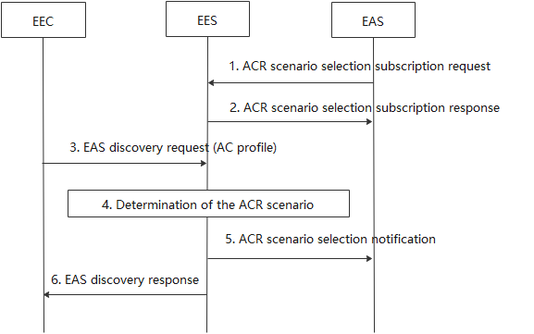
Figure 7.x.2.2-1: EES determines the selected ACR scenario
- The EAS sends an AC information subscription request to the EES. The request contains EAS ID and the EAS service continuity support indicating which ACR scenarios are supported by the EAS.
- The EES sends an AC information subscription response to the EAS with the subscription result.
- The EEC sends the EAS discovery reqeust to the EES, the request contains the AC service continuity support and EEC service continuity support incidateing which ACR scenarios are supported by the AC and the EEC.
- Upon the EES obtains the all the information from UE side (AC and EEC) and EAS side regarding the ACR scenarios supported by the respective entities, then the EES determines one suitable ACR scenario for the AC.
- The EES sends the AC information notification to the EAS, the notification contains the selected ACR scenario and related ACID.
- The EES sends the EAS discovery response to the EEC including the selected ACR scenario and related ACID, then the EEC may notify the AC with the selected ACR scenario.

7.x.3 Solution evaluation

* * * End of Change * * * *

