3GPP TSG-SA WG6 Meeting #47-e S6-220252
e-meeting, 14th – 22nd February 2022 (revision of S6-xxxx)

Source: Huawei, Hisilicon
Title: Key issue on EAS discovery in roaming scenario
Spec: 3GPP TR 23.700-98 v0.4.0
Agenda item: 9.9
Document for: Approval
Contact: Yajie Hu <Huyajie1@huawei.com>

1. Introduction
This pCR provides a Key issue on EAS discovery in roaming scenario.
2. Reason for Change
In some deployment case, the EAS#4 can be deployed by the ECSP1/PLMN 1 but register to the EES#2 which belongs to the ECSP2/PLMN2 based on the business relationship. In such case, it is not clear how to discover and determine the EAS in the initial EAS discovery procedure. Furthermore, it is also not clear how to discover and determine the T-EAS when ACR happens.
3. Conclusions
<Conclusion part (optional)>
4. Proposal
It is proposed to agree the following changes to 3GPP TR 23.700-98.

* * * First Change * * * *

4.X Key issue #X: EAS discovery in roaming scenario
In some deployment case, the EAS#4 can be deployed by the ECSP1/PLMN 1 but register to the EES which belongs to the ECSP2/PLMN2 based on the business relationship. The EAS#1-3 can only provide edge computing service for the user of ECSP1/PLMN 1. ECSP1/HPLMN wants to provide edge computing service in the partner ECSP or VPLMN to its users, so the ECSP1/HPLMN can determine to only deploy EAS in the partner ECSP or VPLMN to provide service for its user. In such case, it is not clear how to discover and determine the EAS in the initial EAS discovery procedure. Furthermore, it is also not clear how to discover and determine the T-EAS when ACR happens.
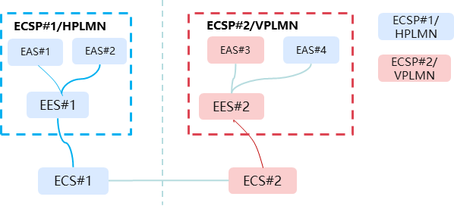
Figure 4.x-1 EAS deployed by different ECSPs or PLMNs
The following study is needed:
- How can EES discover and determine a suitable EAS in the initial EAS discovery procedure?
- How can T-EES discover and determine a suitable T-EAS in the T-EAS discovery procedure when ACR happens across ECSP or PLMN?

* * * End of Change * * * *

