3GPP TSG-SA WG6 Meeting #36-BIS-e S6-200514
E-meeting, 31st March – 8th April 2020 (revision of S6-20xxxx)

Source: Huawei, Hisilicon
Title: Deployment models update
Spec: 3GPP TS 23.558 v0.1.2
Agenda item: 7.4
Document for: Approval
Contact: Cuili Ge – geuili@huawei.com

1. Introduction
This pCRis proposed to update the deployment models in Annex A.
2. Reason for Change
(1) Currently in Annex A.2, one DNAI is mapped to a single UPF. As per 5GC specifications, multiple UPFs can be associated with a DNAI.
(2) Also as per 5GC specifications, a DNAI is not associated with any particular DN, and multiple DNs can be associated with the same DNAI. The text in A.2 needs to be aligned with such understanding.
(3) For using LADN to support edge computing service, there are two types usage of LADN to suuport edge computing service. One option is that the LADN service area of a LADN is mapped to a single EDN, and the other option is that the subset of the tracking areas corresponding to the LADN service area of a LADN is mapped to an EDN, thus allowing multiple EDNs to be mapped to the LADN service area of a LADN. So in option#3, one EDN is either identified by LADN DNN or by LADN DNN and subset of tracking areas of a LADN service area.
3. Conclusions
4. Proposal
It is proposed to agree the following changes to 3GPP TS 23.558 v0.1.2.

* * * First Change * * * *

A.2 Deployment models for different DN implementations
This clause describes examples of deployment models with respect to different DN implementations as follows: option 1. use of non-dedicated DN, option 2. use of Edge-dedicated DN, and option 3. use of LADN.
The PLMN supporting edge computing services provides connection to one or multiple DNs.
The following clauses describes the detailed deployment models including relationships between EDN service areas and PLMN area.

A.2.1 Option 1. Use of non-dedicated DN
There is no Edge-dedicated DN for support of edge computing service. A DN common to other services (e.g. internet access) is used to connect to the Edge Application Servers.
The PLMN supporting edge computing services provides connection to EDNs that respectively corresponds to one or more DNAI(s), and each EDN is identified by DNN and one or more DNAI. UEs establishing PDU sessions for the Edge Application Servers identify the DN using the same DNN and slice information as for PDU sessions for non-Edge services.
UEs can access an Edge Application Server or an Edge Enabler Server regardless of their location within PLMN area via local breakout.

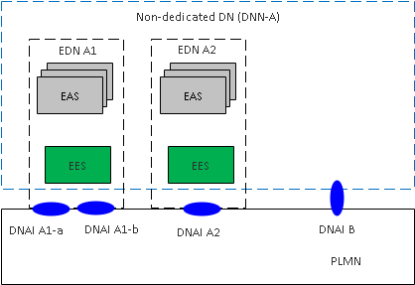
Figure A.2.1-1. Option 1. Use of non-dedicated DN

A.2.2 Option 2. Use of Edge-dedicated DN
The deployment uses Edge-dedicated DNs for support of edge computing service. Each Edge-dedicated DN is configured with one unqiue DNN.
The PLMN supporting edge computing services provides connection to several EDNs that correspond to one or more DNAI(s), and each EDN is identified by DNN of the Edge-dedicated DN and one or more DNAI.

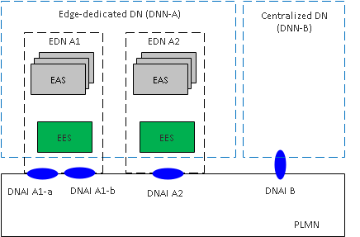
Figure A.2.2-1. Option 2. Use of dedicated DN with Local DN(s)

A.2.3 Option 3. Use of LADN
Edge computing services are provided via Edge-dedicated Data Networks deployed as LADNs. The PLMN supports edge computing services in the EDN service areas which can be identified by the respective LADN DNNs or LADN DNN and subset of Tracking Areas corresponding to the LADN service area. The LADN service area is the service area that the Edge Computing is supported.
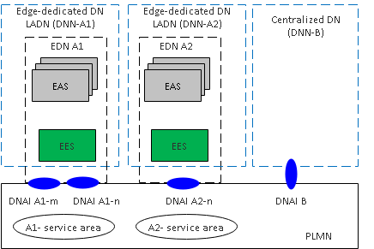
Figure A.2.3-1. Option 3. Use of LADN(s)

