3GPP TSG-SA WG6 Meeting #49-e S6-22xxxx
e-meeting, 16th – 25th May 2022 (revision of S6-221401)

Source: Ericsson
Title: Federated EAS discovery
Spec: 3GPP TS 23.700-98 v0.6.0
Agenda item: 9.8
Document for: Approval
Contact: Wenliang Xu; wenliang.xu@ericsson.com

1. Introduction
This contribution proposes a new solution for KI#6 and KI#22.
2. Reason for Change
For the case where there are several EDNs coverage for the current UE location and the contracted OP for the EEC cannot provide a desired EAS in its EDN, this solution offers an option so that the EEC contracted OP can use its partner’s OP to discover the desired EAS in the partner’s EDN for the UE.
For CC on June 1st:
The OPG.02 has a service flow depicting inter-OP communication to satisfy an UC (i.e. EEC in the EDGEAPP term) application discovery request. The UC is not aware of the presence of OP Partner, which is also mentioned in clause 3.3.5 of OPG.02:
The East/Westbound interface enables Operator B's OP to retrieve the application instance
access information and provide it to the user. This approach allows performing service
discovery and delivery in the same way as when the application was delivered from a
Cloudlet in Operator B's own network.
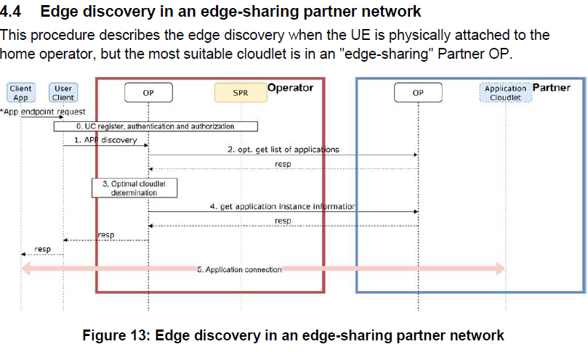
3. Conclusions
<Conclusion part (optional)>
4. Proposal
It is proposed to agree the following changes in TS 23.700-98.

* * * First Change * * * *

7.x Solution #XX: EAS discovery for Edge node sharing

7.x.1 Architecture enhancements
None.

7.x.2 Solution description
As specified in clause 3.5.4.3.3 of GSMA OPG.02 Operator Platform Telco Edge Requirements (version 2.0), Edge node sharing is a scenario wherein an OP, when serving the UNI requests originating from (its own) UCs (i.e. EEC in EDGEAPP term), decides to provide the application from the Edge nodes of a partner OP, it has the following requirements for the E/WBI service:
1. Publish Application, including application metadata information (including information about the policies controlling application distribution restrictions);
- Availability Zones;
- Unpublish application;
- Get a list of Applications;
- Get Application instance information;
This solution addressed how to discover an EAS that is deployed in the partner’s OP (i.e. OP-A) in edge node sharing case, corresponding to requirement 4 and 5 above. Figure 7.x.2-1 shows relationship between EDGEAPP architecture and GSMA OPG architecture as depicted in 3GPP TS 23.558 [2] Annex D with EDGE-10 connection between ECS of two operator platforms. The two operator platforms can communicate with each other via EDGE-9 and EDGE-10.
Assumption is that the EEC in UE does not have access directly to enabler/configuration server in the OP-A (e.g. the EEC is not authorized to access ECS and EES in OP-A, or there is no connectivity between the EEC and OP-A), the OP-B has SLA with OP-A and servers in OP-B can serve the EEC directly (e.g. the EEC has connectivity with OP-B and is authorized to access ECS and EES in OP-B). For the AC in UE, it can access EAS(s) deployed in OP-A. This is based on figure 4.22-1 in KI#22 and figure 3 in GSMA OPG.02 Operator Platform Telco Edge Requirements (version 2.0) where the application (instance) retrieval relies on E/WBI between OPs.
NOTE: A subscriber of Operator B accesses its home network/operator platform and asks for the required Edge-Enhanced or Edge-Native Application. When Operator B's OP identifies that the most suitable edge node is in Partner A, Operator B's OP requests the Edge Cloud service through the E/WBI to Partner A's OP. This may be due to the Operator's policy controls, specific Application Provider restrictions, due to constraints originating from the federation agreement between the Operators and others.
Editor's Note: It is needed to verify this assumption with edge node sharing described in GSMA OPG.02.
For the case where there are several EDNs coverage for the current UE location and the contracted OP for the EEC cannot provide a desired EAS in its EDN, this solution offers an option so that the EEC contracted OP can use its partner’s OP to discover the desired EAS in the partner’s EDN for the UE.
Figure 7.x.2-1: Relationship between EDGEAPP architecture and GSMA OPG reference architecture
Figure 7.x.2-2: EAS discovery for edge node sharing
In step 0, the EAS may be registered in EES of OP-A over EDGE-3 reference point. The EAS may be dynamically instantiated during EAS discovery processing on the EES (OP-A) and then registered in the EES (OP-A).
NOTE: The EES (OP-A) also registers into the ECS (OP-A) via EDGE-6 reference point, which is not shown for simplicity.
In step 1, the service provisioning request happens over EDGE-4 reference point.
In step 2, the ECS (OP-B) cannot find any EAS in the EES profile being registered so it determines to use edge service from its partner OP-A.
In step 3, based on SLA between OPs, the T-EES discovery procedure happens as described in step 3 of solution#5 via EDGE-10 reference point.
NOTE 1: The ECS (OP-B) can have SLA with other multiple OPs and need to repeat step 3 with more than one partner OP in order to discover T-EES.
In step 4, the service provisioning response includes the EES (OP-A) endpoint and the ECS (OP-B) determined EES (OP-B) endpoint. The endpoint of EES (OP-B) is determined based on SLA with OP-A so that the EES (OP-B) can be authorized by the EES (OP-A). The endpoint of EES (OP-A) is sent by EES in a way that is transparent to EEC.
NOTE 2: OP-A can have ECSP level SLA with OP-B so that any EES from OP-B can be authorized by the EES (OP-A)
In step 5, the EEC sends EAS discovery request to EES (OP-B) over EDGE-1 reference point and include the endpoint of EES (OP-A) in the request. The endpoint of EES (OP-A) is transferred between the ECS (OP-B) and the EES (OP-B) transparently to the EEC.
NOTE 3: How the EES (OP-A) endpoint is transferred in a transparent way to EEC between the ECS (OP-B) and the EES (OP-B) is in the scope of SA3.
In step 6, the EES (OP-B) validates the edge service SLA and sends EAS discovery request over EDGE-9 reference point to the EES (OP-A).
In step 7, the EES (OP-A) validates the edge service SLA and returns EAS discovery response including the discovered candidate EAS(s) to the EES (OP-B).
In step 8, the EEC receives the EAS discovery response sent by the EES (OP-B). The EEC may select an EAS for the AC.

7.x.3 Solution evaluation
This solution addresses KI#22 for the EAS discovery in edge node sharing case.
This solution also addresses KI#6 for Edge services support across ECSPs, specifically the open issue about how the ECS can discover a T-EES having SLA with S-EES based on the federation agreements between ECSPs before EDGE-9 interaction.
* * * End of Changes * * * *

