3GPP TSG-SA5 (Telecom Management) S5-110280
Meeting SA5#75, 24 - 28 Jan 2011, Sorrento, ITALY revision of S5-110148
CR-Form-v9.6
CHANGE REQUEST
 | 32.172 | CR | 0026 |  rev | 1 |  Current version: | 10.1.0 | 
For HELP on using this form look at the pop-up text over the  symbols. Comprehensive instructions on how to use this form can be found at http://www.3gpp.org/specs/CR.htm.

Proposed change affects:  | UICC apps |  | ME |  | Radio Access Network |  | Core Network | X

Title:  | Improve Subscription Management (SuM) Network Resource Model (NRM) Integration Reference Point (IRP) access service modelling
Source to WG:  | Ericsson
Source to TSG:  | S5
Work item code:  | OAM10-SuM |  |  |  |  |  |  | Date:  |  | 28/01/2011
Category:  | C |  |  |  |  |  |  | Release:  |  | Rel-10
 | Use one of the following categories:  F (correction)  A (corresponds to a correction in an earlier release)  B (addition of feature),  C (functional modification of feature)  D (editorial modification)  Detailed explanations of the above categories can  be found in 3GPP TR 21.900. |  |  |  |  |  |  |  | Use one of the following releases:  R99 (Release 1999)  Rel-4 (Release 4)  Rel-5 (Release 5)  Rel-6 (Release 6)  Rel-7 (Release 7)  Rel-8 (Release 8)  Rel-9 (Release 9)  Rel-10 (Release 10)
Reason for change:  |  | The existing modelling for packet access network Service Profile in SuM NRM IS Rel-9 is found to have some drawbacks:  - SuM NRM IRP should not expose all network details (i.e., data attribute sharing among different Service Profile instances) to IRP Manager directly. Instead, it shall provide a transparent layer and hide data/node complexity to IRP Manager;  - The added value or features of SuM NRM IRP shall be not only transportation protocol translation but also data information model translation;  - It requires more extra operations between IRP Manager and IRP Agent to provision a Service Profile instance;  - It introduces possible problems for data consistency and atomic operation.  The current attribute definition of Circuit Switch access network Service Profile is out of date and needs to be aligned with TS 23.008.
Summary of change:  |  | - The naming diagram is updated to remove unnecessary IOCs;  - The Service Profile NRM association diagram is updated;  - The inheritance diagrams are updated to introduce new IOCs: PSCommonServiceProfile, Common3GPPAccessServiceProfile;  - The attributes of CSServiceProfile are updated according to the latest revision of TS 23.008;  - The attributes of CSServiceProfile, GPRSServiceProfile and EPSServiceProfile are re-organized according to new modelling way;  - New definitions of PSCommonServiceProfile and Common3GPPAccessServiceProfile are introduced.
Consequences if   not approved: |  | Inefficient modelling way and obsolete attributes.
Clauses affected:  |  | 6.2.1, 6.2.2, 6.3.12.2, 6.3.13.2, 6.3.29.2, 6.3.30, 6.3.X (new), 6.5.1
 |  | Y | N
Other specs  |  |  | x | Other core specifications 
affected: |  |  | x | Test specifications
 |  | x |  | O&M Specifications |  |  | 32.176
Other comments: 

1st Modified Section

6.2 Class diagram

6.2.1 Attributes and relationships
This clause depicts the set of IOCs that encapsulate information relevant for this service. This sub-clause provides the overview of all information object classes in UML. Subsequent clauses provide more detailed specification of various aspects of these Information Object Classes (IOCs).
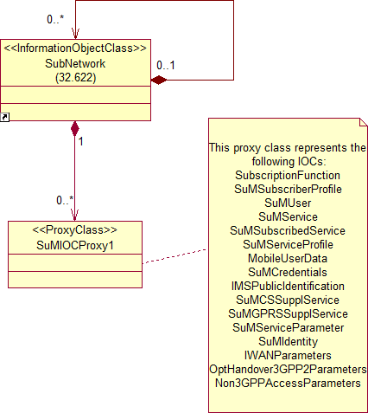
Figure 1a: SuM NRM naming diagram 1

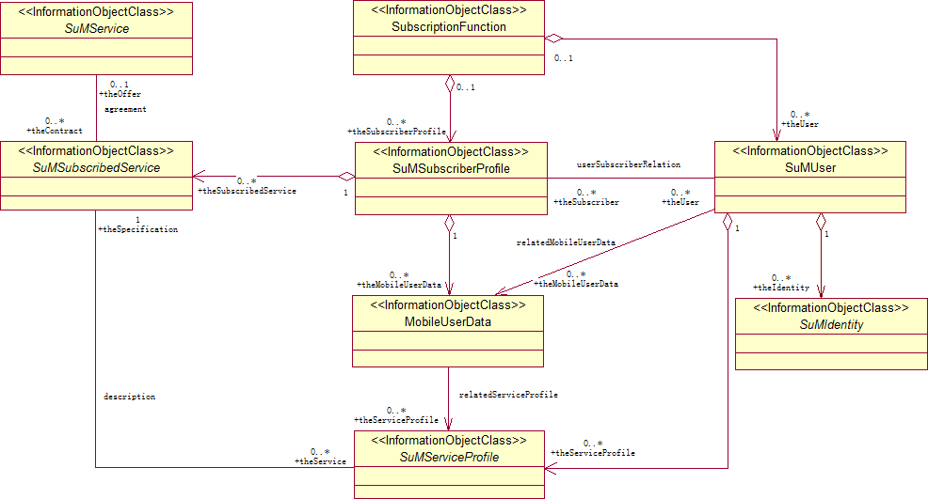
Figure 1b: SuM NRM Containment and Association diagram 1
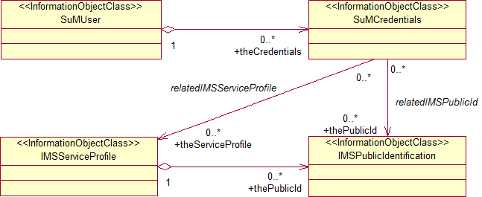
Figure 1c: SuM NRM Containment and Association diagram 2

Figure 1d: SuM Supplementary Service NRM Aggregation diagram 1

Figure 1e: SuM Supplementary Service NRM Aggregation diagram 2

Figure 1f: SuM Supplementary Service NRM Aggregation diagram 3

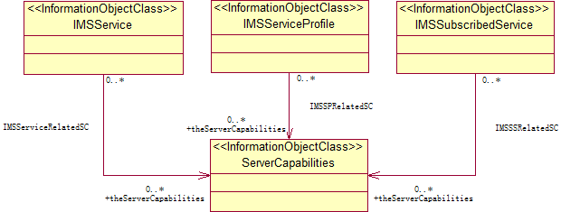
Figure 1g: SuM IMS Service Containment and Association diagram 1

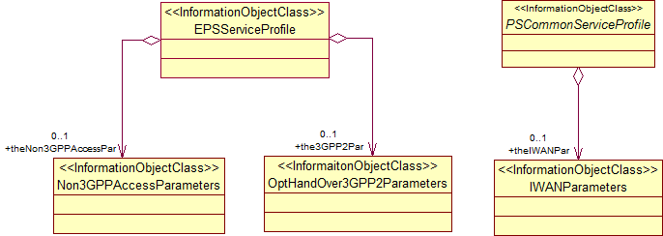

Figure 1.h: Service Profile NRM Association diagram

6.2.2 Inheritance
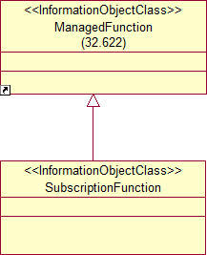

Figure 2a: SuM NRM Inheritance Hierarchy 1

Figure 2b: SuM NRM Inheritance Hierarchy 2

Figure 2c: SuM NRM Inheritance Hierarchy 3

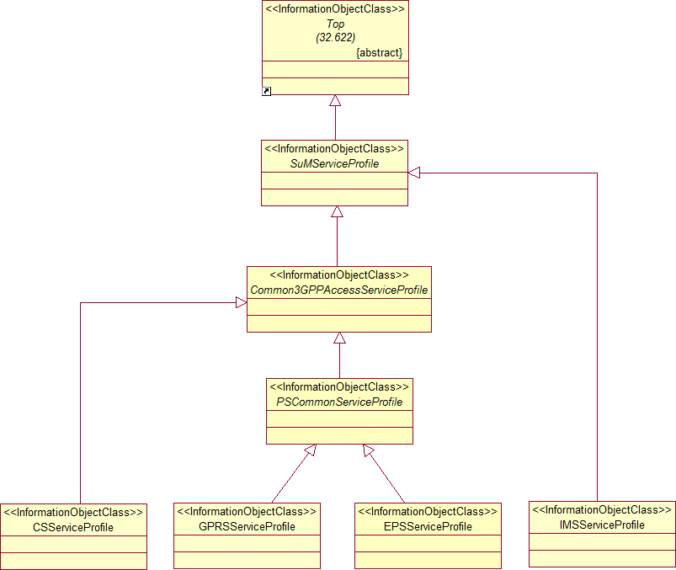

Figure 2d: SuM NRM Inheritance Hierarchy 4
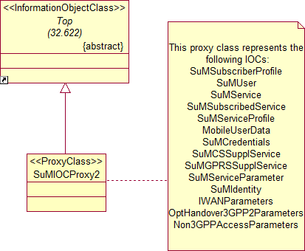

Figure 2e: SuM NRM Inheritance Hierarchy 5

Figure 2f: Void

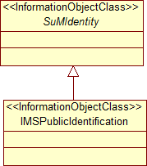
Figure 2g: SuM NRM Inheritance Hierarchy 8

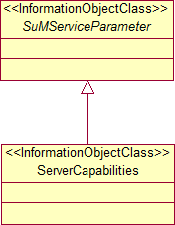
Figure 2h: SuM NRM Inheritance Hierarchy 9
Next Modified Section

6.3.12 CSServiceProfile

6.3.12.1 Definition
This class represents for a subscribed CS service (see 3GPP TS 23.008 [7]) the service preferences and settings chosen for a user.

6.3.12.2 Attributes

Attributes of CSServiceProfile
Attribute name | Support Qualifier | Read Qualifier | Write Qualifier
networkAccessMode | M | M | M
basicMSISDNIndicator | O | M | M
mSISDNAlertIndicator | O | M | M
vLRNumber | M | M | -
mSCNumber | M | M | -
subscriptionRestriction | O | M | M
rSZIlists | O | M | M
mSCAreaRestrictedFlag | M | M | -
oDBinducedBarringData | O | M | -
roamingRestrictionDueToUnsupportedFeature | M | M | -
lSAIdentity | O | M | M
lSAPriority | O | M | M
lSAPreferentialAccessIndicator | O | M | M
lSAActiveModeSupportIndicator | O | M | M
lSAOnlyAccessIndicator | O | M | M
lSAActiveModeIndicator | O | M | M
vPLMNIdentifier | O | M | M
accessRestrictionData | O | M | M
privacyExceptionList | O | M | M
gMLCNumbers | O | M | M
mOLRList | O | M | M
serviceTypes | O | M | M
ageIndicator | O | M | -
lMSI | M | M | -
mobileStationCategory | M | M | M
lMUIdentifier | O | M | M
mNRRMSC | M | M | -
subscriberStatus | O | M | 
notificationToCSEFlagForODB | O | M | -
gsmSCFaddresslistForODB | O | M | -
messagesWaitingData | O | M | -
mobileStationNotReachableFlag | O | M | -
memoryCapacityExceededFlag | M | M | -
traceReference | O | M | -
traceType | O | M | -
operationsSystemsIdentity | O | M | -
hLRTraceType | O | M | -
mAPErrorOnTrace | O | M | -
traceActivatedInVLR | O | M | -
provisionOfBearerService | M | M | M
provisionOfTeleservice | M | M | M
bCAllocation | O | M | M
checkSSIndicator | M | M | -
mSPurgedForNonGPRSFlag | M | M | -
barringOfOutgoingCalls | O | M | M
barringOfIncomingCalls | O | M | M
barringOfRoaming | O | M | M
barringOfPremiumRateCalls | O | M | M
barringOfSupplementaryServiceManagement | O | M | M
barringOfRegistrationOfCallForwarding | O | M | M
barringOfInvocationOfCallTransfer | O | M | M
operatorDeterminedBarringPLMNspecificData | O | M | M
vGCSGroupMembershipList | O | M | M
vBSGroupMembershipList | O | M | M
broadcastCallInitiationAllowedList | O | M | M
originatingCAMELSubscriptionInformationOCSI | O | M | M
terminatingCAMELSubscriptionInformationTCSI | O | M | M
vMSCTerminatingCAMELSubscriptionInformationVTCSI | O | M | M
locationInformationSubscriberStateInformation | O | M | M
uSSDCAMELSubscriptionInformationUCSI | O | M | M
sSInvocationNotificationSSCSI | O | M | M
translationInformationFlagTIFCSI | O | M | M
dialledServiceCAMELSubscriptionInformationDCSI | O | M | M
uSSDGeneralCAMELServiceInformationUGCSI | O | M | M
oCSINegotiatedCAMELCapabilityHandling | O | M | -
sSCSINegotiatedCAMELCapabilityHandling | O | M | -
vTCSINegotiatedCAMELCapabilityHandling | O | M | -
shortMessageServiceCAMELSubscriptionInformationMOSMSCSI | O | M | M
shortMessageServiceCAMELSubscriptionInformationMTSMSCSI | O | M | M
mOSMSCSIVLRNegotiatedCAMELCapabilityHandling | O | M | -
mTSMSCSIVLRNegotiatedCAMELCapabilityHandling | O | M | M
mCSINegotiatedCAMELCapabilityHandling | O | M | -
vLRSupportedCAMELPhases | O | M | -
gsmSCFaddressforCSI | O | M | M
vLROfferedCAMEL4CSIs | O | M | -
iSTAlertTimer | O | M | M
cSAllocationRetentionpriority | O | M | M
TraceReference2 | O | M | -
TraceDepth | O | M | -
ListofNeTypestoTrace | O | M | -
TriggeringEvents | O | M | -
ListofInterfacestoTrace | O | M | -
iCSIndicator | O | M | M

6.3.12.3 Attribute constraints
The optional attributes shall be supported for the following criteria: The NE supports the parameter (see TS 23.008 [7]).

Next Modified Section

6.3.13 GPRSSServiceProfile

6.3.13.1 Definition
This class represents for a subscribed GPRS service (see 3GPP TS 23.008 [7]) the service preferences and settings chosen for a user.

6.3.13.2 Attributes

Attributes of GPRSServiceProfile
Attribute name | Support Qualifier | Read Qualifier | Write Qualifier
basicMSISDNIndicator | O | M | M
mSISDNAlertIndicator | O | M | M
vLRNumber | M | M | -
lSAIdentity | O | M | M
lSAPriority | O | M | M
lSAPreferentialAccessIndicator | O | M | M
lSAActiveModeSupportIndicator | O | M | M
lSAOnlyAccessIndicator | O | M | M
lSAActiveModeIndicator | O | M | M
vPLMNIdentifier | O | M | M
ageIndicator | O | M | -
sGSNNumber | M | M | -
gGSNNumber | M | M | M
mNRG | M | M | -
provisionofTeleservice | O | M | M
transferofSMoption | M | M | M
mSpurgedforGPRSflag | M | M | -
pDPType | O | M | M
pDPAddress | O | M | M
gGSNlist | M | M | -
qualityofServiceSubscribed | O | M | M
pDPContextIdentifier | O | M | -
pDPContextChargingCharacteristics | O | M | M
gPRSCAMELSubscriptionInformationGPRSCSI | O | M | M
mOShortMessageServiceCAMELSubscriptionInformationMOSMSCSI | O | M | M
mTShortMessageServiceCAMELSubscriptionInformationMTSMSCSI | O | M | M
mOSMSCSISGSNNegotiatedCAMELCapabilityHandling | O | M | M
mTSMSCSISGSNNegotiatedCAMELCapabilityHandling | O | M | M
mobilityManagementforGPRSeventnotificationMGCSI | O | M | M
mGCSINegotiatedCAMELCapabilityHandling | O | M | M
gPRSCSINegotiatedCAMELCapabilityHandling | O | M | -
sGSNSupportedCAMELPhases | O | M | -
sGSNOfferedCAMEL4CSIs | O | M | -
gsmSCFaddressforCSI | O | M | M
gSMSCFaddresslistForODB | O | M | M
iPSMGWNumber | O | M | -
mNRR-SGSN | O | M | -
notificationToCSEFlagForODB | O | M | -
thePSCommonPar | M | M | M

6.3.13.3 Attribute constraints
The optional attributes shall be supported for the following criteria: The NE supports the parameter (see TS 23.008 [7]).

Next Modified Section

6.3.29 EPSServiceProfile

6.3.29.1 Definition
This class represents for a subscribed EPS service (see 3GPP TS 23.008 [7]) the service preferences and settings chosen for a user.

6.3.29.2 Attributes
Attributes of EPSServiceProfile
Attribute name | Support Qualifier | Read Qualifier | Write Qualifier
aPNAMBR | M | M | M
contextIdentifier | M | M | M
pDNAddress | O | M | M
aPNOIReplacement | O | M | M
subscribedUEAMBR | M | M | M
aPNConfigurationProfile | M | M | M
rFSP | O | M | M
pDNGWIdentity | O | M | M
ePSPDNConnectionChargingCharacteristics | O | M | M
vPLMNAddressAllowed-EPS | M | M | M
pDNGWAllocationType | M | M | M
aPNLevelAPNOIReplacement | O | M | M
roamingRestrictionDueToUnsupportedFeatureMME | M | M | -
roamingRestrictionDueToUnsupportedFeatureSGSN | M | M | -
mSPurgedForEPSFlag | M | M | -
uRRPMME | O | M | -
mMEName | M | M | -
sGSNName | M | M | -
iWFNumber | O | M | -
sGSNAreaRestrictedFlag | M | M | -
theOptHandover3GPP2Par | M | M | O
theNon3GPPAccessPar | M | M | O
thePSCommonPar | M | M | M

6.3.29.3 Attribute constraints
The optional attributes shall be supported for the following criteria: The NE supports the parameter (see TS 23.008 [7]).

Next Modified Section

6.3.30 PSCommonServiceProfile

6.3.30.1 Definition
This is an abstract IOC provided for sub-classing only. It provides attribute(s) that are common to PS Service Profile IOCs (Regarding GPRS or EPS service, please see 3GPP TS 23.008 [7]).

6.3.30.2 Attributes

Attributes of PSCommonServiceProfile
Attribute name | Support Qualifier | Read Qualifier | Write Qualifier
id | M | M | -
rSZIlists | O | M | M
roamingRestrictedintheSGSNduetounsupportedfeature | M | M | -
accessRestrictionData | O | M | M
subscriberStatus | O | M | M
barringOfOutgoingCalls | O | M | M
barringOfRoaming | O | M | M
operatorDeterminedBarringPLMNspecificData | O | M | M
barringofPacketOrientedServices | O | M | M
traceReference2 | O | M | -
traceDepth | O | M | -
listOfNETypestoTrace | O | M | -
triggeringEvents | O | M | -
listOfInterfacesToTrace | O | M | -
traceActivatedinSGSN | O | M | -
iPAddressOfTraceCollectionEntity | O | M | -
accessPointName | O | M | M
privacyExceptionList | O | M | M
gMLCNumbers | O | M | M
iCSIndicator | O | M | M
mOLRList | O | M | M
serviceTypes | O | M | M
subscribedChargingCharacteristics | O | M | M
sTNSR | O | M | M
networkAccessMode | M | M | M
closedSubscriberGroupInformation | O | M | M
theIWANPar | M | M | O

6.3.30.3 Attribute constraints
The optional attributes shall be supported for the following criteria: The NE supports the parameter (see TS 23.008 [7]).

Next Modified Section

6.3.X Common3GPPAccessServiceProfile

6.3.X.1 Definition
This is an abstract IOC provided for sub-classing only. It provides attribute(s) that are common to CS/PS Service Profile IOCs (Regarding CS, GPRS or EPS service, please see 3GPP TS 23.008 [7]).

6.3.X.2 Attributes
Attributes of Common3GPPAccessServiceProfile
Attribute name | Support Qualifier | Read Qualifier | Write Qualifier
rSZIlists | O | M | M
accessRestrictionData | O | M | M
subscriberStatus | O | M | M
barringOfOutgoingCalls | O | M | M
barringOfRoaming | O | M | M
operatorDeterminedBarringPLMNspecificData | O | M | M
traceReference2 | O | M | -
traceDepth | O | M | -
listOfNETypestoTrace | O | M | -
triggeringEvents | O | M | -
listOfInterfacesToTrace | O | M | -
privacyExceptionList | O | M | M
gMLCNumbers | O | M | M
iCSIndicator | O | M | M
mOLRList | O | M | M
serviceTypes | O | M | M
networkAccessMode | M | M | M

6.3.X.3 Attribute constraints
The optional attributes shall be supported for the following criteria: The NE supports the parameter (see TS 23.008 [7]).

Next Modified Section

6.5 Information attribute definitions

6.5.1 Definitions and legal values
The following table defines the attributes that are present in several IOCs of the present document.

Attributes
Attribute Name | Definition | Legal Values
id | An attribute whose ‘name+value’ can be used as an RDN when naming an instance of the SuM information object class. This RDN uniquely identifies the object instance within the scope of its containing (parent) object instance.
suMSubscriberProfileInfo | A description of (information for) the Subscriber Profile. It is with free structure and format.
userLabel | A user-friendly (and user assigned) name of the associated object. IOCs inheriting from ManagedFunction will have this attribute. Other IOCs may have it as well, if explicitly defined for them.
theContract | Models the agreement relationship to a subscribed service. This attribute contains a list of the DN(s) of the related SuMSubscribedService instance(s).
theOffer | Models the agreement relationship to a service. This attribute contains the DN of the related SuMService instance.
theService | Models the description relationship to a service profile. This attribute contains a list of the DN(s) of the related SuMServiceProfile instance(s).
theSpecification | Models the description relationship to a subscribed service. An attribute whose ‘name+value’ can be used as DN when referencing an instance of the SuMSubscribedService object class.
thePublicId | Models the relatedIMSPublicId relationship from a user’s credentials to the IMS Public Identification. This attribute contains a list of the DN(s) of the related IMSPublicIdentification instance(s).
theMobileUserData | Models the relatedMobileUserData relationship from a user to the user data of a mobile User Equipment. This attribute contains a list of the DN(s) of the related MobileUserData instance(s).
theServiceProfile | Models the relatedServiceProfile relationship from the user data of a mobile User Equipment to a service profile or from a user’s credentials to an IMS service profile. This attribute contains a list of the DN(s) of the related SuMServiceProfile derived instance(s).
theSubscriber | Models the userSubscriberRelation relationship from a user to a subscriber. This attribute contains a list of the DN(s) of the related SuMSubscriberProfile instance(s).
theUser | Models the userSubscriberRelation relationship from a subscriber to a user. This attribute contains a list of the DN(s) of the related SuMUser instance(s).
theCSSupplServiceForCS | Models the relationship from a CS service to a CS supplement service. This attribute contains a list of the DN(s) of the aggregated SuMCSSupplService instance(s).
thePSSupplServiceForPS | Models the relationship from a PS service to a PS supplement service. This attribute contains a list of the DN(s) of the aggregated SuMPSSupplService instance(s).
theCSSupplServiceForCSSS | Models the relationship from a CS subscribed service to a CS supplement service. This attribute contains a list of the DN(s) of the aggregated SuMCSSupplService instance(s).
thePSSupplServiceForPSSS | Models the relationship from a PS subscribed service to a PS supplement service. This attribute contains a list of the DN(s) of the aggregated SuMPSSupplService instance(s).
theCSSupplServiceForCSSP | Models the relationship from a CS service profile to a CS supplement service. This attribute contains a list of the DN(s) of the aggregated SuMCSSupplService instance(s).
thePSSupplServiceForPSSP | Models the relationship from a PS service profile to a PS supplement service. This attribute contains a list of the DN(s) of the aggregated SuMPSSupplService instance(s).
theSubscribedService | Models the relationship from a subscriber profile to a subscribed service. This attribute contains a list of the DN(s) of the aggregated SuMSubscribedService derived instance(s).
thePublicId | Models the relationship from an IMS service profile to a public identification. This attribute contains a list of the DN(s) of the aggregated IMSPublicIdentification instance(s).
theUser | Models the relationship from a Subscription Function to a user. This attribute contains a list of the DN(s) of the aggregated SuMUser instance(s).
theSubscriberProfile | Models the relationship from a Subscription Function to a subscriber profile. This attribute contains a list of the DN(s) of the aggregated SuMSubscriberProfile instance(s).
theCredentials | Models the relationship from a user to a credential. This attribute contains a list of the DN(s) of the aggregated SuMCredentials instance(s).
theServiceProfile | Models the relationship from a user to a service profile. This attribute contains a list of the DN(s) of the aggregated SuMServiceProfile instance(s).
theIdentity | Models the relationship from a user to an identity. This attribute contains a list of DN(s) of the related SuMIdentity instance(s).
theServerCapabilities | Models the relationship from a SuM IOC object instance (E.g., IMSService, IMSSubscribedService, IMSServiceProfile) to a Server Capabilities object instance.
thePSCommonParameters | Models the common packet access service profile relationship from either a GPRS service profile or an EPS service profile. This attribute contains one of DN of the related PSCommonParameters instance.
theIWANPar | Models the relationship between the common packet access service parameters and the I-WAN service parameters. This attribute contains the DN of the related IWANParameters instance.
theOptHandover3GPP2Par | Models the relationship between the EPS service profile when designed for optimal handover to a 3GPP2 access network. This attribute contains the DN of the related OptHandover3GPP2Parameters instance.
theNon3GPPAccessPar | Models the relationship between the EPS service profile and another set of service parameters needed to when access is via a non 3GPP network. This attribute contains the DN of the related Non3GPPAccessParameters instance.

Attribute Name | Definition | Legal Values
iMSI | 23.008 clause 2.1.1.1
networkAccessMode | 23.008 clause 2.1.1.2
mSISDN | 23.008 clause 2.1.2
multinumberingMSISDNs | 23.008 clause 2.1.3
basicMSISDNIndicator | 23.008 clause 2.1.3.1
mSISDNAlertIndicator | 23.008 clause 2.1.3.2
lMSI | 23.008 clause 2.1.8
mobileStationCategory | 23.008 clause 2.2.1
lMUIdentifier | 23.008 clause 2.2.2
iMEISV | 23.008 clause 2.2.3
subscriptionRestriction | 23.008 clause 2.4.10
rSZIlists | 23.008 clause 2.4.11.1
mSCAreaRestrictedFlag | 23.008 clause 2.4.12
sGSNarearestrictedflag | 23.008 clause 2.4.14
oDBinducedBarringData | 23.008 clause 2.4.15.1
roamingRestrictionDueToUnsupportedFeature | 23.008 clause 2.4.15.2
roamingRestrictedintheSGSNduetounsupportedfeature | 23.008 clause 2.4.15.3
lSAIdentity | 23.008 clause 2.4.17.1
lSAPriority | 23.008 clause 2.4.17.2
lSAPreferentialAccessIndicator | 23.008 clause 2.4.17.2A
lSAActiveModeSupportIndicator | 23.008 clause 2.4.17.2B
lSAOnlyAccessIndicator | 23.008 clause 2.4.17.3
lSAActiveModeIndicator | 23.008 clause 2.4.17.4
vPLMNIdentifier | 23.008 clause 2.4.17.5
accessRestrictionData | 23.008 clause 2.4.18
vLRNumber | 23.008 clause 2.4.5
mSCNumber | 23.008 clause 2.4.6
sGSNNumber | 23.008 clause 2.4.8.1
gGSNNumber | 23.008 clause 2.4.8.2
provisionOfBearerService | 23.008 clause 2.5.1
provisionOfTeleservice | 23.008 clause 2.5.2
bCAllocation | 23.008 clause 2.5.3
transferofSMoption | 23.008 clause 2.5.4
mNRG | 23.008 clause 2.7.2
checkSSIndicator | 23.008 clause 2.7.4.4
mSPurgedForNonGPRSFlag | 23.008 clause 2.7.5
mSpurgedforGPRSflag | 23.008 clause 2.7.6
mNRRMSC | 23.008 clause 2.7.7
subscriberStatus | 23.008 clause 2.8.1
barringOfOutgoingCalls | 23.008 clause 2.8.2.1
barringOfIncomingCalls | 23.008 clause 2.8.2.2
barringOfRoaming | 23.008 clause 2.8.2.3
barringOfPremiumRateCalls | 23.008 clause 2.8.2.4
barringOfSupplementaryServiceManagement | 23.008 clause 2.8.2.5
barringOfRegistrationOfCallForwarding | 23.008 clause 2.8.2.6
barringOfInvocationOfCallTransfer | 23.008 clause 2.8.2.7
barringofPacketOrientedServices | 23.008 clause 2.8.2.8
operatorDeterminedBarringPLMNspecificData | 23.008 clause 2.8.3
notificationToCSEFlagForODB | 23.008 clause 2.8.4
gsmSCFaddresslistForODB | 23.008 clause 2.8.5
messagesWaitingData | 23.008 clause 2.10.1
mobileStationNotReachableFlag | 23.008 clause 2.10.2
memoryCapacityExceededFlag | 23.008 clause 2.10.3
traceReference | 23.008 clause 2.11.1
traceType | 23.008 clause 2.11.2
operationsSystemsIdentity | 23.008 clause 2.11.3
hLRTraceType | 23.008 clause 2.11.4
mAPErrorOnTrace | 23.008 clause 2.11.5
traceActivatedInVLR | 23.008 clause 2.11.6
traceActivatedinSGSN | 23.008 clause 2.11.7
vGCSGroupMembershipList | 23.008 clause 2.12.1
vBSGroupMembershipList | 23.008 clause 2.12.2
broadcastCallInitiationAllowedList | 23.008 clause 2.12.2.1
pDPType | 23.008 clause 2.13.1
gGSNlist | 23.008 clause 2.13.11
qualityofServiceSubscribed | 23.008 clause 2.13.12
pDPAddress | 23.008 clause 2.13.2
pDPContextIdentifier | 23.008 clause 2.13.24
pDPContextChargingCharacteristics | 23.008 clause 2.13.25
accessPointName | 23.008 clause 2.13.6
vPLMNAddressAllowed | 23.008 clause 2.13.8
vPLMNAddressAllowed-EPS | 23.008 clause 2.13.40
originatingCAMELSubscriptionInformationOCSI | 23.008 clause 2.14.1.1/3.1
gPRSCAMELSubscriptionInformationGPRSCSI | 23.008 clause 2.14.1.10/2.14.4.4
dialledServiceCAMELSubscriptionInformationDCSI | 23.008 clause 2.14.1.11/3.7
mobilityManagementforGPRSeventnotificationMGCSI | 23.008 clause 2.14.1.12/2.14.4.4
terminatingCAMELSubscriptionInformationTCSI | 23.008 clause 2.14.1.2
vMSCTerminatingCAMELSubscriptionInformationVTCSI | 23.008 clause 2.14.1.2/3.2
locationInformationSubscriberStateInformation | 23.008 clause 2.14.1.3
uSSDCAMELSubscriptionInformationUCSI | 23.008 clause 2.14.1.4
sSInvocationNotificationSSCSI | 23.008 clause 2.14.1.5/3.2
translationInformationFlagTIFCSI | 23.008 clause 2.14.1.6/3.6
shortMessageServiceCAMELSubscriptionInformationMOSMSCSI | 23.008 clause 2.14.1.8/2.14.3.5
mOShortMessageServiceCAMELSubscriptionInformationMOSMSCSI | 23.008 clause 2.14.1.8/2.14.4.1
shortMessageServiceCAMELSubscriptionInformationMTSMSCSI | 23.008 clause 2.14.1.9/2.14.3.6
mTShortMessageServiceCAMELSubscriptionInformationMTSMSCSI | 23.008 clause 2.14.1.9/2.14.4.2.
gPRSCSINegotiatedCAMELCapabilityHandling | 23.008 clause 2.14.2.1
mCSINegotiatedCAMELCapabilityHandling | 23.008 clause 2.14.2.1
mGCSINegotiatedCAMELCapabilityHandling | 23.008 clause 2.14.2.1
mOSMSCSISGSNNegotiatedCAMELCapabilityHandling | 23.008 clause 2.14.2.1
mOSMSCSIVLRNegotiatedCAMELCapabilityHandling | 23.008 clause 2.14.2.1
mTSMSCSISGSNNegotiatedCAMELCapabilityHandling | 23.008 clause 2.14.2.1
mTSMSCSIVLRNegotiatedCAMELCapabilityHandling | 23.008 clause 2.14.2.1
oCSINegotiatedCAMELCapabilityHandling | 23.008 clause 2.14.2.1
sSCSINegotiatedCAMELCapabilityHandling | 23.008 clause 2.14.2.1
vTCSINegotiatedCAMELCapabilityHandling | 23.008 clause 2.14.2.1
SGSNOfferedCAMEL4CSIs | 23.008 clause 2.14.2.2A
vLROfferedCAMEL4CSIs | 23.008 clause 2.14.2.2A
sGSNSupportedCAMELPhases | 23.008 clause 2.14.2.2
vLRSupportedCAMELPhases | 23.008 clause 2.14.2.2
gsmSCFaddressforCSI | 23.008 clause 2.14.2.4
uSSDGeneralCAMELServiceInformationUGCSI | 23.008 clause 2.14.2.3
iSTAlertTimer | 23.008 clause 2.15.1
privacyExceptionList | 23.008 clause 2.16.1.1
gMLCNumbers | 23.008 clause 2.16.1.2
mOLRList | 23.008 clause 2.16.1.3
serviceTypes | 23.008 clause 2.16.1.4
ageIndicator | 23.008 clause 2.17.1
cSAllocationRetentionpriority | 23.008 clause 2.18.1
subscribedChargingCharacteristics | 23.008 clause 2.19.1
iMSPrivateUserIdentity | 23.008 clause 3.1.1
publicUserIdentity | 23.008 clause 3.1.2
barringIndication | 23.008 clause 3.1.3
listofauthorizedvisitednetworkidentifiers | 23.008 clause 3.1.4  23.008 clause 3B.1.4
registrationStatus | 23.008 clause 3.2.1
sCSCFName | 23.008 clause 3.2.2
diameterClientAddressofSCSCF | 23.008 clause 3.2.3
serverCapabilities | 23.008 clause 3.4.1
initialFilterCriteriaList | This attribute is a list which contains multiple items of initialFilterCriteria (Ref. 23.008 clause 3.5.2)
applicationServerInformation | 23.008 clause 3.5.3
serviceIndicationList | This attribute is a list which contains multiple items of serviceIndication (Ref. 23.008 clause 3.5.4)
subscribedMediaProfileIdentifier | 23.008 clause 3.6.1
primaryEventChargingFunctionName | 23.008 clause 3.7.1  23.008 clause 3B.7.4
secondaryEventChargingFunctionName | 23.008 clause 3.7.2  23.008 clause 3B.7.5
primaryChargingCollectionFunctionName | 23.008 clause 3.7.3
secondaryChargingCollectionFunctionName | 23.008 clause 3.7.4
gsmSCFaddressforIMCSI | 23.008 clause 3.8.4
iMSSFaddressforIMCSI | 23.008 clause 3.8.5
oIMCSI | 23.008 clause 3.8.1
vTIMCSI | 23.008 clause 3.8.2
dIMCS | 23.008 clause 3.8.3
gAAServiceType | 23.008 clause 3A.1
gAAServiceIdentifier | 23.008 clause 3A.2
gBAUserSecuritySettings | 23.008 clause 3A.3
userSecuritySetting | 23.008 clause 3A.4
userPublicIdentity | 23.008 clause 3A.5
gAAAuthorizationflag | 23.008 clause 3A.6
keyLifetime | 23.008 clause 3A.8
uICCSecuritySetting | 23.008 clause 3A.9
nAFGroupIdentity | 23.008 clause 3A.11
w-APN | 23.008 clause 3B.1.3
3GPPAAAServerName | 23.008 clause 3B.1.6
wLANUERemoteIPaddress | 23.008 clause 3B.1.10
staticWLANUERemoteIPAddressList | 23.008 clause 3B.5.1.4
w-APNBarringTypeList | 23.008 clause 3B.5.1.2
w-APNChargingDataList | 23.008 clause 3B.5.1.3
accessDependenceFlag | 23.008 clause 3B.5.2
i-WLANAccessType | 23.008 clause 3B.5.3
chargingCharacteristics | 23.008 clause 3B.7.1.1
primaryOCSChargingFunctionName | 23.008 clause 3B.7.2
secondaryOCSChargingFunctionName | 23.008 clause 3B.7.3
sS-Code | 23.008 clause 2.6  29.002 clause 7.6.4.1
provisioningState | 23.008 clause 2.6  29.002 clause 7.6.4.2
activationState | 23.008 clause 2.6  29.002 clause 7.6.4.2
registrationState | 23.008 clause 2.6  29.002 clause 7.6.4.2
overrideCategory | 23.008 clause 2.6  29.002 clause 7.6.4.4
cLIRestrictionOption | 23.008 clause 2.6  29.002 clause 7.6.4.5
forwarded-toNumber | 23.008 clause 2.6  29.002 clause 7.6.2.22
forwarded-toSubaddress | 23.008 clause 2.6  29.002 clause 7.6.2.23
noReplyConditionTimer | 23.008 clause 2.6  29.002 clause 7.6.4.7
maximumEntitledPriority | 23.008 clause 2.6  29.002 clause 7.6.4.41
defaultPriority | 23.008 clause 2.6  29.002 clause 7.6.4.41
nbrUser | 23.008 clause 2.6  29.002 clause 7.6.4.47
nbrSB | 23.008 clause 2.6  29.002 clause 7.6.4.47
TraceReference2 | 23.008 Clause 2.11.9
TraceDepth | 23.008 Clause 2.11.10
ListofNeTypestoTrace | 23.008 Clause 2.11.11
TriggeringEvents | 23.008 Clause 2.11.12
ListofInterfacestoTrace | 23.008 Clause 2.11.13
iCSIndicator | 23.008 Clause 2.20.1
iCSIndicator | 23.008 Clause 2.20.1
sTNSR | 23.008 Clause 2.21.1
3GPPAAAProxyName | 23.008 Clause 3B.1.5
w-APNIdentifierList | 23.008 Clause 3B.5.1.1
maxNumberAccessesList | 23.008 Clause 3B.5.1.5
maxSubscribedBandwidth | 23.008 Clause 3B.6.1
subscribed3GPPWLANQoSProfile | 23.008 Clause 3B.6.4
userStatus | 23.008 Clause 3B.2.1
rATType | 23.008 Clause 2.13.75
iPAddressOfTraceCollectionEntity | 23.008 Clause 2.11.14
aPNConfigurationProfile | 23.008 Clause 2.13.31
pDNAddress | 23.008 Clause 2.13.39
permanentUserIdentity | 23.008 Clause 2.13.79
visitedNetworkIdentifier | 23.008 Clause 2.13.82
mIPSubscriberProfile | 23.008 Clause 2.13.86
aPNAMBR | 23.008 Clause 2.13.32
contextIdentifier | 23.008 Clause 2.13.38
aPNOIReplacement | 23.008 Clause 2.13.29
subscribedUEAMBR | 23.008 Clause 2.13.30
rFSP | 23.008 Clause 2.13.33
pDNGWIdentity | 23.008 Clause 2.13.41
ePSPDNConnectionChargingCharacteristics | 23.008 Clause 2.13.71
pDNGWAllocationType | 23.008 Clause 2.13.105
aPNLevelAPNOIReplacement | 23.008 Clause 2.13.109
closedSubscriberGroupInformation | 23.008 Clause 2.4.22
roamingRestrictionDueToUnsupportedFeatureMME | 23.008 Clause 2.4.15.3a
mSPurgedForEPSFlag | 23.008 Clause 2.7.6A
uRRPMME | 23.008 Clause 2.7.9.1
mMEName | 23.008 Clause 2.13.26
sGSNName | 23.008 Clause 2.13.100
iWFNumber | 23.008 Clause 2.4.8.3

End of Modifications

