3GPP TS 28.662 V18.0.0 (2024-03)
Technical Specification
3rd Generation Partnership Project;
Technical Specification Group Services and System Aspects;
Telecommunication management;
Generic Radio Access Network (RAN)
Network Resource Model (NRM)
Integration Reference Point (IRP);
Information Service (IS)
(Release 18)



The present document has been developed within the 3rd Generation Partnership Project (3GPP TM) and may be further elaborated for the purposes of 3GPP..
The present document has not been subject to any approval process by the 3GPP Organizational Partners and shall not be implemented.
This Specification is provided for future development work within 3GPP only. The Organizational Partners accept no liability for any use of this Specification.
Specifications and Reports for implementation of the 3GPP TM system should be obtained via the 3GPP Organizational Partners' Publications Offices.

Keywords
NRM, IRP, Converged Management, Generic RAN
3GPP
Postal address

3GPP support office address
650 Route des Lucioles - Sophia Antipolis
Valbonne - FRANCE
Tel.: +33 4 92 94 42 00 Fax: +33 4 93 65 47 16
Internet
http://www.3gpp.org
Copyright Notification
No part may be reproduced except as authorized by written permission.
The copyright and the foregoing restriction extend to reproduction in all media.

© 2024, 3GPP Organizational Partners (ARIB, ATIS, CCSA, ETSI, TSDSI, TTA, TTC).
All rights reserved.

UMTS™ is a Trade Mark of ETSI registered for the benefit of its members
3GPP™ is a Trade Mark of ETSI registered for the benefit of its Members and of the 3GPP Organizational Partners
LTE™ is a Trade Mark of ETSI registered for the benefit of its Members and of the 3GPP Organizational Partners
GSM® and the GSM logo are registered and owned by the GSM Association
Contents
Foreword 4
Introduction 4
1 Scope 5
2 References 5
3 Definitions and abbreviations 6
3.1 Definitions 6
3.2 Abbreviations 6
4 Model 7
4.1 Imported information entities and local labels 7
4.2 Class diagrams 7
4.2.1 Relationships 7
4.2.2 Inheritance 8
4.3 Class definitions 9
4.3.1 SectorEquipmentFunction 9
4.3.1.1 Definition 9
4.3.1.2 Attributes 9
4.3.1.3 Attribute constraints 9
4.3.1.4 Notifications 10
4.3.2 AntennaFunction 10
4.3.2.1 Definition 10
4.3.2.2 Attributes 10
4.3.2.3 Attribute constraints 10
4.3.2.4 Notifications 10
4.3.3 TMAFunction 11
4.3.3.1 Definition 11
4.3.3.2 Attributes 11
4.3.3.3 Attribute Constraints 11
4.3.3.4 Notifications 11
4.3.4 GSMCellPart 12
4.3.4.1 Definition 12
4.3.4.2 Attributes 12
4.3.4.3 Attribute constraints 12
4.3.4.4 Notifications 12
4.3.5 CommonBsFunction 12
4.3.5.1 Definition 12
4.3.5.2 Attributes 12
4.3.5.3 Attribute constraints 12
4.3.5.4 Notifications 13
4.3.6 CellReferences 13
4.3.6.1 Definition 13
4.3.6.2 Attributes 13
4.3.6.3 Attribute constraints 13
4.3.6.4 Notifications 13
4.3.7 RepeaterFunction 13
4.3.7.1 Definition 13
4.3.7.2 Attributes 13
4.3.7.3 Attribute constraints 14
4.3.7.4 Notifications 14
4.3.8 ProxyCell <<ProxyClass>> 14
4.3.8.1 Definition 14
4.3.8.3 Attribute constraints 14
4.3.8.4 Notifications 14
4.3.9 ProxyBsFunction <<ProxyClass>> 14
4.3.8.1 Definition 14
4.3.8.3 Attribute constraints 14
4.3.8.4 Notifications 14
4.4 Attribute definitions 15
4.4.1 Attribute properties 15
4.4.2 Constraints 21
4.5 Common Notifications 22
4.5.1 Alarm notifications 22
4.5.2 Configuration notifications 22
Annex A (informative): Change history 23

Foreword
This Technical Specification has been produced by the 3rd Generation Partnership Project (3GPP).
The contents of the present document are subject to continuing work within the TSG and may change following formal TSG approval. Should the TSG modify the contents of the present document, it will be re-released by the TSG with an identifying change of release date and an increase in version number as follows:
Version x.y.z
where:
x the first digit:
1 presented to TSG for information;
2 presented to TSG for approval;
3 or greater indicates TSG approved document under change control.
y the second digit is incremented for all changes of substance, i.e. technical enhancements, corrections, updates, etc.
z the third digit is incremented when editorial only changes have been incorporated in the document.

Introduction
The present document is part of a TS-family covering the 3rd Generation Partnership Project; Technical Specification Group Services and System Aspects; Telecommunication management; as identified below:
28.661: Generic Radio Access Network (RAN) Network Resource Model (NRM); Integration Reference Point (IRP); Requirements;
28.662: Generic Radio Access Network (RAN) Network Resource Model (NRM); Integration Reference Point (IRP); Information Service (IS);
28.663: Generic Radio Access Network (RAN) Network Resource Model (NRM); Integration Reference Point (IRP); Solution Set (SS) definitions.

1 Scope
The present document specifies the Generic Radio Access Network (RAN) network resource model (NRM) that can be communicated between an IRPAgent and an IRPManager for telecommunication network management purposes, including management of converged networks.
This document specifies the semantics and behaviour of information object class attributes and relations visible across the reference point in a protocol and technology neutral way. It does not define their syntax and encoding.
In order to access the information defined by this NRM, an Interface IRP such as the "Basic CM IRP" is needed (3GPP TS 32.602 [5]). However, which Interface IRP is applicable is outside the scope of the present document.

2 References
The following documents contain provisions which, through reference in this text, constitute provisions of the present document.
- References are either specific (identified by date of publication, edition number, version number, etc.) or non-specific.
- For a specific reference, subsequent revisions do not apply.
- For a non-specific reference, the latest version applies. In the case of a reference to a 3GPP document (including a GSM document), a non-specific reference implicitly refers to the latest version of that document in the same Release as the present document.
[1] 3GPP TR 21.905: "Vocabulary for 3GPP Specifications".
[2] 3GPP TS 32.101: "Telecommunication management; Principles and high level requirements".
[3] 3GPP TS 32.102: "Telecommunication management; Architecture".
[4] 3GPP TS 32.150: "Telecommunication management; Integration Reference Point (IRP) Concept and definitions".
[5] 3GPP TS 32.602: "Telecommunication management; Configuration Management (CM); Basic CM Integration Reference Point (IRP); Information Service (IS)".
[6] Void.
[7] 3GPP TS 36.104: "Evolved Universal Terrestrial Radio Access (E_UTRA); Base Station (BS) radio transmission and reception".
[8] Void.
[9] Void.
[10] 3GPP TS 28.661: "Telecommunication management; Generic Radio Access Network (RAN) Network Resource Model (NRM) Integration Reference Point (IRP); Requirements".
[11] 3GPP TS 32.111-2: "Telecommunication management; Fault Management; Part 2: Alarm Integration Reference Point (IRP): Information Service (IS)".
[12] 3GPP TS 28.652: "Telecommunication management; Universal Terrestrial Radio Access Network (UTRAN) Network Resource Model (NRM) Integration Reference Point (IRP); Information Service (IS)".
[13] 3GPP TS 28.658: "Telecommunication management; Evolved Universal Terrestrial Radio Access Network (E-UTRAN) Network Resource Model (NRM) Integration Reference Point (IRP); Information Service (IS)".
[14] 3GPP TS 28.655:"Telecommunication management; GSM/EDGE Radio Access Network (GERAN) Network Resource Model (NRM) Integration Reference Point (IRP); Information Service (IS)".
[15] 3GPP TS 28.622: "Telecommunication management; Generic Network Resource Model (NRM) Integration Reference Point (IRP); Information Service (IS)".
[16] 3GPP TS 32.302: "Telecommunication management; Configuration Management (CM); Notification Integration Reference Point (IRP): Information Service (IS)".
[17] 3GPP TS 32.662: "Telecommunication management; Configuration Management (CM); Kernel CM Information Service (IS)".
[18] 3GPP TS 25.106: "Technical Specification Group Radio Access Network; UTRA repeater radio transmission and reception".
[19] 3GPP TS 45.005: "Radio transmission and reception".
[20] 3GPP TS 45.010: "Radio subsystem synchronization".
[21] 3GPP TS 25.104: "Base Station (BS) radio transmission and reception (FDD)".
[22] 3GPP TS 25.105: "Base Station (BS) radio transmission and reception (TDD)".
[23] 3GPP TS 38.104: "NR; Base Station (BS) radio transmission and reception".
[24] 3GPP TS 28.541: "NR and NG-RAN Network Resource Model (NRM) stage 2 and stage 3".
[25] 3GPP TS 28.652: "UTRAN Network Resource Model (NRM) Integration Reference Point (IRP): Information Service (IS)".
[26] 3GPP TS 37.466: "Iuant Interface: Application Part".

3 Definitions and abbreviations

3.1 Definitions
For the purposes of the present document, the definitions given in TR 21.905 [1], TS 32.150 [4], TS 32.101 [2], TS 32.102 [3] and the following apply. The definitions defined in the present document take precedence over those, if any, in TS 32.150 [4], TS 32.101 [2], TS 32.102 [3] and TR 21.905 [1], in that order.
Network Resource Model (NRM): See definition in TS 28.622 [15].

3.2 Abbreviations
For the purposes of the present document, the abbreviations given in TR 21.905 [1] and the following apply. An abbreviation defined in the present document takes precedence over the definition of the same abbreviation, if any, in TR 21.905 [1].

CM Configuration Management
DN Distinguished Name
IOC Information Object Class
RDN Relative Distinguished Name
SS Solution Set

4 Model

4.1 Imported information entities and local labels
Label reference | Local label
3GPP TS 28.622 [15], IOC, ManagedFunction | ManagedFunction
3GPP TS 28.652 [12], IOC, UtranGenericCell | UtranGenericCell
3GPP TS 28.658 [13], IOC, EUtranGenericCell | EUtranGenericCell
3GPP TS 28.655 [14], IOC, GSMCell | GSMCell
3GPP TS 28.541 [24], IOC, NRSectorCarrier | NRSectorCarrier
3GPP TS 28.541 [24], IOC, NRCellDU | NRCellDU
3GPP TS 28.658 [13], IOC, ENBFunction | ENBFunction
3GPP TS 28.652 [25], IOC, NodeBFunction | NodeBFunction
3GPP TS 28.655 [14], IOC, BssFunction | BssFunction

4.2 Class diagrams

4.2.1 Relationships
This subclause depicts the set of classes (e.g. IOCs) that encapsulates the information relevant for this IRP. This subclause provides the overview of the relationships of relevant classes in UML. Subsequent subclauses provide more detailed specification of various aspects of these classes.
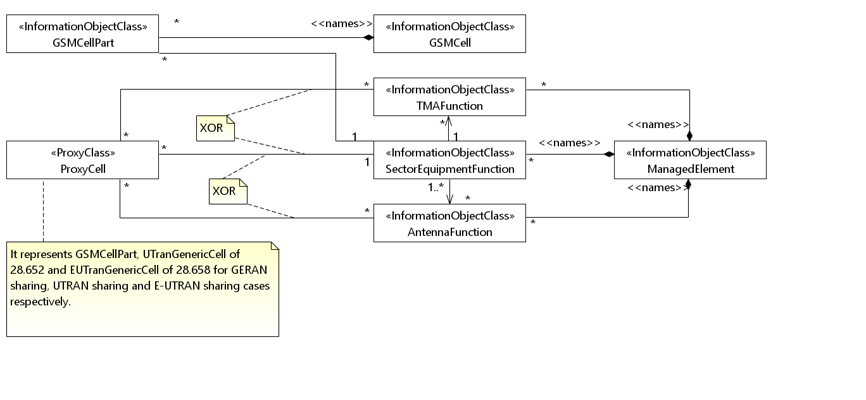
Figure 4.2.1.1: UTRAN/E-UTRAN/NR/GERAN sharing (1/2)
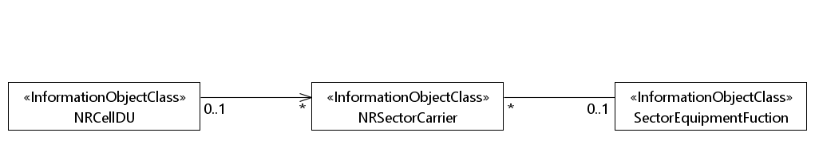

Figure 4.2.1.2: UTRAN/E-UTRAN/NR/GERAN sharing (2/2)
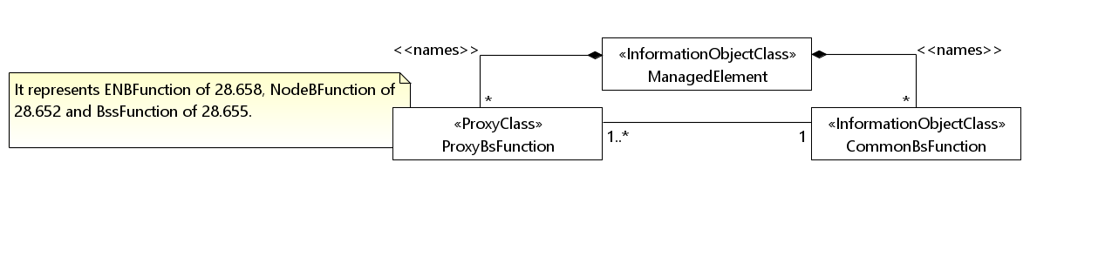
Figure 4.2.1.3: CommonBsFunction NRM fragment

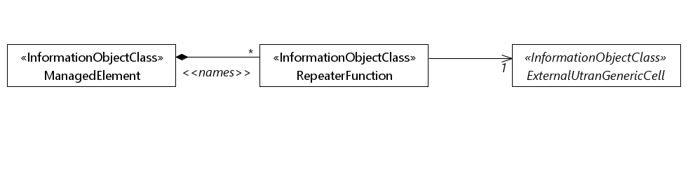
Figure 4.2.1.4: RepeaterFunction NRM fragment
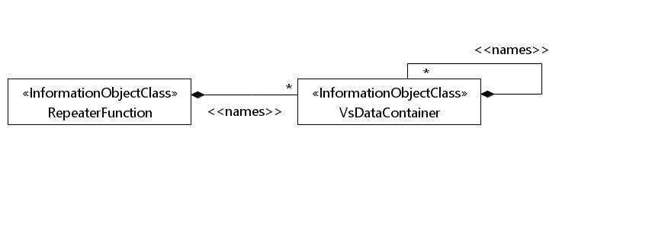
Figure 4.2.1.5: RepeaterFunction related VsDataContainer Containment/Naming and Association diagram

4.2.2 Inheritance
This subclause depicts the inheritance relationships.
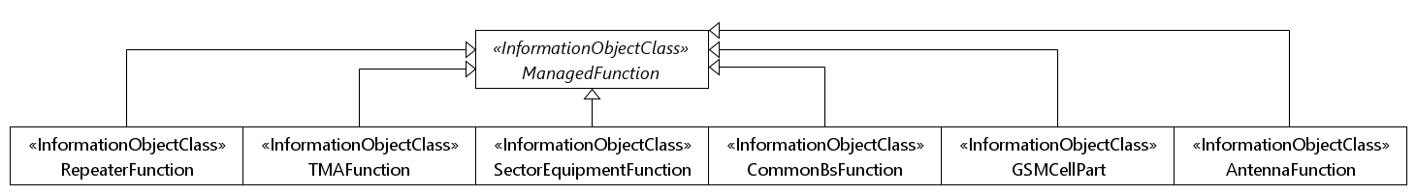
Figure 4.2.2.1: Inheritance diagram (1/2)
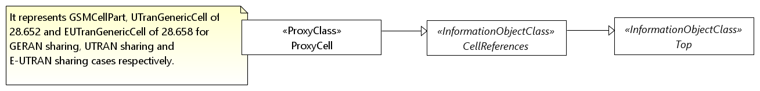
Figure 4.2.21.2: Inheritance diagram (2/2)

4.3 Class definitions

4.3.1 SectorEquipmentFunction

4.3.1.1 Definition
This IOC represents a set of cells within a geographical area that has common functions relating to AntennaFunction, TMAFunction and supporting equipment, such as power amplifier.
This IOC is required as part of the capability to satisfy the Requirements statement identified below.
Referenced TS | Requirement label | Comment
3GPP TS 28.661 [10] | REQ-GRAN_NRM-CON-001
3GPP TS 28.661 [10] | REQ-GRAN_NRM-CON-002

4.3.1.2 Attributes
Attribute name | Support Qualifier | isReadable | isWritable | isInvariant | isNotifyable
fqBand | CM | T | F | F | T
eUTRANFqBands | CM | T | F | F | T
nRFqBands | CM | T | F | F | T
uTRANFDDFqBands | CM | T | F | F | T
uTRANTDDFqBands | CM | T | F | F | T
confOutputPower | O | T | T | F | F
Attribute related to role
theTMAList | CM | T | F | F | T
theAntennaList | CM | T | F | F | T
theCellList | CM | T | F | F | T
theNRSectorCarrierList | CM | T | F | F | T

4.3.1.3 Attribute constraints
Name | Definition
fqBand CM Support Qualifier | Condition: EUTRAN is supported, and only one EUTRAN frequency band is supported, and eUTRANFqBands is not used.
eUTRANFqBands CM Support Qualifier | Condition: EUTRAN is supported, and fqBand is not used.
nRFqBands CM Support Qualifier | Condition: NR is supported.
uTRANFDDFqBands CM Support Qualifier | Condition: UTRAN FDD is supported.
uTRANTDDFqBands CM Support Qualifier | Condition: UTRAN TDD is supported.
theTMAList CM Support Qualifier | Condition: Association between SectorEquipmentFunction and AntennaFunction is absent AND is supporting the UTRAN/E-UTRAN sharing/non-sharing case OR is supporting the GERAN sharing case. In such case, at least one TMAFunction is present.
theAntennaList CM Support Qualifier | Condition: Association between SectorEquipmentFunction and TMAFunction is absent AND is supporting the UTRAN/E-UTRAN sharing/non-sharing OR is supporting GERAN sharing case. In such case, at least one AntennaFunction is present.
theCellList CM Support Qualifier | Condition: Supporting UTRAN/E-UTRAN sharing (and non-sharing) cases. In such case, at least one UtranGenericCell/EUtranGenericCell is present.  Condition: Supporting the GERAN sharing case. In such case, at least one GSMCellPart is present.
theNRSectorCarrierList CM Support Qualifier | Condition: Supporting NR sharing and non-sharing cases. In such cases, at least one NRSectorCarrier is present.

4.3.1.4 Notifications
The common notifications defined in subclause 4.5 are valid for this IOC, without exceptions or additions.

4.3.2 AntennaFunction

4.3.2.1 Definition
This IOC represents an array of radiating elements that may be tilted to adjust the RF coverage of a cell(s).
This IOC is required as part of the capability to satisfy the Requirements statement identified below.
Referenced TS | Requirement label | Comment
3GPP TS 28.661 [10] | REQ-GRAN_NRM-CON-001
3GPP TS 28.661 [10] | REQ-GRAN_NRM-CON-002

4.3.2.2 Attributes
Attribute name | Support Qualifier | isReadable | isWritable | isInvariant | IsNotifyable
retTiltValue | O | T | T | F | T
bearing | O | T | T | F | T
retGroupName | O | T | T | F | T
height | O | T | T | F | T
maxAzimuthValue | O | T | T | F | T
minAzimuthValue | O | T | T | F | T
horizBeamwidth | O | T | T | F | T
vertBeamwidth | O | T | T | F | T
Attribute related to role
theCellList | CM | T | F | F | T

4.3.2.3 Attribute constraints
Name | Definition
theCellList CM Support Qualifier | Condition: Association between SectorEquipmentFunction and ProxyCell is absent; and association SectorEquipmentFunction and NRSectorCarrier is absent.

4.3.2.4 Notifications
The common notifications defined in subclause 4.5 are valid for this IOC, without exceptions or additions.

4.3.3 TMAFunction

4.3.3.1 Definition
This IOC represents a Tower Mounted Amplifier or a number of TMA subunits within one TMA, each separately addressable by a specific index at the application layer.
This IOC is required as part of the capability to satisfy the Requirements statement identified below.
Referenced TS | Requirement label | Comment
3GPP TS 28.661 [10] | REQ-GRAN_NRM-CON-001
3GPP TS 28.661 [10] | REQ-GRAN_NRM-CON-002

4.3.3.2 Attributes
Attribute name | Support Qualifier | isReadable | isWritable | isInvariant | isNotifyable
tmaSubunitNumber | M | T | T | F | T
tmaStateFlag | M | T | O | F | T
tmaFunctionFlag | M | T | T | F | T
tmaMinGain | M | T | F | F | T
tmaMaxGain | M | T | F | F | T
tmaResolution | M | T | F | F | T
tmaGainFigure | M | T | O | F | T
tmaNumberOfSubunits | M | T | F | F | T
tmaBaseStationId | CO | T | CO | F | T
tmaSectorId | CO | T | CO | F | T
tmaAntennaBearing | CO | T | CO | F | T
tmaInstalledMechanicalTilt | CO | T | CO | F | T
tmaSubunitType | CO | T | CO | F | T
tmaSubunitRxFrequencyBand | CO | T | CO | F | T
tmaSubunitTxFrequencyBand | CO | T | CO | F | T
tmaGainResolution | CO | T | CO | F | T
Attribute related to role
theCellList | CM | T | F | F | T

4.3.3.3 Attribute Constraints
Name | Definition
theCellList CM Support Qualifier | Condition: Association between SectorEquipmentFunction and ProxyCellList is absent; and association between SectorEquipmentFunction and NRSectorCarrier is absent.

Name | Definition
The CO support qualifier of the attributes tmaBaseStationId through tmaGainResolution | Condition: The TMA subunit supports the read operation in 3GPP TS 37.466 [26]
The CO write qualifier of the attributes tmaBaseStationId through tmaGainResolution | Condition: The TMA subunit supports the write operation in 3GPP TS 37.466 [26]

4.3.3.4 Notifications
The common notifications defined in subclause 4.5 are valid for this IOC, without exceptions or additions.

4.3.4 GSMCellPart

4.3.4.1 Definition
A GSM cell can consist of a number of carriers. These carriers can be configured in a number of ways, for example, the carriers can have different propagation properties which are sent with different antenna tilt, with different RF power, different radio band and even possibly different antenna.
The various GSMCellPart instances capture different radio propagation properties allowing different frequency planning schemes, e.g. some GSMCellPart instances can use frequency groups planned for tighter frequency reuse.
Hence, a GSM cell can, and in some cases must, be distributed on more than one SectorEquipmentFunction.
This IOC is required as part of the capability to satisfy the Requirements statement identified below.
Referenced TS | Requirement label | Comment
3GPP TS 28.661 [10] | REQ-GRAN_NRM-CON-001
3GPP TS 28.661 [10] | REQ-GRAN_NRM-CON-002

4.3.4.2 Attributes
Attribute name | Support Qualifier | isReadable | isWritable | isInvariant | IsNotifyable
aRFCN | M | T | T | F | T
tsc | M | T | T | F | T
aTA | M | T | T | F | T
Attribute related to role
theSectorEquipment | M | T | F | F | T

4.3.4.3 Attribute constraints
None

4.3.4.4 Notifications
The common notifications defined in subclause 4.5 are valid for this IOC, without exceptions or additions.

4.3.5 CommonBsFunction

4.3.5.1 Definition
This IOC represents common aspects of Base Station (BS) functionality shared by several radio access technologies.
Referenced TS | Requirement label | Comment
3GPP TS 28.661 [10] | REQ-GRAN_NRM-CON-001
3GPP TS 28.661 [10] | REQ-GRAN_NRM-CON-002

4.3.5.2 Attributes
Attribute name | Support Qualifier | isReadable | isWritable | isInvariant | isNotifyable
sharedTechnologies | M | T | O | F | T
Attribute related to role
theProxyBsList | M | T | F | F | T

4.3.5.3 Attribute constraints
None

4.3.5.4 Notifications
There is no notification defined.

4.3.6 CellReferences

4.3.6.1 Definition
This IOC represents the three references to TMAFunction, SectorEquipmentFunction and AntennaFunction. The references are used by various classes of cells, e.g. UtranGenericCell.
This is an abstract class.

4.3.6.2 Attributes
Attribute name | Support Qualifier | isReadable | isWritable | isInvariant | isNotifyable
Attribute related to role
relatedSectorEquipment | CM | T | F | F | T
relatedTMAList | CM | T | F | F | T
relatedAntennaList | CM | T | F | F | T

4.3.6.3 Attribute constraints
Name | Definition
relatedSectorEquipment CM Support Qualifier | Condition: Supporting the GERAN sharing case. In such case, there shall be at least one GSMCellPart present at one end of this association.
relatedAntennaList CM Support Qualifier | Condition: Association between SectorEquipmentFunction and ProxyCell is absent.
relatedTMAList CM Support Qualifier | Condition: Association between SectorEquipmentFunction and ProxyCell is absent.

4.3.6.4 Notifications
There is no notification defined.

4.3.7 RepeaterFunction

4.3.7.1 Definition
This IOC represents the management aspect of a repeater. For the information on repeater see 3GPP TS 25.106 [18].
This IOC is required as part of the capability to satisfy the Requirements statement identified below.
Referenced TS | Requirement label | Comment
3GPP TS 28.661 [10] | REQ-GRAN_NRM-CON-003

4.3.7.2 Attributes
Attribute name | Support Qualifier | isReadable | isWritable | isInvariant | isNotifyable
priority | M | T | T | F | T
latitude | M | T | F | F | F
longitude | M | T | F | F | F
ctrlConnMode | M | T | T | F | T
environmentInfo | M | T | - | F | -
powerSwitch | M | T | T | F | T
ulAttenuation | M | T | T | F | T
dlAttenuation | M | T | T | F | T
firmwareVer | M | T | F | F | F
repeaterType | M | T | F | F | F
Attribute related to role
externalUTRANCell | M | T | F | F | T

4.3.7.3 Attribute constraints
None.

4.3.7.4 Notifications
The common notifications defined in subclause 4.5 are valid for this IOC, without exceptions or additions.

4.3.8 ProxyCell <<ProxyClass>>

4.3.8.1 Definition
This IOC represents GSMCellPart, UTranGenericCell and EUtranGenericCell.

4.3.8.3 Attribute constraints
See respective IOCs

4.3.8.4 Notifications
See respective IOCs.

4.3.9 ProxyBsFunction <<ProxyClass>>

4.3.8.1 Definition
This IOC represents ENBFunction, NodeBFunction and BssFunction.

4.3.8.3 Attribute constraints
See respective IOCs.

4.3.8.4 Notifications
See respective IOCs.

4.4 Attribute definitions

4.4.1 Attribute properties
Attribute Name | Documentation and Allowed Values | Properties
aRFCN | This attribute (Absolute Radio Frequency Channel Number) defines a pair of Radio Frequency (RF) channel frequencies for uplink and downlink use.  See 3GPP TS 45.005 [19] clause 2 for the ARFCN for GSM. ARFCN are based on a 200 kHz channel raster.  allowedValues: See 3GPP TS 45.005 [19] clause 2 | type: String  multiplicity: 1  isOrdered: N/A  isUnique: N/A  defaultValue: None  isNullable: True
aTA | This attribute (allowed Timing Advance) defines the signal sent by the BTS to the MS which the MS uses to advance its timings of transmissions to the BTS so as to compensate for propagation delay.  allowedValues: See 3GPP TS 45.010 [20] | type: Integer  multiplicity: 1  isOrdered: N/A  isUnique: N/A  defaultValue: None  isNullable: True
bearing | The bearing in degrees that the antenna is pointing in. Antenna bearing" in Ref. 3GPP TS 25.463 [8].  allowedValues: See "Antenna bearing" in 3GPP TS 25.463 [8]. | type: Integer  multiplicity: 1  isOrdered: N/A  isUnique: N/A  defaultValue: None  isNullable: True
confOutputPower | It defines the allowed total power to use for all cells together in this sector. It may be set by the operator and/or limited by HW limitation or licensed power, e.g.: 20, 40, 60, 80,120 watts  allowedValues: N/A | type: Integer  multiplicity: 1  isOrdered: N/A  isUnique: N/A  defaultValue: None  isNullable: True
ctrlConnMode | Remote communication mode used by a repeater to send and receive control message, such as GSM SMS, WCDMA SMS, Circle Switch Data-CSD, Package Switch Dat-IP, Serial port.  allowedValues: N/A | type: String  multiplicity: 1  isOrdered: N/A  isUnique: N/A  defaultValue: None  isNullable: True
dlAttenuation | Downlink signal attenuation of the device to change downlink gain.  allowedValues: N/A | type: Integer  multiplicity: 1  isOrdered: N/A  isUnique: N/A  defaultValue: None  isNullable: True
environmentInfo | The repeater device is located either in the building or out of the building.  allowedValues: N/A | type: String  multiplicity: 1  isOrdered: N/A  isUnique: N/A  defaultValue: None  isNullable: True
eUTRANFqBands | This is the list of LTE frequency bands supported by the hardware associated with the SectorEquipmentFunction.  The earfcnDl and earfcnUl or earfcn of LTE cells associated with the SectorEquipmentFunction must be assigned with value within one of the specified eUTRANFqBands values.  allowedValues: A list of frequency bands expressed as strings.  Valid frequency band values are specified in sub-clause 5.7.3 in 36.104 [7].  For HW not supporting LTE frequency bands, the list shall be empty. | type: String  multiplicity: 1..*  isOrdered: N/A  isUnique: True  defaultValue: None  isNullable: True
firmwareVer | Version of the device firmware.  allowedValues: N/A | type: String  multiplicity: 1  isOrdered: N/A  isUnique: N/A  defaultValue: None  isNullable: True
fqBand | This is the LTE frequency band supported by the hardware associated with the SectorEquipmentFunction. The earfcnDl and earfcnUl of cells associated with the SectorEquipmentFunction must be assigned with value within this fqBand value.  allowedValues: See clause 5 Table 5.2-1 “E-UTRA frequency band” of 3GPP TS 36.104 [7]. | type: Integer  multiplicity: 1  isOrdered: N/A  isUnique: N/A  defaultValue: None  isNullable: True
nRFqBands | This is the list of NR frequency bands supported by the hardware associated with the SectorEquipmentFunction.  The arfcnDl and arfcnUl of the NRSectorCarrier must be assigned with value within one of the specified nRFqBands values – if the attributes on NRSectorCarriers are set.  The arfcnDl and arfcnUl of the NRCellDU associated with the NRSectorCarrier must be assigned with value within one of the specified nRFqBands values – if there is a NRCellDU associated with the NRSectorCarrier.  allowedValues:  A list of frequency bands expressed as strings.  Valid frequency band values are specified in sub-clause 5.4.2 in 3GPP TS 38.104 [23].  For HW not supporting NR frequency bands, the list shall be empty. | type: String  multiplicity: 1..*  isOrdered: N/A  isUnique: True  defaultValue: None  isNullable: False
height | The height of an antenna above sea level.  Note: The value of this attribute has no operational impact on the network, e.g. the NE behavior is not affected by the value setting of this attribute. Note as well that this attribute is not supported over the Iuant interface according to Ref. 3GPP TS 37.466 [26].  An integral value representing a number of meters in 0.1 meter increments.  allowedValues: N/A | type: Integer  multiplicity: 1  isOrdered: N/A  isUnique: N/A  defaultValue: None  isNullable: True
horizBeamwidth | The 3 dB power beamwidth of the antenna pattern in the horizontal plane. A value of 360 indicates an omni-directional antenna.  Note: The value of this attribute has no operational impact on the network, e.g. the NE behaviour is not affected by the value setting of this attribute. Note as well that this attribute is not supported over the Iuant interface according to Ref. 3GPP TS37.466 [26].  A single integral value corresponding to an angle in degrees between 0 and 360.  allowedValues: N/A | type: Integer  multiplicity: 1  isOrdered: N/A  isUnique: N/A  defaultValue: None  isNullable: True
latitude | The latitude of the antenna location based on World Geodetic System (1984 version) global reference frame (WGS 84). Positive values correspond to the northern hemisphere.  allowedValues: -90.0000 to +90.0000 | type: Integer  multiplicity: 1  isOrdered: N/A  isUnique: N/A  defaultValue: None  isNullable: True
longitude | The longitude of the antenna location based on World Geodetic System (1984 version) global reference frame (WGS 84). Positive values correspond to degrees east of 0 degrees longitude.  allowedValues: -180.0000 to +180.0000 | type: Integer  multiplicity: 1  isOrdered: N/A  isUnique: N/A  defaultValue: None  isNullable: True
maxAzimuthValue | The maximum amount of change of azimuth the RET system can support. This is the change in degrees clockwise from bearing.  Note: The value of this attribute has no operational impact on the network, e.g. the NE behaviour is not affected by the value setting of this attribute. Note as well that this attribute is not supported over the Iuant interface according to Ref. 3GPP TS 37.466 [26].  A single integral value corresponding to an angle in degrees between 0 and 360 with a resolution of 0.1 degrees.  allowedValues: N/A | type: Integer  multiplicity: 1  isOrdered: N/A  isUnique: N/A  defaultValue: None  isNullable: True
minAzimuthValue | The minimum amount of change of azimuth the RET system can support. This is the change in degrees counter-clockwise from bearing.  Note: The value of this attribute has no operational impact on the network, e.g. the NE behaviour is not affected by the value setting of this attribute. Note as well that this attribute is not supported over the Iuant interface according to Ref. 3GPP TS 25.466 [9].  A single integral value corresponding to an angle in degrees between 0 and 360 with a resolution of 0.1 degrees.  allowedValues: N/A | type: Integer  multiplicity: 1  isOrdered: N/A  isUnique: N/A  defaultValue: None  isNullable: True
priority | The priority of a repeater decided by an operator.  allowedValues: N/A | type: Integer  multiplicity: 1  isOrdered: N/A  isUnique: N/A  defaultValue: None  isNullable: True
powerSwitch | Power switch of device which has two status: ON/OFF.  allowedValues: ON, OFF | type: Boolean  multiplicity: 1  isOrdered: N/A  isUnique: N/A  defaultValue: None  isNullable: True
relatedAntennaList | This attribute contains the DNs of one or more AntennaFunction.  allowedValues: N/A | type: DN  multiplicity: 1..*  isOrdered: N/A  isUnique: T  defaultValue: None  isNullable: True
relatedSectorEquipment | This attribute contains the DN of one SectorEquipmentFunction.  allowedValues: N/A | type: DN  multiplicity: 1  isOrdered: N/A  isUnique: N/A  defaultValue: None  isNullable: True
relatedTMAList | This attribute contains the DNs of one or more TmaFunction.  allowedValues: N/A | type: DN  multiplicity: 1..*  isOrdered: N/A  isUnique: T  defaultValue: None  isNullable: True
repeaterType | The repeater type defined by operator, such as wide band, frequency selective, indoor and fiber optic.  allowedValues: N/A | type: String  multiplicity: 1  isOrdered: N/A  isUnique: N/A  defaultValue: None  isNullable: True
retGroupName | The group name is a textual, alpha-numeric string to define a logical grouping of antennas which may be in different cells.  This attribute permits the definition of a logical grouping of the antennas. This may be defined either at installation time, or by management activity to provisioning the group name via the Itf-N.  allowedValues: N/A (String size is bounded to 80 characters.) | type: String  multiplicity: 1  isOrdered: N/A  isUnique: N/A  defaultValue: None  isNullable: True
retTiltValue | The electrical tilt setting of the antenna, "Tilt value" in Ref. 3GPP TS 37.466 [26].  allowedValues: See "Tilt value" in Ref. 3GPP TS 37.466 [26]. | type: Integer  multiplicity: 1  isOrdered: N/A  isUnique: N/A  defaultValue: None  isNullable: True
sharedTechnologies | This attribute defines the radio access technologies sharing the common functionalities of a Base Station (BS).  allowedValues: GSM, UMTS, LTE, or any combination thereof | type: Integer  multiplicity: 1  isOrdered: N/A  isUnique: N/A  defaultValue: None  isNullable: True
tmaAntennaBearing | A data field defined in Table B.3 of 3GPP TS 37.466 [26].  See definition in 3GPP TS 37.466 [26].  allowedValues: N/A | type: Integer  multiplicity: 1  isOrdered: N/A  isUnique: N/A  defaultValue: None  isNullable: True
tmaBaseStationId | A data field defined in Table B.3 of 3GPP TS 37.466 [26]  allowedValues: N/A | type: String  multiplicity: 1  isOrdered: N/A  isUnique: N/A  defaultValue: None  isNullable: True
tmaFunctionFlag | Defined in 3GPP TS 37.466 [26]  allowedValues: N/A | type: Integer  multiplicity:  isOrdered: N/A  isUnique: N/A  defaultValue: None  isNullable: True
tmaGainFigure | Defined in 3GPP TS 37.466 [26]  allowedValues: N/A | type: Integer  multiplicity: 1  isOrdered: N/A  isUnique: N/A  defaultValue: None  isNullable: True
tmaGainResolution | A data field defined in Table B.3 of 3GPP TS 37.466 [26]  allowedValues: N/A | type: Integer  multiplicity: 1  isOrdered: N/A  isUnique: N/A  defaultValue: None  isNullable: True
tmaInstalledMechanicalTilt | A data field defined in Table B.3 of 3GPP TS 37.466 [26]  allowedValues: N/A | type: Integer  multiplicity: 1  isOrdered: N/A  isUnique: N/A  defaultValue: None  isNullable: True
tmaMaxGain | Defined in 3GPP TS 37.466 [26]  allowedValues: N/A | type: Integer  multiplicity: 1  isOrdered: N/A  isUnique: N/A  defaultValue: None  isNullable: True
tmaMinGain | Defined in 3GPP TS 37.466 [26]  allowedValues: N/A | type: Integer  multiplicity: 1  isOrdered: N/A  isUnique: N/A  defaultValue: None  isNullable: True
tmaNumberOfSubunits | Defined in 3GPP TS 37.466 [26]  allowedValues: -- | Defined in 3GPP TS 37.466 [26]  type: --  multiplicity: --  isOrdered: --  isUnique: --  defaultValue: --  isNullable: --
tmaResolution | Defined in 3GPP TS 37.466 [26]  allowedValues: N/A | type: Integer  multiplicity: 1  isOrdered: N/A  isUnique: N/A  defaultValue: None  isNullable: True
tmaSectorId | A data field defined in Table B.3 of 3GPP TS 37.466 [26]  allowedValues: N/A | type: String  multiplicity: 1  isOrdered: N/A  isUnique: N/A  defaultValue: None  isNullable: True
tmaStateFlag | Defined in 3GPP TS 37.466 [26]  allowedValues: N/A | type: Integer  multiplicity: 1  isOrdered: N/A  isUnique: N/A  defaultValue: None  isNullable: True
tmaSubunitNumber | Defined in 3GPP TS 37.466 [26]  allowedValues: N/A | type: Integer  multiplicity: 1  isOrdered: N/A  isUnique: N/A  defaultValue: None  isNullable: True
tmaSubunitRxFrequencyBand | A data field defined in Table B.3 of 3GPP TS 37.466 [26]  allowedValues: See 3GPP TS 37.466 [26]. | type: Integer  multiplicity: 2  isOrdered: True  isUnique: True  defaultValue: None  isNullable: False
tmaSubunitType | A data field defined in Table B.3 of 3GPP TS 37.466 [26]  allowedValues: N/A | type: Integer  multiplicity: 1  isOrdered: N/A  isUnique: N/A  defaultValue: None  isNullable: True
tmaSubunitTxFrequencyBand | A data field defined in Table B.3 of 3GPP TS 37.466 [26]  allowedValues: See 3GPP TS 37.466 [26]. | type: Integer  multiplicity: 2  isOrdered: True  isUnique: True  defaultValue: None  isNullable: False
tsc | This attribute has the same definition as the one used in GsmCell IOC. The presence of GSMCellPart means the tsc attribute in GsmCell IOC instance is irrelevant (not applicable).  allowedValues: N/A | type: Integer  multiplicity: 1  isOrdered: N/A  isUnique: N/A  defaultValue: None  isNullable: True
ulAttenuation | Uplink signal attenuation of the device to change uplink gain.  allowedValues: N/A | type: Integer  multiplicity: 1  isOrdered: N/A  isUnique: N/A  defaultValue: None  isNullable: True
uTRANFDDFqBands | This is the list of UTRAN FDD frequency bands supported by the hardware associated with the SectorEquipmentFunction.  The arfcnDl and arfcnUl of UTRAN FDD cells associated with the SectorEquipmentFunction must be assigned with value within one of the specified uTRANFDDFqBands values.  allowedValues: A list of frequency bands expressed as strings.  Valid frequency band values are specified in sub-clause 5.2 of 3GPP TS 25.104 [21]. | type: String  multiplicity: 1..*  isOrdered: N/A  isUnique: True  defaultValue: None  isNullable: True
uTRANTDDFqBands | This is the list of UTRAN TDD frequency bands supported by the hardware associated with the SectorEquipmentFunction.  The earfcn of UTRAN TDD cells associated with the SectorEquipmentFunction must be assigned with value within one of the specified uTRANTDDFqBands values.  allowedValues: A list of frequency bands expressed as strings.  Valid frequency band values are specified in sub-clause 5.2 of 3GPP TS 25.105 [22]. | type: String  multiplicity: 1..*  isOrdered: N/A  isUnique: True  defaultValue: None  isNullable: True
vertBeamwidth | The 3 dB power beamwidth of the antenna pattern in the vertical plane.  The value of this attribute has no operational impact on the network, e.g. the NE behaviour is not affected by the value setting of this attribute.  This attribute is not supported over the Iuant interface according to Ref. 3GPP TS 37.466 [26].  allowedValues: A single integral value corresponding to an angle in degrees between 0 and 180. | type: Integer  multiplicity: 1  isOrdered: N/A  isUnique: N/A  defaultValue: None  isNullable: True
Attribute related to role
externalUTRANCell | This role (when present) represents RepeaterFunction capability to identify one ExternalUtranCell.  When present, it shall contain one ExternalUtranCell DN.  allowedValues: N/A | type: DN  multiplicity: 1  isOrdered: N/A  isUnique: N/A  defaultValue: None  isNullable: True
theAntennaList | This attribute contains the DNs of one or more AntennaFunction.  allowedValues: N/A | type: DN  multiplicity: 1..*  isOrdered: False  isUnique: True  defaultValue: None  isNullable: True
theCellList | This attribute contains the DNs of EUtranGenericCell or UtranGenericCell if associations between them exist.  This attribute contains the DNs of GSMCellPart if association between them exist.  allowedValues: N/A | type: DN  multiplicity: 1..*  isOrdered: False  isUnique: True  defaultValue: None  isNullable: True
theProxyBsList | A CommonBsFunction instance serves a number of ProxyBsFunction instances. This CommonBsFunction role-attribute contains a list of DNs of ENBFunction (3GPP TS 28.658 [13]), NodeBFunction (3GPP TS 28.652 [12]) and BssFunction (3GPP TS 28.655 [14]) that it serves.  allowedValues: N/A | type: DN  multiplicity: 1..*  isOrdered: False  isUnique: True  defaultValue: None  isNullable: True
theTMAList | This attribute contains the DNs of one or more TMAFunction.  allowedValues: N/A | type: DN  multiplicity: 1..*  isOrdered: False  isUnique: True  defaultValue: None  isNullable: True

4.4.2 Constraints
None

4.5 Common Notifications

4.5.1 Alarm notifications
This subclause presents a list of notifications, defined in 3GPP TS 32.111-2 [11], that IRPManager can receive. The notification header attribute objectClass/objectInstance, defined in 3GPP TS 32.302 [16], would capture the DN of an instance of an IOC defined in this IRP specification.
Name | Qualifier | Notes
notifyAckStateChanged | See Alarm IRP (3GPP TS 32.111-2 [11])
notifyChangedAlarm | See Alarm IRP (3GPP TS 32.111-2 [11])
notifyClearedAlarm | See Alarm IRP (3GPP TS 32.111-2 [11])
notifyNewAlarm | See Alarm IRP (3GPP TS 32.111-2 [11])
notifyComments | See Alarm IRP (3GPP TS 32.111-2 [11])
notifyAlarmListRebuilt | See Alarm IRP (3GPP TS 32.111-2 [11])
notifyPotentialFaultyAlarmList | See Alarm IRP (3GPP TS 32.111-2 [11])

4.5.2 Configuration notifications
This subclause presents a list of notifications, defined in 3GPP TS 32.662 [17], that IRPManager can receive. The notification header attribute objectClass/objectInstance, defined in 3GPP TS 32.302[16], would capture the DN of an instance of an IOC defined in this IRP specification.
Name | Qualifier | Notes
notifyAttributeValueChange | O
notifyObjectCreation | O
notifyObjectDeletion | O

Annex A (informative):
Change history

Change history
Date | Meeting | TDoc | CR | Rev | Cat | Subject/Comment | New version
2013-09 | SA#61 | SP-130433 | 0001 |  | F | Add missing Repeater Object IS definitions | 11.1.0
2014-06 | SA#64 | SP-140359 | 0002 |  | F | remove the feature support statements | 11.2.0
2014-10 | - | - | - |  |  | Update to Rel-12 version (MCC) | 12.0.0
2016-01 | - | - | - |  |  | Update to Rel-13 version (MCC) | 13.0.0
2016-06 | SA#72 | SP-160408 | 0005 | 1 | A | Correcting references and reintroducing attributes. | 13.1.0
2017-03 | SA#75 | - | - | - |  | Promotion to Release 14 without technical change | 14.0.0
2018-06 | - | - | - | - | - | Update to Rel-15 version (MCC) | 15.0.0
2018-12 | SA#82 | SP-181156 | 0007 | 1 | F | Correct SectorEquipmentFunction property to support NR. | 15.1.0
2018-12 | SA#82 | SP-181156 | 0008 | 2 | F | Align NR frequency bands supported by the hardware associated with the SectorEquipmentFunction | 15.1.0
2019-09 | SA#85 | SP-190751 | 0009 | - | F | Correct references and add reference to TR21.905 | 15.2.0
2019-12 | SA#86 | SP-191173 | 0010 | 1 | F | Correct use of ProxyCellList | 15.3.0
2020-07 | - | - | - | - | - | Update to Rel-16 version (MCC) | 16.0.0
2022-03 | - | - | - | - | - | Update to Rel-17 version (MCC) | 17.0.0
2024-03 | SA#103 | SP-240205 | 0014 | - | F | R18 CR 28.662 Rapporteur's clean up for Rel-18 upgrade | 18.0.0

