3GPP TSG-SA5 Meeting #148-e S5-233357

e-meeting, 17-25 April 2023

Source: Huawei

Title: pCR 28.903 add conclusion and recommendation for resource reservation related issue

Document for: Approval

Agenda Item: 6.9.6.2

1 Decision/action requested
The group is asked to discuss and agree on the proposal.

2 References
[1] 3GPP TR 28.903-050 “Study on alignment with ETSI MEC for Edge computing management”

3 Rationale
This pCR suggests to add conclusion and recommendation for resource reservation.

4 Detailed proposal
It is proposed to add conclusion and recommendation for resource reservation in TR 28.903-050 [1].

1st change

6.1 Key Issue# 1: Issue for resource reservation

6.1.1 Description
As described in clause 2.2.2.3 GSMA OPG [2], resource reservation is one of its NBI requirements, it indicates that,
- The OP (Operator Platform) shall enable Application Providers to express the resource (e.g., compute, networking, storage, acceleration) requirements that the Application Provider wants to be guaranteed.
- The NBI shall allow an Application provider to request a set of resources to be booked.
- The NBI allows an Application Provider to reserve resources ahead of the application onboarding and unrelated to any specific application, only related to the Application Provider themselves. The NBI allows an Application Provider to consume the reserved resources when onboarding a new application, creating the association between the resources and the application (resources allocation). The NBI allows an Application Provider to delete their reservation.
TS 28.538 [6] defines the lifecycle management procedure for EAS with ETSI NFV MANO, while the resource reservation related to the ASP requirements is not specified in [6].
It is important to investigate the method for ASP to request the resource reservation.
REQ-resource-reservation-1: ECSP management system shall have a capability allowing ASP to request resource reservation related to virtualisation resources (e.g., compute, networking, storage, acceleration).
REQ-resource-reservation-2: ECSP management system shall have a capability to reserve a set of resources for ASP unrelated to any specific application.

6.1.2 Potential solutions

6.1.2.1 Potential solution#1
In this solution, a new IOC called ResourceReservationJob is suggested to be sent to ECSP management system for resource reservation. Figure 6.1.2.1-1 depicts the main steps for ASP asking for resource reservation.
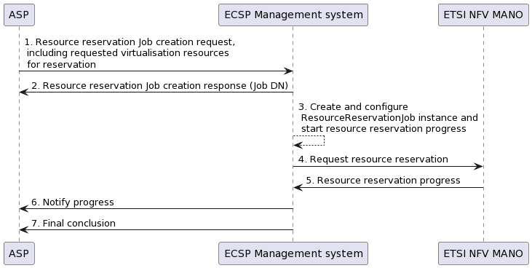
1. ECSP management system receives a resource reservation job creation request (createMOI operation for creation ResourceReservationJob), the ResourceReservationJob contains the following attributes, but not limited to,
…- Location at which the resource are to be reserved;
- compute resource for reservation, including GPU resource;
- storage resource for reservation;
- networking resource for reservation;
- Hardware accelerators resource for reservation;
…- expiration time
2. ECSP management system sends the ResourceReservationJob creation response to ASP for the received Job DN.
3. ECSP management system creates the ResourceReservationJob instance and configures the attribute from the request and ECSP management system starts the executing the resource reservation process.
4. ECSP management system request resource reservation (See clause 7.3.3 in ETSI GS NFV-IFA 013 [7] by interworking with ETSI NFV MANO.
5. Response with the progress of the requested resource reservation.
6. ECSP management system sends notification of the progress of the requested resource reservation job.
7. ECSP management system sends the final notification with the reservation status.

6.1.2.2 Solution evaluation
This solution introduces a new ResourceReservationJob IOC which can be used by ASP to request resource reservation. ECSP management system needs to support ResourceReservationJob IOC and create a ResourceReservationJob instance based on the request from ASP. The information includes in ResourceReservationJob IOC could be location information, expiration time, reservation statues and virtualized resource information required for reservation, including compute, storage, networking, GPU and Hardware accelerators resource.

2nd change

7 Conclusion and recommendation

7.x.x Issue#1: Issue for resource reservation
It is recommended to introduce a new ResourceReservationJob IOC for resource reservation. The information includes in ResourceReservationJob IOC could be location information, expiration time, reservation statues and virtualized resource information required
The detailed solution see clause 6.1.2.

End of change

