3GPP TS 28.405 V18.2.0 (2023-03)
Technical Specification

3rd Generation Partnership Project;
Technical Specification Group Services and System Aspects;
Telecommunication management;
Quality of Experience (QoE) measurement collection;
Control and configuration
(Release 18)
 | 
The present document has been developed within the 3rd Generation Partnership Project (3GPP TM) and may be further elaborated for the purposes of 3GPP.
The present document has not been subject to any approval process by the 3GPP Organizational Partners and shall not be implemented.
This Specification is provided for future development work within 3GPP only. The Organizational Partners accept no liability for any use of this Specification.
Specifications and Reports for implementation of the 3GPP TM system should be obtained via the 3GPP Organizational Partners' Publications Offices.

3GPP
Postal address

3GPP support office address
650 Route des Lucioles - Sophia Antipolis
Valbonne - FRANCE
Tel.: +33 4 92 94 42 00 Fax: +33 4 93 65 47 16
Internet
http://www.3gpp.org

Copyright Notification
No part may be reproduced except as authorized by written permission.
The copyright and the foregoing restriction extend to reproduction in all media.

© 2023, 3GPP Organizational Partners (ARIB, ATIS, CCSA, ETSI, TSDSI, TTA, TTC).
All rights reserved.

UMTS™ is a Trade Mark of ETSI registered for the benefit of its members
3GPP™ is a Trade Mark of ETSI registered for the benefit of its Members and of the 3GPP Organizational Partners
LTE™ is a Trade Mark of ETSI registered for the benefit of its Members and of the 3GPP Organizational Partners
GSM® and the GSM logo are registered and owned by the GSM Association

Contents
Foreword 5
Introduction 6
1 Scope 7
2 References 7
3 Definitions of terms, symbols and abbreviations 8
3.1 Terms 8
3.2 Symbols 8
3.3 Abbreviations 8
4 Quality of Experience (QoE) measurement collection 8
4.1 Management based activation in UTRAN 8
4.1.1 Activation of measurement collection job and reporting of collected information in UTRAN 8
4.1.2 Handling of measurement collection at handover in UTRAN 10
4.1.2.1 Handover between cells within an RNC 10
4.1.2.2 Handover between RNCs 10
4.1.3 Deactivation of measurement collection job in UTRAN 11
4.1.3.1 Forced deactivation in UTRAN 11
4.1.3.2 Deactivation of recording session in UTRAN 11
4.2 Management based activation in LTE 11
4.2.1 Activation of measurement collection job and reporting of collected information in LTE 11
4.2.2 Handling of measurement collection at handover in LTE 12
4.2.2.1 Handover between cells within an eNB 12
4.2.2.2 Handover between eNBs 13
4.2.3 Deactivation of measurement collection job in LTE 14
4.2.3.1 Forced deactivation 14
4.2.3.2 Deactivation of recording session 14
4.2.4 Void 14
4.3 Signalling based activation in UTRAN 14
4.3.1 Activation of measurement collection job in UTRAN 14
4.3.2 Handling of measurement collection at handover in UTRAN 16
4.3.3 Deactivation of measurement collection job in UTRAN 16
4.3.3.1 Pre-set time has elapsed in UTRAN 16
4.33.2 Forced deactivation in UTRAN 16
4.3.3.3 Deactivation of recording session in UTRAN 16
4.4 Signalling based activation in LTE 16
4.4.2 Activation of measurement collection for a UE in LTE 16
4.4.2.0 General 16
4.4.2.1 Activation of QoE measurement task before UE attaches to the network 16
4.4.2.2 Activation of QoE measurement task after UE attachement to the network 17
4.4.3 Handling of measurement collection at handover in LTE 19
4.4.4 Deactivation of measurement collection for a UE in LTE 19
4.4.4.1 Pre-set time has elapsed in LTE 19
4.4.4.2 Forced deactivation in LTE 19
4.4.4.3 Deactivation of recording session in LTE 19
4.5 Management based activation in NR 19
4.5.1 Activation of measurement collection job and reporting of collected information in NR 19
4.5.3 Deactivation of measurement collection job in NR 21
4.5.3.1 Forced deactivation 21
4.5.3.2 Deactivation of recording session 21
4.5.4 Temporary stop and restart of QoE information reporting during RAN overload in NR 21
4.6 Signalling based activation in NR 22
4.6.1 Activation of measurement collection for a UE in NR 22
4.6.1.0 General 22
4.6.1.1 Activation of QoE measurement task after completion of UE registration procedure 22
4.6.1.2 Activation of QoE measurement task before UE Registration procedure to the network 23
4.6.2 Handling of measurement collection at handover in NR 24
4.6.2.1 NG Based Handover for Signalling Based Activation 24
5 Quality of Experience (QoE) measurement management parameters 25
5.1 QoE collection entity address (M) 25
5.2 QoE reference (M) 25
5.3 PLMN target (CM) 25
5.4 Area scope (CM) 26
5.5 QMC configuration file (container) (M) 26
5.6 QMC target (M) 26
5.7 Recording session id (M) 26
5.8 Service type (M) 27
5.9 Slice scope (CM) 27
5.10 QoE Target (CM) 27
5.11 jobId (O) 27
5.12 Available RAN visible QoE metrics (O) 27
Annex A (informative): Change history 28

Foreword
This Technical Specification has been produced by the 3rd Generation Partnership Project (3GPP).
The contents of the present document are subject to continuing work within the TSG and may change following formal TSG approval. Should the TSG modify the contents of the present document, it will be re-released by the TSG with an identifying change of release date and an increase in version number as follows:
Version x.y.z
where:
x the first digit:
1 presented to TSG for information;
2 presented to TSG for approval;
3 or greater indicates TSG approved document under change control.
y the second digit is incremented for all changes of substance, i.e. technical enhancements, corrections, updates, etc.
z the third digit is incremented when editorial only changes have been incorporated in the document.
In the present document, modal verbs have the following meanings:
shall indicates a mandatory requirement to do something
shall not indicates an interdiction (prohibition) to do something
The constructions "shall" and "shall not" are confined to the context of normative provisions, and do not appear in Technical Reports.
The constructions "must" and "must not" are not used as substitutes for "shall" and "shall not". Their use is avoided insofar as possible, and they are not used in a normative context except in a direct citation from an external, referenced, non-3GPP document, or so as to maintain continuity of style when extending or modifying the provisions of such a referenced document.
should indicates a recommendation to do something
should not indicates a recommendation not to do something
may indicates permission to do something
need not indicates permission not to do something
The construction "may not" is ambiguous and is not used in normative elements. The unambiguous constructions "might not" or "shall not" are used instead, depending upon the meaning intended.
can indicates that something is possible
cannot indicates that something is impossible
The constructions "can" and "cannot" are not substitutes for "may" and "need not".
will indicates that something is certain or expected to happen as a result of action taken by an agency the behaviour of which is outside the scope of the present document
will not indicates that something is certain or expected not to happen as a result of action taken by an agency the behaviour of which is outside the scope of the present document
might indicates a likelihood that something will happen as a result of action taken by some agency the behaviour of which is outside the scope of the present document
might not indicates a likelihood that something will not happen as a result of action taken by some agency the behaviour of which is outside the scope of the present document
In addition:
is (or any other verb in the indicative mood) indicates a statement of fact
is not (or any other negative verb in the indicative mood) indicates a statement of fact
The constructions "is" and "is not" do not indicate requirements.

Introduction
The present document is part of a TS-family covering the 3rd Generation Partnership Project; Technical Specification Group Services and System Aspects; Telecommunication management, as identified below:
TS 28.404: "Quality of Experience (QoE) measurement collection; Concepts, use cases and requirements";
TS 28.405: "Quality of Experience (QoE) measurement collection; Control and configuration";
TS 28.406: "Quality of Experience (QoE) measurement collection; Information definition and transport".
One main motivation of mobile network evolution is to improve the user experience, which is why the evaluation of the user experience at the UE side is vital to network operators. This is especially true when the operators provide high bit rate real-time services like streaming services (typically video services), where even intermittent quality degradation is very annoying. Many of these streaming services are a significant part of the commercial traffic growth rate, therefore the focus is on the end users' experience.
Quality of Experience (QoE) information collection provides detailed information at session level on a number of UEs.
The capability to log information within a UE, and in particular the QoE of an end user service, initiated by an operator, provides the operator with QoE information. The collected information (specified in 3GPP TS 26.247 [6]) cannot be deduced from performance measurements in the mobile network.
The QoE information is information collected by the end user application in the UE.
The QoE information is collected by the management system for analysis and/or KPI calculations.

1 Scope
The present document addresses the mechanisms used for the function Quality of Experience (QoE) measurement collection in 3GPP networks . The measurements that are collected are DASH [6], MTSI [7] and Virtual Reality (VR) (see TS 26.118 [13]) measurements.
The function includes collecting QoE information from UEs frequenting a specified area or an individual UE for a specified end user service/end user service type. The document describes the activation and deactivation of a network request session, UE request session and recording session and also the reporting of recorded information [2].

2 References
The following documents contain provisions which, through reference in this text, constitute provisions of the present document.
- References are either specific (identified by date of publication, edition number, version number, etc.) or non-specific.
- For a specific reference, subsequent revisions do not apply.
- For a non-specific reference, the latest version applies. In the case of a reference to a 3GPP document (including a GSM document), a non-specific reference implicitly refers to the latest version of that document in the same Release as the present document.
[1] 3GPP TR 21.905: "Vocabulary for 3GPP Specifications".
[2] 3GPP TS 28.404: "Telecommunication management;Quality of Experience (QoE) measurement collection; Concepts, use cases and requirements".
[3] 3GPP TS 28.308: "Management of Quality of Experience (QoE) measurement collection Integration Reference Point (IRP); Information Service (IS)".
[4] 3GPP TS 25.331: "Radio Resource Control (RRC) protocol specification".
[5] 3GPP TS 27.007: "AT command set for User Equipment (UE)".
[6] 3GPP TS 26.247: "Transparent end-to-end Packet-switched Streaming Service (PSS); Progressive Download and Dynamic Adaptive Streaming over HTTP (3GP-DASH)".
[7] 3GPP TS 26.114: "IP Multimedia Subsystem (IMS); Multimedia Telephony; Media handling and interaction".
[8] 3GPP TS 36.331: "Evolved Universal Terrestrial Radio Access (E-UTRA); Radio Resource Control (RRC) protocol specification".
[9] 3GPP TS 36.413: "Evolved Universal Terrestrial Radio Access Network (E-UTRAN); S1 Application Protocol (S1AP)".
[10] 3GPP TS 25.413: "UTRAN Iu interface Radio Access Network Application Part (RANAP) signalling".
[11] 3GPP TS 38.331: " NR; Radio Resource Control (RRC); Protocol specification".
[12] 3GPP TS 38.413: " NG-RAN; NG Application Protocol (NGAP)".
[13] 3GPP TS 26.118: "Virtual Reality (VR) profiles for streaming applications".
[14] Void
[15] 3GPP TS 28.622: "Telecommunication management; Generic Network Resource Model (NRM) Integration Reference Point (IRP); Information Service (IS)".

3 Definitions of terms, symbols and abbreviations

3.1 Terms
For the purposes of the present document, the terms given in TR 21.905 [1] and the following apply. A term defined in the present document takes precedence over the definition of the same term, if any, in TR 21.905 [1].
Network session: A network session is used when a NF requests a UE to perform QoE Measurement Collection for a specified end user service type. Supported end user service types are defined in clause 5.8.

3.2 Symbols
Void.

3.3 Abbreviations
For the purposes of the present document, the abbreviations given in TR 21.905 [1] and the following apply. An abbreviation defined in the present document takes precedence over the definition of the same abbreviation, if any, in TR 21.905 [1].
DM Domain Manager
MCE Measurement Collector Entity
NB Node B
QMC QoE Measurement Collection
QoE Quality of Experience
VR Virtual Reality

4 Quality of Experience (QoE) measurement collection

4.1 Management based activation in UTRAN

4.1.1 Activation of measurement collection job and reporting of collected information in UTRAN
The parameters for the network request session are sent from the management system to the RNCs that host the cells that are included in the collection job request in the activateAreaQMCJob operation [3]. The RNC starts a network request session, with the Network request session id [3] given in activateAreaQMCJob operation [3]. For the duration of the network request session, the RNC(s) checks for connections where the UE has the UE Application Layer Measurement Capability [10]. The UE Application Layer Measurement Capability is sent from the UE to RNC (via the core network) in message INITIAL UE MESSAGE [10].
When a session is found that has a UE with the UE Application Layer Measurement Capability, the RNC starts a UE request session by sending a MEASUREMENT CONTROL message [4] to the UE via the NB.
The AT command +CAPPLEVMC [5] activates provisioning of measurement reporting from the lower layers to the application within the UE by an unsolicited result code +CAPPLEVMC. When information about a measurement report is received in the UE from the network, the unsolicited result code +CAPPLEVMC contains the relevant parameters (service_type, start_stop-indication and config-file & config-file length if applicable) that are provided from the lower layers in the UE to the application.
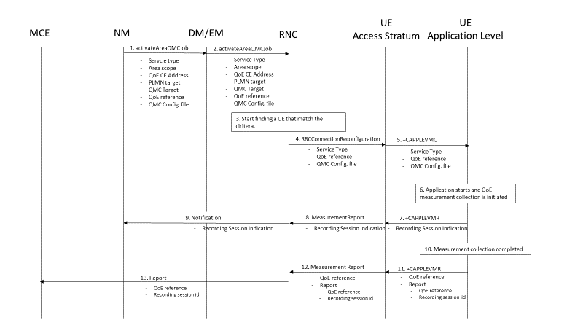
Figure 4.1.1-1: QMC activation and reporting in UTRAN
1. The NM sends activateAreaQMCJob to DM/EM that controls the impacted RNC(s), and includes the parameters: serviceType, areaScope, qoECollectionEntityAddress, pLMNTarget, qMCTarget, qoEReference and QMC configuration file.
2. The DM/EM forwards activateAreaQMCJob to impacted RNC(s), and includes the parameters: serviceType, areaScope, qoECollectionEntityAddress, pLMNTarget, qMCTarget, qoEReference and QMC configuration file.
3. The RNC checks for connections where the UE has the UE Application Layer Measurement Capability [10] that match the criteria for serviceType in the activateAreaQMCJob.
4. When a connection is found that has the UE Application Layer Measurement Capability [10], the RNC start a UE request session and stores the associated QoECollectionEntityAddress, sends the message RRCConnectionReconfiguration to the UE, and includes the following: serviceType, qoEReference and QMC configuration file.
5. The access stratum in the UE sends the AT command +CAPPLEVMC to application level and includes the following: serviceType, qoEReference and QMC configuration file.
6. When the application in the serviceType starts, the QMC is initiated.
7. The application layer sends the AT command +CAPPLEVMR including a recording session indication that a session has started to the access stratum.
8. The UE sends the message MeasurementReport including the recording session indication to the RNC.
9. The RNC sends a notification including the recording session indication to the NM.
10. When the QMC is completed, the recorded information is collected in a QMC report [6], [7], including qoEReference and recordingSessionId. The qoEReference, Client Id [6], [7] in the reporting container (that represent the UE request session), and recordingSessionId are needed in the QMC collection entity for post processing purposes.
11. The application layer sends the AT command +CAPPLEVMR including qoEReference and the QMC report to the access stratum.
12. The UE sends the message MeasurementReport including qoEReference and the QMC report to the RNC.
13. The RNC sends the QMC report to the MCE associated to the qoEReference.

4.1.2 Handling of measurement collection at handover in UTRAN

4.1.2.1 Handover between cells within an RNC
When handover is made, the measurement area is checked.
- If the mobile is inside the measurement area after the handover, the RNC sends in an indication that the UE is inside the measurement area in the RRCConnectionReconfiguration message [4] to the UE. The UE send the +CAPPLEVMC AT command [5] to the application to inform that recording shall start if the application becomes active (when the UE moves into the measurement area).
- If the mobile has moved outside the measurement area, there is no indication that the UE is inside the measurement area in the RRCConnectionReconfiguration message [4] from the RNC to the UE. The UE sends the +CAPPLEVMC AT command [5] to the application to inform that recording shall not be started even if the application becomes active.

4.1.2.2 Handover between RNCs
The figure 4.1.2.2-1 and the text below describes the handling at handover between RNCs.
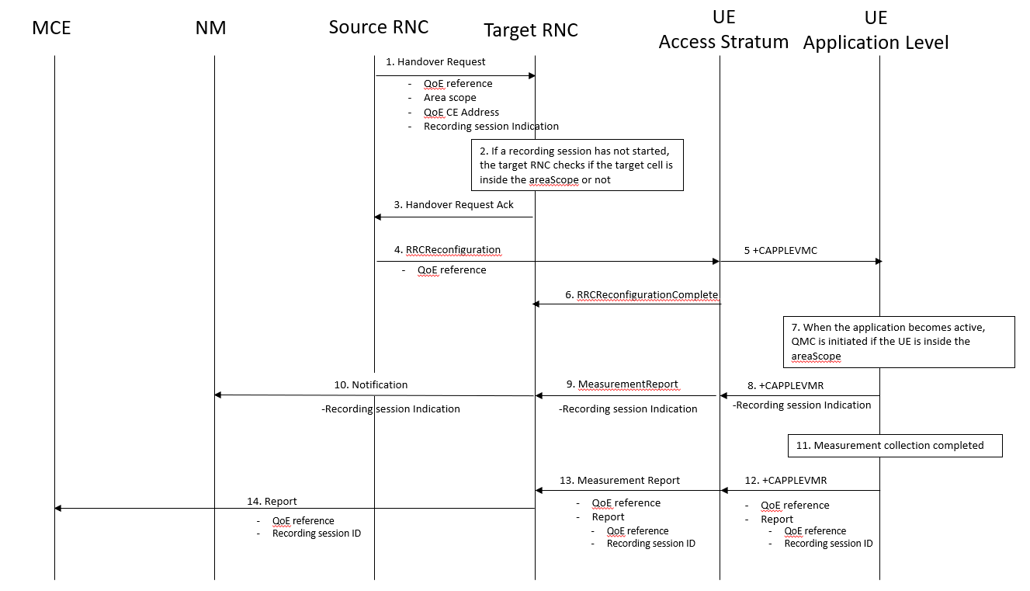
Figure 4.1.2.2-1: Handling of QMC activation in case of handover in UTRAN
1. Source RNC sends the message HandoverRequest to Target RNC and includes areaScope, qoECollectionEntityAddress and a recording session indication indicating whether a recording session has started.
2. If a recording session has not started, the target RNC checks if the target cell is inside the areaScope or not.
3. The target RNC sends the message Handover Request Ack to the source RNC.
4. The source RNC sends the message RRCReconfiguration to the UE.
5. The access stratum in the UE sends the AT command +CAPPLEVMC to application level.
6. The UE sends the message RRCReconfigurationComplete to the RNC.
7. When the application becomes active, QMC is initiated if the UE is inside the areaScope.
8. The application layer sends the AT command +CAPPLEVMR including a recording session indication to the access stratum.
9. The UE sends the message MeasurementReport including the recording session indication to the RNC.
10. The RNC sends a notification including the recording session indication to the NM.
11. When the QMC is completed, the recorded information is collected in a QMC report [6] and [7]. including qoEReference and recordingSessionId. The qoEReference, Client Id [6] and [7] in the reporting container (that represent the UE request session) and recordingSessionId are needed in the QoE collection entity for post processing purposes.
12. The application layer sends the AT command +CAPPLEVMR including qoEReference and the QMC report to the access stratum.
13. The UE sends the message MeasurementReport including qoEReference and the QMC report to the RNC.
14. The RNC sends the QMC report to the MCE associated to the qoEReference.

4.1.3 Deactivation of measurement collection job in UTRAN

4.1.3.1 Forced deactivation in UTRAN
If the operator technician or the management application wants to deactivate a measurement collection job before the pre-set time has expired, the management system sends the deactivateQMCJob operation [3] to the RNC. The RNC sets the network request session to ended, but does not delete the UE request session id and the Collection Entity Address parameters [3], as the UE still may send reports which shall be send to the collection centre. For UE request sessions which have reported that a recording session is started, the RNC sends the MeasurementControl message [4] with the DeactivateJob request to relevant UEs. The Access stratum sends +CAPPLEVMC AT command [5] to the application with the DeactivateJob request. The application stops the recording session and stops recording of the requested information. The UE request session id and the Collection Entity Address parameters [3] in the RNC are deleted when the UE request session is ended.

4.1.3.2 Deactivation of recording session in UTRAN
Regardless of whether the pre-set time has elapsed or not, the recording session continues to be active until the session for the application is ended.

4.2 Management based activation in LTE

4.2.1 Activation of measurement collection job and reporting of collected information in LTE
The parameters for the network request session are sent from the management system to the eNBs that host the cells that are included in the collection job request in the activateAreaQMCJob operation [3]. The eNB starts a network request session, with the Network request session id [3] given in activateAreaQMCJob operation [3]. For the duration of the network request session, the eNB(s) checks for connections where the UE has the QoE-MeasReport capability [8] for collection of streaming services or the QoE-MTSI-MeasReport capability [8] for collection of MTSI services. The UE capability is sent from the UE to eNB via the core network in message UE CAPABILITY INFO INDICATION [9].
When a session is found that has a UE with the wanted UE capability, the eNB starts a UE request session and sends a RRCConnectionReconfiguration [8] to the UE.
The AT command +CAPPLEVMC [5] activates provisioning of measurement reporting from the lower layers to the application within the UE by an unsolicited result code +CAPPLEVMC. When information about a measurement report is received in the UE from the network, the unsolicited result code +CAPPLEVMC contains the relevant parameters (service_type, start_stop-indication and config-file & config-file length if applicable) that are provided from the lower layers in the UE to the application.
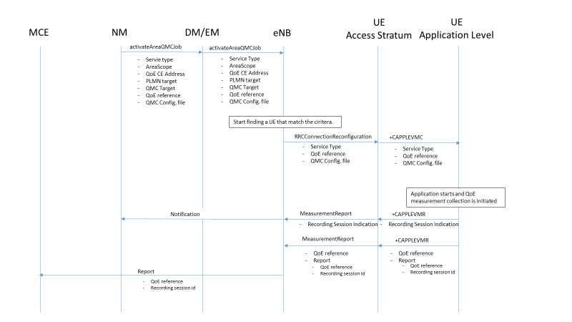
Figure 4.2.1-1: QMC activation and reporting in LTE
1. The NM sends activateAreaQMCJob to DM/EM that controls the impacted eNB(s), and includes the parameters: serviceType, areaScope, qoECollectionEntityAddress, pLMNTarget, qoETarget, qoEReference and QMC configuration file.
2. The DM/EM forwards activateAreaQMCJob to impacted eNB(s), and includes the parameters: serviceType, areaScope, qoECollectionEntityAddress, pLMNTarget, qoETarget, qoEReference and QMC configuration file.
3. The eNB checks for connections where the UE has the UE capability [9] that match the criteria for serviceType in the activateAreaQMCJob.
4. When a connection is found that has the wanted UE capability [9], the eNB starts a UE request session and stores the associated QoECollectionEntityAddress, sends the message RRCConnectionReconfiguration to the UE, and includes the following: serviceType, qoEReference and QMC configuration file.
5. The access stratum in the UE sends the AT command +CAPPLEVMC to application level and includes the following: serviceType, qoEReference and QMC configuration file.
6. When the application in the serviceType starts, the QMC is initiated.
7. The application layer sends the AT command +CAPPLEVMR including a recording session indication that indicates that a session is started to the access stratum.
8. The UE sends the message MeasReportAppLayer including the recording session indication to the eNB.
9. The eNB sends a notification including the recording session indication to the NM.
10. When the QMC is completed, the recorded information is collected in a QMC report [6], [7], including qoEReference and recordingSessionId. The qoEReference, Client Id [6] and [7] in the reporting container (that represent the UE request session), and recordingSessionId are needed in the QMC collection entity for post processing purposes.
11. The application layer sends the AT command +CAPPLEVMR including qoEReference and the QMC report to the access stratum.
12. The UE sends the message MeasReportAppLayer including qoEReference and the QMC report to the eNB.
13. The eNB sends the QMC report to the MCE associated to the qoEReference.

4.2.2 Handling of measurement collection at handover in LTE

4.2.2.1 Handover between cells within an eNB
When handover is made and no Recording session id is provided, the measurement area is checked.
- If the mobile is inside the measurement area after the handover, the eNB sends in an indication that the UE is inside the measurement area in the RRCConnectionReconfiguration message [8] to the UE. The UE send the +CAPPLEVMC AT command [5] to the application to inform that recording shall start if the application becomes active (when the UE moves into the measurement area).
- If the mobile has moved outside the measurement area, there is no indication that the UE is inside the measurement area in the RRCConnectionReconfiguration message [8] from the eNB to the UE. The UE sends the +CAPPLEVMC AT command [5] to the application to inform that recording shall not be started even if the application becomes active.

4.2.2.2 Handover between eNBs
The figure 4.2.2.2-1 and the text below describes the handling at handover between eNBs.
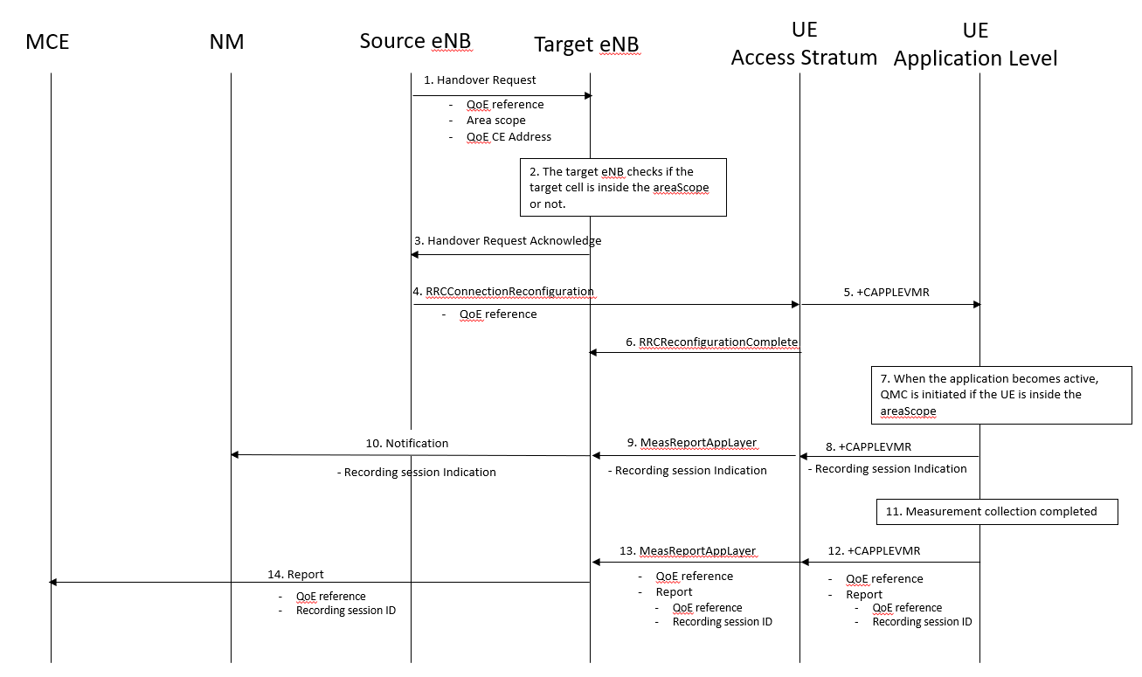
Figure 4.2.2.2-1: Handling of QMC activation in case of handover in LTE
1. Source eNB sends the message HandoverRequest to Target eNB and includes areaScope and qoECollectionEntityAddress.
2. The target eNB checks if the target cell is inside the areaScope or not.
3. The target eNB sends the message HandoverRequestAcknowledge to the source eNB.
4. The source eNB sends the message RRCConnectionReconfiguration to the UE.
5. The access stratum in the UE sends the AT command +CAPPLEVMC to application level.
6. The UE sends the message RRCConnectionReconfigurationComplete to the eNB.
7. When the application becomes active, QMC is initiated if the UE is inside the areaScope.
8. The application layer sends the AT command +CAPPLEVMR including a recording session indication indicating that a session has started to the access stratum.
9. The UE sends the message MeasReportAppLayer including the recording session indication to the eNB.
10. The eNB sends a notification including the recording session indication to the NM.
11. When the QMC is completed, the recorded information is collected in a QMC report [6], [7]. including qoEReference and recordingSessionId. The qoEReference, Client Id [6] and [7] in the reporting container (that represent the UE request session) and recordingSessionId are needed in the QoE collection entity for post processing purposes.
12. The application layer sends the AT command +CAPPLEVMR including qoEReference and the QMC report to the access stratum.
13. The UE sends the message MeasReportAppLayer including qoEReference and the QMC report to the eNB.
14. The eNB sends the QMC report to the MCE associated to the qoEReference.

4.2.3 Deactivation of measurement collection job in LTE

4.2.3.1 Forced deactivation
When the operator technician or the management application wants to deactivate a measurement collection job, the management system sends the deactivateQMCJob operation [3] to the eNB. The eNB sets the network request session to ended, but does not delete the UE request session id and the Collection Entity Address parameters [3], as the UE still may send reports which shall be send to the collection centre. For UE request sessions which have reported that a recording session is started, the eNB sends the RRCConnectionReconfiguration message [8] to relevant UEs. The RRCConnectionReconfiguration message is including measConfigAppLayer set to discard application layer measurement report information in otherConfig [8]. The Access stratum sends +CAPPLEVMC AT command [5] to the application with the discard request. The application stops the recording session and stops recording of the requested information. The UE request session id and the Collection Entity Address parameters [3] in the eNB are deleted when the UE request session is ended.

4.2.3.2 Deactivation of recording session
Regardless of whether the pre-set time has elapsed or not, the recording session continues to be active until the session for the application is ended.

4.2.4 Void

4.3 Signalling based activation in UTRAN

4.3.1 Activation of measurement collection job in UTRAN
In Signalling based activation, the QoE measurement collection is sent to the UE from the OAM via CN. The messages from EMS propagated to HSS, MSE Server/SGSN and RNC. QoE measurement collection activation request is propagated to UE.
When HSS activates the QoE measurement collection for a job, the MSC Server/SGSN can send the QoE measurement collection to the UE through RNC, the following configuration parameters shall be included in the message: serviceType, areaScope, qoECollectionEntityAddress, pLMNTarget, qoETarget, qoEReference and QMC configuration file.
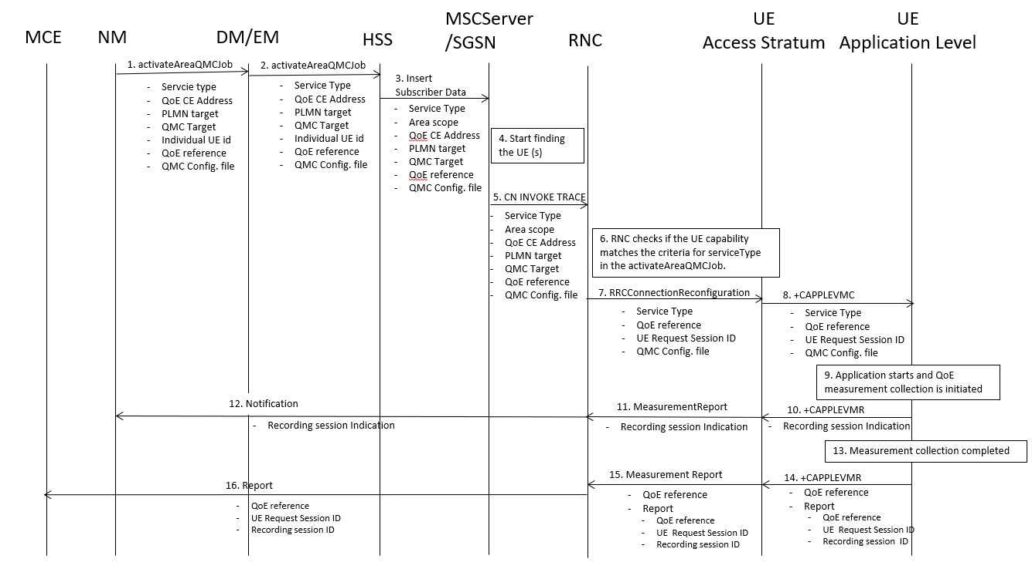

1) The NM sends activateAreaQMCJob to DM/EM that controls the impacted RNC(s), and includes the parameters: serviceType, areaScope, qoECollectionEntityAddress, pLMNTarget, qMCTarget, Individual UE Id, qoEReference and QMC configuration file.
2) The DM/EM sends activateAreaQMCJob to HSS that controls the impacted RNC(s), and includes the parameters: serviceType, areaScope, qoECollectionEntityAddress, pLMNTarget, qoETarget, Individual UE Id,qoEReference and QMC configuration file.
3) The HSS sends an Insert Subscriber Data to the MSC Server/SGSN that is registered in the HSS in a previous Update Location Request message.
4) The MSC Server/SGSN starts finding the UE and check if that the UE capability matches the criteria for ServiceType in activateAreaQMCJob
5) The MSC Server/SGSN sends message CN INVOKE TRACE to the RNC and includes the parameters: serviceType, areaScope, qoECollectionEntityAddress, pLMNTarget, qoETarget,qoEReference and QMC configuration file.
6) The RNC checks for connections where the UE has the UE Application Layer Measurement Capability that match the criteria for serviceType in the activateAreaQMCJob.
7) The RNC start a UE request session and stores the associated QoECollectionEntityAddress, sends the message RRCConnectionReconfiguration to the UE, and includes the following: serviceType, qoEReference and QMC configuration file.
8) The access stratum in the UE sends the AT command +CAPPLEVMC to application level and includes the following: serviceType, qoEReference and QMC configuration file.
9) When the application in the serviceType starts, the QMC is initiated.
10) The application layer sends the AT command +CAPPLEVMR including a recording session indication that a session has started to the access stratum.
11) The UE sends the message MeasurementReport including the recording session indication to the RNC.
12) The RNC sends a notification including the recording session indication to the NM.
13) When the QMC is completed, the recorded information is collected in a QMC report, including qoEReference and recordingSessionId. The qoEReference, Client Id, in the reporting container (that represent the UE request session), and recordingSessionId are needed in the QMC collection entity for post processing purposes.
14) The application layer sends the AT command +CAPPLEVMR including qoEReference and the QMC report to the access stratum.
15) The UE sends the message MeasurementReport including qoEReference and the QMC report to the RNC.
16) The RNC sends the QMC report to the MCE associated to the qoEReference.

4.3.2 Handling of measurement collection at handover in UTRAN
See clause 4.1.2.

4.3.3 Deactivation of measurement collection job in UTRAN

4.3.3.1 Pre-set time has elapsed in UTRAN
When the pre-set time is elapsed, the HSS or SGSN and the RNC sets the network request session to ended, but do not delete the UE request session id and the Collection Entity Address parameters [3], due to that reports still can come from the UE that has to be transferred to the collection centre. The UE request session id and the Collection Entity Address parameters [3] are deleted when the session is ended.

4.33.2 Forced deactivation in UTRAN
If the operator technician or the management application wants to deactivate a measurement collection job, the management system sends the deactivateQoEJob operation [3] to the HSS or SGSN, that propagate it to the RNC. The RNC sets the network request session to ended, but does not delete the UE request session id and the Collection Entity Address parameters [3], as the UE still may send reports which shall be send to the collection centre. For UE request sessions which have reported that a recording session is started, the RNC sends the MeasurementControl message [4] with the DeactivateJob request to relevant UEs. The Access stratum sends +CAPPLEVMC AT command [5] to the application with the DeactivateJob request. The application stops the recording session and stops recording of the requested information. The UE request session id and the Collection Entity Address parameters [3] in the RNC are deleted when the UE request session is ended.

4.3.3.3 Deactivation of recording session in UTRAN
See clause 4.1.3.3.

4.4 Signalling based activation in LTE

4.4.2 Activation of measurement collection for a UE in LTE

4.4.2.0 General
Activation of measurement collection for a UE can be done before UE attachment or after UE is attached.

4.4.2.1 Activation of QoE measurement task before UE attaches to the network
When HSS activates the QoE measurement collection for a job, to the MME the following configuration parameters shall be included in the message: serviceType, areaScope, qoECollectionEntityAddress, pLMNTarget, qoETarget, qoEReference and QMC configuration file.
At UE attachment the configuration parameters for the QoE measurement collection for a job is propagated to the UE.
The MME receives and stores QoE measurement collection job as part of Update Location Answer (or Insert Subscriber Information). Then the same procedure for activation of measurement collection job is applied as after UE is attached, described in see 4.4.2.2.
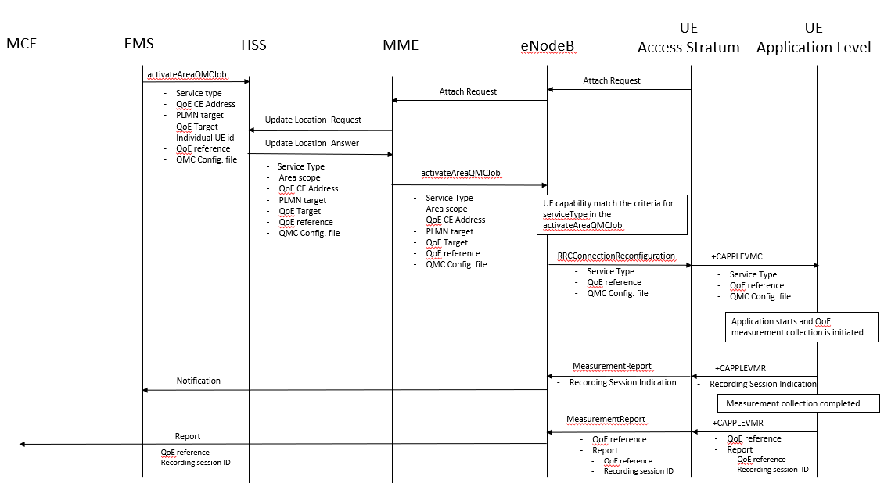

4.4.2.2 Activation of QoE measurement task after UE attachement to the network
The QoE measurement collection is sent to the UE from the OAM via CN. The messages from EMS propagated to HSS, MME and eNodeB are the same as previous section. QoE measurement collection activation request is propagated to UE finally.
When MME can send the QoE measurement collection to the UE through eNodeB, the following configuration parameters shall be included in the message: serviceType, areaScope, qoECollectionEntityAddress, pLMNTarget, qoETarget, qoEReference and QMC configuration file. QoE measurement collection activation request is propagated to UE.
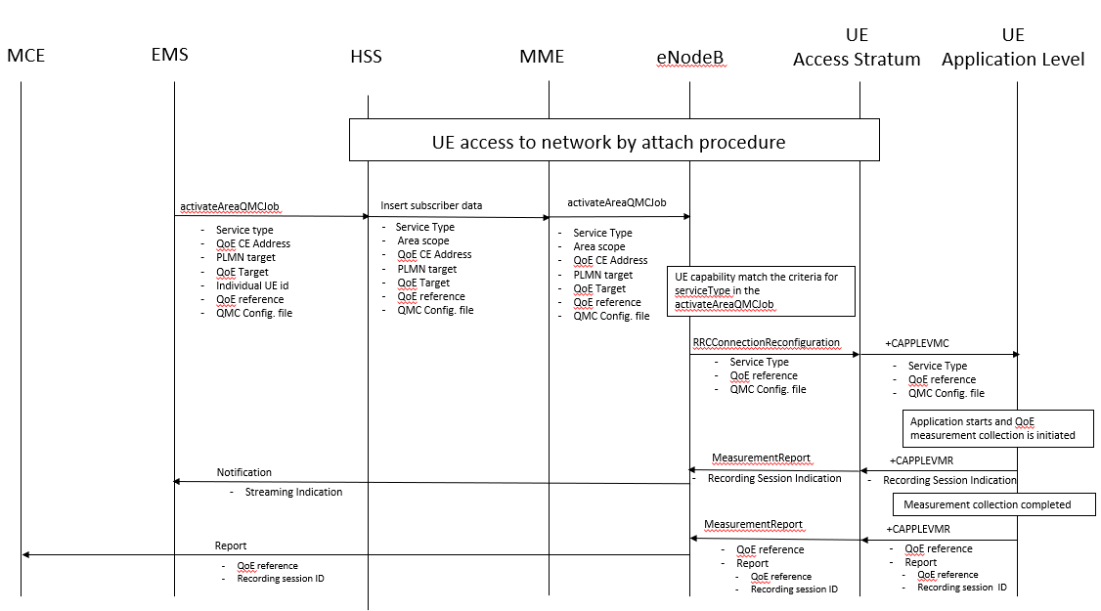

1) The EMS sends activateAreaQMCJob to HSS that controls the impacted eNB(s), and includes the parameters: serviceType, areaScope, qoECollectionEntityAddress, pLMNTarget, qoETarget, qoEReference and QMC configuration file.
2) The HSS inserts subscriber related data and forwards it to the MME.
3) The MME forwards activateAreaQMCJob to impacted eNB(s), and includes the parameters: serviceType, areaScope, qoECollectionEntityAddress, pLMNTarget, qoETarget, qoEReference and QMC configuration file.
4) The eNB checks if the UE capability that matches the criteria for serviceType in the activateAreaQMCJob.
5) If the UE has the wanted UE capability, the eNB starts a UE request session and stores the associated QoECollectionEntityAddress, sends the message RRCConnectionReconfiguration to the UE, and includes the following: serviceType, qoEReference and QMC configuration file.
6) The access stratum in the UE sends the AT command +CAPPLEVMC to application level and includes the following: serviceType, qoEReference and QMC configuration file.
7) When the application in the serviceType starts, the QMC is initiated.
8) The application layer sends the AT command +CAPPLEVMR including a recording session indication that indicates that a session is started to the access stratum.
9) The UE sends the message MeasReportAppLayer including the recording session indication to the eNB.
10) The eNB sends a notification including the recording session indication to the NM.
11) When the QMC is completed, the recorded information is collected in a QMC report [6], [7], including qoEReference and recordingSessionId. The qoEReference, Client Id [6] and [7] in the reporting container (that represent the UE request session), and recordingSessionId are needed in the QMC collection entity for post processing purposes.
12) The application layer sends the AT command +CAPPLEVMR including qoEReference and the QMC report to the access stratum.
13) The UE sends the message MeasReportAppLayer including qoEReference and the QMC report to the eNB.
14) The eNB sends the QMC report to the MCE associated to the qoEReference.

4.4.3 Handling of measurement collection at handover in LTE
See clause 4.2.2.

4.4.4 Deactivation of measurement collection for a UE in LTE

4.4.4.1 Pre-set time has elapsed in LTE
When the pre-set time is elapsed, the MME and the eNB sets the network request session to ended, but do not delete the UE request session id and the Collection Entity Address parameters [3], due to that reports still can come from the UE that has to be transferred to the collection centre. The UE request session id and the Collection Entity Address parameters [3] are deleted when the session is ended.

4.4.4.2 Forced deactivation in LTE
When the operator technician or the management application wants to deactivate a measurement collection job, the management system sends the deactivateQMCJob operation [3] to the MME that propgates to the eNB . The eNB sets the network request session to ended, but does not delete the UE request session id and the Collection Entity Address parameters [3], as the UE still may send reports which shall be send to the collection centre. For UE request sessions which have reported that a recording session is started, the eNB sends the RRCConnectionReconfiguration message [8] to relevant UEs. The RRCConnectionReconfiguration message is including measConfigAppLayer set to discard application layer measurement report information in otherConfig [8]. The Access stratum sends +CAPPLEVMC AT command [5] to the application with the discard request. The application stops the recording session and stops recording of the requested information. The UE request session id and the Collection Entity Address parameters [3] in the eNB are deleted when the UE request session is ended.

4.4.4.3 Deactivation of recording session in LTE
See clause 4.2.3.2.

4.5 Management based activation in NR

4.5.1 Activation of measurement collection job and reporting of collected information in NR
Management Based Activation enables collection of application layer measurements from the UEs in the specified area for specified end user service type.
The parameters for the network request session are sent from the MnS Consumer via the management system to the gNBs that host the cells that are included in the QoE Measurement Collection job request in the Create MOI QMC operation [15]. A QMC Job is activated by creating a QMCJob object instance in the MnS producer.
Figure 4.5.1-1 and the text below describe the activation of QoE measurement collection.

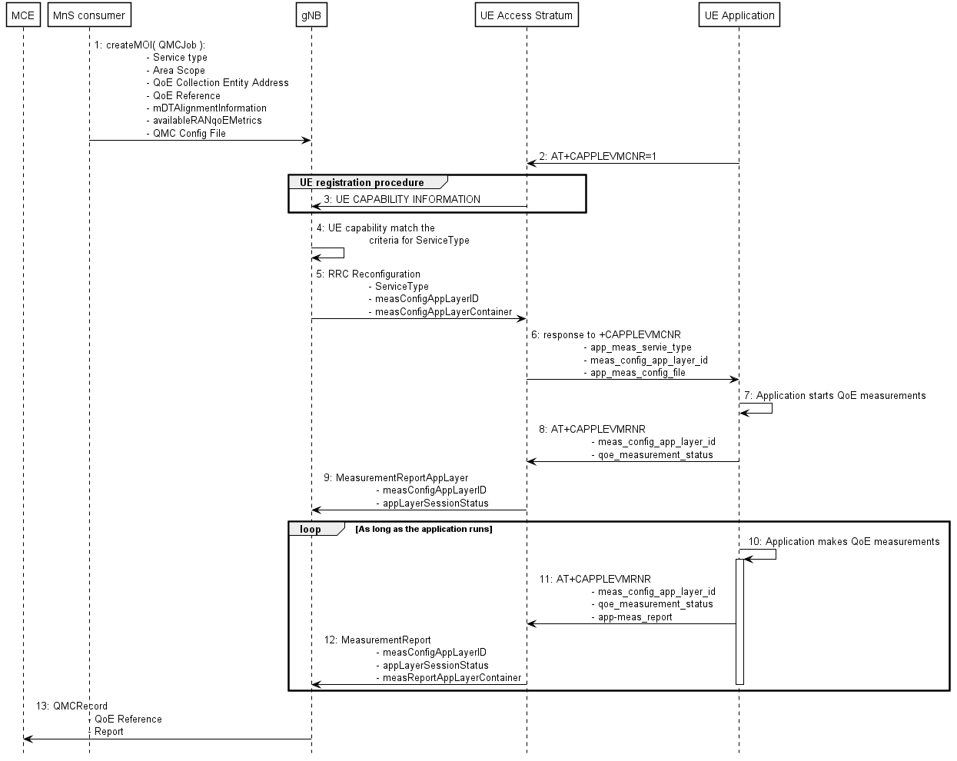
Figure 4.5.1-1: QMC activation example for Management Based Activation and Reporting in NR
1) A QoE Measurement Collection Job begins when the MnS Consumer sends createMOI request for QMCJob to the MnS Producer serving the impacted gNB(s), and includes the parameters: serviceType, areaScope, qoECollectionEntityAddress, qoEReference, mDTAlignmentInformation, availableRANqoEMetrics and qMCConfigFile. Step 2 and step 3 are asynchronous in time with respect to Step 1; they may occur before or after step 1.
NOTE: The RAN visible QoE measurements are supported for the DASH streaming and VR services.
2) Application level measurement configuration. The Application in the UE shall send AT command +CAPPLEVMCNR [5] containing the parameter <n> set to 1 to the Access Stratum. This enables the the Access Stratum to present an unsolicited result code to the Application at a later time. Step 2 and step 3 are asynchronous in time with respect to Step 1; they may occur before or after step 1.
3) UE registration procedure. The UE shall register QMC capability with the gNB by setting qoe-Streaming-MeasReport to “supported” in UE-NR-Capability [11]. Step 2 and step 3 are asynchronous in time with respect to Step 1; they may occur before or after step 1.
4) The gNB starts a network request session, with the QoE Reference [3] given in createMOI for QMCJob [3]. For the duration of the network request session, the gNB(s) checks for connections where the UE has qoe-Streaming-MeasReport set to “supported” [11] in step 2.
5) If a UE has the wanted capability, the gNB stores the associated qoECollectionEntityAddress and starts a UE request session by sending RRCReconfiguration to the UE including serviceType, measConfigAppLayerId (set to the value of qoEReference from step 3) and measConfigAppLayerContainer.
NOTE: The IE measConfigAppLayerId indicates the identity of the application layer measurement configuration, see [11].
6) The access stratum in the UE sends an unsolicited response to the Application including app-meas_service_type, meas_config_app_layer_id and app-meas_config_file. These IEs map directly to the IEs in step 5. The unsolicited response is for the AT command +CAPPLEVMCNR [5] which is sent from Application in step 2.
7) The QMC Job remains inactive until the Application for the specified serviceType initiates service.
8) When the Application begins service, it sends the AT command +CAPPLEVMRNR [5], including meas_config_app_layer_id and qoe_measurement_status to indicate a recording session has started, to the access stratum.
9) The UE sends the message MeasurementReportAppLayer including measConfigAppLayerId and appLayerSessionStatus to the gNB to indicate a recording session has started.
10) While active, the Application collects measurement reports. When the QMC is completed or at the end of period for periodic report, the recorded information is formatted in a QMC report, see [6] for DASH, [7] for MTSI or [13] for VR.
11) When a formatted measurement report is available, the Application sends the AT command +CAPPLEVMRNR [5] including meas_config_app_layer_id, qoe_measurement_status and app-meas_report to the Access Stratum. If the QMC Job has ended, qoe_measurement_status is set to indicate the Job has ended.
12) When the AT command +CAPPLEVMRNR is received from the Application, the Access Stratum sends the message MeasurementReportAppLayer including measConfigAppLayerId, appLayerSessionStatus and measReportAppLayerContainer to the gNB.
13) The gNB sends the QMCRecord to the MCE associated to the qoECollectionEntityAddress. The report contains the QoE Reference from step 3 and measReportAppLayerContainer from step 12.

4.5.3 Deactivation of measurement collection job in NR

4.5.3.1 Forced deactivation
When the operator technician or the management application wants to deactivate a measurement collection job, the management system sends the deactivateQMCJob operation [3] to the gNB. The gNB sets the network request session to ended, but does not delete the UE request session id and the Collection Entity Address parameters [3], as the UE still may send reports which shall be sent to the collection centre. For UE request sessions which have reported that a recording session is started, the gNB sends the RRCReconfiguration message [11] to relevant UEs. The RRCReconfiguration message is including measConfigAppLayerId set to discard application layer measurement report information in otherConfig [11]. The Access Stratum sends +CAPPLEVMC AT command [5] to the application with the discard request. The application stops the recording session and stops recording of the requested information. The QoE Reference Id and the QoE Collection Entity Address parameters [3] in the gNB are deleted when the UE request session is ended.

4.5.3.2 Deactivation of recording session
The recording session continues to be active until the session for the Application is ended.

4.5.4 Temporary stop and restart of QoE information reporting during RAN overload in NR
In case of overload in RAN, the gNB may temporarily stop the reporting from the UE by sending the RRCReconfiguration message [11] to relevant UEs. The RRCReconfiguration message [11] includes pauseReporting set to TRUE in appLayerMeasConfig to temporarily stop application layer measurement reporting. The access stratum continues recording further information until the data storage capacity for the reporting is fully used or the UE request session ends. Then the recorded data is kept until it is reported to the gNB or when the UE request session is ended.
When the overload situation in RAN is ended the gNB restart the reporting from the UE by sending the RRCReconfiguration message [11] to relevant UEs. The RRCReconfiguration message is including pauseReporting set to FALSE in appLayerMeasConfig to restart application layer measurement reporting.
The UE application level is not directly affected by the RAN overload.

4.6 Signalling based activation in NR

4.6.1 Activation of measurement collection for a UE in NR

4.6.1.0 General
Activation of measurement collection for a UE can be done after UE is registered or before UE Registration procedure.

4.6.1.1 Activation of QoE measurement task after completion of UE registration procedure
Figure 4.6.1.1-1 and the text below describe the activation of QoE measurement collection after completion of UE registration procedure.
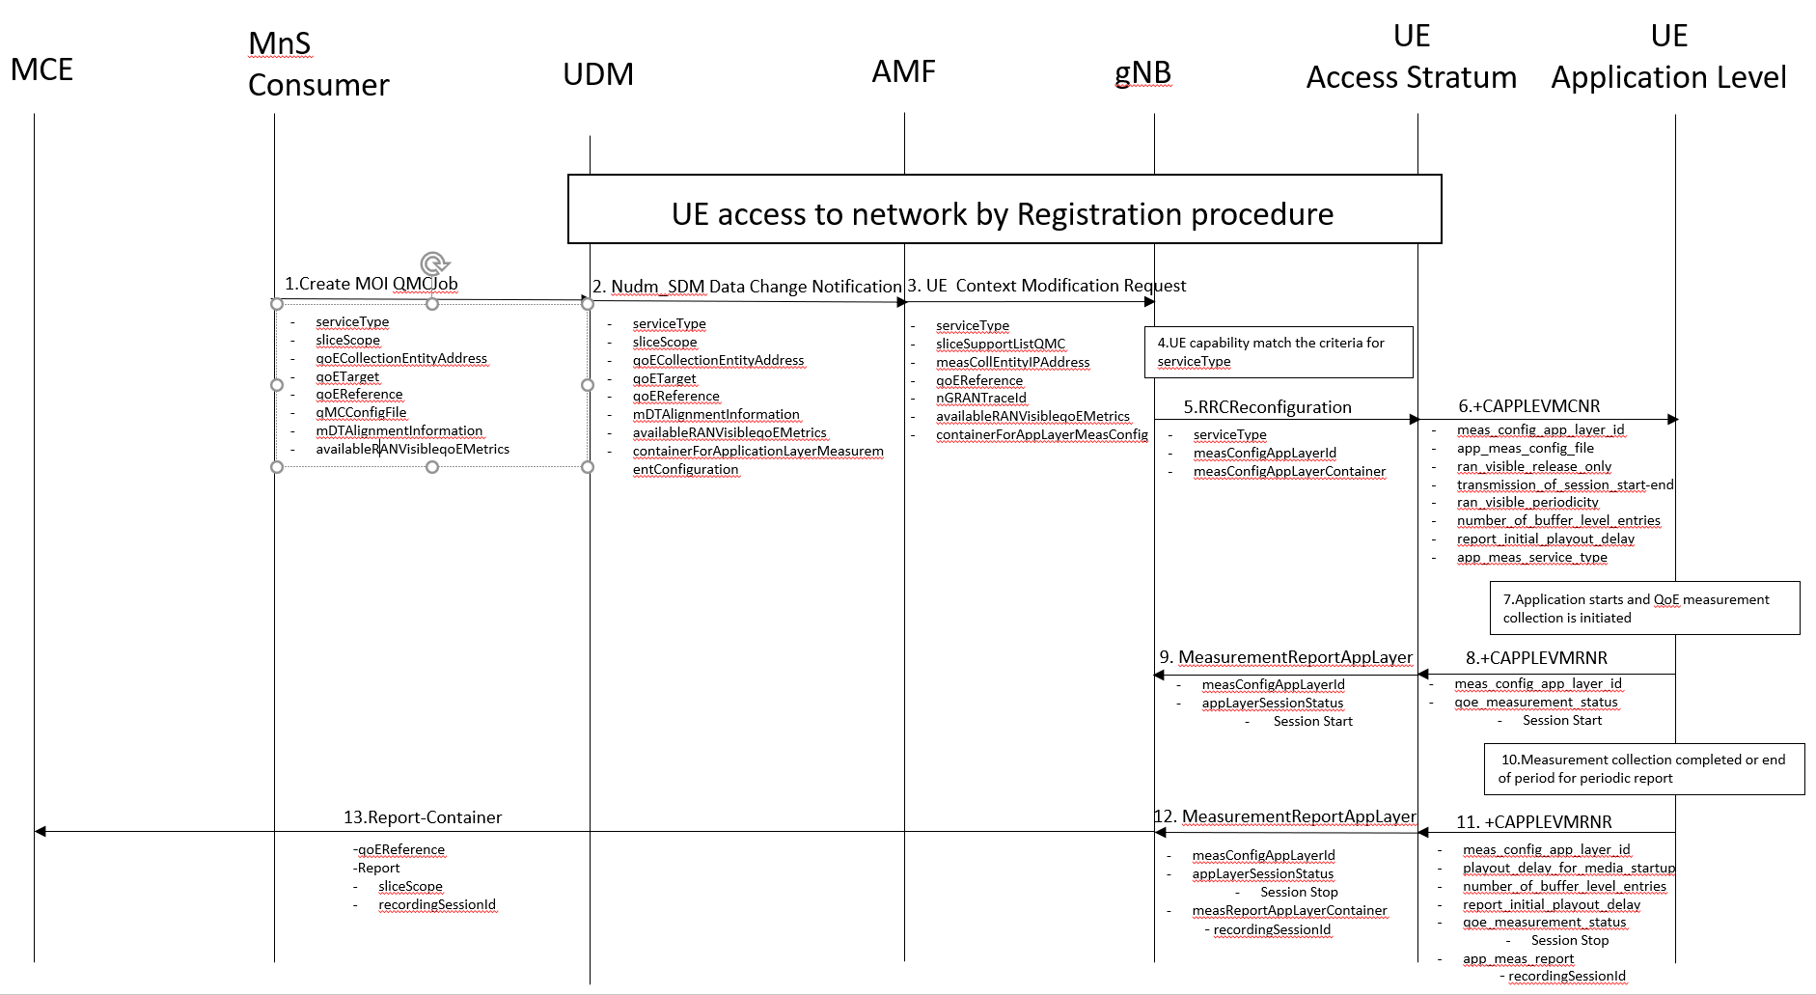
Figure 4.6.1.1-1: QMC activation and reporting example in NR after UE is registered

1. The MnS Consumer sends createMOI request for QMCJob to UDM that controls the impacted gNB(s), and includes the parameters: serviceType, sliceScope, qoECollectionEntityAddress, qoETarget, qoEReference, mDTAlignmentInformation, availableRANqoEMetrics and qMCConfigFile.
2. The UDM inserts subscriber related data and forwards it to the AMF.
3. The AMF forwards the configuration parameters serviceType, sliceSupportListQMC, measCollEntityIPAddress, qoEReference, nGRANTraceId, availablerANqoEMetrics and containerForAppLayerMeasConfig in message UE Context Modification Request to the impacted gNB.
4. The gNB checks if the UE capability matches the criteria for serviceType in the QoE measurement configuration information.
5. If the UE has the wanted UE capability, the gNB starts a UE request session and stores the associated qoECollectionEntityAddress, sends the message RRCReconfiguration to the UE including serviceType, measConfigAppLayerId and measConfigAppLayerContainer.
NOTE: The IE measConfigAppLayerId indicates the identity of the application layer measurement configuration, see [11].
6. The access stratum in the UE sends an unsolicited response to the application level including app-meas_service_type, meas_config_app_layer_id, ran_visible_release_only, transmission_of_session_start-end, ran_visible_periodicity, number_of_buffer_level_entries, report_initial_playout_delay and app-meas_config_file. The unsolicited response is for the AT command +CAPPLEVMCNR which is sent from UE Application Level to UE Access Stratum during Registration procedure.
7. When the application for the specified serviceType starts, the QMC is initiated. To specify the session which is started, the application generates a recordingSessionId.
8. The application layer sends the AT command +CAPPLEVMRNR [7] including meas_config_app_layer_id and qoe_measurement_status that indicates that a session is started to the access stratum.
9. The UE sends the message MeasurementReportAppLayer including measConfigAppLayerId and appLayerSessionStatus to the gNB.
10. When the QMC is completed or at the end of period for periodic report, the recorded information is collected in a QMC report, see [6], [7] or [13].
11. The application layer sends the AT command +CAPPLEVMRNR [7] including meas_config_app_layer_id, playout_delay_for_media_startup, number_of_buffer_level_entries, report_initial_playout_delay, qoe_measurement_status indicating that session has ended and app-meas_report including recordingSessionId to the access stratum.
12. The UE sends the message MeasurementReportAppLayer including measConfigAppLayerId, appLayerSessionStatus and measReportAppLayerContainer including recordingSessionId to the gNB.
13. The gNB sends the QMC report to the MCE associated to the qoEReference. The report contains the qoEReference and the RAN transparent container including the recordingSessionId and sliceScope, which contains only the S-NSSAI used. Note that the qoEReference is mapped to the measConfigAppLayerId at gNB on the previous step and is included in QMC report.

4.6.1.2 Activation of QoE measurement task before UE Registration procedure to the network
Figure 4.6.1.2-1 and the text below describe the activation of QoE measurement collection before UE registration procedure to the network.
The AMF receives and stores QoE measurement collection job as part of API: Numd_SDM . Then the same procedure for activation of measurement collection job is applied as after completion of UE registration procedure, except that instead of UE Context Modification Request the message Initial Context Setup Request is sent, see 4.6.1.1.
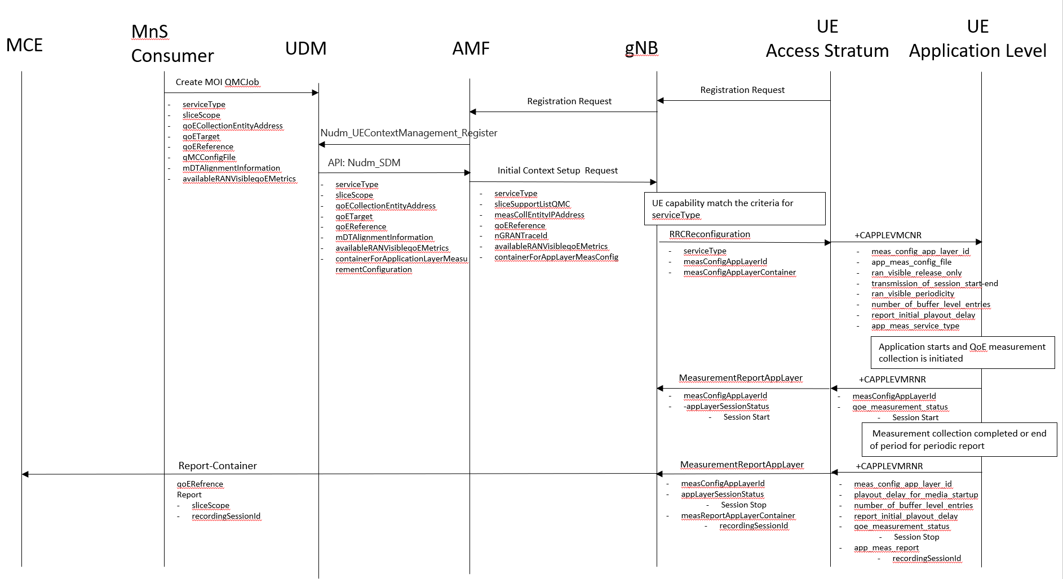
Figure 4.6.1.2-1: QMC activation and reporting example in NR before UE Registration procedure to the network

4.6.2 Handling of measurement collection at handover in NR

4.6.2.1 NG Based Handover for Signalling Based Activation
The figure 4.6.2.1-1 and the text below describe the handling at NG Based handover between gNBs for Signalling Based Activation case.
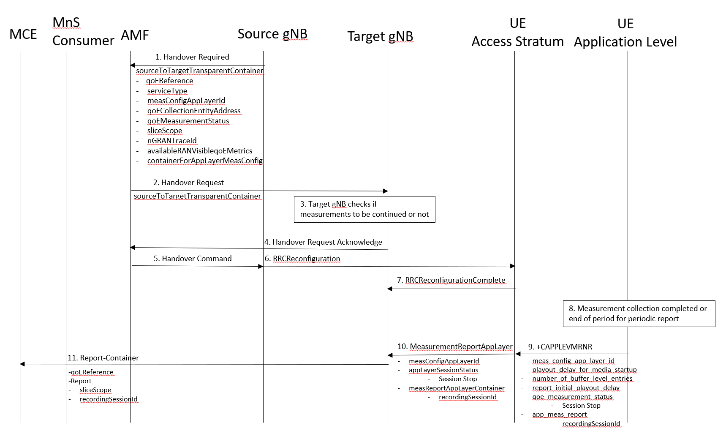
Figure 4.6.2.1-1: Handling of QMC activation example in case of NG Based handover in NR for Signalling Based Activation
1. Source gNB sends the message HANDOVER REQUIRED to AMF. The message includes the Source to Target Transparent Container which contains qoEReference, serviceType, measConfigAppLayerID, measCollEntityIPAddress, qoEMeasurementStatus, sliceSupportListQMC, nGRANTraceId, availableRANVisibleqoEMetrics and containerForAppLayerMeasConfig.
2. AMF sends the message HANDOVER REQUEST to the Target gNB. The message includes the Source to Target Transparent Container which contains the same parameters as in step 1.
3. The target gNB checks if the measurements will be continued or not.
4. The target gNB sends the message HANDOVER REQUEST ACKNOWLEDGE to the AMF.
5. The AMF sends the message HANDOVER COMMAND to the source gNB.
6. The source gNB sends the message RRCReconfiguration to the UE.
7. The UE sends the message RRCReconfigurationComplete to the gNB.
8. When the ongoing QMC is completed or end of periodic reporting is reached, the recorded information is collected in a QMC report, see [6], [7] or [13], at UE Application Level.
9. The application layer sends the AT command +CAPPLEVMRNR including meas_config_app_layer_id, qoe_measurement_status playout_delay_for_media_startup, number_of_buffer_level_entries, report_initial_playout_delay, and the app-meas_report to the access stratum.
10. The UE sends the message MeasurementReportAppLayer including measConfigAppLayerId, appLayerSessionStatus and measReportAppLayerContainer to the gNB.
11. The gNB sends the QMC report to the MCE associated to the qoEReference. The report contains the qoEReference and the RAN transparent container including the recordingSessionId and sliceScope (which contains only S-NSSAI that is used). Note that the qoEReference is mapped to the measConfigAppLayerId at gNB on the previous step and is included in QMC report.

5 Quality of Experience (QoE) measurement management parameters

5.1 QoE collection entity address (M)
This is a parameter which defines the IP address to which the QMC records shall be transferred. Ipv4 or Ipv6 address(es) may be used.

5.2 QoE reference (M)
The QoE reference parameter specify the network request session. The QoE reference shall be globally unique therefore it is composed as follows:
MCC+MNC+QMC ID, where the MCC and MNC are coming with the QMC activation request from the management system to identify one PLMN containing the management system, and QMC ID is a 3 byte Octet String.
The QMC ID is generated by the management system or the operator.
It is used to identify the QoE measurement collection job in the traffic nodes and in the measurement collection centre.

5.3 PLMN target (CM)
This parameter defines the PLMN for which sessions shall be selected in the network request session in case of area based QMC when several PLMNs are supported in the RAN (this means that shared cells and not shared cells are allowed for the specified PLMN. Furthermore, several PLMNs can be used for not shared RAN cases as well as for shared RAN cases.). Only the sessions may be selected where the PLMN that the UE reports as selected PLMN is the same as the PLMN Target.
Note that the PLMN Target might differ from the PLMN specified in the Network Request Session Id, as that specifies the PLMN that is containing the management system requesting the Network Request Session from the NE.
The parameter is mandatory if network sharing is deployed.

5.4 Area scope (CM)
The area scope parameter defines the area in terms or cells or Tracking Area/Routing Area/Location Area where the QMC shall take place. If the parameter is not present the QMC shall be done throughout the PLMN specified in PLMN target.
The area scope parameter in UMTS is either:
- List of cells, identified by CGI. Maximum 32 CGI can be defined.
- List of Routing Area, identified by RAI. Maximum of 8 RAIs can be defined.
- List of Location Area, identified by LAI. Maximum of 8 LAIs can be defined.
The area scope parameter in LTE is either:
- list of cells, identified by E-UTRAN-CGI. Maximum 32 CGI can be defined.
- List of Tracking Area, identified by TAC. Maximum of 8 TAC can be defined.
The area scope parameter in NR is either:
- list of cells, identified by N-CGI. Maximum 32 NCGI can be defined.
- List of Tracking Area, identified by TAC. Maximum of 8 TAC can be defined.
The parameter is mandatory if area based QMC is requested.

5.5 QMC configuration file (container) (M)
The QMC configuration file is a container that is specified in Annex L of TS 26.247 [6], clause 16.5 of TS 26.114[7] or clause 9.4 of TS 26.118 [13].
The corresponding parameter name for this container in Radio Resource Control (RRC) Protocol specification is measConfigAppLayerContainer in case of NR and LTE, see TS 38.331 [11], TS 25.331 [4] or "Container for application layer measurement configuration" in case of UTRAN, see TS 36.331 [8]
For NR, the QMC configuration file parameter in the management interface defines the location of the container..

5.6 QMC target (M)
The QMC target parameter specifies it the QMC is area based or individual UE based.
- Area based QMC (0)
- Individual UE based QMC (1)
NOTE: Void.

5.7 Recording session id (M)
This parameter shall be a 2 byte octet string. The recording session id shall be the same for the whole session in the application, while for each different session in the application the recording session id shall be changed. The recording session id is generated by the application in the UE.
It is used in the measurement collection centre to identify which session within a UE has collected information in the application.

5.8 Service type (M)
Which kind of service that shall be recorded.
- DASH (0)
- MTSI (1)
- VR (2)
DASH measurements are specified in [6]. MTSI measurements are specific in [7]. VR measurements are specified in TS 26.118 [13].

5.9 Slice scope (CM)
This parameter contains a list of S-NSSIAs (Single Network Slice Selection Assistance Information). A Network Slice end to end is identified by S-NSSAI.

5.10 QoE Target (CM)
This parameter specifies the target object (individual UE) for the QMC in case of signalling based QMC. The qoETarget parameter shall be able to carry "IMSI” or "SUPI".

5.11 jobId (O)
This parameter presents the job identifier of a QMCJob instance. The jobId can be used to associate multiple QMCJob instances.

5.12 Available RAN visible QoE metrics (O)
This parameter indicate available RAN visible QoE metrics to the gNB. The list of available RAN visible metrics are outside the legacy QoE configuration file. This parameter is optional and is valid for NR only.
The gNB configures the RAN visible QoE measurement to collect all or some of the available RAN visible QoE metrics, where the indication of metric availability is received from the OAM or the 5GC. Available RAN visible QoE Metrics are: "Application Layer Buffer Level List" and "Playout Delay for Media Startup".
The RAN visible QoE measurements are supported for the DASH streaming and VR services.
5.13 MDT Alignment information (O)
This parameter indicates the MDT measurements with which alignment of QoE measurement is required. This parameter is optional and is valid for NR only.
The gNB may activate the MDT measurements upon/after receiving the MDT activation message from the OAM.
The gNB includes time stamp information to the QoE measurement reports to enable the correlation of corresponding measurement results of MDT and QoE at the MCE/TCE. In addition, the gNB includes the MDT session identifiers (Trace Reference and Trace Recording Session Reference) in the corresponding QoE measurement report.

Annex A (informative):
Change history
Change history
Date | Meeting | TDoc | CR | Rev | Cat | Subject/Comment | New version
2020-07 | SA#88e |  |  |  |  | Upgrade to version under change control | 16.0.0
2021-09 | SA#93e | SP-210883 | 0001 | - | F | Aligning with RAN specifications 36.331 and 25.331 | 16.1.0
2021-12 | SA#94e | SP-211454 | 0004 | 1 | F | Corrent the description of QoE reference and PLMN target | 16.2.0
2021-12 | SA#94e | SP-211453 | 0003 | 1 | B | Adding Signalling Based Activation for UTRAN and LTE | 17.0.0
2022-03 | SA#95e | SP-220181 | 0005 | - | B | Adding Management Based Activation and Temporary stop and restart during RAN overload in NR | 17.1.0
2022-03 | SA#95e | SP-220181 | 0008 |  | B | Update to include NR and adding VR | 17.1.0
2022-06 | SA#96 | SP-220500 | 0011 | 1 | F | Adding missing parameters and updating definition | 17.2.0
2022-09 | SA#97e | SP-220850 | 0012 | - | F | Align Requirements of handling QMC during RAN overload to RAN specifications | 17.3.0
2022-09 | SA#97e | SP-220855 | 0014 | 1 | B | Adding Signalling Based Activation for NR | 18.0.0
2022-09 | SA#97e | SP-220855 | 0015 | 1 | B | Handling of QoE measurement collection at handover in NR | 18.0.0
2022-12 | SA#98e | SP-221167 | 0017 | 2 | F | Clean up | 18.1.0
2022-12 | SA#98e | SP-221176 | 0018 | 1 | F | Management based activation in NR correction for SBMA | 18.1.0
2022-12 | SA#98e | SP-221176 | 0019 | - | B | Add MDT alignment Information and RAN visible QoE Metrics to Handling QMC at Handover | 18.1.0
2022-12 | SA#98e | SP-221176 | 0021 | - | B | Definition of parameters MDT Alignment Information and Available RAN Visible QoE Metrics | 18.1.0
2023-03 | SA#99 | SP-230204 | 0022 | - | B | Add MDT Alignment Information and RAN visible QoE Metrics to Signalling Based Activation | 18.2.0

