3GPP TSG-SA5 Meeting #146Bis-e S5-231142
Electronic meeting, 16 - 19 January 2023

Source: Huawei

Title: DP AIML collaboration with other 3GPP groups

Document for: Approval
Agenda Item: 6.2.1

1 Decision/action requested
The group is asked to discuss and approve this tdoc..

2 References
[1] RP-220635 Revised WID: Artificial Intelligence (AI)/Machine Learning (ML) for NG-RAN
[2] RP-221348 Revised SID: Study on Artificial Intelligence (AI)/Machine Learning (ML) for NR Air Interface
[3] SP-210587 New WID on AI/ML model transfer in 5GS (AMMT)
[4] SP-220071 Revised SID on System Support for AI/ML-based Services
[5] SP-211443 New Study on AI/ ML management
[6] SP-220488 New SID Study on measurement data collection to support RAN intelligence
[7] 3GPP TR 38.843 Study on Artificial Intelligence (AI)/Machine Learning (ML) for NR air interface
[8] 3GPP TS 38.300 Technical Specification Group Radio Access Network; NR; NR and NG-RAN Overall Description; Stage 2
[9] 3GPP TR 23.700-80 Study on 5G System Support for AI/ML-based Services
[10] 3GPP TR 28.838 Study on measurement data collectionto support RAN intelligence

3 Rationale

3.1 Analysis of AIML related discussion in RAN1/RAN3/SA2/SA1
There are several AIML related work items discussed in RAN1/RAN3/SA1/SA2/SA5, including:

3.1.1 RAN1 SID FS_NR_AIML_air
There is one RAN1 study related to AIML topic (RAN1 SID FS_NR_AIML_air (UID: 940084) in RP-221348 [2]), the objective is as following:
============================Extract from RAN1 RP-221348 start===============================
4 Objective
4.1 Objective of SI or Core part WI or Testing part WI
Study the 3GPP framework for AI/ML for air-interface corresponding to each target use case regarding aspects such as performance, complexity, and potential specification impact.

Use cases to focus on:
- Initial set of use cases includes:
  - CSI feedback enhancement, e.g., overhead reduction, improved accuracy, prediction [RAN1]
  - Beam management, e.g., beam prediction in time, and/or spatial domain for overhead and latency reduction, beam selection accuracy improvement [RAN1]
  - Positioning accuracy enhancements for different scenarios including, e.g., those with heavy NLOS conditions [RAN1]
- Finalize representative sub use cases for each use case for characterization and baseline performance evaluations by RAN#98
  - The AI/ML approaches for the selected sub use cases need to be diverse enough to support various requirements on the gNB-UE collaboration levels

Note: the selection of use cases for this study solely targets the formulation of a framework to apply AI/ML to the air-interface for these and other use cases. The selection itself does not intend to provide any indication of the prospects of any future normative project.

AI/ML model, terminology and description to identify common and specific characteristics for framework investigations:
- Characterize the defining stages of AI/ML related algorithms and associated complexity:
  - Model generation, e.g., model training (including input/output, pre-/post-process, online/offline as applicable), model validation, model testing, as applicable
  - Inference operation, e.g., input/output, pre-/post-process, as applicable
- Identify various levels of collaboration between UE and gNB pertinent to the selected use cases, e.g.,
  - No collaboration: implementation-based only AI/ML algorithms without information exchange [for comparison purposes]
  - Various levels of UE/gNB collaboration targeting at separate or joint ML operation.
- Characterize lifecycle management of AI/ML model: e.g., model training, model deployment, model inference, model monitoring, model updating
- Dataset(s) for training, validation, testing, and inference
- Identify common notation and terminology for AI/ML related functions, procedures and interfaces
- Note: Consider the work done for FS_NR_ENDC_data_collect when appropriate

================================Extract from RP-221348 end===============================
Analysis:
Based on the objective of the RAN1 SID FS_NR_AIML_air, it can be found that the objective information including various levels of collaboration between UE and gNB pertinent, and lifecycle management of AI/ML model: e.g., model training, model deployment, model inference, model monitoring, model updating may be potentially related to SA5.

3.1.2 RAN3 WID NR_AIML_NGRAN
There is one RAN3 work item related to AIML topic (RAN3 WID NR_AIML_NGRAN (UID: 220635) in RP-220635 [1]), the objective is as following:
============================Extract from RAN3 RP-220635 start===============================
4 Objective
4.1 Objective of SI or Core part WI or Testing part WI
Normative work is based on the conclusions captured in TR37.817. The detailed objectives of the WI are listed as follows:
- Specify data collection enhancements and signaling support within existing NG-RAN interfaces and architecture (including non-split architecture and split architecture) for AI/ML-based Network Energy Saving, Load Balancing and Mobility Optimization. (RAN3)

Note: On security impacts, coordination with SA3 when needed. On OAM aspects, coordination with SA5 when needed.
Note: Specify new UE measurements when needed if any.
Note: Specify MDT procedure enhancements when needed if any.
============================Extract from RAN3 RP-220635 end===============================
In TS 38.300 [8], some description on the coordination with OAM is also mentioned as shown below.
==========================Extract from R3-226107 (TS 38.300) start=============================
X.X.2 Mechanisms and Principles
The AI/ML function requires inputs from neighbour NG-RAN nodes (e.g. predicted information, feedback information, measurements) and/or UEs (e.g. measurement results), in support to AI/ML processes such as AI/ML Model Inference and AI/ML Model Training.
AI/ML algorithms and models are out of 3GPP scope, and the details of model performance feedback are also out of 3GPP scope.
For the deployments of RAN intelligence, following scenarios may be supported:
• AI/ML Model Training is located in the OAM and AI/ML Model Inference is located in the gNB.
• AI/ML Model Training and AI/ML Model Inference are both located in the gNB.
==========================extract from R3-226107 (TS 38.300) end=============================
Analysis:
The RAN3 WID NR_AIML_NGRAN is to include the mechanisms and principles about AI/ML for the use case of AI/ML-based Network Energy Saving, Load Balancing and Mobility Optimization. According their agreed conclusion, the AI/ML model training is located in the OAM and AI/ML model inference is located in the gNB.
Based on the objective of the RAN3 WID NR_AIML_NGRAN and its agreement of mechanisms and principles, it can be found that the scenarios of AI/ML model training is located in the OAM and AI/ML model inference is located in the gNB is closely related to SA5.

3.1.3 SA1 WID AIML_MT
There is one SA1 study related to AIML topic (SA1 WID AIML_MT (UID: 920030) in SP-210587 [3]), the objective is as following:
=============================extract from SA11 SP-210587 start===============================
4 Objective
The objective is to specify performance requirements (for end-to-end latency, experienced data rate, communication service availability) and service requirements (for AI/ML QoS management, AI/ML model /data distribution/transfer, network performance and resource utilization monitoring/prediction) for 5GS to support the following AI/ML operations for various applications (e.g. image/speech recognition, media editing/enhancements, robot control, automotive):
- AI/ML operation splitting between AI/ML endpoints;
- AI/ML model/data distribution and sharing over 5G system;
- Distributed/Federated Learning over 5G system.
=============================extract from SA1 SP-210587 end===============================
In TR 22.874, some description on the AI/ML operation and AIML model/data distribution are mentioned which may be potentially related to SA5 as shown below.
================================extract from TR 22.874 start===============================
4 Overview
Artificial Intelligence (AI)/Machine Learning (ML) is being used in a range of application domains across industry sectors. In mobile communications systems, mobile devices (e.g. smartphones, automotive, robots) are increasingly replacing conventional algorithms (e.g. speech recognition, image recognition, video processing) with AI/ML models to enable applications. The 5G system can at least support three types of AI/ML operations:
- AI/ML operation splitting between AI/ML endpoints;
- AI/ML model/data distribution and sharing over 5G system;
- Distributed/Federated Learning over 5G system.
The scheme of split AI/ML inference can be depicted as in Figure 4-1. The AI/ML operation/model is split into multiple parts according to the current task and environment. The intention is to offload the computation-intensive, energy-intensive parts to network endpoints, whereas leave the privacy-sensitive and delay-sensitive parts at the end device. The device executes the operation/model up to a specific part/layer and then sends the intermediate data to the network endpoint. The network endpoint executes the remaining parts/layers and feeds the inference results back to the device.
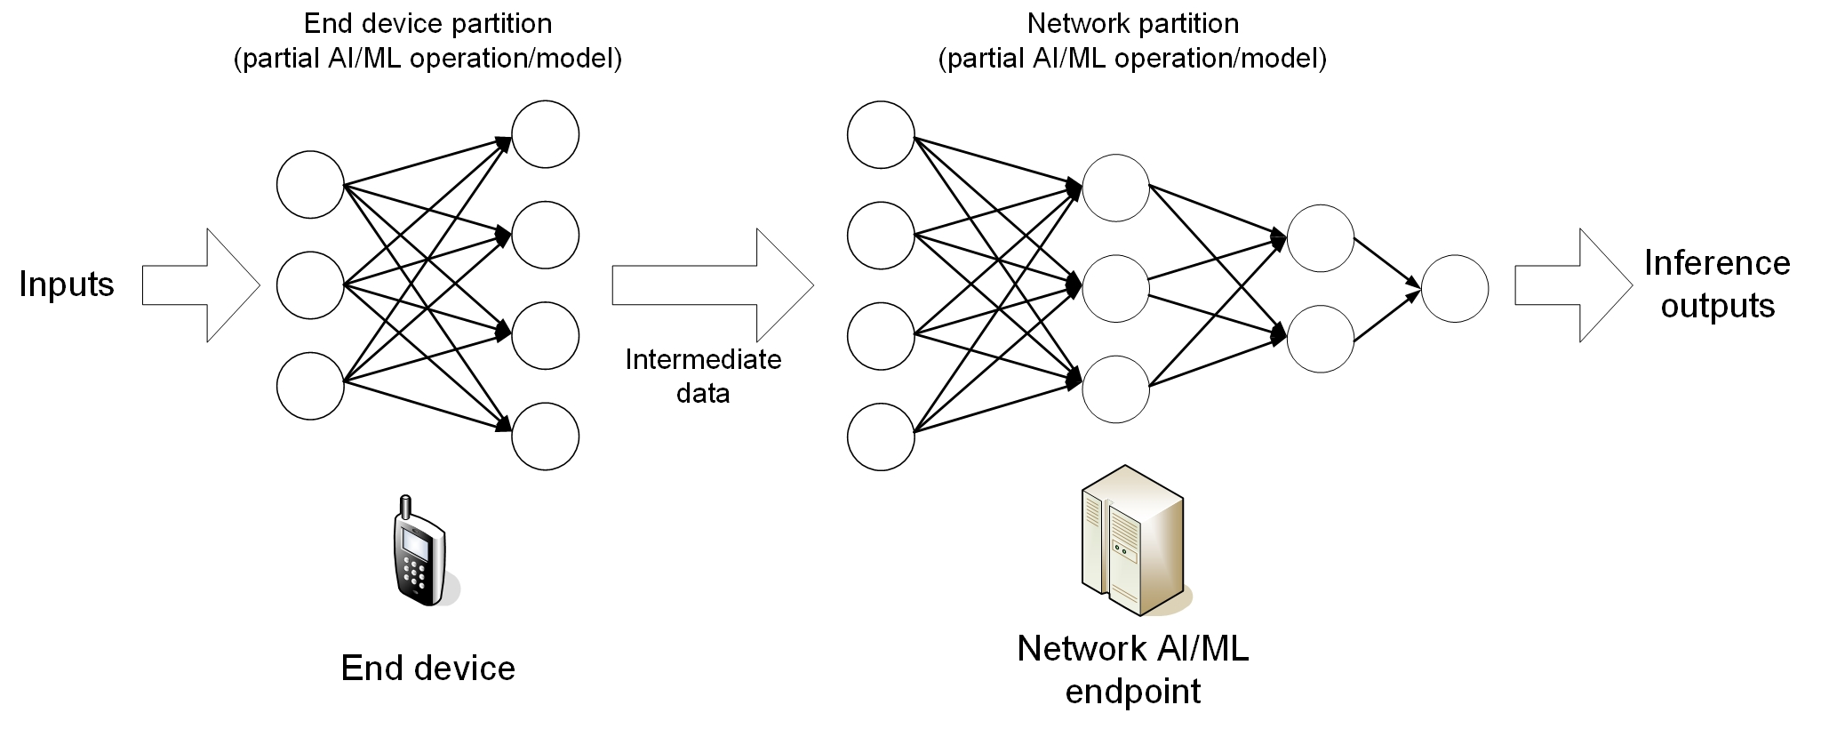
Figure 4-1. Example of split AI/ML inference
The scheme of AI/ML model distribution can be depicted as in Figure 4-2. Multi-functional mobile terminals might need to switch the AI/ML model in response to task and environment variations. The condition of adaptive model selection is that the models to be selected are available for the mobile device. However, given the fact that the AI/ML models are becoming increasingly diverse, and with the limited storage resource in a UE, it can be determined to not pre-load all candidate AI/ML models on-board. Online model distribution (i.e. new model downloading) is needed, in which an AI/ML model can be distributed from a NW endpoint to the devices when they need it to adapt to the changed AI/ML tasks and environments. For this purpose, the model performance at the UE needs to be monitored constantly.
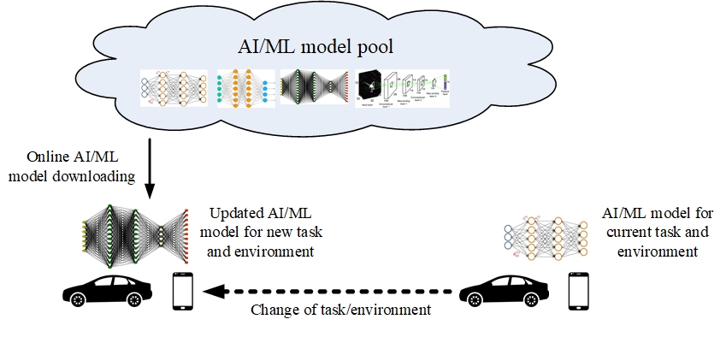
Figure 4-2. AI/ML model downloading over 5G system
The scheme of Federated Learning (FL) can be depicted as in Figure 4-3. The cloud server trains a global model by aggregating local models partially-trained by each end devices. Within each training iteration, a UE performs the training based on the model downloaded from the AI server using the local training data. Then the UE reports the interim training results to the cloud server via 5G UL channels. The server aggregates the interim training results from the UEs and updates the global model. The updated global model is then distributed back to the UEs and the UEs can perform the training for the next iteration.
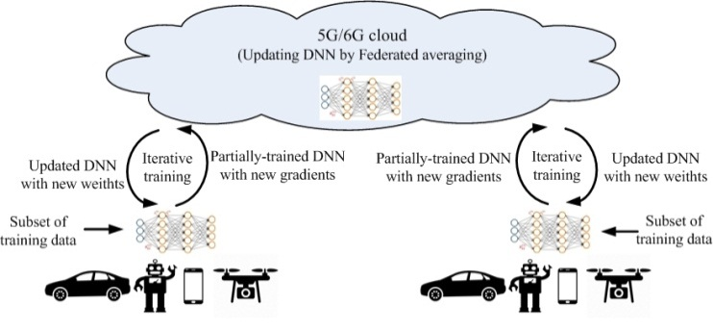
Figure 4-3. Federated Learning over 5G system
================================extract from TR 22.874 end===============================
Analysis:
The SA1 WID AIML_MT is to support three types of AI/ML operations including AI/ML operation splitting between AI/ML endpoints, AI/ML model/data distribution and sharing over 5G system and distributed/federated Learning over 5G system. For the type AI/ML operation splitting between AI/ML endpoints, mainly focus on training and inference is located on the server, where inference is performed jointly by the server and UE. For the type AI/ML model/data distribution and sharing over 5G system, mainly focus on online model download and update, where training is performed on the server, and inference is performed on the UE. For distributed/federated Learning over 5G system, mainly focus on training where training is jointly performed by the server and the terminal and inference can be performed on the UE or jointly performed by the cloud server and the UE.
Based on the objective of the SA1 WID AIML_MT and its agreement TR 22.874, it can be found that these three types of AI/ML operations may be related to SA5.

3.1.4 SA2 SID FS_AIMLsys
There is one SA2 study related to AIML topic (SA2 SID FS_AIMLsys (UID: 940071) in SP-220071 [4]), the objective is as following:
============================Extract from SA2 SP-220071 start===============================
4 Objective
The intent of this study is to focus on enabling, as defined by SA1 Rel-18 AMMT requirements, TS 22.261, the AI/ML Services & Transmissions with 5GS assistance to support AI/ML model distribution, transfer, training for various applications, e.g. video/speech recognition, robot control, automotive etc. for the following three main types of AI/ML operations:
- AI/ML operation splitting between AI/ML endpoints
- AI/ML model/data distribution and sharing over 5G system
- Distributed/Federated Learning (FL) over 5G system
The following describes the objectives of this study on how the AI/ML service providers could leverage 5GS as the platform to provide the intelligent transmission support for application layer AI/ML operation.
- Objective 1 (WT#1.1): Study the possible architectural and functional extensions to support the Application layer AI/ML operations defined in TS 22.261, more specifically:
- Support monitoring of network resource utilization in the 5G system relevant to the UE in order to support Application AI/ML operation with AI/ML model provider.
- 5GS information exposure extensions for 5GC NF(s) to expose UE and/or network conditions and performance prediction (e.g. location, QoS, load, congestion, etc.) and whether and how to expose such information to the UE and/or to the authorized 3rd party to assist the Application AI/ML operation.
- Enhancements of external parameter provisioning to 5GC (e.g. expected UE activity behaviors, expected UE mobility, etc.) based on Application AI/ML operation.
- Investigate the enhancements of other 5GC features that could be used to assist the Application AI/ML operations as described in clause 6.40 in TS 22.261.
NOTE 1: Any security, privacy and user consent related aspects are expected to be handled by SA3, and if any, to provide guidance for specific SA2 impact.
NOTE 2: Any potential impact towards NWDAF will be coordinated with eNA study in Rel-18.
- Objective 2 (WT#1.2): Study possible QoS, Policy enhancements to support Application AI/ML operational traffic while supporting regular (non Application-AI/ML) 5GS user traffic.
- Objective 3 (WT#1.3): Study whether and how 5GS provides assistance to AF and the UE for the AF and UE to manage the FL operation and model distribution/redistribution (i.e. FL members selection, group performance monitoring, adequate network resources allocation and guarantee.) to facilitate collaborative Application AI/ML based Federated Learning operation between the application clients running on the UEs and the Application Servers.
In Rel-18, all UEs who are participating in the given Application AI/ML operation are served by the same S-NSSAI as the AF does.
NOTE 3: In Rel-18, roaming is not supported, however, the architecture of the 5GAIML in Rel-18 should not preclude the support of roaming in a future release.
============================Extract from SA2 SP-220071 end===============================
Analysis:
The SA2 SID FS_AIMLsys is based on requirements which is raised by SA1 AIML model transfer in 5GS, and it is to support AI/ML model distribution, transfer, training for various applications. Based on the objective of the SA2 SID FS_AIMLsys, it can be found that these may be related to SA5.

3.1.5 SA5 AIML related SID
There are two SA5 studies which are related to AIML topics.

3.1.5.1 SA5 SID FS_MEDACO_RAN
SID FS_MEDACO_RAN(UID: 960024) in SP-220488 [6], the objective as following:
============================Extract from SA5 SP-220488 start===============================
4 Objective
The objectives of this study item include:
- Study the concept, use cases, potential requirements, and possible solutions for collecting measurement data (e.g., the UE measurement data from the serving node / neighboring nodes, and predicted results from RAN nodes) for the use cases of Network Energy Saving, Load Balancing, and Mobility Optimization in TR 37.817 to support AI/ML functions in OAM.
Note: Energy saving, LBO and MRO features in Rel-17 5G EE and SON WIs do not require UE measurements for AI/ML model training in OAM.
- Investigate whether the existing management service (e.g., performance assurance, MDT/Trace, QoE) can be reused, or a new management service is needed for the collection of the measurement data from the serving node and neighboring nodes to be used as input data to AI/ML functions residing in OAM.
This study may need to cooperate with RAN2 and RAN3.
============================Extract from SA5 SP-220488 end===============================
In TR 28.838 [10], Model training. Validation, Inference and testing mechanisms are provided.
==============================Extract from TR 28.838 start=================================
4.1 Overview
The present document is intended to study the mechanisms needed to collect the measurement data that will be used as the input to AI/ML functions residing in OAM [2]. Figure 4.1-1 depicts that the measurement data includes the UE measurements (i.e. MDT and RRM measurements), and actor feedback from the NG-RAN serving node, and the input information from the NG-RAN neighbouring nodes [2].
Figure 4.1-1: Measurement data collection
==============================Extract from TR 28.838 end=================================
Analysis:
The SA5 SID FS_MEDACO_RAN is mainly foucs on the measurement data collection to support AI/ML functions in OAM.

3.1.5.2 SA5 SID FS_AIML_MGMT
SA5 SID FS_AIML_MGMT(UID: 940039) in SP-211443 [5] , the objective as following:
============================Extract from SA5 SP-211443 end===============================
4 Objective
To study the AI/ML management capabilities and management services to support/coordinate AI/ML in 5GS (3GPP management system, 5GC and NG-RAN) without disclosing or restricting the proprietary algorithm of AI/ML model, including
- the use cases, potential requirements, and possible solutions for management of AI/ML capabilities for the AI/ML-enabled functions (e.g., MDA, RAN intelligence, NWDAF, etc.) in 5GS, including but not limited to the following capabilities:
- Validation of AI/ML model and AI/ML-enabled function
- Testing of AI/ML model and AI/ML-enabled function (before deployment)
- Deployment of AI/ML model (new or updated model) and AI/ML-enabled function
- Configuration of AI/ML-enabled function
- Performance evaluation of AI/ML-enabled function
- investigation of coordination between the AI/ML management capabilities and the AI/ML capabilities in 5GC;
- relation between AI/ML management and other services/functions/entities (including MnSs and network functions/entities);
- investigation of deployment scenarios where the solutions are needed for AI/ML model training and each of the AI/ML model management capability mentioned in objective 1).
The study will also investigate whether there are available AI/ML management mechanisms developed outside of 3GPP can be considered.
Note: as a priority, the study will first focus on the objective 1), specifically addressing management capabilities for AI/ML model validation, testing and deployment to support the AI/ML in NG-RAN when AI/ML model training is in OAM and inference is in NG-RAN.
============================Extract from SA5 SP-211443 end===============================
Analysis:
The SA5 SID FS_AIML_MGMT is to study the AI/ML management capabilities and management services to support/coordinate AI/ML in 5GS. Regarding these AIML discussed by the RAN1, RAN3, SA1, SA2 and SA5, we need to coordinate the relationship between SA5 and its position in the entire 5GS.

3.2 Proposal for Rel-18 AIML
Regarding each group items, the training and inference subject may be located in the OAM, server or NF. There seems unclear and confusing about what is the difference and relationship between OAM and server and what is OAM indicated in SA5. We need to distinguish these clearly so as to distinguish and coordinate the relationship between the training and inference locations mentioned by each group.
Proposal: It proposes to calrify the relationship with SA5 on related AIML WID/SID topics and some alignment on AIML work is needed regarding:
- Align the AIML function operations related terminology (e.g. AIML training, AIML inference, AIML deployment, AIML testing.)
- Clarify where the AIML training and inference execution are expected to be located.
- Training located in OAM, inference locate in gNB
- Training located in server, inference locate in gNB or UE
- Training and inference located in gNB
The following table lists all SIDs/WIDs with related TRs/TSs and gives a brief analysis based on where they are trained and inferenced, confirmation from the related groups are needed.
Training located in OAM, Inference located in gNB | Training located in server, Inference located in server, gNB or UE | Training and inference located in gNB
 | SA1 AIML_MT (TR 22.874, TS 22.261)
 | SA2 FS_AIMLsys (TR 23.700-80 [9])
SA5 FS_MEDACO_RAN (TR 28.838 [10])
 |  | RAN1 FS_NR_AIML_air (TR 38.843 [7])
RAN3 NR_AIML_NGRAN (TS 38.300 [8]) |  | RAN3 NR_AIML_NGRAN (TS 38.300 [8])

4 Detailed proposal
It proposes to discuss and endorse the following proposals.
Proposal: It proposes to calrify the relationship with SA5 on related AIML WID/SID topics and some alignment on AIML work is needed regarding:
- Align the AIML function operations related terminology (e.g. AIML training, AIML inference, AIML deployment, AIML testing.)
- Clarify clarify where the AIML training and inference execution are expected to be located.
- Training located in OAM, inference locate in gNB
- Training located in server, inference locate in gNB or UE
- Training and inference located in gNB
The following table lists all SIDs/WIDs with related TRs/TSs and gives a brief analysis based on where they are trained and inferenced, confirmation from the related groups are needed.
Training located in OAM, Inference located in gNB | Training located in server, Inference located in server, gNB or UE | Training and inference located in gNB
 | SA1 AIML_MT (TR 22.874, TS 22.261)
 | SA2 FS_AIMLsys (TR 23.700-80 [9])
SA5 FS_MEDACO_RAN (TR 28.838 [10])
 |  | RAN1 FS_NR_AIML_air (TR 38.843 [7])
RAN3 NR_AIML_NGRAN (TS 38.300 [8]) |  | RAN3 NR_AIML_NGRAN (TS 38.300 [8])

