**3GPP TSG-SA5 Meeting #146Bis-e S5-231104**

**Electronic meeting, 16 - 19 January 2023**

**Source: Ericsson, Deutsche Telekom, Telefonica**

**Title: Potential solution for network slice intent**

**Document for: Endorsement**

**Agenda Item: 6.1.1**

# 1 Decision/action requested

***The group is asked to endorse the detailed proposal.***

# 2 References

[1] GSMA Generic Network Slice Template [Version 7.0 17 June 2022](https://www.google.com/url?sa=t&rct=j&q=&esrc=s&source=web&cd=&cad=rja&uact=8&ved=2ahUKEwjw7czA9Ir8AhUVWcAKHRKUD30QFnoECAUQAQ&url=https%3A%2F%2Fwww.gsma.com%2Fnewsroom%2Fwp-content%2Fuploads%2F%2FNG.116-v7.0.pdf&usg=AOvVaw1q_XCuVeshIn1e4XW1lpnf)

[2] [TS 28.312](https://www.3gpp.org/DynaReport/285312): "Management and orchestration; Intent driven management services for mobile networks"

[3] [TS 28.541](https://www.3gpp.org/DynaReport/28541.htm); "Management and orchestration; 5G Network Resource Model (NRM); Stage 2 and stage 3"

[4] [TR 28.912](https://portal.3gpp.org/desktopmodules/Specifications/SpecificationDetails.aspx?specificationId=3969): "Study on enhanced intent driven management services for mobile networks"

# 3 Rationale

# 3.1 Intent driven network slice MnS

This discussion paper examines a solution for handling a network slice request based on GSMA GST, see reference [1], using an intent driven management service between an MnS consumer and an MnS producer. The MnS consumer implements the role and responsibilities of an Intent Owner and the MnS producer implements the role and responsibilities of an Intent Handler.

The definitions used for the intent driven management interface are specified in TS 28.312, see reference [2], and the GSMA GST parameters that are specified in TS 28.541, see reference [3], in the dataType named ServiceProfile.

The parameters in the service profile are requirements for a service, which are provided to a MnS producer using managed resources and group them such that the purpose of the requirements in the service profile can be fulfilled. The following information is captured in a service profile; the expectation that an area should be covered and UEs can access a network slice in this coverage area, consisting of logical networks each with specified characteristics and capability.

In a scenario where an intent handler is deployed to manage network slices the consumer expects a network slice object (instance), this information is captured in the dataType for expectationObject. In case there is no network slice type or instance known by the consumer, the context information, also captured by the expectationObjec can be used by the producer to find the matching network slice. If no matching network slice can be found the producer will create and deploy a new network slice instance.

The characteristics of the service requested by the MnS consumer are captured by the dataType for expectationTarget. The characteristics is a subset of the attributes in the dataType ServiceProfile.

The functional or traffical requirements are captured in a serviceProfile to allow the management system to configure the managed functions and associated resources. The functional requirements that are not captured by the objectContext are captured as expectationContexts.

## 3.2 MnS producer for handling network slice intent

In this solution the NetworkSlice is the result of a NetworkSlice Expectation. The consumer manages the lifecycle of the expectation. The managed object allocated (created and/or modified) is the NetworkSlice (NetworkSliceSubnet) and the lifecycle of this object is managed by the producer.

From a modelling perspective an example of an MnS Producer handling intent with use case specific network slice expectation is shown in Figure 3.2.1. The MnS Producer exposes the intent driven management services interface allowing a MnS_consumer to manage network slice resources through an intent object. The dotted line in Figure 3.2.1 shows an association between the Intent and NetworkSliceSubnet, this association is however not specified. If and association between Intent and NetworkSlice is needed it may be defined by the IntentExpectation.ExpectationObject as shown in Table 3.2.1.1.

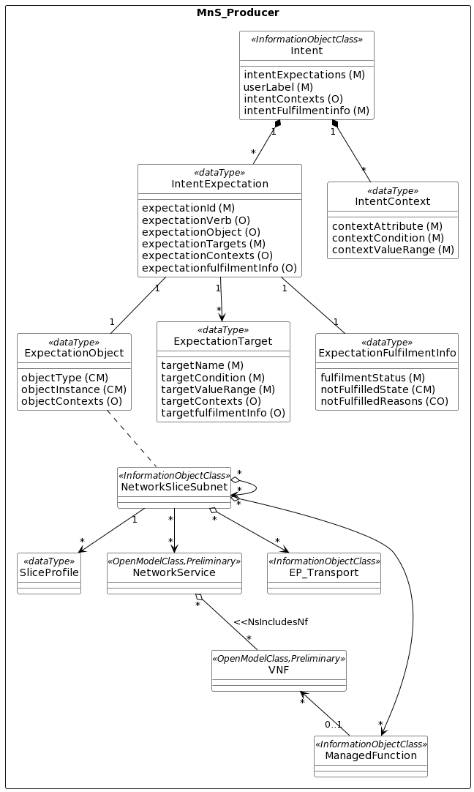

[PlantText UML Editor](https://planttext.com/?text=ZLPDZzem4BtxLrYSjgjcrLuhXBP584Kg7rhGNghLoea7S75iP3jbLzN-zzfnI4nY2bo2vhrvyppZZFAe3L6cB3ZIUoOEH942PoJVRvKi1HrBBXK-xfY10CyvqVh75PA2t12nvN2DwDMaeg0y8UCs8o2iTeJA8nDRl25SXwb2cglo5ITGx-94ANaC2-yO1PmpbND0g3a5dedLwr99MkQWy5_aRUDK61063uUfs4XL4CEaM6I_RTROuQEHezeVgtYJjuFJSoIDxsQVAgZKe7wI37WJyUInj8ytOucBC3mj-ORnmlvZjcIJyt5oD0Tpb6g_uYo7LPa9-9-xKrB5jgUpoc3fb1YoVZz0IvWHGRP0fwN8dSWDaYSVeFvORPkmE82OIGgy8dvUAk2iO8AezpRfUJwzaJbPlguL4VeWrIq7JBlzFpjbFIHeuPGsdGsYpw2oPXn1t9UC8MkYjc1qJAmttm3RD4DEgo4lEaDEmniIEqhkeU_6A9QL1Xe3DM1JAQlwq06U2I_XoLvvw5-jIU_4aSgoGbm8turh1HzBXTqr8k_5Uus85VIDZ1Kq5J8dHUlOX_fdzF784Pk4SoC-V6qOWSlfEJNYjXLRsPIolHbsJ_bi3jH1GPj2w0c8hhR7kB7nWVg3INvHedT0NvB8Ga3rrXfy7U3x9C63-q7_1RbCgjk4-k-KupggVVGiNQIFAkdUg6-MF-yvYkm_fozFXIBjYAK4riBbYBgBq166II8lQEDBVhfs_9gywZvSUyXjoxe-7dnvUB2Uk_PGPmtNOjNJfd-pLtIkKv7paeAURn1w147Try0_)

Figure 3.2.1 Example of MnS producer for handling network slice intent.

NOTE: In Figure 3.2.1 the NetworkSlice IOC is covered by Intent IOC and the ServiceProfile dataType is covered by IntentExpectation dataType.

### 3.2.1 Definition of ExpectationObject for NetworkSlice

The definition of an expectationObject that is applicable to intent driven network slice management is shown in Table 3.2.1.1

|  |  |
| --- | --- |
| **Attribute Name** | **Attribute Values** |
| ObjectType | NetworkSlice |
| ObjectInstance | DN of NetworkSlice instance |
| ObjectContexts | plmnInfoList  coverageArea sST  radioSpectrum  sliceSimultanuousUse |

Table 3.2.1.1 Definition of an ExpectationObject for a NetworkSlice instance

### 3.2.2 Definition of expectationTargets

The expectationTargets that are applicable to intent driven network slice management is shown in Table 3.2.2.1

|  |  |
| --- | --- |
| **Attributes** | **Attribute Values** |
| expectationTargets | maxNumberofUEs  dLLatency  uLLatency  availability  dlThptPerUE  UlThptPerUE  dlThptPerSlice  UlThptPerSlice  maxNumberofPDUSessions  Reliability  maxDLDataVolume  maxULDataVolume |

Table 3.2.2.1 Definitions of expectationTarget for a NetworkSlice instance

### 3.2.3 Definition of expectationContexts

The expectationContexts that are applicable to intent driven network slice management is shown in Table 3.2.3.1

|  |  |
| --- | --- |
| **Attributes** | **Attribute Values** |
| expectationContexts | uEMobilityLevel  networkSliceSharingIndicator  delayTolerance  dLDeterministicComm  uLDeterministicComm  dLMaxPktSize  uLMaxPktSize  v2XCommModels  termDensity  activityFactor  uESpeed  survivalTime  nBIoT  synchronicity  positioning  nssaaSupport  n6Protection |

Table 3.2.3.1 Definitions of expectationContext for a NetworkSlice instance

### 3.2.4 Service profile attributes not part of intent definition

The service profile attributes that are not mapped to the intent definitions are shown in Table 3.2.4.1.

|  |  |
| --- | --- |
| **Attribute name** | **Reason** |
| serviceProfileId | Identifier generated by producer, therefore not applicable to Intent which uses different identifiers. |
| kPIMonitoring | Not applicable as the performance is monitored based on the defined expectationTargets. |
| userMgmtOpen | Not applicable as OAM does not have knowledge about individual terminals/UEs |
| jitter | Jitter is not defined in GSMA/GST, see reference [1] and should probably be removed from TS 28.541 [3]. |
| energyEfficiency | Mapping is being studied in TR 28.912 [4] |

Table 3.2.4.1 Definitions of expectationTarget for a NetworkSlice instance

## 3.3 MnS producer for handling service support intent

The specification for intent in TS 28.312 has specified the Service Support expectation to be used in an edge computing context. Many of the parameters are the same as those in a ServcieProfile. The Service support expectation could be extended to support the ServiceProfile parameters.

In this solution the NetworkSlice may be the result of a Service Support Expectation. The consumer manages the lifecycle of the expectation. The managed object allocated (created and/or modified) may be a NetworkSlice (NetworkSliceSubnet) and the lifecycle of this object is managed by the producer.

Editor’s Note: Details on parameter mapping is planned to be provided for next meeting.

## 3.4 Observations

- A potential solution to create a network slice using intent seems feasible using the current specifications for intent as baseline.

- The serviceProfile attributes may be mapped to the following intent dataTypes: ExpectationObject, ExpectationTargets and ExpectationContexts.

- Not all service profile attributes are to be mapped to intent.

- Two potential alternatives are described:

Alternative 1: add Network slice expectation to TS 28.312

Alternative 2: extend Service Support expectation in TS 28.312 with ServiceProfile parameters

# 4 Detailed proposal

The group is asked to endorse the observations in section 3.4.