**3GPP TSG SA WG5 Meeting#146-bis-e S5-231102**

**e-meeting, 16-19 January 2023**

**Source: Ericsson, Deutsche Telekom, Telefonica**

**Title: Intent driven management for network slicing**

**Document for: Endorsement**

**Agenda Item: 6.1.1**

# 1 Decision/action requested

The group is asked to endorse this discussion paper

# 2 References

[1] [GSMA NG.116](https://www.gsma.com/newsroom/wp-content/uploads/NG.116-v6.0-1.pdf): "Generic Network Slice Template Version 6.0 25 November 2021"

[2] [TS 28.312](https://www.3gpp.org/DynaReport/285312): "Management and orchestration; Intent driven management services for mobile networks"

[3] [TS 28.541](https://www.3gpp.org/DynaReport/28541.htm); "Management and orchestration; 5G Network Resource Model (NRM); Stage 2 and stage 3"

[4] [TS 28.531](https://www.3gpp.org/DynaReport/28531.htm): "Management and orchestration; Provisioning"

[5] [TMF921A](https://www.tmforum.org/resources/standard/tmf921a-intent-management-api-profile-v1-1-0/): "Intent Management API Profile v1.1.0"

[6] [TM Forum IG1253](https://www.tmforum.org/resources/how-to-guide/ig1253-intent-in-autonomous-networks-v1-2-0/): "Intent in Autonomous Networks v1.2.0"

[7] [TM Forum IG1253C](https://www.tmforum.org/resources/how-to-guide/ig1253c-intent-life-cycle-management-and-interface-v1-1-0/): "Intent Lifecycle Management Interface v1.1.0"

[8] [TS 28.533](https://www.3gpp.org/DynaReport/28533.htm): "Management and orchestration; Architecture framework"

[9] [TS 28.532](https://www.3gpp.org/DynaReport/28532.htm): "Management and orchestration; Generic management services"

[10] [TS 28.552](https://www.3gpp.org/DynaReport/28552.htm): "Management and orchestration; 5G performance measurements"

[11] [TR 28.912](https://portal.3gpp.org/desktopmodules/Specifications/SpecificationDetails.aspx?specificationId=3969): "Study on enhanced intent driven management services for mobile networks (Release 18) "

[12] [TM Forum IG1253D](https://www.tmforum.org/resources/standard/ig1253d-intent-manager-capability-profiles-v1-0-0/): "Intent Manager Capability Profiles v1.0.0"

[13] [TS 28.554](https://portal.3gpp.org/desktopmodules/Specifications/SpecificationDetails.aspx?specificationId=3415): "Management and orchestration; 5G end to end Key Performance Indicators (KPI)"

# 3 Overview

This discussion paper examines topics that are relevant for the study on intent driven management for network slicing. The baseline of this document are solutions documented in published specifications from different SDOs. The first part describes the specfications in different SDO’s relating to intent and network slice management. The SDO’s covered by this clause are GSMA, TM Forum and 3GPP.

## 3.1 GSMA

The original CSP requirements for network slicing were documented by GSMA in NG.116 [1]. The requirements are expressed as attributes that describe both the characteristics and the scalability/capacity of a network slice. The characteristics are further divided into performance related characteristics supported by a network slice (for example KPI’s on throughput and latency) and functionality provided by a network slice (for example positioning, capacity and QoS), both are applicable before a network slice is instantiated, and provide control and management related attributes which are relevant after a network slice is instantiated

The Generic network Slice Template (GST) can be said to give a template that an NSP can use to get both service fulfilment and service assurance requirements for certain services from an NSC.

The GST has been used as one set of the input requirements for network slice management in SA5.

## 3.2 TM Forum

TM Forum have specified a framework for intent driven management which is documented in IG1253, see reference [6] allowing an intent (requirement) owner to convey the intent to an intent handler. The information captured in an intent provides the intent handler with sufficient information to realize the intent and provide intent reports to the owner of the intent. The intent owner can invoke an intent handler using a standard set of procedures, see reference [6].

TM Forum developed their solution based on the lifecycle stages of an intent. The lifecycle stages are show in Figure 3.2.1.

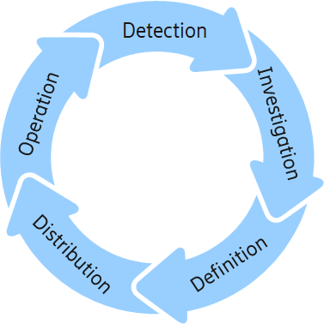

Figure 3.2.1: The lifecycle stages of an intent documented by TM Forum in IG1253 [6].

The functional areas that describe what is supported by an intent driven management interface are:

- Intent Setting

- Intent Reporting

- Intent Negotiation

- Intent Manager Registration and discovery

To support the functional areas a set of standard procedures are available to an intent owner to interact with an intent handler, this interaction is shown in Figure 3.2.2. Various procedures are supported on the intent interface, which is the interface between an intent owner and intent handler. The intent owner is represented by an MnS Consumer and the intent handler is represented by an MnS Producer.

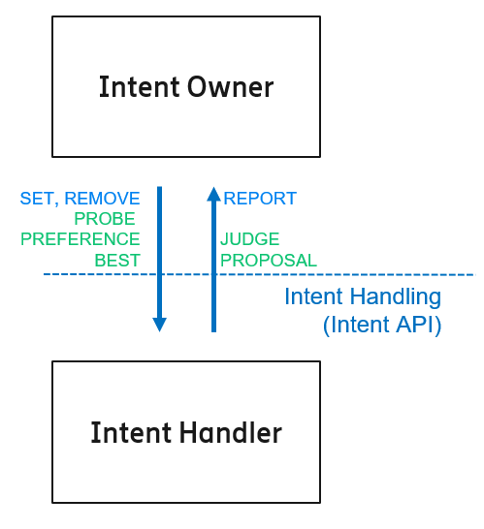

Figure 3.2.2: The procedures for intent driven management [6]

The supported procedures across the intent interface documented in IG1253C, see reference [7] are:

- Mandatory procedure for intent lifecycle management, SET/REMOVE/REPORT, see further details clause 3 reference [7],

- Optional procedure for collaborative evaluation, JUDGE/PREFERENCE, see further details in clause 4 reference [7],

- Optional procedure for intent probing, PROBE/ESTIMATE, see further details in clause 4.2 reference [7],

- Optional procedure for intent best options, BEST/PROPOSAL see further details in clause 4.3 reference [7].

Through the interface the intent management functions manage the life cycle of intent objects. An intent owner role is implemented through an Intent Management Function (Intent Owner in Figure 3.2.2) and the intent handler role is implemented through another Intent Management Function. An Intent Management Function can play/implement the role of an Intent Owner and Intent Handler in the same implementation.

The Intent Management Function (IMF) can be both Intent Owner and Intent Handler at the same time allowing to build hierarchies of IMFs, examples of these hierarchies are shown clause 3.6.

For this discussion paper an Intent Handler produces intent driven management services and, an Intent Owner consumes intent driven management services.

Each Intent Management Function or Intent Handler has an operational scope which is referred to as an Intent Management Scope or intent handler scope, see for further details IG1253D reference [12]. There may be Intent Management Functions/Intent Handlers with different operational scope.

## 3.3 3GPP SA5

### 3.3.1 Slice Management

The 3GPP network slice management use cases, requirements and solutions are specified in TS 28.531 [4] and TS 28.541 [3]. The solution specifies interaction between an MnS consumer and an MnS producer on how to allocate and manage a network slice or network slice subnet based on the input provided by the consumer as a list of ServiceProfile and SliceProfile attributes. The network slice information model is documented in UML and can be found in TS 28.541 [3]. The network slice provisioning procedures are documented in TS 28.531 [4] are shown in the list below.

- Network Slice Instance Allocation

- Network Slice Subnet Instance Allocation

- Network Slice Instance Deallocation

- Network slice subnet instance deallocation

- Network Slice Instance Modification

- Network Slice Subnet Instance Modification

- Network slice activation

- Network slice deactivation

- Network slice subnet activation

- Network slice subnet deactivation

- Obtaining Network Slice Subnet Capability

- Resource reservation and checking feasibility of NSI

- Resource reservation and checking feasibility of network slice subnet.

- TN coordination supporting network slicing

These procedures are supported by the network slicing operations; AllocateNsi, DeallocateNsi, AllocateNssi, DeallocateNssi also specified in TS 28.531 [2] and by multiple operations from the generic provisioning MnS specified in TS 28.532 [9], for example getMOIAttributes is used for obtaining capability of MnS producer, createMOI and deleteMOI is used for feasibility check and resource reservation. For the procedure of TN co-ordination, the 3GPP Management system interacts with TN management through requirements derived from the ServiceProfile, see TS 28.541 Annex L.2 [3].

### 3.3.2 Intent Management

To support the functional areas and lifecycle management of intent as documented by TM Forum, SA5 have developed corresponding solutions TS 28.312, see reference [2].

TS 28.312 [2] defines the procedures for an intent driven management function (IDMF):

* Create intent
* Modify intent
* Delete intent
* Query intent

These procedures define the life cycle management of intents in 3GPP, management capabilities to support intent lifecycle management also include activation and deactivation of intents, although no procedures are defined. The procedures allow an MnS consumer to convey requirements, goals, and contexts (constraints and conditions) as expectation(s) to an MnS producer, the MnS producer creates the Intent and adds the fulfilment status to the expectations and to the Intent. The information conveyed through expectation(s) is specific to 3GPP domain and the operational scope of the intent are operational tasks associated with a Subnetwork. The procedures can be used to operate on a 3GPP defined intent information model, see TS 28.312 [2].

## 3.4 Procedures and operations

For management of network slicing the network slice management interface and the intent management interface of TM Forum [5] and 3GPP [2] support similar functionality. The mapping of the TM Foum intent procedures to 3GPP intent procedures and network slicing procedures is shown in Table 3.4.1.

|  |  |  |  |  |  |
| --- | --- | --- | --- | --- | --- |
| **Intent procedures TMF IG1253** | | **Intent procedures TS 28.312** | | **Network slicing procedure TS 28.531** | |
| **Intent Owner** | **Intent Handler** | **MnS consumer** | **MnS producer** | **MnS consumer** | **MnS producer** |
| SET/ REMOVE | REPORT | createMOI  modifyMOIAttributes  deleteMOI | Create/Modify/delete response on action  Notification on fulfilment status for Create/Modify | ALLOCATENSI/ DEALLOCATENSI REQUEST  ALLOCATENSSI/ DEALLOCATENSSI REQUEST  modifyMOIAttributes* REQUEST  *MOI can be an Nsi or Nssi | ALLOCATENSI/ DEALLOCATENSI RESPONSE  ALLOCATENSSI/ DEALLOCATENSSI RESPONSE  Each modifyMOIAttributes has a corresponding response, see TS 28.532 [9] |
| Retrieve | Return Intent object | getMOIAttributes | Response (intent object) | getMOIAttributes* REQUEST | getMOIAttributes has a corresponding response, see TS 28.532 [9] |
| JUDGE | PREFERENCE |  |  | No equivalent procedure or information model attributes | No equivalent procedure or information model attributes |
| BEST | PROPOSAL |  |  | No equivalent procedure or information model attributes | No equivalent procedure or information model attributes |
| PROBE | ESTIMATE |  |  | REQUEST “CREATION of FeasibilityCheckandResourceReservationJob IOC” | FeasibilityResult is FEASIBLE or InFEASIBLE  Each operation has a corresponding response, see TS 28.532 [9] |

Table 3.4.1: Mapping of Intent procedures to Network slicing procedures

NOTE 1: Resource reservation capability is not explicit in the TM Forum specification for intent.

NOTE 2: All TMF procedures are not addressed by 3GPP.

NOTE 3: The detailed mapping between 3GPP Intent management operation and TM Forum intent management operations is shown in Table 3.4.1, this table is copied from TR 28.912 [11]

Table 3.4.2 the mapping between 3GPP Intent Management operations and TM Forum intent management operations

|  |  |
| --- | --- |
| 3GPP Intent management operations | TM Forum Intent management operations |
| createMOI operation, the MOI is instance of intent IOC | Set Intent |
| modifyMOIAttributes operation, the MOI is instance of intent IOC |
| getMOIAttributes operation, the MOI is instance of intent IOC | Retrieve Intent |
| deleteMOI operation, the MOI is instance of intent IOC | Remove Intent |
| notifyMOIAttributeValueChanges Notification for the attribute "intentFulfillmentInfo" in the instance of intent IOC | Intent Report Event |

## 3.5 Operational scope of an intent handler

The operational scope of an intent handler is bounded by the responsibility it has for the resources involved in the fulfilment and assurance of intents, and related operational tasks. TM Forum gives examples of possible intent handlers for business operation, service operation and resource operation. Business operation is outside the scope of this discussion paper. For service and resource operations the following examples of intent handlers and their operational scope are documented by TM Forum in IG1253D [12] and shown in the following list:

* Service Orchestration and Assurance: The intent handler with this scope receives all intent about services that need to be delivered. It interacts with orchestration and assurance systems to break down the service intent resources to be used and their configuration across multiple autonomous domains. Typically, this intent handler would act by setting multiple intents in resource operation.
* Core Network Intent Management Scope: This is the scope of an intent handler that has the responsibility for core network resources and the related operational tasks.
* Transport Management Scope: This is the scope of an intent handler that has the responsibility for transport resources and the related operational tasks.
* Slice Management Scope: This is the scope of an intent handler that has the responsibility for setup and assurance of slices.
* Network Function Management Scope: This is the scope of an intent handler responsible to coordinate the deployment and assurance of network functions.

The resources within the scope of SA5 defined solution are contained within SubNetwork, therefore the operational scope of the intent are the operational tasks associated with a SubNetwork. The resource operation may be extended to include the following scope for RAN:

* RAN Intent Management Scope: This is the scope of an intent handler that has the responsibility for RAN resources and the related operational tasks.

Furthermore, deployment and assurance of network functions would in SA5 be associated with ETSI NFV solution, the RAN and CN NFs would be deployed using ETSI NFV as a standard based solution for cloud management. SA5 have not specified solutions for any other cloud solutions.

Slice management has the responsibility for set-up and assurance of network slices. Following the principles in 3GPP for slice management it would be up the the discretion of the Service orchestration and assurance Intent Handler to, within its operational scope, ensure fulfillment of the communications service requirements provided as intents. In its task it may use other Intent Handlers with operational scope to allocate the network resources needed.

The following intent handlers with operational scopes could be applicable to set-up an assure resources for the fulfilment and assurance of network slice requirements:

- CN intent scope

- RAN intent scope

- TN intent scope

- NFV intent scope

NOTE 1: 3GPP does not address the operational scope of an intent management producer, which is part of the TMF intent concept. Only the Intent Handlers for Communication service, RAN and CN fall within the scope of 3GPP. Liasons with other SDOs may be needed to address interoperability across technology domains.

NOTE 2: The interoperability across technology domains is addressed by TMF by their federated intent model paradigm.

## 3.6 Topology and responsibilities

### 3.6.1 Introduction

In this clause different options are explored for decomposition of intent for communication service expectation (may be realized by a network slice) to intent with a suiteable intent scope that can be handled by subnetwork managers. In each scenario an Intent_owner provides communication service requirements, conditions, and constraints and the Intent_handler after accepting the intent, reports the fulfilment to the Intent_owner. The cloud (e.g., ETSI NFV) is not shown in the scenarios in this clause to simplify the scenarios and if deemed necessary they could be added later.

### 3.6.2 Mapping to intent handlers

#### 3.6.2.1 Service orchestration and assurance directly interacting with TN

Figure 3.6.2.1.1 shows the scenario where the Service orchestration and assurance intent handler decomposes the communication service intent from an Intent_owner to intents for RAN, CN, and TN. Each of these intent handlers independently deploys the intent and report the fulfilment of their handled intent to the Service orchestration and assurance intent handler owning the intents. Service orchestration and assurance intent handler in Figure 3.6.2.1.1 owns the intent to fulfil the requirements on a communication service (realized by a network slice). How the Service orchestration and assurance intent owner has received or derived the communication service requirement is not specified as the intent owner resides in BSS.

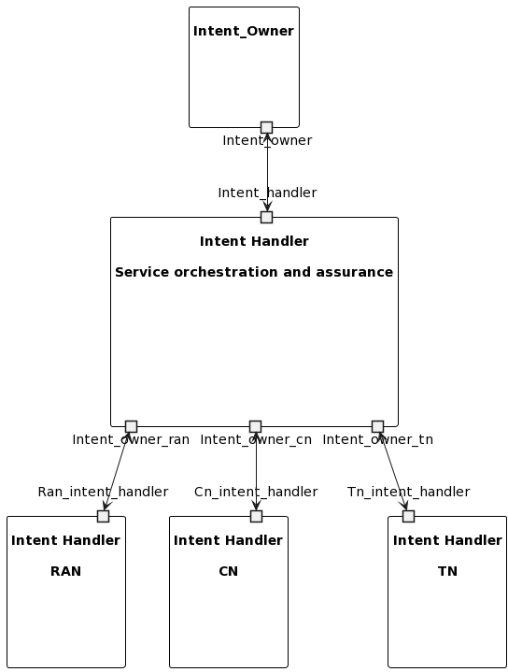

[PlantText UML Editor](https://planttext.com/?text=XLFBQiCm4BphAvRSymUbv75fBoqaWLm2GPMtiOYyQrRhXbBoxvMhXiQEK_iaFBFpMA5PL2lQLC74ewVQYgt0SLKp8IbycRL-1WH1fvOE0StvYhUw_5rOTpm8DrGiER30jlIAWqIM0YMJ5Y5DNP7cJbd6b3Bf7vLOse9FdWxmRaD4ero3ChonAbTG-BQ9PpBch-HaHy-awRH_FH7A9BM6zDKioet2ByOjzWES1uVXoL8HK7QqepNAXtS8BAx4g69RIqWus1WRiUGmkxGUdYuMPLOmmzxxD7SFSdSHfNHb8t5NyvTEd9MblUz66jLOTYMM0mfZ4fkkn6P8uheRF4odZ_tTzJUMIGEDUllBlDlOlMLcscqqCqCgsbVq3G00)

Figure 3.6.2.1.1: Service orchestration and assurance directly interacting with TN

The scope for the Service orchestration and assurance intent handler in Figure 3.6.2.1.1 is to handle Service orchestration and assurance intents, and provides an abstracted and aggregated view of the RAN, CN and TN intents. The scope for the RAN intent handler is to handle RAN intents which may originate from other intent owners than the Service orchestration and assunce intent handler, the same applies for the CN and TN intent handlers.

There may be scenarios where there is no interaction with TN intent hander, the reason is that this interaction is not needed as Service orchestration and assurance can determine the fulfilment of the combined RAN/CN service using for example throughput and delay measurements and KPIs from RAN and CN specified in TS 28.552 and 28.554, see reference [10] and [13].

NOTE 1: Observe that this implies that intents where RAN or CN needs TN resources, these intents are conveyed via the Service orchestration and assurance Intent Handler

#### 3.6.2.2 Service orchestration and assurance indirectly interacting with TN

Figure 3.6.2.2.1 shows the scenario where the Service orchestration and assurance intent handler decomposes the service intent from an Intent_owner to intents for RAN and CN and the RAN and CN create new intents for TN. RAN and CN intent handlers independently deploys the intent and report the fulfilment of their handled intents to the Service orchestration and assurance intent handler owning the intents. The TN intent handler independently deploys the intents and reports the fulfilment of the intents to the RAN and CN intent handlers owning the intents.

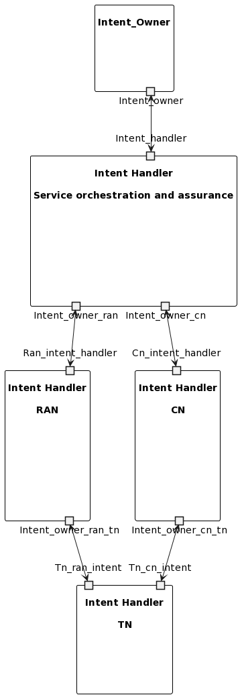

[PlantText UML Editor](https://planttext.com/?text=ZPFBRi9034NtynKMU_wWgdXisaqh0H8Rf6WwSSc8YHqvJb5LyU-TCBm2QI6hoFVw7jjHHhLQqQOCfjvuggpO4XoN5HEIme-PwtT047HgQHtGx2vyisDrOjrcBTnGFkN00il2A_OQMNAKP9g4s7LX6ZjbkPUKJF-ar8NDUUjf3Pysr6YKAr263rRb4dBVRkAPZ3alELZHAsbyozwtX3A8MqDyAXRbHk6WSQljXLrlCxnOoWFAYbOqH_do3e755LYhs1O9KGTRrurOSfWeBSFJ4L6a1DFFpcBVNvAZ-67k33KRltMWCqkPVnISwGE4QHSmVJJV7UBlvI-w-GlQJvOOdR8xLMFe9GgUXiFdwtDVxvfCFUUv6ZhvRhVikLsoTWU-FS79TPxVZ93ozk_y1G00)

Figure 3.6.2.2.1: Service orchestration and assurance indirectly interacting with TN

The scope for the Service orchestration and assurance intent handler in Figure 3.6.2.2.1 is to handle Service orchestration and assurance intents, and provides an abstracted and aggregated view of the RAN, CN intents. The scope for the RAN intent handler is to handle RAN intents which may originate from other intent owners than the Service orchestration and assunce intent handler, the same applies for the CN intent handlers.

There may be scenarios where there is no interaction with TN intent hander, the reason is that this interaction is not needed as RAN or CN can determine the fulfilment of the combined RAN/CN service using for example throughput and delay measurements and KPIs from RAN and CN specified in TS 28.552 and 28.554, see reference [10] and [13].

NOTE 2: Observe that this implies that intents where RAN or CN needs TN resources, these intents are directly handled by the RAN and CN intent handlers.

## 3.7 Example of procedure intent for communication service

The example of a procedure for handling a request for intent for a communication service involves a Service orchestration and assurance intent handler, a RAN intent handler and a CN intent handler. Both RAN and CN are fully responsible for the fulfilment and assurance of the requirements on transport. The Service orchestration and assurance intent owner can verify the fulfilment of a communication service intent using the transport level measurement between RAN and CN (a.k.a. backhaul) and which are measured by the RAN and CN and available in the management system.

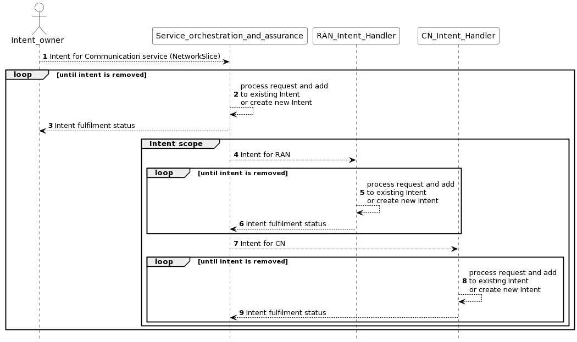

[PlantText UML Editor](https://planttext.com/?text=jP71Yjim48RlUeeXFUS5IWXDT2Y5tR2i3Rqic8azIKHiZJkIDWkbxrx9JcedNbYwxVeap_pwv_z6xcXiYu8DEFeHo9O4FzLAX4-QQnPOrrWUrQhqB6kMYcHQZgUzSB1Lt_f-C9xK0uetfMdH-kczSVFLstTcHtV6qlHgqdyTwHUBTPOL3yBFo-LPyakvFr0RzlJwY1lDPD3GTmUi-6Ji7dPOEr87Kn7icFsMNnG6ppOqMnAb5APzmEpUPeLcwq93CWDqe5Kx4CDiG_x4SYnSRKegMCe3EI_e3Ti2RLMWSq4mFaLtUUCOuTCfXOPhdyVLfhX7YtjgoFfE_CZON8loYIQVQFH4evD6AGtp-R9By1c-MH-x4LpW392b_0gWPcuXM6zgCBt8E11g-9cgsEu91gDMk2JdW5vQAds73H4RiAgUhETODywdTVSJdsoSM0fXvBTqEbUJhuR5V7wJBjGxKoSCSD4wE9M4a9w_XOeRD7PaCCwMDdS56RURXQsbY_8jokvBBYEx_uOwP4t8rradoBsQufoK-HOqlmNDty6PNpZpZ-JC_uLJttBgTt3g2wV-I4xzrvpnHmqbK5_YCJIr-Wq0)

Figure 3.7.1 Example of communication service intent handling with RAN and CN intent. Service orchestration and assurance is both intent handler and intent owner.

Description of the steps in the sequence diagram in Figure 3.7.1.

Step 1: There is a request from an intent owner for the Service orchestration and assurance intent handler to fulfil a communication service intent (realized by a network slice).

NOTE 1: an example of a communication service target is provided in clause 3.7.

Step 2: The Service orchestration and assurance intent handler validates and accepts the request. The fulfilment status of the request is updated.

Step 3: After the handler has started to process the new or modified intent the handler reports the intent fulfilment status to the intent owner.

NOTE 2: The intent handler continues to orchestrate and assure the request until the consumer removes it from the intent.

NOTE 3: The following steps are needed when the Service orchestration and assurance intent handler needs to interact with intent handlers responsible for the resources.

Step 4: The Service orchestration and assurance may decide to create a new intent or modify an existing intent towards the RAN intent handler.

Step 5: The RAN intent handler validates and accepts the RAN intent. The fulfilment status of the intent is updated.

Step 6: After the RAN intent handler has started to process the new or modified intent the RAN intent handler reports the intent fulfilment status and to the Service orchestration and assurance intent owner.

Step 7: The Service orchestration and assurance may decide to create a new intent or modify an existing intent towards the CN intent handler.

Step 8: The CN intent handler validates and accepts the CN intent. The fulfilment status of the intent is updated. .

Step 9: After the CN intent handler has started to process the new or modified intent the CN intent handler reports the intent fulfilment status and to the Service orchestration and assurance intent owner.

## 3.8 Observations

Based on the descriptions in this discussion paper the following observation can be made.

In a scenario where an Intent Handler has full responsibility to fulfil the network slice requirements from an Intent Owner the network slice requirements need to be conveyed as an intent for the Intent Handler to manage the lifecycle of a network slice.

## 3.9 Recommendations

To map service profile attributes to expectations that can be used to transfer network slice related requirements through an intent-based interface.

NOTE 1: This mapping requires the ServiceProfile attributes to follow the Intent Expectation model.

NOTE 2: The intent-based interface is offered by an intent handler .

# 4 Detailed proposal

The group is asked to endorse the recommendations in clause 3.9.