3GPP TSG-SA5 Meeting #145-e S5-225521rev1
e-meeting, Aug 15 - 24, 2022

Source: Ericsson

Title: pCR Add Intent Reporting support to NRM

Document for: Approval

Agenda Item: 6.7.3.2

1 Decision/action requested
The group is asked to discuss and approval.

2 References
[1] 3GPP TS 28.312: “Intent driven management services for mobile networks (Release 17)”
v17.0.1
[2] 3GPP TS 28.912: “Study on enhanced intent driven management services for mobile networks (Release 18)” v0.3.0

3 Rationale
As indicated in 28.912 [2], “Issue #4.5 Intent Report” the current ability to report intent fulfilment status is not sufficient, and further support to support Intent Reporting is required.

The NRM needed to support the Intent Reporting reqs specified in [2], sec 4.5.1 is not yet defined. A solution is briefly described in [2], sec 4.5.2.1 however it needs to be enhanced to better support the above description.

4 Detailed proposal
This contribution proposes additions to the support Intent Reporting requirements defined in 28.912 [2], sec 4.5.1.
As stated in 28.912 [2], sec 4.5.1 it is understood that reporting needs may differ across MnS Consumers: “Different MnS consumer may have different requirements for intent report (e.g. Some MnS consumer may want to have corresponding performance value information while others don't want, Different MnS consumer may want to calculate or monitor the performance value in different period).”
For example, MnS Consumer can monitor the status of a specific ExpectionObject would configure the specific ExpectionObject (by its id) in the IntentReport.

1st Change

4.5 Issue#4.5: Intent Report

4.5.1 Description
In TS 28.312 [2], the Fulfilment information (including the intentFulfilmentinfo, expectationfulfilmentInfo and targetfulfilmentInfo) are defined for the MnS consumer obtain the intent fulfilment information. However, the intent report haven't been defined. The intent report can contain the current and optional predicted value for performance indicated by corresponding expectation targets (e.g. WeakRSRPRatio for the weakRSRPRatioTarget, Average UL RAN UE Throughput for aveULRANUEThptTarget), which can be used by MnS consumer to validate whether the intent is really fulfilled and to evaluate whether the intent (especially for expectation targets) needs to be updated if needed (improve the target value when corresponding target is fulfilled or reduce the target value when corresponding target is not fulfilled or not fulfilled with the reason of target confliction).
Different MnS consumer may have different requirements for intent report (e.g. Some MnS consumer may want to have corresponding performance value information while others don't want, Different MnS consumer may want to calculate or monitor the performance value in different period).
REQ-Intent_Driven_MnS: The intent driven MnS should have capability enabling MnS consumer to request intent report information.
REQ-Intent_Driven_MnS: The intent driven MnS should have capability enabling MnS consumer to obtain intent report information with current performance value for corresponding expectation targets.
REQ-Intent_Driven_MnS: The intent driven MnS should have capability enabling MnS consumer to configure intent reports including specifying the content of the report, and frequency of the reports.
REQ-Intent_Driven_MnS: The intent driven MnS should allow multiple reports to be configured for the same intent.

4.5.2 Potential solutions

4.5.2.1 Potential solution #1
This solution extends the existing model in 28.312 [2] by adding new attributes to the Intent IOC to indicate what is to be observed, and a new IntentReport IOC to report the current values.
The following specific changes would be made:
- Extend the IntentExpectation <<dataType>> with the following attribute:
- "reportIndicator", represents MnS consumer's requirements for intent Report, which is a Boolean value. If the value is TRUE, MnS producer needs to create an instance of IntentReport IOC to capture the current performance values for corresponding Expectation Targets.
- "observationTime", represents MnS consumer's requirements for the observation period of performance value for corresponding Expectation Targets. The performance value for corresponding Expectation Targets will be observed from the start of each observation period, then at the end of each observation period, the value will be derived and configured
- Introduce the IntentReport <<IOC>>, represents the performance values for the Expectation Targets in the associated Intent. Then The MnS consumer can use the "getMOIAttributeValue" operation to query the IntentReport <<IOC>> to obtain the intent report information. The IntentReport <<IOC>> include the following attributes:
- "DN of the Intent <<IOC>>", indicates the associated instance of Intent <<IOC>>
- "TargetMetricInfoList", which is the list of [targetMetricName, currentValue]. The targetMetricName is same as ExpectationTarget Name in the associated Intent <<IOC>.
This could result in NRM for Intent Reporting as follows:
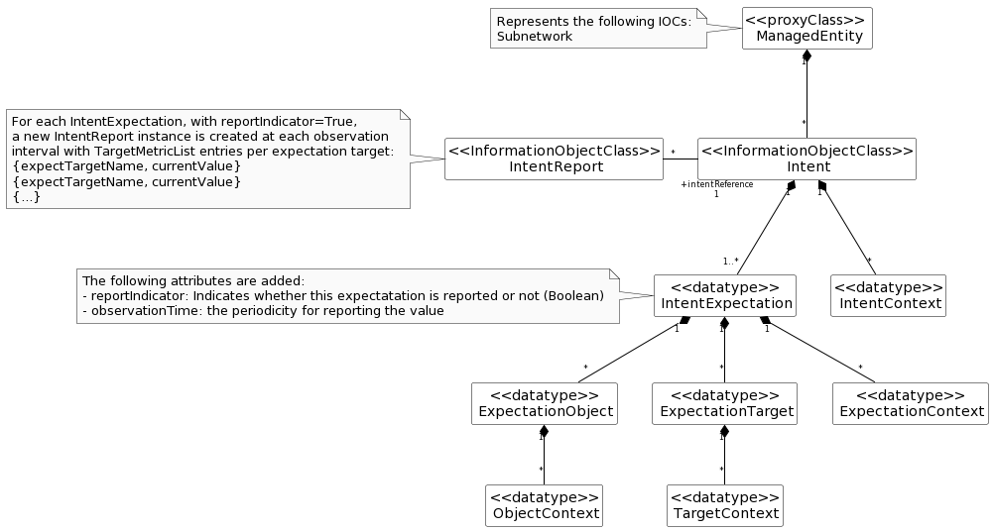

The above solution would require, per Intent, that:
  - MnS Consumer configures each IntentExpectation to be reported with ‘reportIndicator=True’ and ‘observationTime=N’
  - For each period N, MnS Producer reports the current value
  - For every period N, MnS Producer creates a new instance of IntentReport IOC, in which it reports the current value of the intent expectation as follows:
    - Each intent expectation appears in the report as: [targetMetricName, currentValue]
  - MnS Consumer receives notifications each time a new IntentReport IOC is created

Observations on this approach:
  - The configuration of the report output is contained in the Intent itself, and is a Boolean. This effectively limits the content of the report to a single report per Intent.
  - Each IntentExpectation is reported separately. Onus will be on the MnS Consumer to consolidate this output, e.g. if reporting is done at different observation internvals?

4.5.2.2 Potential solution #2
This solution extends the existing model in 28.312 [2] by adding new attributes to the Intent IOC to indicate what is to be observed, and a new IntentReport IOC to report the achieved values.
The following specific changes could be made:
- Extend the IntentExpectation <<dataType>> with the following attribute:
- "observationTime", represents MnS consumer's requirements for the observation period of performance value for corresponding Expectation Targets. The performance value for corresponding Expectation Targets will be observed from the start of each observation period, then at the end of each observation period, the value will be derived and configured
- Introduce the "achieveValue" attribute in the ExpectationTarget to represent the performance value for the ExpectationTarget. Then The MnS consumer can use the "getMOIAttributeValue" operation to query the Intent <<IOC>> to obtain the achieveValue for a given ExpectationTarget.
This could result in NRM for Intent Reporting as follows:

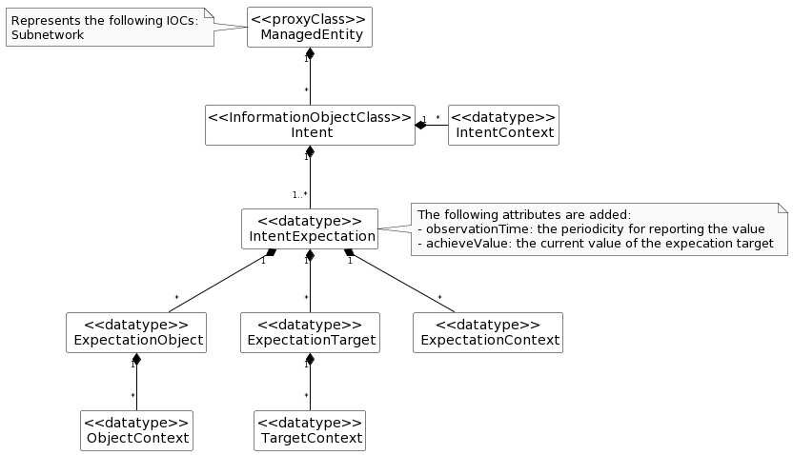

The above solution would require, per Intent, that:
  - MnS Consumer configures each IntentExpectation to be reported with ‘observationTime=N’
  - For each period N, MnS Producer reports the achieved value*
  - For every period N, MnS Producer update the achieveValue of each expectation target
  - MnS Consumer queries achieveValue of interested targets
* Editor’s Note: would ‘achievedValue’ be current value (per Solution #1, as available in NRM at time of reporting), or some other computed value for the interval. If computed, the definition and format could vary based on which attribute(s) are included.
Observations on this approach:
  - Should avoid mix-and-match of observability
    - For attributes defined in NRM, existing subscription mechanism can be used to monitor updates. E.g. ‘achieveValue’ proposed in this solution
    - for content not defined in NRM, new notifications would need to be defined for the intent content to be reported. E.g. associated PM/KPI
  - The configuration of the report output is contained in the Intent itself.
  - MnS Consumer would need to query (i.e. polling). Notifications would be preferred.
  - Since the observationTime of each IntentExpectation is configured separately, MnS Consumer would need to be aware of how relatively up-to-date each value is.
  - Should use of the term “report” which can be misleading, as there is no ‘report’ object (e.g. NRM, file, stream). This solution is completely notification based.

4.5.2.x Potential solution #x
This solution would not modify the existing model in 28.312 [2]. A separate IntentReportCtrl IOC is proposed. The IntentReport IOC is used to contain the output of the expectation targets, as well as other status information currently contained in Intent. The latter would be removed to further separate the configuration of the Intent, from the monitoring/reporting of it throughout its lifecycle.

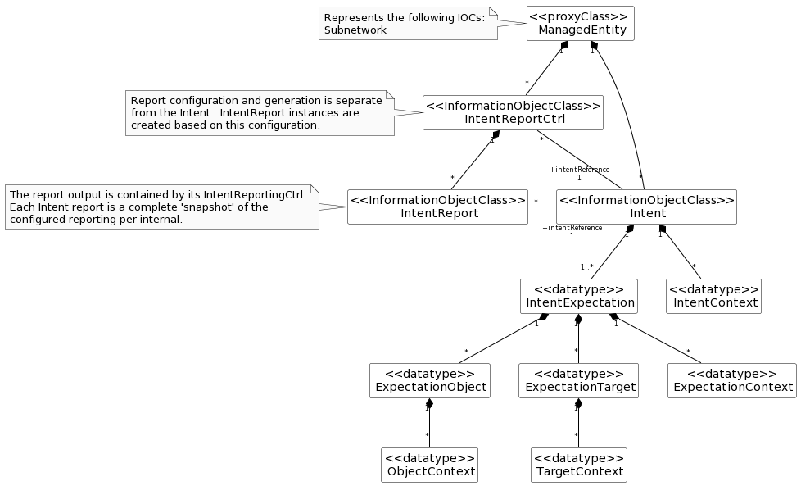

The above solution would require, per Intent, that:
  - MnS Consumer configures each IntentReportCtrl with ‘reportingPeriod=N’, and reference ‘intentReference’ to the Intent instance for which the report is to be producer
  - For each period N, MnS Producer generates an IntentReport instance
  - For every period N, MnS Producer ‘snapshots’ the Intent values
  - MnS Consumer receives notification of the new IntentReport instance

Observations on this approach:
  - The configuration of the report output is external to the Intent itself, and supports ability to configure different reports per Intent. The content (i.e. attributes) and reporting intervals can different for each report generated.
  - Each report is a complete ‘snapshot’ of the Intent at time of generation, available in NRM.
  - MnS Consumer does not need to handle different ‘observationIntervals’ per attribute within same Intent.

4.5.2.x.1 IntentReportCtrl <<IOC>>
4.5.2.x.1.1 Definition
This IOC represents a request to produce Intent Reports which provide intent driven management updates from MnS producer.
The IntentReportCtrl contains configuration used by MnS Producer to determine the content and frequency at which reports should be provided for an Intent.
MnS Consumer creates an instance of IntentReportCtrl instance with a reference to the Intent instance for which the Intent reports will be produced. Multiple IntentReportCtrl instances can reference the same Intent instance, meaning different reports can be produced for the same Intent.
The MnS Consumer configures the report output via intentExpectation, intentContext, and intentFulfilment attributes. These parameters are writable and can be configured to restrict (i.e. filter) the report results.
The content of each Intent report produced is based on its containing IntentReportCtrl configuration at the time it is produced. Only content configured in the reporting control will be included in its intent reports.
The userLabel contains the same value as userLabel in the associated Intent.
The IntentReportCtrl configures the report output, and determines when new IntentReport instances are created based.
The reportPeriod value indicates the frequency at which report are created by MnS Producer. A value of “0” indicates the MnS Producer will determine the periodicity.
The IntentReportCtrl IOC includes the attribute objectClass and objectInstance from the TOP IOC. The value of attribute objectClass is "IntentReport" and the value of attribute objectInstance is the DN of the instance of the IntentReport IOC.

4.5.2.x.1.2 Attributes
The Intent IOC includes attributes inherited from TOP IOC (defined in 3GPP TS 28.622 [6]) and the following attributes.
Table 6.2.1.2.1.2-1
Attribute Name | Support Qualifier | isReadable | isWritable | isInvariant | isNotifyable
intentReference | M | T | T | F | F
userLabel | M | T | T | F | F
reportingPeriod | M | T | T | F | F
intentExpectation | O | T | T | F | F
intentContext | O | T | T | F | F
intentFulfilmentInfo | O | T | T | F | F

4.5.2.x.1.3 Attribute constraints
None.

4.5.2.x.2 IntentReport <<IOC>>
4.5.2.x.2.1 Definition
This IOC represents an Intent Report to provide Intent status details from MnS producer.
The userLabel contains the same value as userLabel in the associated Intent.
The reportTimestamp contains the time at which the report was last updated. No further updates to the contents of a report are made once set.
The xxxInfo parameters are not writable in the report output. The content of the report is based on the configuration of its containing IntentReportCtrl. Each xxxInfo parameter contains information about the status of the associated xxx parameter in the Intent.
4.5.2.x.2.2 Attributes
The Intent IOC includes attributes inherited from TOP IOC (defined in 3GPP TS 28.622 [6]) and the following attributes.
Table 6.2.1.2.1.2-1
Attribute Name | Support Qualifier | isReadable | isWritable | isInvariant | isNotifyable
intentReference | M | T | F | F | F
userLabel | M | T | F | F | F
reportTimestamp | M | T | F | F | F
intentExpectationInfo | O | T | F | F | F

4.5.2.x.2.3 Attribute constraints
None.

4.5.2.y Potential solution #y
4.5.2.y.1 Description
This solution does not modify the existing model in 28.312 [2]. A separate IntentReportJob IOC is proposed, along with a file/stream based Intent report similar to other performance reporting.
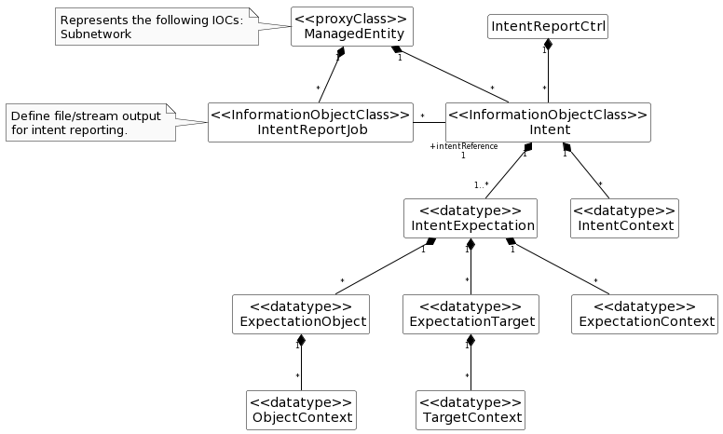

The above solution would require, per Intent, that:
  - MnS Consumer configures each IntentReportJob control for file or streaming output, and a reference ‘intentReference’ to the Intent instance for which the report is to be producer
  - For every period N, MnS Producer outputs the report content as configured in the job
    - for file based, MnS Consumer receives notification of the new Intent report file
    - for stream, MnS Consumer receives streaming content

Observations on this approach:
  - This approach is consistent with other performance related reporting
  - Each report should be complete and self-describing, and suitable for offline processing and/or archival
  - A schema will need to be agreed, perhaps based on the existing PM/KPI formats

4.5.2.y.1 IntentReportJob <<IOC>>
4.5.2.y.2.1 Definition
This IOC represents a request to create a Job to perform intent reporting.
MnS Consumer creates an instance of IntentReportJob with a reference to the Intent instance for which the Intent reports will be produced. Multiple IntentReportJob instances can reference the same Intent instance, meaning different reports can be produced for the same Intent.
The content of each Intent report produced is based on values in the Intent at the time of reporting.
The userLabel contains the same value as userLabel in the associated Intent.
The attribute reportingCtrl specifies the method and associated control parameters for reporting the produced measurements to MnS consumers. Three methods are available: file-based reporting with selection of the file location by the MnS producer, file-based reporting with selection of the file location by the MnS consumer, and stream-based reporting.
Editor’s Note: the schema for the reporting format (file and stream) will need to be defined. What content to include in the output could be supported by options similar to those in other solutions, i.e. explicitly configured in the Intent itself (e.g. Solution 2, ‘reportIndicator’) or configured separately in the IntentReportJob (e.g. Solution X, IntentReportCtrl attributes).
4.5.2.y.2.2 Attributes
The PerfMetricJob IOC includes attributes inherited from Top IOC (defined in clause 4.3.29) and the following attributes:
Attribute name | S | isReadable | isWritable | isInvariant | isNotifyable
administrativeState | M | T | T | F | T
operationalState | M | T | F | F | T
jobId | M | T | T | T | T
granularityPeriod | M | T | T | F | T
intentReference | M | T | T | F | F
userLabel | M | T | T | F | F
reportingPeriod | M | T | T | F | F
reportingCtrl | M | T | T | F | T
_linkToFiles | CO | T | F | T | F

Table zzz

4.5.2.y.2.3 Attribute constraints

4.5.2.y Potential solution #z
4.5.2.z.1 Description
This solution would modify the existing model in 28.312 [2] to add configuration of notifications of achieved values. The values to be notified are defined directly in the Intent.
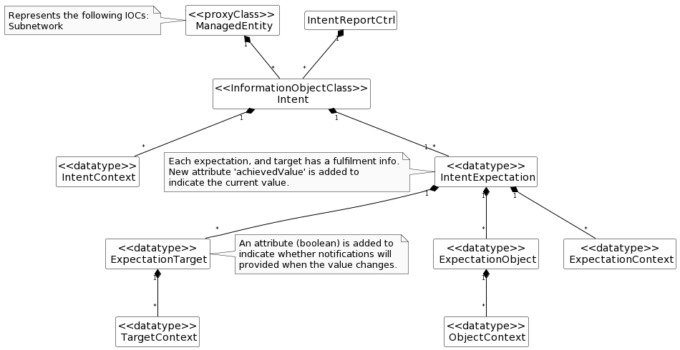

  - MnS Consumer configures each Intent with ‘reportIndicator=True’ for values to be monitored.
  - MnS Consumer subscribes to the ‘achievedValues’ in IntentExpection.
  - MnS Consumer receives notifications each time a new value is available.

Observations on this approach:
  - The configuration of the report output is contained in the Intent itself, and is a Boolean. This effectively limits the content of the report to a single report per Intent.
  - This approach is different than subscribing to attribute notifications.
  - The notifications required, and how they represent values in NRM and/or derived values not in the NRM, needs to be defined.
  - There would be no “report’ objects with this approach.

The IntentExpectation would require additional attributes to configure which updates to include in the notifications.
Table 6.2.1.3.1.2-1
Attribute Name | Support Qualifier | isReadable | isWritable | isInvariant | isNotifyable
notifyAchievement | O | T | F | F | T

The ExpectationTarget would require additional attributes for reporting the values, and for configuring notifications.
Table zzz
Attribute Name |  | Support Qualifier |  | isReadable |  | isWritable |  | isInvariant |  | isNotifyable
achievedValue |  | O |  | T |  | F |  | F |  | T
notifyAchievement | O |  | T |  | T |  | F |  | T

End of changes

