3GPP TSG SA WG5 Meeting 145-e S5-225501

electronic meeting, online, 15-24th August 2022
CR-Form-v12.0
CHANGE REQUEST
 | 28.405 | CR | 0015 | rev | - | Current version: | 17.2.0
For HELP on using this form: comprehensive instructions can be found at
http://www.3gpp.org/Change-Requests.

Proposed change affects: | UICC apps |  | ME |  | Radio Access Network | X | Core Network | X

Title: | Handling of QoE measurement collection at handover in NR
Source to WG: | Ericsson, Nokia
Source to TSG: | S5
Work item code: | eQoE |  |  |  |  |  | Date: |  |  | 2022-08-03
Category: | B |  |  |  |  |  | Release: |  |  | Rel-18
 | Use one of the following categories:  F (correction)  A (mirror corresponding to a change in an earlier release)  B (addition of feature),  C (functional modification of feature)  D (editorial modification)  Detailed explanations of the above categories can  be found in 3GPP TR 21.900. |  |  |  |  |  |  |  | Use one of the following releases:  Rel-8 (Release 8)  Rel-9 (Release 9)  Rel-10 (Release 10)  Rel-11 (Release 11)  …  Rel-15 (Release 15)  Rel-16 (Release 16)  Rel-17 (Release 17)  Rel-18 (Release 18)
Reason for change: |  | The features are missing in the specification
Summary of change: |  | Adding Handling of measurement collection at handover in NR.
Consequences if not approved: |  | Functionality is missing resulting in interoperability problem
Clauses affected: |  | 4.z.2 (new), 4.z.2.1 (new)
 |  | Y | N
Other specs |  |  | x | Other core specifications |  |  |  | TS/TR ... CR ...
affected: |  |  | x | Test specifications |  |  |  | TS/TR ... CR ...
(show related CRs) |  |  | x | O&M Specifications |  |  |  | TS 28.405 CR 0014
Other comments: |  | TS 28.405 CR 0014
This CR's revision history:

First change

4.z Signalling based activation in NR

4.z.2 Handling of measurement collection at handover in NR

4.z.2.1 NG Based Handover for Signalling Based Activation
The figure 4.z.2.1-1 and the text below describes the handling at NG Based handover between gNBs for Signalling Based Activation case.
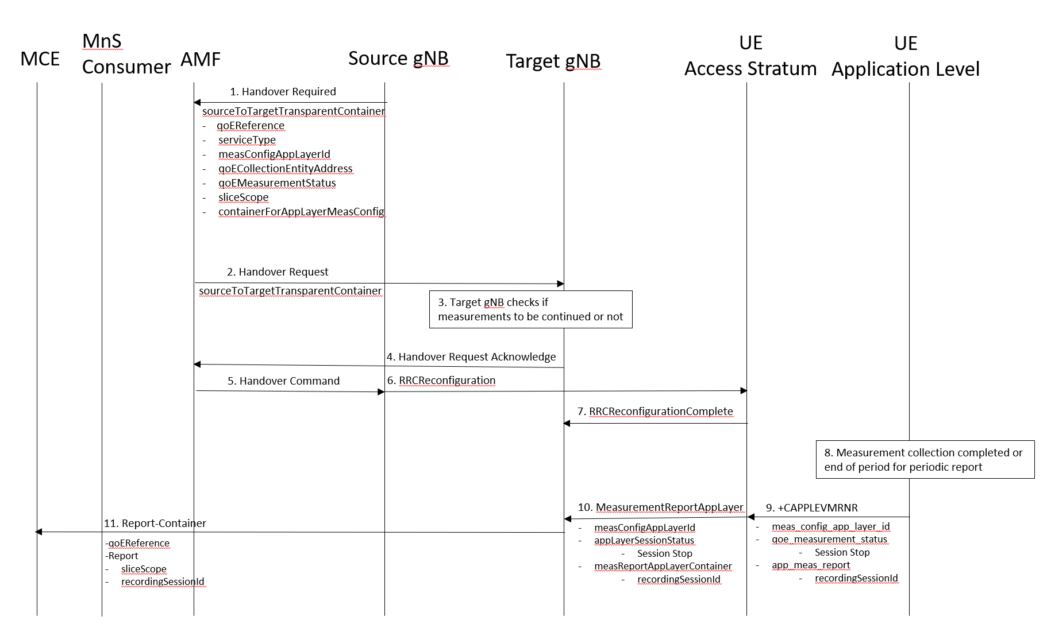
Figure 4.z.2.1-1: Handling of QMC activation in case of NG Based handover in NR for Signalling Based Activation
1. Source gNB sends the message HANDOVER REQUIRED to AMF. The message includes the Source to Target Transparent Container which contains qoEReference, serviceType, measConfigAppLayerID, measCollEntityIPAddress, qoEMeasurementStatus, sliceSupportListQMC and containerForAppLayerMeasConfig.
2. AMF sends the message HANDOVER REQUEST to the Target gNB. The message includes the Source to Target Transparent Container which contains the same parameters as in step 1.
3. The target gNB checks if the measurements will be continued or not.
4. The target gNB sends the message HANDOVER REQUEST ACKNOWLEDGE to the AMF.
5. The AMF sends the message HANDOVER COMMAND to the source gNB.
6. The source gNB sends the message RRCReconfiguration to the UE.
7. The UE sends the message RRCReconfigurationComplete to the gNB.
8. When the ongoing QMC is completed or end of periodic reporting is reached, the recorded information is collected in a QMC report, see [6], [7] or [13], at UE Application Level.
9. The application layer sends the AT command +CAPPLEVMRNR including meas_config_app_layer_id, qoe_measurement_status and the app-meas_report to the access stratum.
10. The UE sends the message MeasurementReportAppLayer including measConfigAppLayerId, appLayerSessionStatus and measReportAppLayerContainer to the gNB.
11. The gNB sends the QMC report to the MCE associated to the qoEReference. The report contains the qoEReference and the RAN transparent container including the recordingSessionId and sliceScope (which contains only S-NSSAI that is used). Note that the qoEReference is mapped to the measConfigAppLayerId at gNB on the previous step and is included in QMC report.
End change

