**3GPP TSG-SA5 Meeting #145-e *S5-225394***

**e-meeting, 15 - 24 August 2022**

|  |  |  |  |  |  |  |  |  |
| --- | --- | --- | --- | --- | --- | --- | --- | --- |
| *CR-Form-v12.1* | | | | | | | | |
| **CHANGE REQUEST** | | | | | | | | |
|  | | | | | | | | |
|  |  | **CR** |  | **rev** | **1** | **Current version:** |  |  |
|  | | | | | | | | |
| *For* [***HELP***](http://www.3gpp.org/3G_Specs/CRs.htm#_blank)*on using this form: comprehensive instructions can be found at* [*http://www.3gpp.org/Change-Requests*](http://www.3gpp.org/Change-Requests)*.* | | | | | | | | |
|  | | | | | | | | |

|  |  |  |  |  |  |  |  |  |
| --- | --- | --- | --- | --- | --- | --- | --- | --- |
| ***Proposed change affects:*** | UICC apps |  | ME |  | Radio Access Network | **x** | Core Network | **x** |

|  |  |  |  |  |  |  |  |  |  |  |
| --- | --- | --- | --- | --- | --- | --- | --- | --- | --- | --- |
|  | | | | | | | | | | |
| ***Title:*** |  | | | | | | | | | |
|  |  | | | | | | | | | |
| ***Source to WG:*** | Nokia, Nokia Shanghai Bell | | | | | | | | | |
| ***Source to TSG:*** | S5 | | | | | | | | | |
|  |  | | | | | | | | | |
| ***Work item code:*** | eNETSLICE_PRO | | | | |  | ***Date:*** | | | 2022-08-04 |
|  |  | | | |  | |  | | |  |
| ***Category:*** | **F** |  | | | | | ***Release:*** | | | Rel-18 |
|  | *Use one of the following categories:* ***F*** *(correction)* ***A*** *(mirror corresponding to a change in an earlier release)* ***B*** *(addition of feature),* ***C*** *(functional modification of feature)* ***D*** *(editorial modification)*  Detailed explanations of the above categories can be found in 3GPP [TR 21.900](http://www.3gpp.org/ftp/Specs/html-info/21900.htm). | | | | | | | | *Use one of the following releases: Rel-8 (Release 8) Rel-9 (Release 9) Rel-10 (Release 10) Rel-11 (Release 11) … Rel-15 (Release 15) Rel-16 (Release 16) Rel-17 (Release 17) Rel-18 (Release 18)* | |
|  |  | | | | | | | | | |
| ***Reason for change:*** | | Multiplicity of relation between NetworkSlice IOC and NetworkSliceSubnet IOC is incorrect, because the NetworkSliceSubnet MOI which does not represent root/top NetworkSliceSubnet does not have a direct relation with NetworkSlice.   * NetworkSliceSubnets are associated to zero or one NetworkSlice   + Zero: allows to have NetworkSliceSubnets associated to each other, without a NetworkSlice   + One: Allows a NetworkSliceSubnet to be associated to exactly one NetworkSlice * Any NetworkSlice is associated to exactly one NetworkSliceSubnet. | | | | | | | | |
|  | |  | | | | | | | | |
| ***Summary of change:*** | | Multiplicity of relation between NetworkSlice IOC and NetworkSliceSubnet IOC is corrected from 1:1 to 0..1:1.  Description for NetworkSliceSubnet IOC enhanced to describe the relationship between NetworkSlice instance, NetworkSliceSubnet instance representing top network slice subnet, NetworkSliceSubnet instance representing RAN network slice subnet and NetworkSliceSubnet instance representing Core network slice subnet. | | | | | | | | |
|  | |  | | | | | | | | |
| ***Consequences if not approved:*** | | Incorrect standards leads to confusion and incorrect implementation | | | | | | | | |
|  | |  | | | | | | | | |
| ***Clauses affected:*** | | 6.2.1, 6.3.2.1 | | | | | | | | |
|  | |  | | | | | | | | |
|  | | **Y** | **N** |  | | | |  | | |
| ***Other specs*** | |  | **X** | Other core specifications | | | | TS/TR ... CR ... | | |
| ***affected:*** | |  | **x** | Test specifications | | | | TS/TR ... CR ... | | |
| ***(show related CRs)*** | |  | **x** | O&M Specifications | | | | TS/TR ... CR ... | | |
|  | |  | | | | | | | | |
| ***Other comments:*** | |  | | | | | | | | |
|  | |  | | | | | | | | |
| ***This CR's revision history:*** | | 1. S5-225394 is a revision of S5-223451 2. Cover page updated in Rev 1 with change of Category from C to F | | | | | | | | |

|  |
| --- |
| **1st Change** |

### 6.2.1 Relationships

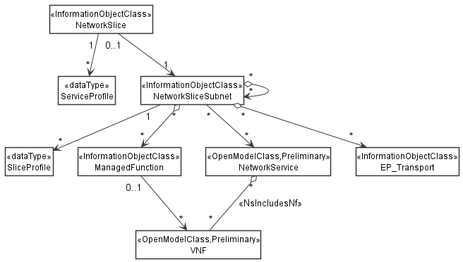

Figure 6.2.1-1: Network slice NRM fragment relationship

NOTE 1: The <<OpenModelClass>> NetworkService and <<OpenModelClass>> VNF are defined in [40].

NOTE 2: The target Network Service (NS) instance represents a group of VNFs and PNFs that are supporting the source network slice subnet instance.

NOTE 3: The instance tree of this NRM fragment would not contain the instances of NetworkService and VNF. However, the NetworkSliceSubNet instances would have an attribute holding the identifiers of NetworkService instances and the ManagedFunction instance would have an attribute holding identifiers of VNF instances.



Figure 6.2.1-2: Transport EP NRM fragment relationship



Figure 6.2.1-3: containment relationship for network slice fragment



Figure 6.2.1-4: containment relationship for feasibility check and resource reservation NRM fragment

|  |
| --- |
| **2nd Change** |

#### 6.3.2.1 Definition

This IOC represents the properties of a network slice subnet in a 5G network. For more information about the network slice subnet instance, see 3GPP TS 28.530 [70].

The NetworkSliceSubnet can be categorized by following types:

- RANSliceSubnet represent the RAN network slice subnet in a 5G network, which is associated to one or multiple “RANSliceSubnetProfile”.

- CNSliceSubnet represent the CN network slice subnet in a 5G network, which is associated to one or multiple “CNSliceSubnetProfile”.

- TopSliceSubnet represent the top network slice subnet in a 5G network, which is associated to one or multiple “TopSliceSubnetProfile”.

The attribute epTransportRef is used to specify a list of EP_Transport instance as transport resources to be aggregated to a NetworkSliceSubnet instance. The MnS consumer determines the EP_Transport instance(s) to support EP_Application instances as part of the NetworkSliceSubnet instance and request the MnS producer to configure the attribute epTransportRef of the NetworkSliceSubnet.

The EP_Transport is name contained by SubNetwork, and an EP_Transport instance can be a new instance created for the EP_Application instances as part of NetworkSliceSubnet instance or an existing instance reused for EP_Application instance.

An instance of NetworkSliceSubnet that represents top network slice subnet shall be associated with one NetworkSlice instance. An instance of NetworkSliceSubnet that represents CN network slice subnet or RAN network slice subnet shall be associated with one instance NetworkSliceSubnet that represents top network slice subnet. An instance of NetworkSliceSubnet that represents CN network slice subnet or RAN network slice subnet may be associated with one or more constituent NetworkSliceSubnet instance(s) represented by attribute networkSliceSubnetRef.

|  |
| --- |
| **End of change** |