**3GPP TSG-SA5 Meeting #145-e *S5-225255rev1***

e-meeting, 27 June - 1 July 2022

**Source: Huawei, Deutsche Telekom**

**Title: New Issue – Roles involved in EE KPI building**

**Document for: Approval**

**Agenda Item: 6.9.2.1**

# 1 Decision/action requested

**Include the proposed text in TR 28.913**

# 2 References

[1] 3GPP TR 28.913: "Study on new aspects of EE for 5G networks phase 2"

[2] SP-211440: "New Study on new aspects of EE for 5G networks Phase 2"

# 3 Rationale

This pCR proposes to investigate on roles involved when the Network Operator wants to collect measurements required to build its EE KPIs. These measurements may come from various sources potentially under the responsibility of different stakeholders.

As the traditional concept of ‘Key Issue / Potential solutions’ does not apply well in this context, it is proposed to use ‘Issue / Potential use cases’ instead in this case.

# 4 Detailed proposal

|  |
| --- |
| **First change** |

# 2 References

The following documents contain provisions which, through reference in this text, constitute provisions of the present document.

- References are either specific (identified by date of publication, edition number, version number, etc.) or non‑specific.

- For a specific reference, subsequent revisions do not apply.

- For a non-specific reference, the latest version applies. In the case of a reference to a 3GPP document (including a GSM document), a non-specific reference implicitly refers to the latest version of that document *in the same Release as the present document*.

[1] 3GPP TR 21.905: "Vocabulary for 3GPP Specifications".

[2] 3GPP TS 28.554: " Management and orchestration; 5G end to end Key Performance Indicators (KPI)".

[3] ETSI GS NFV-IFA 027 V4.2.2 (2021-07): "Network Functions Virtualisation (NFV) Release 4; Management and Orchestration; Performance Measurements Specification".

[4] ETSI ES 202 336-12 V1.2.1 (2019-02): "Environmental Engineering (EE); Monitoring and control interface for infrastructure equipment (power, cooling and building environment systems used in telecommunication networks); Part 12: ICT equipment power, energy and environmental parameters monitoring information model".

[5] ETSI GS NFV-EVE 004 V1.1.1 (2016-03): "Network Functions Virtualisation (NFV); Virtualisation Technologies; Report on the application of Different Virtualisation Technologies in the NFV Framework".

[6] ETSI GR NFV-IFA 029 V3.3.1 (2019-11): "Network Functions Virtualisation (NFV) Release 3; Architecture; Report on the Enhancements of the NFV architecture towards "Cloud-native" and "PaaS"".

[7] 3GPP TS 38.300: "NR; NR and NG-RAN Overall Description; Stage 2".

[8] 3GPP TS 38.401: "NG-RAN; Architecture description".

[9] The Greenhouse Gas Protocol - <https://ghgprotocol.org/sites/default/files/standards/ghg-protocol-revised.pdf>

[a] 3GPP TS 28.530: "Management and orchestration; Concepts, use cases and requirements".

[b] 3GPP TS 28.552: " Management and orchestration; 5G performance measurements".

[c] ETSI GS NFV-IFA 008 V4.3.1 (2022-05): "Management and Orchestration; Ve-Vnfm reference point - Interface and Information Model Specification".

|  |
| --- |
| **Next change** |

## 4.X Issue #X: Roles involved in EE KPI building

### 4.X.1 Description

Building EE KPIs (see TS 28.554 [2] – clause 6.7 requires collecting measurements from various entities. These entities may be or not under the responsibility of various stakeholders.  
TS 28.530 clause 4.8 describes roles, and interactions between them, involved in 5G networks and network slicing management.

This issue aims at investigating, based on different use cases, which roles are involved in the collection of required measurements and in building EE KPIs, and the interactions between them.

In all use cases, the Network Operator (NOP) is involved.

### 4.X.2 Potential use cases

#### 4.X.2.1 Potential use case #1: ‘NOP only, MEs are all PNFs’

##### 4.X.2.1.1 Introduction

In this use case:

# the Network Operator (NOP) operates its network;

# all Managed Elements (ME) on which measurements are collected are Physical Network Functions (PNF), i.e. none are virtualized;

# the NOP has all the MEs in its own premises.

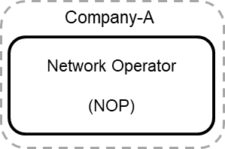

Figure 4.X.2.1.1-1: NOP only, MEs are all PNFs

##### 4.X.2.1.2 Description

In this use case, NOP:

1) collects required performance measurements from MEs. These performance measurements include those used in the upper part of EE KPIs defined in TS 28.554 [2] clause 6.7, e.g. performance measurements related to traffic data volumes, number of registered subscribers, etc.

2) collects PEE (Power, Energy and Environmental) parameters from MEs. Depending on whether Network Elements (NE) are equipped with embedded sensors or external sensors, the NOP may use an OA&M channel (in case of embedded sensor) or a dedicated channel (in case of external sensor) to collect PEE parameters.

3) build EE KPIs using:

a) performance measurements (cf. item 1 above) in the numerator of the KPIs, and

b) PEE parameters (cf. item 2 above) in the denominator of the KPIs;

4) use EE KPIs for its own purpose, i.e. the EE KPIs are not communicated to any other roles.

#### 4.X.2.2 Potential use case #2: ‘NOP deploys virtualized 5GC NFs on internal virtualization infrastructure and data centre’

##### 4.X.2.2.1 Potential sub-use case #2.1

###### 4.X.2.2.1.1 Introduction

In this use case:

# the Network Operator (NOP) operates its 5GC network;

# some 5GC NFs are virtualized and deployed on a virtualization infrastructure;

# the virtualization infrastructure is deployed and operated by an internal Virtualization Infrastructure Service Provider (VISP);

# the VISP deploys its virtualization infrastructure on its own data centre;

# the data centre is deployed and operated by an internal Data Centre Service Provider (DCSP);

# interfaces between NOP and VISP (NOP-VISP) and between NOP and DCSP (NOP-DCSP) are internal to Company A.

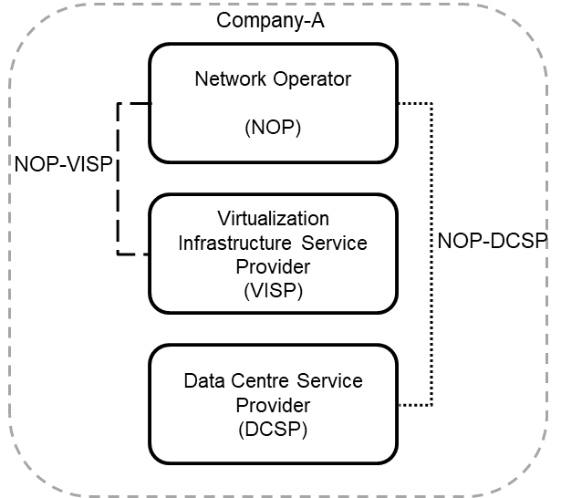

Figure 4.X.2.2.1.1-1: NOP deploys virtualized 5GC NFs on internal virtualization infrastructure and data centre

###### 4.X.2.2.1.2 Description

In this use case, NOP:

1) collects required performance measurements from 5GC NFs via OA&M. These performance measurements include those used in the upper part of EE KPIs defined in TS 28.554 [2] clause 6.7, e.g. performance measurements related to traffic data volumes, number of registered subscribers, etc.

2) gets, from the VISP, performance measurements related to VNF/VNFCs which compose the NOP 5GC NFs. These performance measurements include the vCPU usage and vDisk usage of VNF/VNFCs defined in ETSI GS NFV-IFA 027 [3] clause 7;

3) gets, from the DCSP, PEE (Power, Energy and Environmental) parameters related to NFVI nodes on which the VNF/VNFCs supporting the NOP 5GC NFs run. These PEE parameters are defined in TS 28.552 [b] clause 5.1.1.19 and collected according to the method defined in ETSI ES 202 336-12 [4];

4) build EE KPIs using:

a) performance measurements (cf. item 1 above) in the numerator of the KPIs, and

b) performance measurements related to VNF/VNFCs which compose the NOP 5GC NFs (cf. item 2 above) and PEE parameters (cf. item 3 above) in the denominator of the KPIs;

4) use EE KPIs for its own purpose, i.e. the EE KPIs are not communicated to any other roles.

VISP:

1) collects performance measurements related to VNF/VNFCs which compose the NOP 5GC NFs. These performance measurements include the vCPU usage and vDisk usage of VNF/VNFCs defined in ETSI GS NFV-IFA 027 [3] clause 7;

2) sends them to the NOP via the interface between the VISP ETSI MANO and the NOP OSS (cf. ETSI GS NFV-IFA 008 [c] clause 7.4).

DCSP:

1) collects PEE (Power, Energy and Environmental) parameters from NFVI nodes on which the VNF/VNFCs supporting the NOP 5GC NFs run. These PEE parameters are defined in TS 28.552 [b] clause 5.1.1.19;

2) sends them to the NOP. Depending on whether NFVI nodes (i.e. servers) are equipped with embedded sensors or external sensors, the interactions between the DCSP and the NOP may use an OA&M channel (in case of embedded sensor) or a dedicated channel (in case of external sensor).

##### 4.X.2.2.2 Potential sub-use case #2.2

###### 4.X.2.2.2.1 Introduction

In this use case:

# the Network Operator (NOP) operates its 5GC network;

# some 5GC NFs are virtualized and deployed on a virtualization infrastructure;

# the virtualization infrastructure is deployed and operated by an internal Virtualization Infrastructure Service Provider (VISP);

# the VISP deploys its virtualization infrastructure on its own data centre;

# the data centre is deployed and operated by an internal Data Centre Service Provider (DCSP);

# interfaces between NOP and VISP (NOP-VISP) and between VISP and DCSP (VISP-DCSP) are internal to Company A.

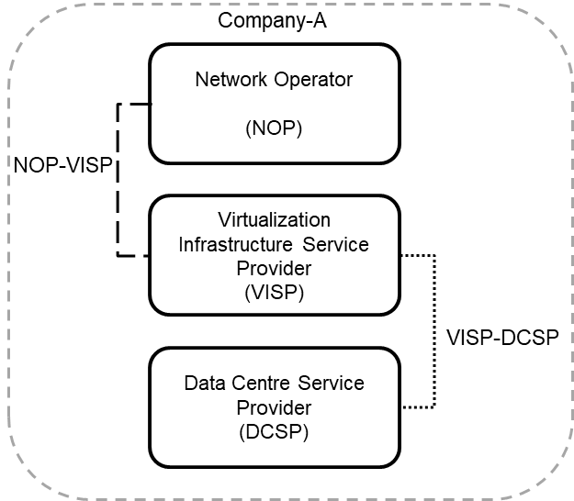

Figure 4.X.2.2.2.1-1: NOP deploys virtualized 5GC NFs on internal virtualization infrastructure and data centre

###### 4.X.2.2.2.2 Description

In this use case, NOP:

1) collects required performance measurements from 5GC NFs via OA&M. These performance measurements include those used in the numerator of EE KPIs defined in TS 28.554 [2] clause 6.7, e.g. performance measurements related to traffic data volumes, number of registered subscribers, etc.

2) gets, from the VISP, performance measurements related to VNF/VNFCs which compose the NOP 5GC NFs. These performance measurements include the vCPU usage and vDisk usage of VNF/VNFCs defined in ETSI GS NFV-IFA 027 [3] clause 7;

3) gets, from the VISP, PEE (Power, Energy and Environmental) parameters related to NFVI nodes on which the VNF/VNFCs supporting the NOP 5GC NFs run. These PEE parameters are defined in TS 28.552 [b] clause 5.1.1.19 and collected according to the method defined in ETSI ES 202 336-12 [4] and are first received by the VISP from the DCSP;

4) build EE KPIs using:

a) performance measurements (cf. item 1 above) in the numerator of the KPIs, and

b) performance measurements related to VNF/VNFCs which compose the NOP 5GC NFs (cf. item 2 above) and PEE parameters (cf. item 3 above) in the denominator of the KPIs;

4) use EE KPIs for its own purpose, i.e. the EE KPIs are not communicated to any other roles.

VISP:

1) collects performance measurements related to VNF/VNFCs which compose the NOP 5GC NFs. These performance measurements include the vCPU usage and vDisk usage of VNF/VNFCs defined in ETSI GS NFV-IFA 027 [3] clause 7;

2) sends them to the NOP via the interface between the VISP ETSI MANO and the NOP OSS (cf. ETSI GS NFV-IFA 008 [c] clause 7.4);

2) collects, from the DCSP, PEE (Power, Energy and Environmental) parameters related to NFVI nodes on which the VNF/VNFCs supporting the NOP 5GC NFs run;

3) sends them to the NOP via the interface between the VISP and the NOP OSS.

DCSP:

1) collects PEE (Power, Energy and Environmental) parameters from NFVI nodes on which the VNF/VNFCs supporting the NOP 5GC NFs run. These PEE parameters are defined in TS 28.552 [b] clause 5.1.1.19;

2) sends them to the VISP via the interface between the VISP and the DCSP.

#### 4.X.2.3 Potential use case #3: ‘NOP deploys virtualized 5GC NFs on external virtualization infrastructure and data centre‘

##### 4.X.2.3.1 Potential sub-use case #3.1

###### 4.X.2.3.1.1 Introduction

In this use case:

# the Network Operator (NOP) operates its 5GC network;

# some 5GC NFs are virtualized and deployed on a virtualization infrastructure;

# the virtualization infrastructure is deployed and operated by an external Virtualization Infrastructure Service Provider (VISP);

# the VISP deploys its virtualization infrastructure on a data centre;

# the data centre is deployed and operated by an external Data Centre Service Provider (DCSP).

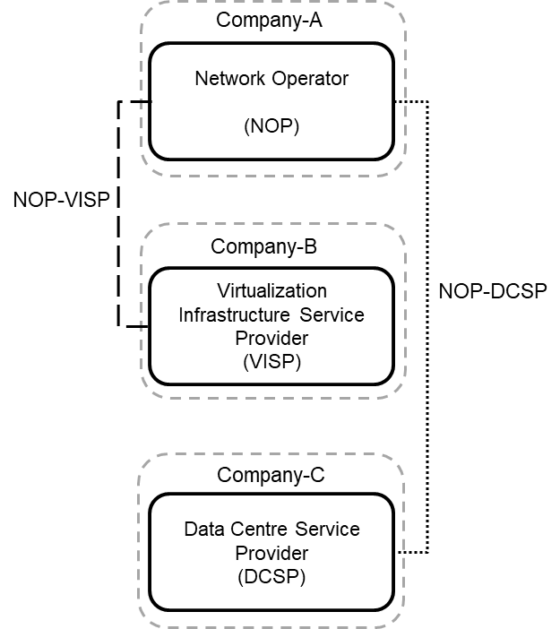

Figure 4.X.2.3.1.1-1: NOP deploys virtualized 5GC NFs on external virtualization infrastructure and data centre

###### 4.X.2.3.1.2 Description

In this use case, NOP:

1) collects required performance measurements from 5GC NFs via OA&M. These performance measurements include those used in the upper part of EE KPIs defined in TS 28.554 [2] clause 6.7, e.g. performance measurements related to traffic data volumes, number of registered subscribers, etc.

2) gets, from the VISP, performance measurements related to VNF/VNFCs which compose the NOP 5GC NFs. These performance measurements include the vCPU usage and vDisk usage of VNF/VNFCs defined in ETSI GS NFV-IFA 027 [3] clause 7;

3) gets, from the DCSP, PEE (Power, Energy and Environmental) parameters related to NFVI nodes on which the VNF/VNFCs supporting the NOP 5GC NFs run. These PEE parameters are defined in TS 28.552 [b] clause 5.1.1.19 and collected according to the method defined in ETSI ES 202 336-12 [4];

4) build EE KPIs using:

a) performance measurements (cf. item 1 above) in the numerator of the KPIs, and

b) performance measurements related to VNF/VNFCs which compose the NOP 5GC NFs (cf. item 2 above) and PEE parameters (cf. item 3 above) in the denominator of the KPIs;

4) use EE KPIs for its own purpose, i.e. the EE KPIs are not communicated to any other roles.

VISP:

1) collects performance measurements related to VNF/VNFCs which compose the NOP 5GC NFs. These performance measurements include the vCPU usage and vDisk usage of VNF/VNFCs defined in ETSI GS NFV-IFA 027 [3] clause 7;

2) sends them to the NOP via the interface between the VISP ETSI MANO and the NOP OSS (cf. ETSI GS NFV-IFA 008 [c] clause 7.4).

DCSP:

1) collects PEE (Power, Energy and Environmental) parameters from NFVI nodes on which the VNF/VNFCs supporting the NOP 5GC NFs run. These PEE parameters are defined in TS 28.552 [b] clause 5.1.1.19;

2) sends them to the NOP. Depending on whether NFVI nodes (i.e. servers) are equipped with embedded sensors or external sensors, the interactions between the DCSP and the NOP may use an OA&M channel (in case of embedded sensor) or a dedicated channel (in case of external sensor).

##### 4.X.2.3.2 Potential sub-use case #3.2

###### 4.X.2.3.2.1 Introduction

In this use case:

# the Network Operator (NOP) operates its 5GC network;

# some 5GC NFs are virtualized and deployed on a virtualization infrastructure;

# the virtualization infrastructure is deployed and operated by an external Virtualization Infrastructure Service Provider (VISP);

# the VISP deploys its virtualization infrastructure on a data centre;

# the data centre is deployed and operated by an external Data Centre Service Provider (DCSP).

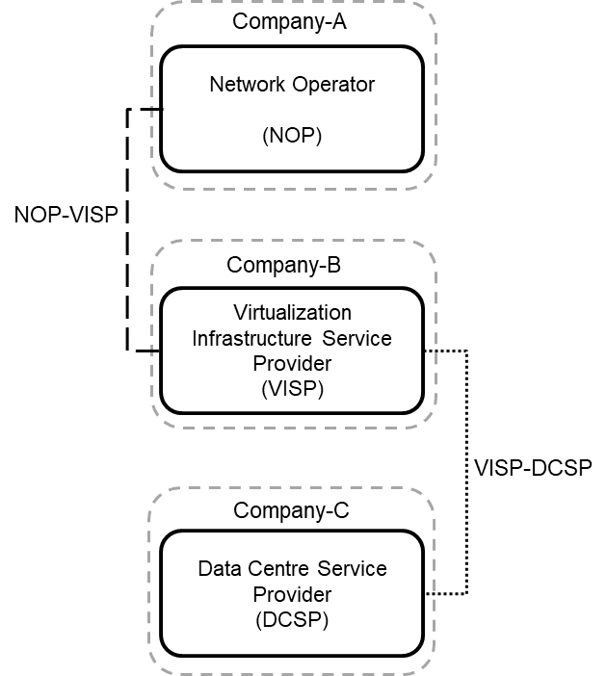

Figure 4.X.2.3.2.1-1: NOP deploys virtualized 5GC NFs on external virtualization infrastructure and data centre

###### 4.X.2.3.2.2 Description

In this use case, NOP:

1) collects required performance measurements from 5GC NFs via OA&M. These performance measurements include those used in the upper part of EE KPIs defined in TS 28.554 [2] clause 6.7, e.g. performance measurements related to traffic data volumes, number of registered subscribers, etc.

2) gets, from the VISP, performance measurements related to VNF/VNFCs which compose the NOP 5GC NFs. These performance measurements include the vCPU usage and vDisk usage of VNF/VNFCs defined in ETSI GS NFV-IFA 027 [3] clause 7;

3) gets, from the VISP, PEE (Power, Energy and Environmental) parameters related to NFVI nodes on which the VNF/VNFCs supporting the NOP 5GC NFs run. These PEE parameters are defined in TS 28.552 [b] clause 5.1.1.19 and collected according to the method defined in ETSI ES 202 336-12 [4] and are first received by the VISP from the DCSP;

4) build EE KPIs using:

a) performance measurements (cf. item 1 above) in the numerator of the KPIs, and

b) performance measurements related to VNF/VNFCs which compose the NOP 5GC NFs (cf. item 2 above) and PEE parameters (cf. item 3 above) in the denominator of the KPIs;

4) use EE KPIs for its own purpose, i.e. the EE KPIs are not communicated to any other roles.

VISP:

1) collects performance measurements related to VNF/VNFCs which compose the NOP 5GC NFs. These performance measurements include the vCPU usage and vDisk usage of VNF/VNFCs defined in ETSI GS NFV-IFA 027 [3] clause 7;

2) sends them to the NOP via the interface between the VISP ETSI MANO and the NOP OSS (cf. ETSI GS NFV-IFA 008 [c] clause 7.4);

2) collects, from the DCSP, PEE (Power, Energy and Environmental) parameters related to NFVI nodes on which the VNF/VNFCs supporting the NOP 5GC NFs run;

3) sends them to the NOP via the interface between the VISP and the NOP OSS.

DCSP:

1) collects PEE (Power, Energy and Environmental) parameters from NFVI nodes on which the VNF/VNFCs supporting the NOP 5GC NFs run. These PEE parameters are defined in TS 28.552 [b] clause 5.1.1.19;

2) sends them to the VISP via the interface between the VISP and the DCSP.

|  |
| --- |
| **End of changes** |