3GPP TSG-SA5 Meeting #144-e S5-225175

Online, , 15th Aug 2022 – 24th Aug 2022
CR-Form-v12.2
CHANGE REQUEST
 | 28.538 | CR | xxx | rev | - | Current version: | 17.1.0
For HELP on using this form: comprehensive instructions can be found at
http://www.3gpp.org/Change-Requests.

Proposed change affects: | UICC apps |  | ME | X | Radio Access Network |  | Core Network | X

Title: | GSMA OP and ECM concept mapping
Source to WG: | Samsung R&D Institute India
Source to TSG: | S5
Work item code: | eECM |  |  |  |  |  | Date: |  |  | 2022-04-28
Category: | B |  |  |  |  |  | Release: |  |  | Rel-18
 | Use one of the following categories:  F (correction)  A (mirror corresponding to a change in an earlier release)  B (addition of feature),  C (functional modification of feature)  D (editorial modification)  Detailed explanations of the above categories can  be found in 3GPP TR 21.900. |  |  |  |  |  |  |  | Use one of the following releases:  Rel-8 (Release 8)  Rel-9 (Release 9)  Rel-10 (Release 10)  Rel-11 (Release 11)  …  Rel-16 (Release 16)  Rel-17 (Release 17)  Rel-18 (Release 18)  Rel-19 (Release 19)
Reason for change: |  | It is crucial to document the relation between the concepys defined in GSMA OPG with the one existing in ECM, in order to support the GSMA NBI requirements.
Summary of change: |  | Provide the introduction and concept mapping wioth GSMS OPG
Consequences if not approved: |  | Ambigious Specification
Clauses affected: |  | Annex X (new)
 |  | Y | N
Other specs |  |  | X | Other core specifications |  |  |  | TS/TR ... CR ...
affected: |  |  | X | Test specifications |  |  |  | TS/TR ... CR ...
(show related CRs) |  |  | X | O&M Specifications |  |  |  | TS/TR ... CR ...
Other comments:
This CR's revision history:

1st Modified Section

Annex X (Informative):
GSMA OP introduction and concept mapping
The Operator Platform (OP) is defined by GSMA OPG [2], it facilitates access to the Edge Cloud capability of an Operator or federation of operators and their partners.
The architecture scope under definition is shown below,
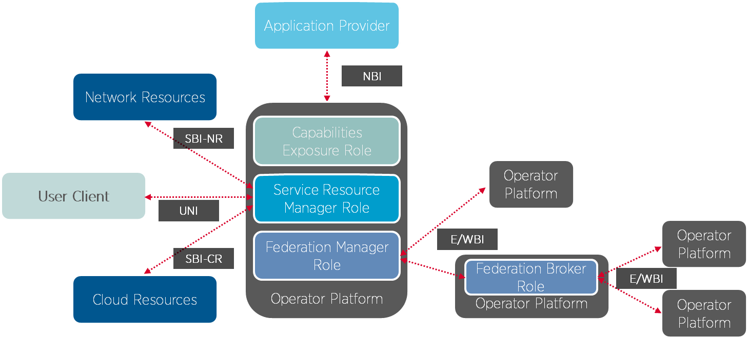
Figure 4.2-1: OP Roles and Interfaces Reference Architecture
The NBI is the interface between the application provider and the Capabilities Exposure Role in the Operator Platform, it allows an OP to advertise the above cloud capabilities that it can provide to application providers. In addition, the NBI allows an application provider to reserve a set of resources or request an Edge Cloud service with the resources and features that they require and for the OP to accept or reject the request.
The following table provides the mapping of concepts (not exhaustive) defined in TS 28.538[6] with the concepts defined in GSMA OPG [x].
GSMA[x] | ECM(TS 28.538) | Comment/Observations
Application Instance  Edge Application | EAS VNF Instance  EAS | Application Instance and EAS VNF Instance are both referring to the application instances running in the edge.  Edge Application and EAS are both referring to the application running in the edge.
Application Provider | Application Service Provider | Application Provider and Application Service Provider both referring to the application providers producing and requesting for the deployment of the applications.
Region | FFS | The higher construct in the hierarchy exposed to a developer who wishes to deploy an Application on the Edge Cloud and broadly represents a geography. A Region typically contains one or multiple Availability Zones.  An OP Region is equivalent to a Region on a public cloud
Availability Zone | FFS | An Availability Zone is the lowest level of abstraction exposed to a developer who wants to deploy an Application on the edge network. The capability to create Cloudlets within an Availability Zone is to be provide by the OP.  An OP Availability Zone is the equivalent of an Availability Zone on Public Cloud
Cloudlet | FFS | A cloudlet is a point of presence for the Edge Cloud. It is the point where Edge Applications are deployed.  While EAS deployment, appropriate EDN is selected to deploy the EAS on.
Capabilities Exposure Role in OP | ECSP Management System | Both Capabilities Exposure Role in Operator Platform and the ECSP Management System are the entities which exposes interface and management service towards ASP.
Northbound Interface | Management services for Edge Computing lifecycle management | NBI maps to management service, enabling LCM for EAS, exposed towards ASP.

End Of Modified Section

