3GPP TSG-SA5 Meeting #145e S5-225060

August 2022, E-meeting

Source: Nokia

Title: pCR 28.912 Solution on AIMLEntity Capability Discovery and mapping

Document for: Approval

Agenda Item: 6.7.3.2

1 Decision/action requested
The group is asked to discuss and agree on the proposal.

2 References
[1] 3GPP TR 28.912-010 “Study on enhanced intent driven management services for mobile networks”.

3 Rationale
The applicability of the ML-based solutions (e.g., which AI/MLEntities shall be applied and how) for accomplishing specific automaton functionalities is not obvious. Some may need the use of AI/ML orchestration while other don’t. In both cases, management services are required to identify the capabilities of the involved AI/MLEntities and to map those capabilities to the desired automation logic.
TR28.908 describes the AIML capabilities of AI/MLEntities as either of:
- a decision-making capability which is in the form of triple <x,y,z> indicating
  - x: the object or object types for which the AI/MLEntity can undertake optimization or control
  - y: the configurable attributes on object or object types x, which the AI/MLEntity optimizes or controls to achieve the desired outcomes
  - z: the performance metrics which the AI/MLEntity optimizes through its actions
- an analysis capability which is in the form of tuple <x,z> indicating
  - x: the object or object types for which the AI/MLEntity can undertakes analysis
  - z: the network context (on object x) for which the AI/MLEntity produces analysis

Intent driven management may rely on these SON and AI/ML capabilities to accomplish the desired automation. The 3GPP management system should have the capabilities to enable intent-driven management to interact with SON Functions and with non-SON AI/ML-enabled functions to realize intents. In particular, the
The 3GPP Management system should have a capability to enable an authorized consumer to request the Producer of Intent-AI/ML capability mapping MnS for a mapping of automation targets to the capabilities of one or more AI/MLEntities
The 3GPP Management system should have a capability to enable an authorized consumer to request the Producer of Intent-driven Management MnS to fulfil an intent using specific AI/ML capabilities

This pCR adds a potential solution on AI/ML Capability Discovery and Mapping .

4 Detailed proposal

5 Use cases, potential requirements and possible solutions

4.A

4.A.4 Possible solutions
Start of modification

The intent driven MnS Producer may rely on available AI/ML capabilities to accomplish the desired automation. Such available AI/ML capabilities may need to be discovered by the consumers as a first step before consumer can request for those capabilities to be applied. Furthermore, the mapping of the discovered AI/ML capabilities to intents or automatin logic needs to be performed. Finally, according configuration and instructions for execution of needed AI/ML capabilities is needed in order to achieve desired outcome.
For example, in the case of intent fulfilment system leveraging on AI/ML capabilities, the discovered available AI/ML capabilities may be to the extent possible, mapped to incoming user or operators’ intents. The solution requires to
- Introduce the AIML_capability_mapping_report <<datatype>> for any intent-MnS producer
- When an intent MnS Producer receives a desired network outcome or automation logic from e.g., network operator with a request for a mapping to available AI/MLEntities and their capabilities, the MnS Producer provides such a mapping of the AI/MLEntities and their capabilities to the received request based on the capabilities obtained from the AI/ML MnS Producer.
- When the intent MnS Producer (here as AI/ML MnS Consumer) requests for information on available AI/MLEntities and their supported AI/ML capabilities from the AI/ML MnS Producer (e.g., inference producer), the AI/ML MnS Producer provides the AIML_capability in the form of a decision or an analytics capability described in TR28.908
- Support intent instantiation that specifies specific AI/MLEntities to be used to fulfil the intent.
When subsequently, the MnS Producer receives a desired network outcome or automation logic from e.g., network operator with a request to exeute the automation logic, the MnS Producer derives the configuration or execution instructions according to the received automation logic or outcomes, and provides such configuration or execution instructions to AI/ML MnS Producer(s)

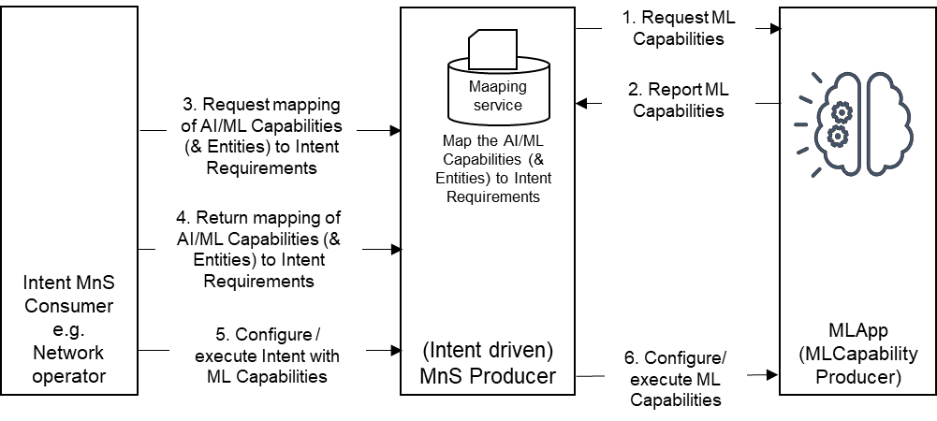
Figure 1 AI/ML capability discovery, mapping, configuration and execution

4.A.5 Evaluation
The solution described in clause 4.A.4 adopts the NRM-based approach, which reuses the existing provisioning MnS operations and notifications. Introducing the AI/ML_capability <<datatype>> the intent driven MnS Producer can inform its potential intent driven MnS consumers about the AI/ML_capabilities it relies on to accomplish intent fulfillment. The intent driven MnS consumers can then request for specific capabilities ot be applied for their intents. Therefore, the solution described in clause 5.8.4 is a feasible solution.

End of modifications

