3GPP TSG-SA5 Meeting # S5- 225044

August 2022, E-meeting

Source: Nokia, CATT

Title: pCR 28.908 Use case on Producer Initiated AIML Training

Document for: Approval

Agenda Item: 6.7.5.7

1 Decision/action requested
The group is asked to discuss and agree on the proposal.

2 References
[1] 3GPP TR 28.908-010 “Study on Artificial Intelligence/Machine Learning (AI/ ML) management”.

3 Rationale
The performance of the AIML entity depends on the distribution of the used data. Over time, the distribution of the network data might change as compared to the distribution of the initial training data, leading to a degradation in the the performance of the AIML entity. The AIML entity may thus need to be retrained based on observed changes in the data This pCR is to add the UC and potential requirements on event-based AIML Retraining.

4 Detailed proposal
Start of modification

5 Use cases, potential requirements and possible solutions

5.9 AI/ML update management

5.9.1 Description
Due to the complexity and time-varying nature of network, the AI/ML entities previously deployed may no longer be applicable to the current network after running for a period of time. Typically, the performance of a trained model may degrades over time. The AI/ML entitie needs to be updated timely to ensure the performance of inference and analysis.

5.9.2 Use cases

5.9.2.2 AI/ML entities updating initiated by producer
The AI/ML entity updating may be initiated by the AI/ML MnS producer. In order to keep the model at a requested level, the AI/ML MnS producer may periodically conduct AI/ML retraining with new available training data. Once a new version AI/ML entity is obtained after the training is finished, it can be used to update the current AI/ML entity with this new version. In another condition, the AI/ML MnS producer may initiate AI/ML entity updating based on the running model performance. For example, if the performance of the running AI/ML model is decreased under a predefined threshold, the AI/ML MnS producer may decide to start ratraining and then update the AI/ML entity to a new version which performs better.

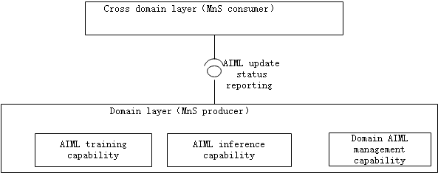

5.9.2.x Producer-initiated event-based AIML Retraining
The performance of the AIML entity depends on the commonality of the distribution of the data used for training and the distribution of the data used for inference. Typically, the model performance would be good soon after deployment. This is because the chances of the distributions of the data used for training and the samples picked for inference are same. As the time progresses, the distribution of the network data might change as compared to the distribution of the train data. In such scenario, the performance of the AIML entity degrades over time. Hence there is a need for monitoring the network events such as PMs, KPIs, alarms etc and use this information in the producer to decide on the retraining.

5.9.2.2-1: Potential requirements
Requirement label | Description | Related use case(s)
REQ-AIML_UPD-CON-3 | The AI/ML MnS producer should have a capability to update the AI/ML entities and inform an authorized consumer about the update status. | AI/ML entities updating initiated by producer (clause 5.X.2.2)
REQ-AIML_RETR-CON-1 | The AIML MnS producer shall have the capability of allowing an authorized AIML MnS consumer to provide the events to be monitored to trigger the retraining of an AIML entity | AI/ML entities updating initiated by producer (clause 5.X.2.2)
REQ-AIML_RETR-CON-2 | The AIML MnS producer shall have the capability of using the events provided by authorized MnS consumer to monitor and trigger the retraining of an AIML entity | AI/ML entities updating initiated by producer (clause 5.X.2.2)
REQ-AIML_RETR-CON-3 | The AIML MnS producer shall have the capability of allowing an authorized AIML MnS consumer to update the AIML entity with the data events to be monitored to trigger the retraining of that AIML entity | AI/ML entities updating initiated by producer (clause 5.X.2.2)

End of modifications

