**3GPP TSG-SA5 Meeting #143-e *S5-223605***

**e-meeting, 9 - 17 May 2022 revision of S5-223262**

**Source: Huawei**

**Title: Add process for multiple vendor case**

**Document for: Approval**

**Agenda Item: 6.5.14.1**

# 1 Decision/action requested

This document is to request approval of the proposed text.

2 References

[1] TR 28.819 v 0.6.0 Management and orchestration; Study on continuous integration continuous delivery support for 3GPP NFs

# 3 Rational

The process for multi-vendor CI-CD in clause 7 is missing,

# 4 Proposed changes

Proposad one possible process for multi-vendor CI-CD in [1].

The start of the 1st change

Annex X: Potential 3GPP management system involvement process

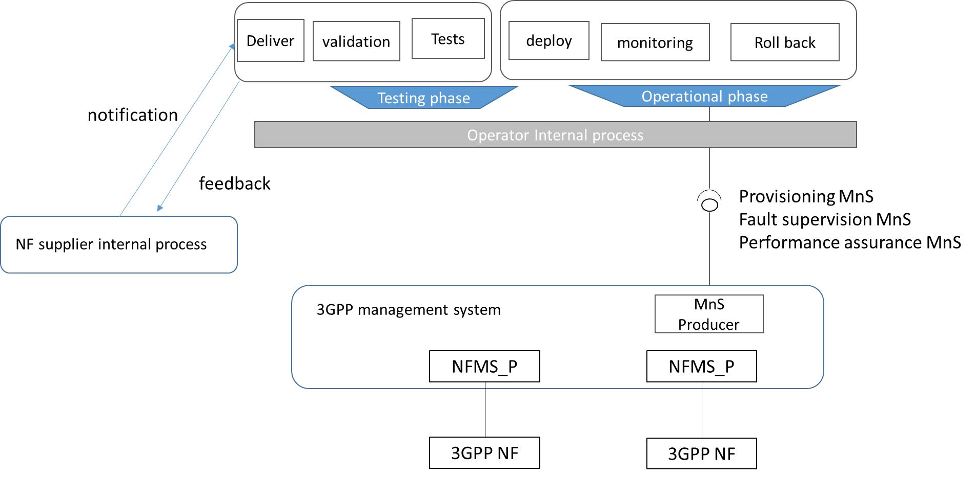

Figure Annex x-1: Example of Potential 3GPP management system involvement process

Figure Annex x-1 shows an example of potential 3GPP management system involvement process, where the Operator CI-CD Pipeline acts as the consumer of the 3GPP management system.

When a new release of a NF is ready, the NF supplier provides a notification to operator, the notification may includes the location on where to fetch the new NF version and NF information. The notification and feedback are representing the information level for a logical interaction i.e. may not be a machine to machine interface.

The Operator CI-CD Pipeline may execute the internal process for with the testing phase for the new NF version, which may includes deliver, validation and tes. At the operational phase, whenever is needed, the operator CI-CD pipeline may interact with the 3GPP management system by requesting corresponding MnSs (e.g. Provisioning MnS, Fault supervision MnS, performance assurance MnS and etc).

For new NF deployment, the Network Function Management Service Provider (NFMS_P) handles provisioning MnS request as described in TS 28.531. The NFMS_P may also trigger its internal process for NF management, which may include VNF test procedure as described in ETSI NFV TST [6].

End of change