**3GPP TSG-SA5 Meeting #143e *S5-223459rev1***

**9 May to 12 April 2022, E-meeting**

**Source: China Telecom**

**Title: New key issue for the performance management of the NWDAF on the output KPI aspect**

**Document for: Approval**

**Agenda Item: 6.5.6**

# 1 Decision/action requested

***The group is asked to discuss and agree on the proposal.***

# 2 References

[1] 3GPP TS 23.288: "Architecture enhancements for 5G System (5GS) to support network data analytics services".

[2] 3GPP TR 28.864 0.0.0 “Study on Enhancement of the management aspects related to NWDAF”.

[3] 3GPP TR 23. 501: “System architecture for the 5G System (5GS)”.

# 3 Rationale

## 3.1 Discussion

In TS 23.288 [1], the procedure for analytics exposure has been defined in clause 6.1. The NWDAF service consumer use the procedure defined in clause 6.1.2 to request and get from NWDAF analytics information. The NWDAF service consumer requests analytics information by invoking Nnwdaf_AnalyticsInfo_Request service operation and providing some input parameters.

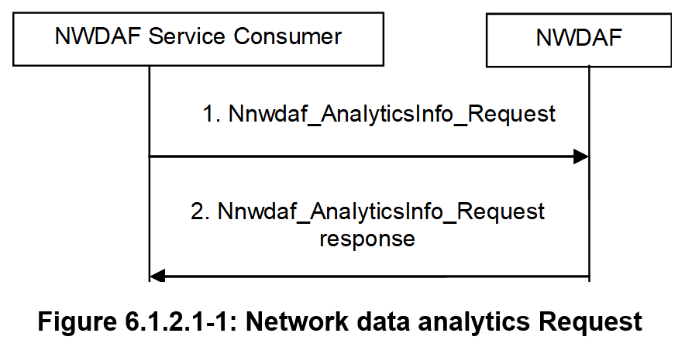

For example, the input parameters include the “Time when analytics information is needed”. The “Time when analytics information is needed” indicates to the NWDAF the latest time the analytics consumer expects to receive analytics data provided by the NWDAF. It is a relative time interval as the gap with respect to analytics request /subscription (e.g. "in 10 minutes").

**Observation 1: The input parameters used by NWDAF service consumer to request and get from NWDAF analytics information may include “Time when analytics information is needed”.**

As described in [1] and [3], the “Supported analytics delay” defined in the NWDAF profile indicates the latest time the analytics information provided by the NWDAF can be generated. The “Time when analytics information is needed” should not be set to a value less than the “Supported analytics delay” of the selected NWDAF if applicable. If the “Time when analytics information is needed” is provided and it is less than the “Supported Analytics Delay” associated with the Analytics ID (if available), it is expected that the NWDAF may not be able to treat the Analytics ID on time. If the “Time when analytics information is needed” is reached the consumer does not need to wait for the analytics information any longer, yet the NWDAF may send an error response or error notification to the consumer.

**Observation 2: The “Time when analytics information is needed” should not be set a value less than the “Supported analytics delay”.** **If the “Time when analytics information is needed” is reached but the analytics information is not ready, the NWDAF may send an error response or error notification to the consumer.**

According to [2], if multiple NWDAF instances are deployed, an NWDAF can act as Aggregator NWDAF, while the other NWDAFs play the role that provides analytics information to this Aggregator NWDAF. When an Aggregator NWDAF receives “Time when analytics information is needed” from the analytics consumer with the value greater than or equal to its “Supported Analytics Delay”, the Aggregator NWDAF should ensure the sum of time needed for the aggregation plus the “Supported Analytics Delay” of other NWDAFs is not beyond the registered “Supported Analytics Delay” of this Aggregator NWDAF when it applies analytics aggregation for related Analytics ID(s). If this cannot be ensured, the aggregator NWDAF may reject the analytics request.

**Observation 3:** **When an Aggregator NWDAF applies analytics aggregation for related Analytics ID(s), it should ensure the sum of time needed for the aggregation plus the “Supported Analytics Delay” of other NWDAFs is not beyond the “Supported Analytics Delay” of this Aggregator NWDAF. If this cannot be ensured, the aggregator NWDAF may reject the analytics request.**

## 3.2 Summary

With the above observations:

* **Observation 1: The input parameters used by NWDAF service consumer to request and get from NWDAF analytics information may include “Time when analytics information is needed”.**
* **Observation 2: The “Time when analytics information is needed” should not be set a value less than the “Supported analytics delay”.** **If the “Time when analytics information is needed” is reached but the analytics information is not ready, the NWDAF may send an error response or error notification to the consumer.**
* **Observation 3: When an Aggregator NWDAF applies analytics aggregation for related Analytics ID(s), it should ensure the sum of time needed for the aggregation plus the “Supported Analytics Delay” of other NWDAFs is not beyond the “Supported Analytics Delay” of this Aggregator NWDAF, and the “Supported analytics delay” of this Aggregator NWDAF should not be greater than the “Time when analytics information is needed” it received. If this cannot be ensured, the aggregator NWDAF may reject the analytics request.**

With the observation above, we propose to study the following KIs on the performance management on output KPI aspect of NWDAF.

# 4 Detailed proposal

|  |
| --- |
| **Start of 1st Change** |

# 4 Key Issues and potential solutions

## 4.X Key Issue #X: Performance Management of the NWDAF on the output KPI aspect

### 4.X.1 Description

According to the TS 23.288 [2], the NWDAF service consumer use the procedure for analytics exposure defined in clause 6.1 to request and get from NWDAF analytics information. When the NWDAF service consumer request the analytics information from NWDAF, it will provide to NWDAF some input parameters which may include “Time when analytics information is needed”.

The “Time when analytics information is needed” indicates to the NWDAF the latest time the analytics consumer expects to receive analytics data provided by the NWDAF. The “Supported analytics delay” defined in NWDAF profile indicates the latest time the analytics data provided by the NWDAF can be generated. The “Time when analytics information is needed” should not be set a value less than the “Supported analytics delay”.

If the “Time when analytics information is needed” is reached but the analytics information is not ready, the NWDAF may send an error response or error notification to the consumer. Moreover, when an Aggregator NWDAF applies analytics aggregation, the sum of time needed for the aggregation plus the “Supported Analytics Delay” of other NWDAFs should not beyond the “Supported Analytics Delay” of this Aggregator NWDAF. Otherwise, the aggregator NWDAF may reject the analytics request.

Therefore, from the perspective of management, monitoring the performance of NWDAF based on the output KPI aspects is necessary. The output KPI may include the “response time” (or “analytics delay”) of the NWDAF.

However, in the management domain, the performance management of NWDAF on this aspect is missing.

|  |
| --- |
| In this key issue, the potential solution is provided on the metrics or KPIs for performance management of the NWDAF based on the output KPI aspects.**End of Modified Sections** |