**3GPP TSG-SA5 Meeting #143-e *S5-223452***

e-meeting, 9 - 17 May 2022

|  |  |  |  |  |  |  |  |  |
| --- | --- | --- | --- | --- | --- | --- | --- | --- |
| *CR-Form-v12.1* | | | | | | | | |
| **CHANGE REQUEST** | | | | | | | | |
|  | | | | | | | | |
|  | **28.531** | **CR** | **0116** | **rev** | 1 | **Current version:** |  |  |
|  | | | | | | | | |
| *For* [***HE******LP***](http://www.3gpp.org/3G_Specs/CRs.htm#_blank)*on using this form: comprehensive instructions can be found at* [*http://www.3gpp.org/Change-Requests*](http://www.3gpp.org/Change-Requests)*.* | | | | | | | | |
|  | | | | | | | | |

|  |  |  |  |  |  |  |  |  |
| --- | --- | --- | --- | --- | --- | --- | --- | --- |
| ***Proposed change affects:*** | UICC apps |  | ME |  | Radio Access Network | **x** | Core Network | **x** |

|  |  |  |  |  |  |  |  |  |  |  |
| --- | --- | --- | --- | --- | --- | --- | --- | --- | --- | --- |
|  | | | | | | | | | | |
| ***Title:*** | Update procedures for asynchronous mode of operations for Network Slice and Network Slice Subnet LCM | | | | | | | | | |
|  |  | | | | | | | | | |
| ***Source to WG:*** | Nokia, Nokia Shanghai Bell | | | | | | | | | |
| ***Source to TSG:*** | S5 | | | | | | | | | |
|  |  | | | | | | | | | |
| ***Work item code:*** | eNETSLICE_PRO | | | | |  | ***Date:*** | | | 2022-05-12 |
|  |  | | | |  | |  | | |  |
| ***Category:*** | **B** |  | | | | | ***Release:*** | | | Rel-17 |
|  | *Use one of the following categories:* ***F*** *(correction)* ***A*** *(mirror corresponding to a change in an earlier release)* ***B*** *(addition of feature),* ***C*** *(functional modification of feature)* ***D*** *(editorial modification)*  Detailed explanations of the above categories can be found in 3GPP [TR 21.900](http://www.3gpp.org/ftp/Specs/html-info/21900.htm). | | | | | | | | *Use one of the following releases: Rel-8 (Release 8) Rel-9 (Release 9) Rel-10 (Release 10) Rel-11 (Release 11) … Rel-15 (Release 15) Rel-16 (Release 16) Rel-17 (Release 17) Rel-18 (Release 18)* | |
|  |  | | | | | | | | | |
| ***Reason for change:*** | | The procedure of allocation of an instance of NetworkSlice and NetworkSliceSubnet described in Section 7.2 and 7.3 in TS 28.531 is not detailed and missing the corresponding notifications for object creation and attribute value change. Since neither NetworkSlice nor NetworkSliceSubnet have the attributes availability status and lifecycle state as of ITU-T X.731, the consumer is not able to follow the status of NetworkSlice and NetworkSliceSubnet during its creation. | | | | | | | | |
|  | |  | | | | | | | | |
| ***Summary of change:*** | | Update the description of the procedure of allocateNSI and allocateNSSI by the corresponding notifications of object creation and attribute value change, Include messages that refer to changes of availability status and lifecycle state. | | | | | | | | |
|  | |  | | | | | | | | |
| ***Consequences if not approved:*** | | Allocation of NetworkSlice and NetworkSliceSubnet are not clearly described including corresponding messages. Without proper usage ot state information the consumer is not able to follow the status of objects and subordinated ubjects. | | | | | | | | |
|  | |  | | | | | | | | |
| ***Clauses affected:*** | | 7.2, 7.3, | | | | | | | | |
|  | |  | | | | | | | | |
|  | | **Y** | **N** |  | | | |  | | |
| ***Other specs*** | |  | **X** | Other core specifications | | | | TS/TR ... CR ... | | |
| ***affected:*** | |  | **X** | Test specifications | | | | TS/TR ... CR ... | | |
| ***(show related CRs)*** | | **X** |  | O&M Specifications | | | | TS 28.541 CR0725 | | |
|  | |  | | | | | | | | |
| ***Other comments:*** | | This CR refers to lifecycleState and availabilityStatus attributes in NetworkSlice and NetworkSliceSubnet IOC in TS 28.541 proposed by CR0725, with tDoc# S5-223453 for TS28.541 | | | | | | | | |
|  | |  | | | | | | | | |
| ***This CR's revision history:*** | | Corrected reason, summary, consequences, and clauses affected.  Clauses 7.4 – 7.7 erroneously appeard as deleted. In fact this CR did not intent to touch these clauses, they should not be part of the docuemt at all but unfortunately got deleted with “revision on”. Not able to show by revision marks the “revertion of deletion”. 7.4 – 7.7 show now as not modified. | | | | | | | | |

|  |
| --- |
| **1st Change** |

7.2 Procedure of Network Slice Instance Allocation

The Figure 7.2-1 illustrates the procedure of creating a new NSI or using an existing NSI to satisfy the required network slice related requirements.

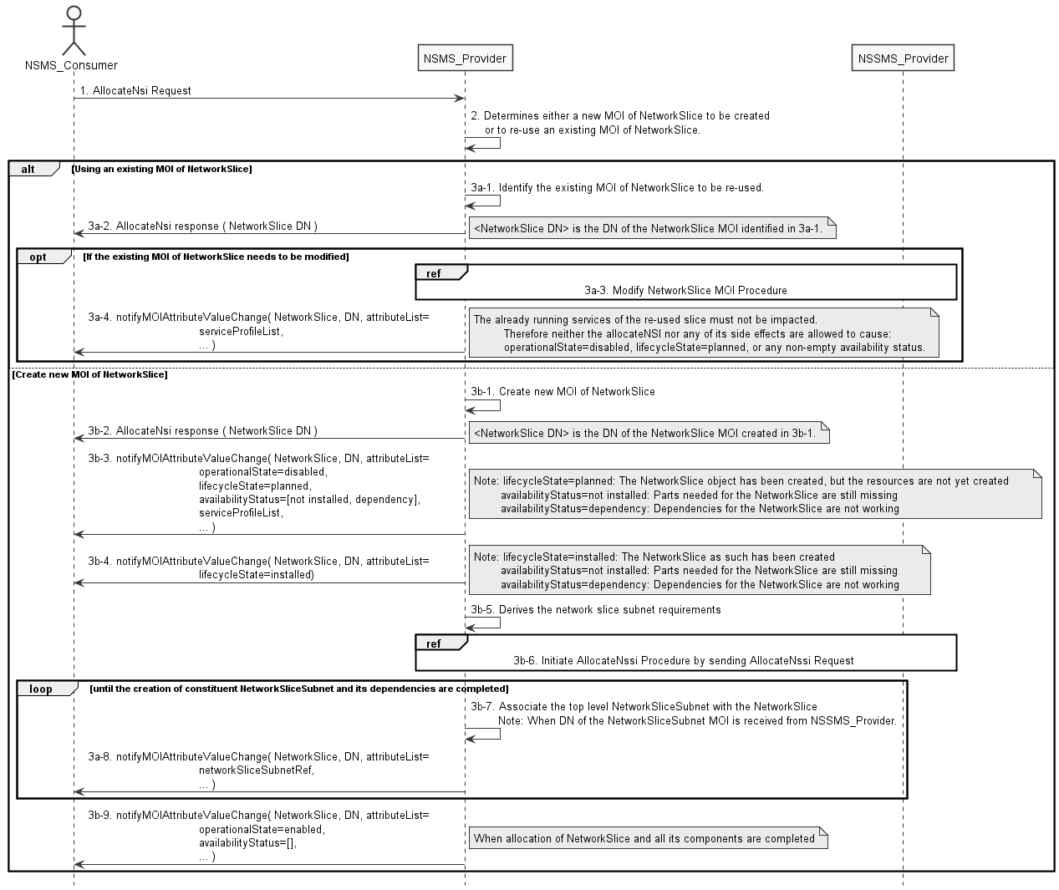

**Figure 7.2-1: Network Slice Instance Allocation Request procedure**

1) Network Slice Management Service Provider (NSMS_Provider) receives an AllocateNsi request (see AllocateNsi operation defined in clause 6.5.1) from Network Slice Management Service Consumer (NSMS_Consumer) with network slice related requirements (the network slice related requirements are defined as the attributes in the ServiceProfile see clause 6.3.3 in TS 28.541 [6]).

2) Based on the network slice related requirement and the knowledge of the capabilities of existing deployed network slices, the NSMS_Provider compare/match the provided requirements against all the candidate NetworkSlice instances, and then decides whether to use an existing NSI or create a new NSI. If the network slice related requirements allow the requested NSI to be shared and if an existing suitable NSI can be reused, the NSMS_Provider may decide to use the existing NSI.

3a-1) If using an existing NSI, the NSMS_Provider identifies the existing NetworkSlice MOI.

3a-2) The NSMS_Provider sends AllocateNsi response to the NSMS_Consumer with the DN of the NetworkSlice MOI, identified in step 3a-1.

3a-3) The identified NetworkSlice MOI needs to be modified to satisfy the network slice related requirements and the NSMS_Provider invokes the procedure to modify the existing NSI as described in clause 7.6.

3a-4) The NSMS_Provider associates the received ServiceProfile with the identified existing NetworkSlice MOI. Additionally, the NSMS_Provider may configure other configuration information for the NetworkSlice MOI. The NSMS_Provider notifies the updated NetworkSlice MOI attributes to NSMS_Consumer.

NOTE: The already running services of the re-used slice must not be impacted. Therefore neither the allocateNSI nor any of its side effects are allowed to cause: operationalState=disabled, lifecycleState=planned, or any non-empty availability status.

3b-1) If creating a new NSI, the NSMS_Provider creates the MOI NetworkSlice instance.

3b-2) The NSMS_Provider sends AllocateNsi response to the NSMS_Consumer with the DN of the NetworkSlice MOI, created in step 3b-1.

3b-3) The NSMS_Provider updates the NetworkSlice MOI instance states. Additionally, the NSMS_Provider may configure other configuration information for the NetworkSlice MOI.

The NSMS_Provider sends notification notifyMOICreation (defined in clause 6.5.2 in TS 28.541 [6] and clause 11.1.1.7 in TS 28.532 [8]) with the following attributes to NSMS_Consumer:

- DN of the NetworkSlice MOI in attribute objectInstance.

- The following NetworkSlice instance states in attributeList:

- operationalState=disabled

- lifecycleState=planned

- availabilityStatus=[not_installed, dependency]

NOTE: The NetworkSlice instance states indicate that the MOI has been created, but corresponding network slice subnets are not created.

- lifecycleState=planned: The NetworkSlice object has been created, but the resources are not yet created

- availabilityStatus=not installed: Parts needed for the NetworkSlice are still missing

- availabilityStatus=dependency: Dependencies for the NetworkSlice are not working

3b-4) When the Network Slice is created, the NSMS_Provider updates the NetworkSlice MOI instance states.

The NSMS_Provider sends notification notifyMOIAttributeValueChanges (defined in clause 6.5.2 in TS 28.541 [6] and clause 11.1.1.7 in TS 28.532 [8]) with the following attributes to NSMS_Consumer:

- DN of the NetworkSlice MOI in attribute objectInstance.

- The following NetworkSlice instance states in attributeList:

- lifecycleState=installed

NOTE: The NetworkSlice instance states indicate that the MOI has been created.

- lifecycleState=installed: The NetworkSlice as such has been created

- availabilityStatus=not installed: Parts needed for the NetworkSlice are still missing

- availabilityStatus=dependency: Dependencies for the NetworkSlice are not working

3b-5) The NSMS_Provider derives the network slice subnet related requirements from the received network slice related requirements. Before NSMS_Provider derives the network slice subnet related requirements, NSMS_Provider may invoke corresponding network slice subnet capability information querying procedure as described in clause 7.8.

3b-6) The NSMS_Provider invokes the NSSI allocation procedure, by sending AllocateNssi request to NSSMS_Provider, as described in clause 7.3.

3b-7) The NSMS_Provider configures the NetworkSlice MOI with the DN of MOI for the NetworkSliceSubnet.

3b-8) The NSMS_Provider and send notification notifyMOIAttributeValueChanges (defined in clause 6.5.2 in TS 28.541 [6], clause 11.1.1.9 in TS 28.532 [8]) with the following attributes to NSMS_Consumer:

- DN of the NetworkSlice MOI in attribute objectInstance.

- The following NetworkSlice instance states in attributeValueChange:

- updated networkSliceSubnetRef

3b-9) When allocation of NetworkSlice and all its constituents is completed, the NSMS_Provider updates the NetworkSlice MOI instance states. Additionally, the NSMS_Provider may configure other configuration information for the NetworkSlice MOI. The NSMS_Provider sends notification notifyMOIAttributeValueChanges (defined in clause 6.5.2 in TS 28.541 [6], clause 11.1.1.9 in TS 28.532 [8]) with the following attributes to NSMS_Consumer:

- DN of the NetworkSlice MOI in attribute objectInstance.

- The following NetworkSlice instance states in attributeValueChange:

- operationalState=enabled

- availabilityStatus=null

Note: The detailed configuration information is described in network slice NRM (see NetworkSlice IOC defined in clause 6.3.1 in TS 28.541 [6]).

Otherwise the result may include the reason of failure, for example, the required latency or user number cannot be satisfied, or the physical resource is not enough.

7.3 Procedure of Network Slice Subnet Instance Allocation

The Figure 7.3-1 illustrates the procedure of creating a new network slice subnet instance or using an existing network slice subnet instance to satisfy the required network slice subnet related requirements.

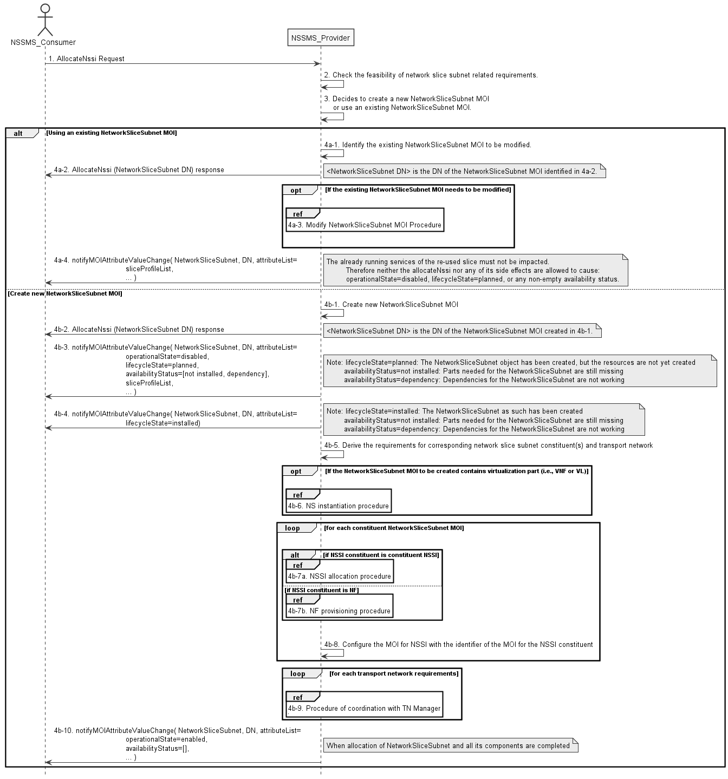

**Figure 7.3-1: Network Slice Subnet Instance Allocation Request procedure**

1) Network Slice Subnet Management Service Provider (NSSMS_Provider) receives an AllocateNssi request (see AllocateNssi operation defined in clause 6.5.2) from Network Slice Subnet Management Service Consumer (NSSMS_Consumer) with network slice subnet related requirements (network slice subnet related requirements defined in SliceProfile see clause 6.3.4 in TS 28.541 [6]).

2) NSSMS_Provider checks the feasibility of network slice subnet related requirements. If the network slice subnet related requirements can be satisfied, the following step 3) are needed, else go to step 5).

3) Based on the network slice subnet related requirements and the existing NSSI capabilities, NSSMS_Provider decides whether to use an existing NSSI or create a new NSSI. If the network slice subnet related requirements allow the requested NSSI to be shared and if an existing suitable NSSI can be reused, the NSSMS_Provider decides to use the existing NSSI.

4a-1) If using an existing NSI, the NDSMS_Provider identifies the existing NetworkSliceSubnet MOI.

4a-2) The NSSMS_Provider sends AllocateNssi response to the NSSMS_Consumer with the DN of the NetworkSliceSubnet MOI, identified in step 4a-1.

4a-3) The identified NetworkSliceSubnet MOI needs to be modified to satisfy the network slice related requirements and the NSMS_Provider invokes the procedure to modify the existing NSSI as described in clause 7.7.

4a-4) The NSSMS_Provider associates the received SliceProfile with the identified existing NetworkSliceSubnet MOI. Additionally, the NSSMS_Provider may configure other configuration information for the NetworkSliceSubnet MOI. The NSSMS_Provider notifies the updated NetworkSliceSubnet MOI attributes to NSSMS_Consumer.

NOTE: The already running services of the re-used slice must not be impacted. Therefore neither the allocateNssi nor any of its side effects are allowed to cause: operationalState=disabled, lifecycleState=planned, or any non-empty availability status.

4b-1) If creating a new NSSI, the NSSMS_P creates the NetworkSliceSubnet MOI.

4b-2) The NSSMS_Provider sends AllocateNssi response to the NSSMS_Consumer with the DN of the NetworkSliceSubnet MOI, created in step 3b-1.

4b-3) The NSSMS_Provider updates the NetworkSliceSubnet MOI instance states. Additionally, the NSMS_Provider may configure other configuration information for the NetworkSliceSubnet MOI.

The NSSMS_Provider sends notification notifyMOICreation (defined in clause 6.5.2 in TS 28.541 [6] and clause 11.1.1.7 in TS 28.532 [8]) with the following attributes to NSSMS_Consumer:

- DN of the NetworkSliceSubnet MOI in attribute objectInstance.

- The following NetworkSliceSubnet instance states in attributeList:

- operationalState=disabled

- lifecycleState=planned

- availabilityStatus=[not_installed, dependency]

NOTE: The NetworkSliceSubnet instance states indicate that the MOI has been created, but corresponding network slice subnets are not created.

- lifecycleState=planned: The NetworkSliceSubnet object has been created, but the resources are not yet created

- availabilityStatus=not installed: Parts needed for the NetworkSliceSubnet are still missing

- availabilityStatus=dependency: Dependencies for the NetworkSliceSubnet are not working

4b-4) When the Network Slice Subnet is created, the NSSMS_Provider updates the NetworkSliceSubnet MOI instance states.

The NSSMS_Provider sends notification notifyMOIAttributeValueChanges (defined in clause 6.5.2 in TS 28.541 [6] and clause 11.1.1.7 in TS 28.532 [8]) with the following attributes to NSSMS_Consumer:

- DN of the NetworkSliceSubnet MOI in attribute objectInstance.

- The following NetworkSliceSubnet instance states in attributeList:

- lifecycleState=installed

NOTE: The NetworkSliceSubnet instance states indicate that the MOI has been created.

- lifecycleState=installed: The NetworkSliceSubnet as such has been created

- availabilityStatus=not installed: Parts needed for the NetworkSliceSubnet are still missing

- availabilityStatus=dependency: Dependencies for the NetworkSliceSubnet are not working

4b-5) NSSMS_Provider derives the corresponding network slice subnet constituent (i.e. NF, constituent NSS) related requirements and transport network related requirements (e.g. 3GPP endpoint information, latency requirements, bandwidth requirements and isolation requirements) from the received network slice subnet related requirements. Part of these requirements may be referenced by attribute "epTransportRef" as defined in clause 6.3.2.2 in TS 28.541[6]. Before NSSMS_Provider derives the constituent network slice subnet related requirements, NSMS_Provider may invoke corresponding network slice subnet capability information querying procedure as described in clause 7.8.2.

4b-6) If the NSSI to be created contains virtualisation part (i.e. VNF or VL), NSSMS_Provider derives the NS instance instantiation information (the NS instance instantiation information is described in clause 7.3.2.2 and clause 7.3.3.2 [3]) based on network slice subnet related requirements. NSSMS_Provider determines new VNF instance(s) that need to be deployed and the existing VNF instance(s) that need to be reused according to the necessary network function(s) and then derives the profile of virtual link(s) according to the connection requirements between the network functions. NSSMS_Provider chooses a proper NSD deployment flavour and creates data concerning the SAPs of the NS instance. NSSMS_Provider invokes the NS instantiation procedures to create a NS instance. NSSMS_Provider configures the NSS MOI with the NS instance identifier.

Note: NS instantiation procedure is described in TS 28.526 [7].

4b-7) For each required NSSI constituent, the following step 4b-7a) and 4b-7b) are needed:

4b-7a) If the required NSSI constituent is constituent NSSI, NSSMS_Provider invokes NSSI Allocation Procedure.

4b-7b) If the required NSSI constituent is NF instance, NSSMS_Provider invokes NF Creation Procedure as described in clause 7.10 or NF Modification Procedure as described in clause 7.11.

4b-8) NSSMS_Provider configures the NetworkSliceSubnet MOI with the DN of the MOI for NSSI constituent (i.e. ManagedFunction MOI, NetworkSliceSubnet MOI).

4b-9) For each required transport network related requirements, NSSMS_Provider invokes corresponding procedure of coordination with relevant TN Manager to handle the TN part as described in clause 7.9.

4b-10) When allocation of NetworkSliceSubnet and all its constituents is completed, the NSSMS_Provider updates the NetworkSliceSubnet MOI instance states. Additionally, the NSSMS_Provider may configure other configuration information for the NetworkSliceSubnet MOI. The NSSMS_Provider sends notification notifyMOIAttributeValueChanges (defined in clause 6.5.2 in TS 28.541 [6], clause 11.1.1.9 in TS 28.532 [8]) with the following attributes to NSSMS_Consumer:

- The following NetworkSlice instance states in attributeValueChange:

- operationalState=enabled

- availabilityStatus=null

Otherwise the result may include the reason of failure, for example, the required latency or user Number cannot be satisfied, or the physical resource is not enough.

7.4 Procedure of Network Slice Instance Deallocation

Figure 7.4-1 depicts the procedure of deallocating a network slice instance by the network slice management service provider to satisfy the NSI deallocation request received from an authorized consumer.

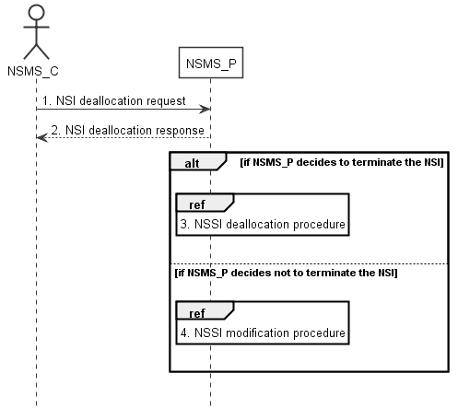

**Figure 7.4-1: Network slice instance deallocation procedure**

1) The network slice management service provider (NSMS_P) receives a NSI deallocation request (see DeallocateNsi operation defined in clause 6.5.3) from network slice management service consumer (NSMS_C) indicating that the NetworkSlice MOI is no longer needed for the given requirements i.e ServiceProfile.

2) The NSMS_P sends the NSI deallocation response (see DeallocateNsi operation defined in clause 6.5.3) to NSMS_C.

3) The NSMS_P may decide to terminate the NSI, then it invokes the NSSI deallocation procedure as described in clause 7.5.

4) The NSMS_P may decide not to terminate the NSI but to modify the NSI, then it invokes the NSI modification procedure as described in clause 7.6.

7.5 Procedure of network slice subnet instance deallocation

Figure 7.5-1 depicts the procedure of deallocating a network slice subnet instance by the network slice subnet management service provider to satisfy the NSSI deallocation request received from an authorized consumer.

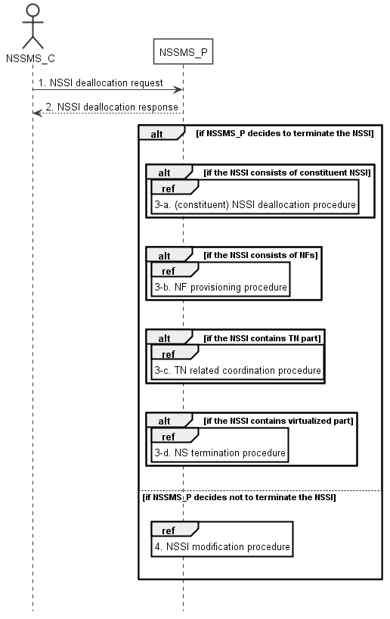

**Figure 7.5-1: Network slice subnet instance deallocation procedure**

1) The network slice subnet management service provider (NSSMS_P) receives NSSI deallocation request (see DeallocateNssi operation defined in clause 6.5.4) from network slice subnet management service consumer (NSSMS_C) indicating that the NetworkSliceSubnet MOI is no longer needed for the given requirements i.e SliceProfile.

2) NSSMS_P sends response (see DeallocateNssi operation defined in clause 6.5.4) of NSSI deallocation service to NSSMS_C.

3-a) NSSMS_P may decide to terminate the NSSI, it invokes (constituent) NSSI deallocation procedure as described in clause 7.5 if the NSSI consists of constituent NSSI.

3-b) NSSMS_P invokes NF deletion procedure as described in clause 7.12 only if the NF is dedicated for this NSSI and not being used by any other NSSI in the network, otherwise, NSSMS_P invokes NF modification procedure as described in clause 7.11.

3-c) NSSMS_P invokes TN related coordination procedure with responsible manager as described in clause 7.9 if the NSSI consists of TN part.

3-d) NSSMS_P invokes NS termination procedure if the NSSI contains virtualized part.

Note: NS termination procedure is described in TS 28.526 [7].

4) NSSMS_P may decide not to terminate the NSSI, it invokes NSSI modification procedure as described in clause 7.7.

7.6 Procedure of Network Slice Instance Modification

The Figure 7.6-1 illustrates the procedure of modifying an existing NSI.

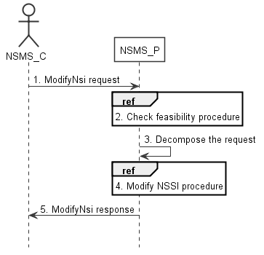

**Figure 7.6-1: Network Slice Instance Modification Request procedure**

1) Network Slice Management Service Provider (NSMS_P) receives a modifyMOIAttributes operation defined in TS 28.532 [8] from Network Slice Management Service Consumer (NSMS_C) with the DN of NetworkSlice MOI and the new network slice related requirements (see ServiceProfile defined in clause 6.3.3 in TS 28.541[6]).

2) Based on the new network slice related requirements, NSMS_P invokes the feasibility check procedure. If the modification requirements can be satisfied, go to step 3), else go to step 5).

3) NSMS_P decomposes the NetworkSlice MOI modification request into NSSI modification request(s), i.e., generating the new network slice subnet related requirements for each NSSI if needed.

4) NSMS_P, as the role of Network Slice Subnet Management Service Consumer (NSSMS_C), invokes the NSSI modification procedure.

5) NSMS_P sends NSI modification result (see modifyMOIAttributes operation defined in TS 28.532 [8]) to NSMS_C.

7.7 Procedure of Network Slice Subnet Instance Modification

The Figure 7.7-1 illustrates the procedure of modifying an existing NSSI.

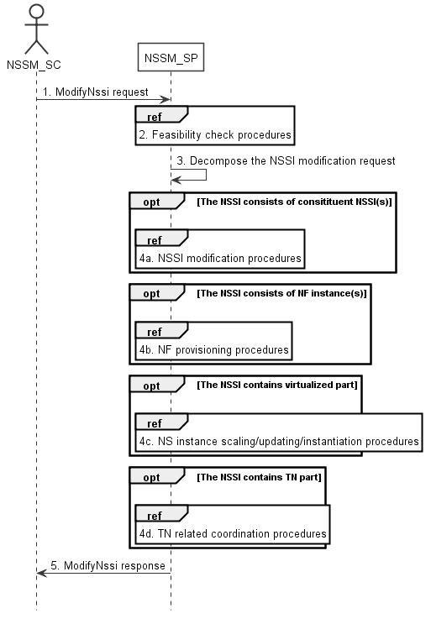

**Figure 7.7-1: Network Slice Subnet Instance Modification Request procedure**

1) Network Slice Subnet Management Service Provider (NSSM_SP) receives a modifyMOIAttributes operation defined in TS 28.532 [8] from Network Slice Subnet Management Service Consumer (NSSM_SC) with the DN of NetworkSliceSubnet MOI and the new network slice subnet related requirements (see SliceProfile defined in clause 6.3.3 in TS 28.541[6]).

2) Based on the new network slice subnet related requirements, NSSM_SP invokes the feasibility check procedure. If the modification requirements can be satisfied, go to step 3), else go to step 5).

3) NSSM_SP decomposes the NetworkSliceSubnet MOI modification request into modification requests for each NSSI constituent.

4a) If the requested NSSI constituent is constituent NSSI, NSSM_SP invokes NSSI modification procedure as described in clause 7.7.

4b) If the requested NSSI constituent is NF instance, NSSM_SP invokes NF creation procedure as described in clause 7.10 or NF modification procedure as described in clause 7.11.

4c) If the NSSI contains the virtualized part, NSSM_SP invokes the NS instance scaling and/or NS instance updating and/or NS instance instantiation procedure as described in TS 28.526 [7].

4d) If the NSSI contains the TN part, NSSM_SP invokes the TN related coordination procedure as described in clause 7.9.

5) NSSM_SP sends NSSI modification results (see modifyMOIAttributes operation defined in TS 28.532 [8]) to NSSM_SC.















|  |
| --- |
| **End of change** |