3GPP TSG-SA5 Meeting #143-e S5-223381rev1
e-meeting, 9 - 17 May 2022

Source: Huawei

Title: pCR TS 28.104 add MDA analysis request and report generic workflow

Document for: Approval
Agenda Item: 6.6.5

1 Decision/action requested
In this box give a very clear / short /concise statement of what is wanted.

2 References
[1] 3GPP TS 28.104 “Management and orchestration; Management Data Analytics”

3 Rationale
This contribution propose to add generic MDA analysis request and reporting workflow in [1].

4 Detailed proposal
It is proposed to apply following changes in [1].
1st modified section

11 Workflows for MDA management

11.X MDA analysis request and reporting workflow

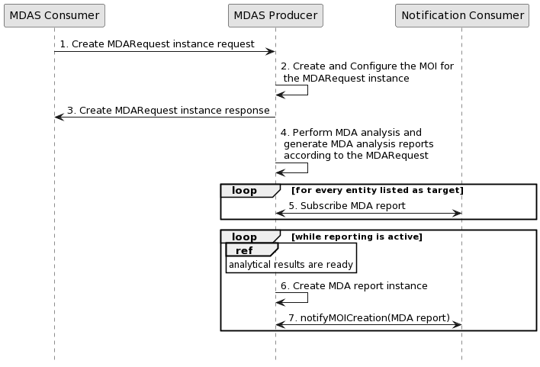
Figure 11.X-1: Generic MDA analysis request/reporting workflow
1 MDAS Producer receives a Create MDARequest MOI request (see createMOI operation defined in TS 28.532 [11]) from MDAS Consumer with MDA request related information.
Note: The MDA request related information see information model definition for MDA request NRM in clause 9.
2 The MDAS Producer creates the MOI for the MDARequest to be created.
3 The MDAS Producer sends the Create MDARequest MOI response (see createMOI operation defined in TS 28.532 [11]) to MDAS Consumer with identifier of MOI.
4 The MDAS Procedure perform MDA analysis and generate MDA report according to the MDA request.
5 The Notification consumer subscribes a MDA report by invoking the subscribe operation.
Editor notes: The reference of MDA report IOC information model definition will be added, when they are available.
6 The MDAS producer creates a MDA report instance.
7 The MDAS producer sends the notification containing the MDA report to subscribed Notification consumers.

End of modified section

